Creating a boundary SVG file for morphologica

This document describes how you can create an SVG document in Inkscape which contains boundary paths which can be read by morph::ReadCurves and output as an array of coordinates (a vector<BezCoord>). This set of coordinates can then be used to initialize a morph::HexGrid with a boundary.
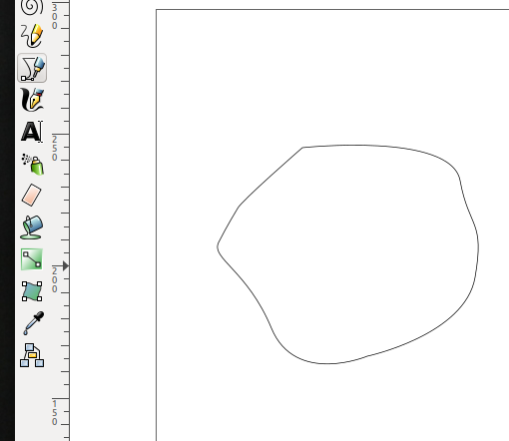 Fig 1: A closed path
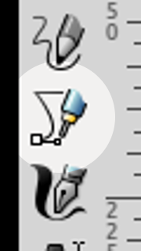
1) Open Inkscape. I am using Inkscape version 0.92.

2) Optionally paste in the image that you want to trace.

3) Choose the “Draw Bezier curves and straight lines” tool:

4) Create a complete, closed path. The line properties don’t matter (any thickness, any colour, any style… probably). The path can contain curves and/or straight lines and any number (or at least a few thousand) segments.

5) Select the path and find “Object Properties” (Shift+Ctrl+O). For the “ID” field, replace the existing ID with the word “cortex”. Press the “Set” button. This is very important, or your change to the ID will not take effect. The path named cortexis used by morphologica as the main boundary for the HexGrid.
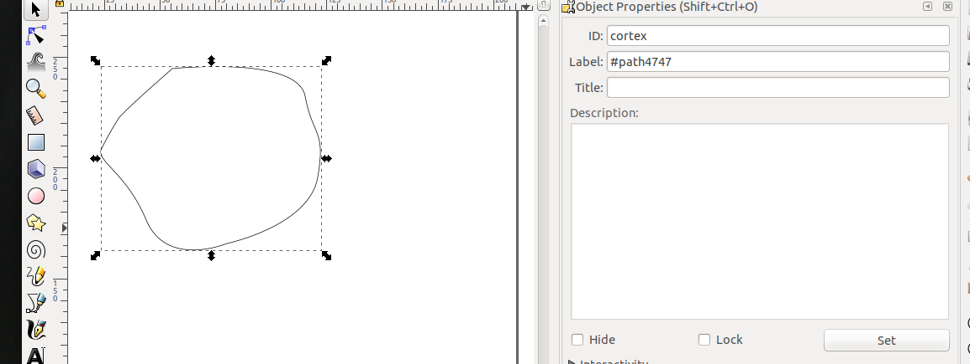Fig 2: Set the ID to cortex (and press the Set button - see bottom right)

6) Now make a scale bar. Choose the “Draw Bezier curves and straight lines” tool again, and draw a straight line of the relevant length (any orientation).
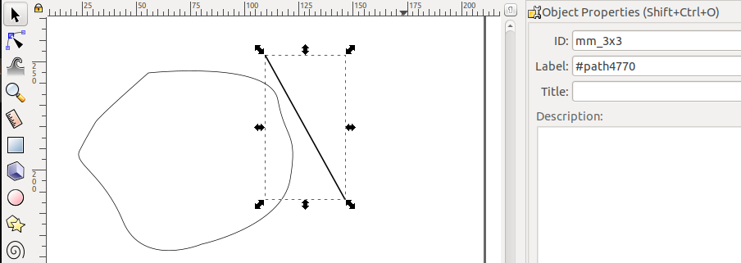Fig 3: A scale bar
7) In “Object Properties” for the scale bar line, set its ID field to a special tag which a) tells morphologica that it’s the scale bar and b) says how long the scale bar is. The format is:
mm_1x3. Don’t forget to press “Set”. The “mm” part is essential. Underscores can be used to space things out. The ‘x’ character is used in place of the decimal point. So this tag means that the scale bar is 1.3 mm long.

8) Save the file as an Inkscape or Plain SVG. (Either should work).

9) Test. Run the program “readcurves” which should install when you install the morphologica library. Readcurves defaults to providing enough HexGrid for about a 1mm wide boundary. If your boundary is larger than this, then provide the HexGrid width, and the size of a Hex like this:

readcurves boundaries/test.svg 6 0.1

This selects an initial HexGrid of around 6mm width with Hexes of size 0.1 mm (centre to centre distance). The result looks like:

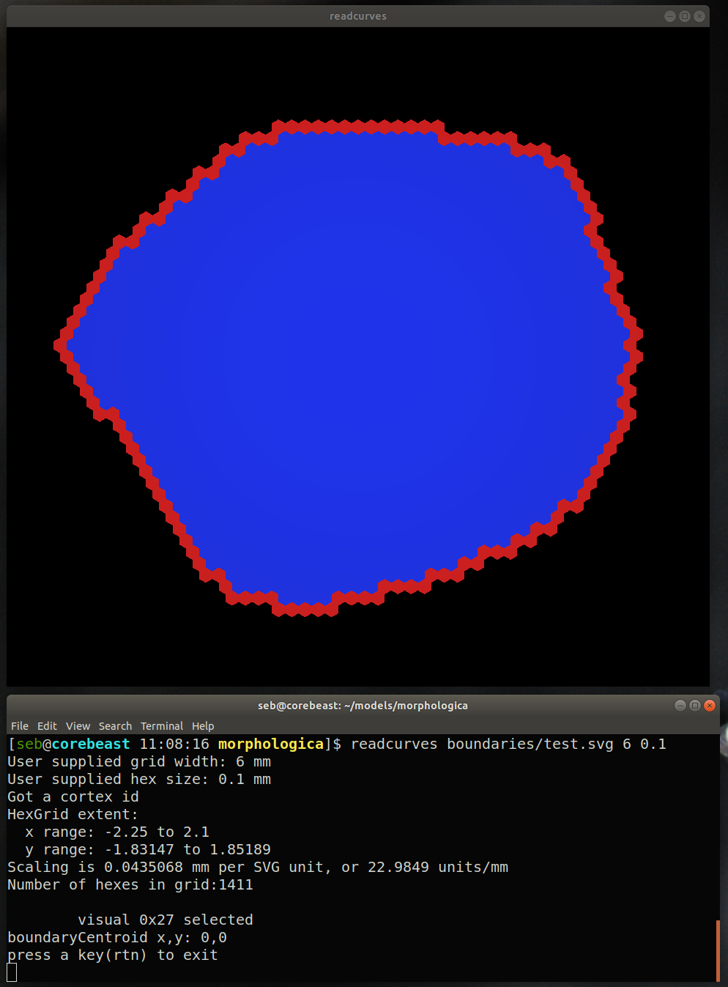

Here’s the result with Hex size 0.05:
