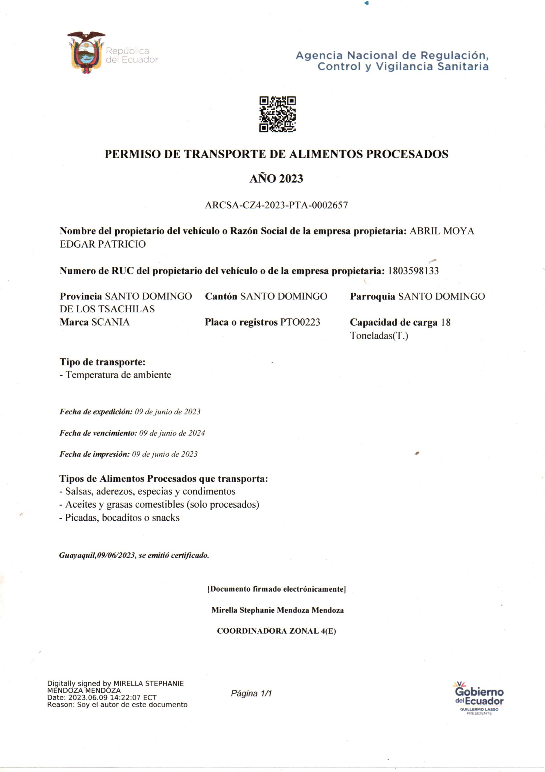

KENWORTH

**GSB 3779**

GUARACA AYNAGU