 |  | % DW
Time |  | LD | SD
1st day | ZT00 | 27,7 | 31,67
1st day | ZT04 | 30,89 | 33,65
1st day | ZT08 | 41,87 | 30,6
1st day | ZT12 | 36,37 | 27,52
1st day | ZT16 | 31,41 | 25,52
1st day | ZT20 | 28,24 | 25,47
2nd day | ZT00 | 29,96 | 30,34
2nd day | ZT04 | 36,22 | 33,11
2nd day | ZT08 | 40,46 | 29,12
2nd day | ZT12 | 34,66 | 27,8
2nd day | ZT16 | 34,37 | 27,52
2nd day | ZT20 | 29,24 | 26,14
Rhythmicity  p-value |  | 1,2x10⁻⁴ | 1,38x10⁻⁴

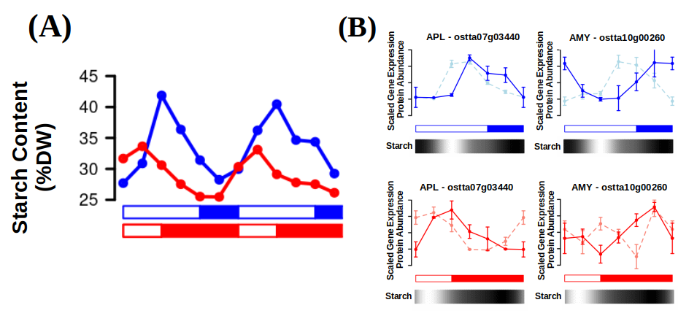Figure 45: Multi-omics integration of starch periodic oscillations. (A) Starch content profile under summer photoperiod (blue) and winter photoperiod (red); (B) Scaled gene expression profiles (lighter dashed lines) and protein abundance profiles (darker solid lines) of the main enzymes involved in starch synthesis (glucose-1-phosphate adenylyltransferase, APL - ostta07g03440) and degradation (amylases, AMY - ostta10g00260). Starch content is represented as a color block that gradually changes from black (low starch content) to white (high starch content).

