 | 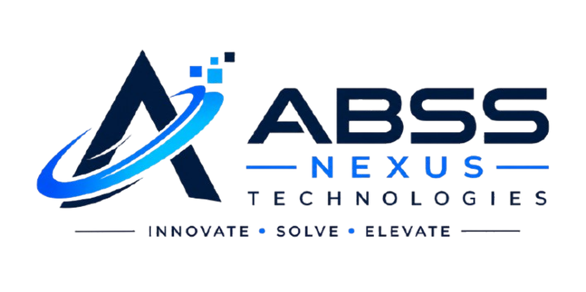  INNOVATE • SOLVE • ELEVATE | ACADEMIC & INDUSTRY RECOGNITION  UDYAM-JH-20-0038921  ISO 9001:2015 Compliant Standards  National Internship Verification Hub
CERTIFICATE OF COMPLETION
INTERNSHIP EXCELLENCE & MERIT
This is proudly presented to
[STUDENT FULL NAME]
for successfully completing the 8-Week Virtual Internship in Full Stack Web Development at ABSS Nexus Technologies, demonstrating outstanding mastery of modern web architecture, responsive user interfaces, backend API services, clean code quality, and collaborative Git version control workflows with Distinction (Grade A+).
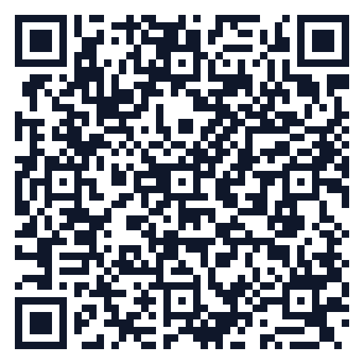  Scan to Verify Credential  abssnexus.in/verify-certificate  Certificate ID: ABSS-CERT-2026-WD-9402  Issue Date: October 2026 |  | 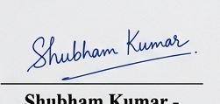  Shubham Kumar  Founder & Technical Lead  ABSS Nexus Technologies  Head of Academic Mentorship  Authorized Signatory

