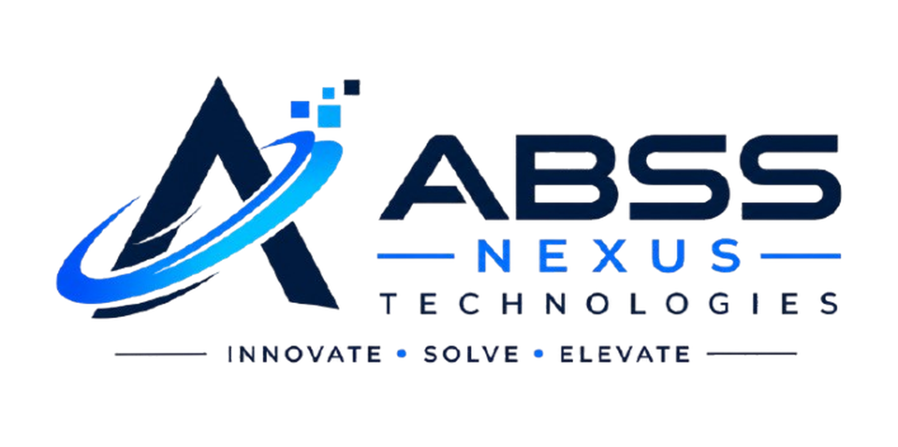  INNOVATE • SOLVE • ELEVATE | ABSS Nexus Technologies  Registered Corporate Office: India  Web: www.abssnexus.in  Email: contact@abssnexus.in  Student Support: +91 87579 28673  CIN / MSME Reg: UDYAM-JH-20-0038921

Ref No: ABSS/INT/2026/0482 | Date of Issue: October 20, 2026
INTERNSHIP OFFER LETTER
Dear [Candidate Name],
On behalf of ABSS Nexus Technologies, we are pleased to offer you an appointment as a Virtual Full Stack Web Development Intern. This offer is extended in recognition of your academic merit, technical aptitude, and enthusiasm for building modern web software architectures.
Designation / Role | Virtual Software Engineering & Web Development Intern
Program Track | Full Stack Web Development (HTML5, Modern CSS, JavaScript, APIs)
Program Duration | 8 Weeks (Structured Project Milestones)
Commencement Date | November 01, 2026 to December 26, 2026
Work Mode | 100% Remote / Virtual with Weekly Git Code Reviews
Reporting Mentor | Shubham Kumar — Founder & Technical Lead
Credential Awarded | Industry-Verifiable Certificate of Completion & Letter of Recommendation
Key Program Highlights & Code of Conduct:
- Hands-on Engineering: You will build production-grade modules including responsive layouts, API integrations, and database schemas with clean commits on GitHub.
- Weekly Milestone Reviews: Your code deliverables will be reviewed against real-world engineering rubrics: accessibility, semantic correctness, code modularity, and speed.
- Verifiable Credential: Upon achieving passing rubric scores on all project milestones, you will receive a QR-verifiable certificate recognized under MSME registration.
- Letter of Recommendation (LoR): Candidates demonstrating Grade A distinction receive a personalized LoR signed by the Founder to support job interviews.
- Academic Honesty: Plagiarism or submitting AI-generated code without comprehension violates company standards and leads to revocation of credentials.
We are excited to welcome you into our engineering cohort and look forward to partnering in your professional development as a software developer.
Sincerely,  For ABSS Nexus Technologies  Human Resources & Talent Desk  ABSS Nexus Technologies |  | 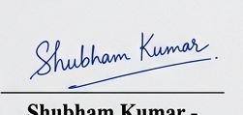  Shubham Kumar  Founder & Technical Lead  ABSS Nexus Technologies

CANDIDATE ACCEPTANCE & ACKNOWLEDGEMENT (Please sign & return copy):
I accept the offer of Virtual Internship on the terms described above. I agree to abide by all intellectual property, confidentiality, and engineering guidelines of ABSS Nexus Technologies.
Candidate Full Name: _______________________ Signature: _______________________ Date: _______________

