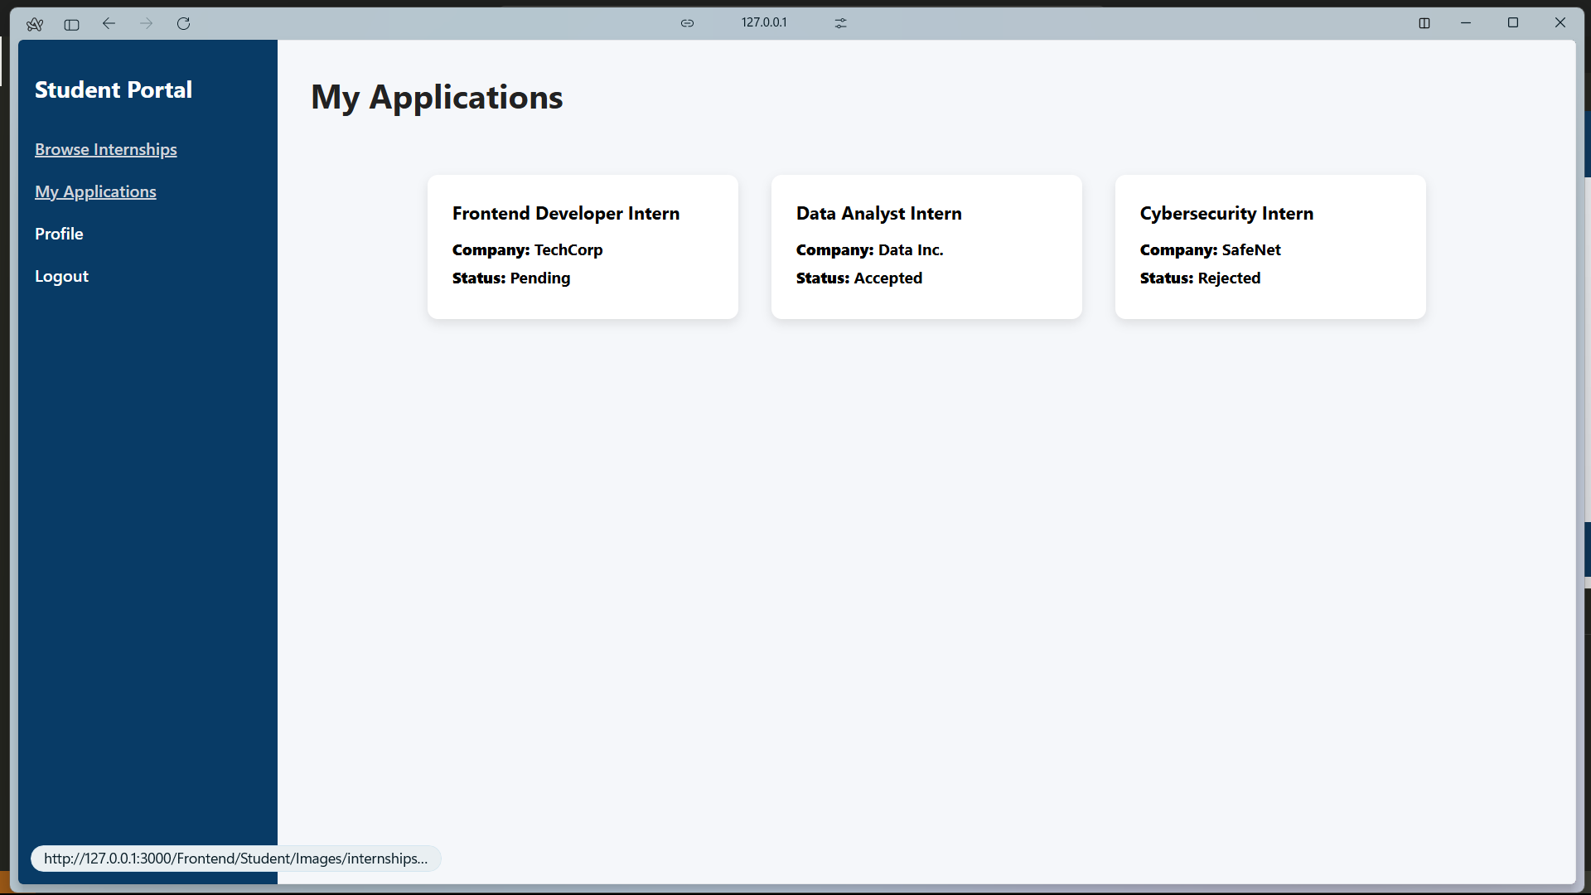

Left menu set text decoration to none.

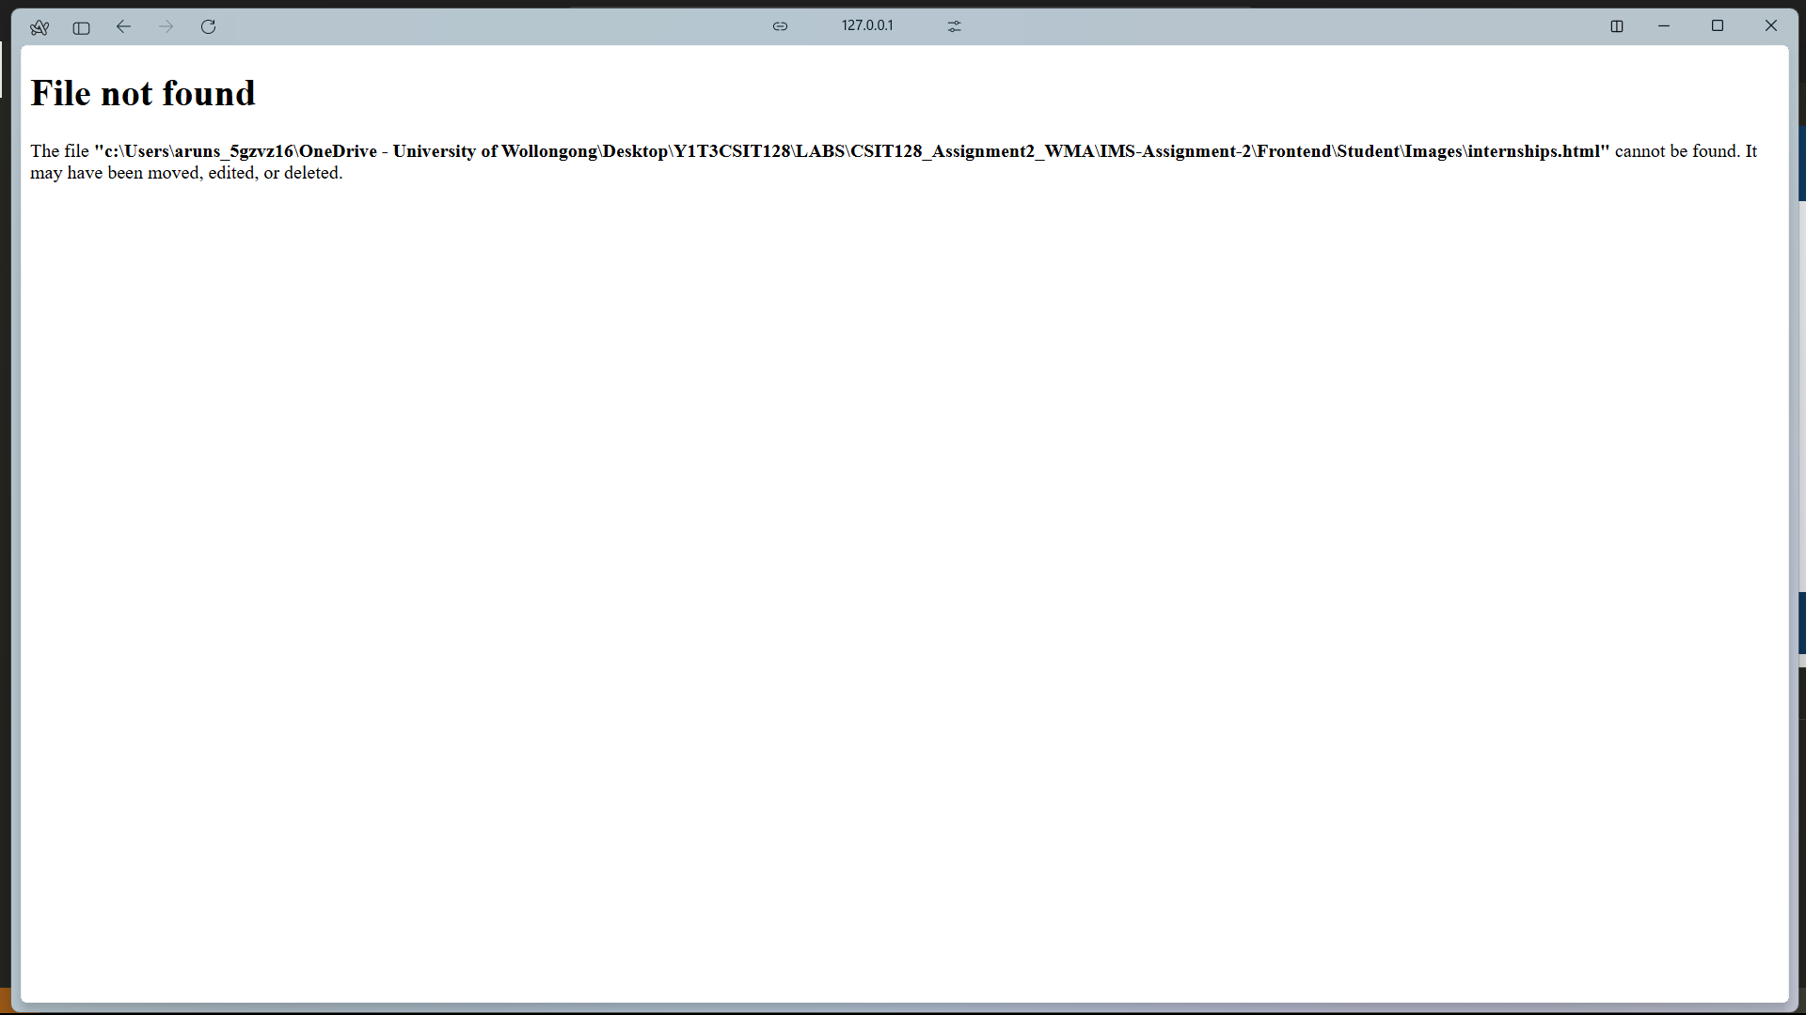

set list of available internships to browse.

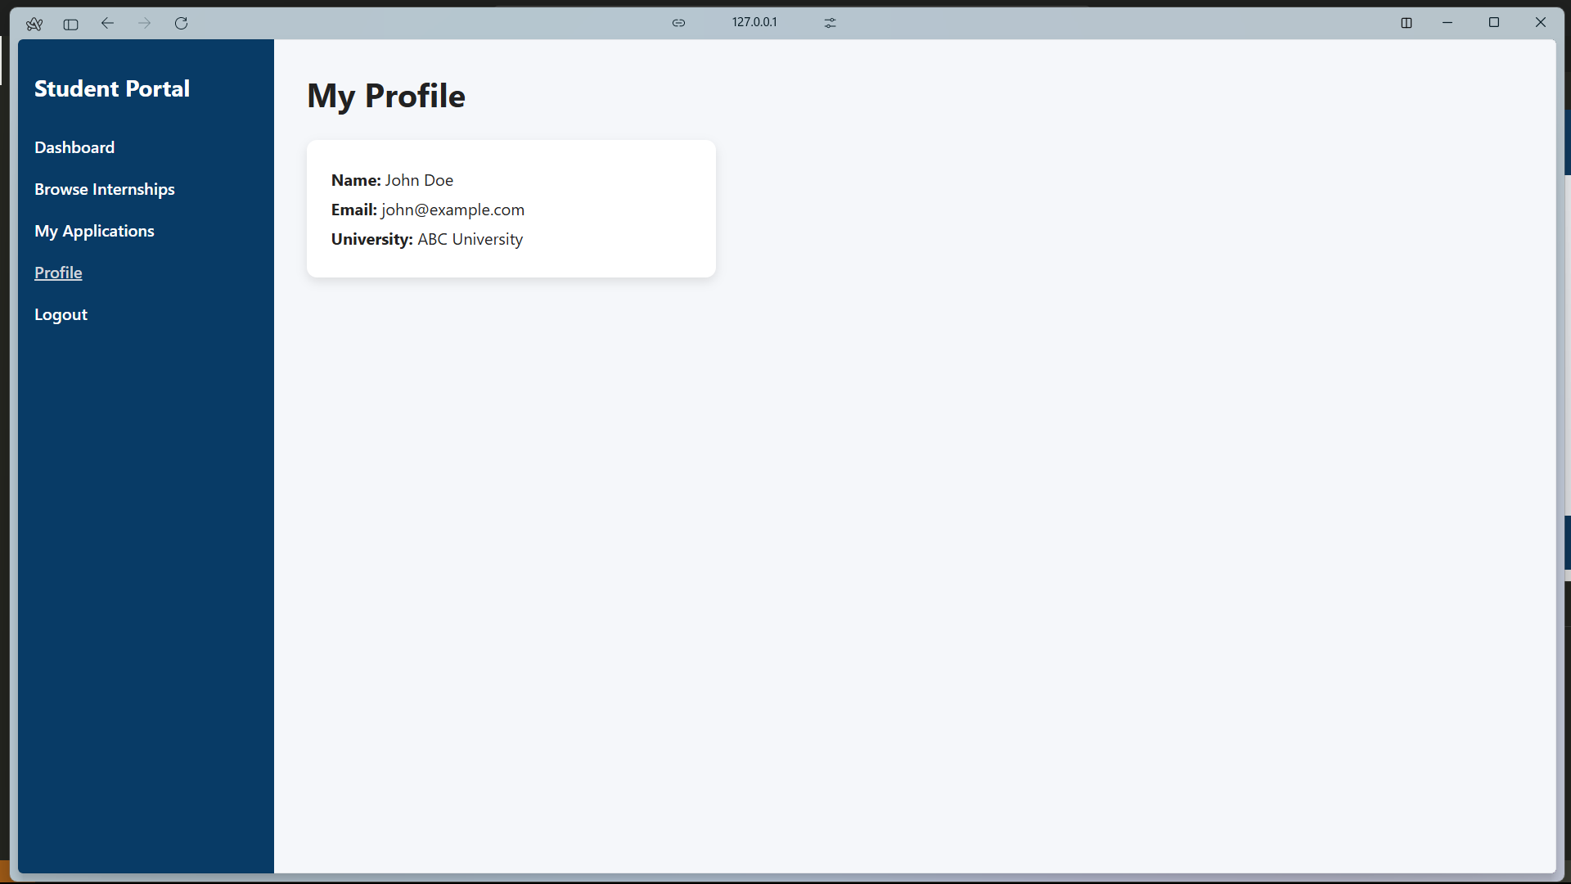

Make profile section a little bit more conventional.

Change student to the name of the logged student user.

Link login with database.

Create regex for phone number.

Link signup with database.

Fix admin login page layout.

Fix admin signup page layout.

Link signup with admin database.

Check if regex is implemented for email.

Link with login with admin database.

Change text to welcome company based on name in admin database.

Change navbar text decoration to none.

set list of available internships to browse.

Fix layout of admin’s view applications page.

Fix back to dashboard button styling in admin’s profile page.

Fix all admin’s pages navbar and styling.