**Introduction**

Since the first railway opened in England in 1830, railways have made transportation more easier for us. The development of railways has been important from 1830 to 2020. The concept of blockchain is growing rapidly, and as a result, public interest is increasing fast. Investors and businessmen who seek visibility and equity in their transactions are among the most enthusiastic supporters of blockchain. Now that blockchain is more than just a concept, its deployment in trains is expected to make travel more efficient.

Satoshi Nakamoto invented blockchain technology on the bitcoin platform in 2009. Blockchain is a distributed open ledger that eliminates the need for a third party to complete a transaction. The usage of blockchain will reduce transaction costs, making transactions more beneficial for customers. Blockchain also improves the transaction's security, reducing the risk of fraud. Aside from financial convenience and security, blockchain has a lot of applications in the transportation industry. The network rail technological strategy, published in 2013, identifies the areas in which railways require innovation. It has the properties of a cryptographically secure transaction, as well as authenticity, transparency, and a low-cost and efficient transaction. (RWaltz Software, 2020)

**Why Blockchain?**

1. Cryptographically secure: Cryptographic security has a high threshold as compared to the present approach.

2. Integrity: The data obtained through blockchain is completely efficient, accurate, and trustworthy.

3. Low-cost and efficient:  blockchain allows you to conduct transactions without the involvement of a third party, the additional expense is eliminated, making it both affordable and efficient.

4. Transparency: The data on a blockchain cannot be changed, it provides a time-stamped version of the 'truth.' (RWaltz Software, 2020)

**Blockchain in Railway Industry**

Railways are a high complexity, interconnected, and high-risk industry. To connect the entire network with villages, cities, regions, and countries, a vast dynamic database was deployed. Without 24-hour observation and governance, it's difficult to prevent security challenges, accidents, miscommunications, passenger insecurity, and other problems. As a result, a single erroneous piece of data can bring a network to its knees. (J. D. Preece; J. M. Easton, 2020)

The majority of current rail networks in many nations are still controlled by manual operations, with the exception of Canada, Brazil, the United States, and Chile. The manual operations are handled by some important conventional railway software, which is not fully streamlined.

**Why Blockchain Is Essential for Railway Industry**

The railway traffic is not the same as the traffic on the roads. The local rail systems have independent technical frameworks to impose tight safety measures because the network includes of a lot of interconnected narrow railway lines leading different trains to different destinations from one end to another end at varying time intervals. Each track is assigned to a train at a time based on train timings, and the central operator never allows any other trains to bypass the track during that time.

In the current conventional railway operations, signals and other information from control rooms are directly passed to the drivers, not the trains. So the live information receiver is a human. This manual comment receiving and implementation can result in technical failure. So, to make this entire system more dynamic, we need to decentralize it, as a result, trains(drivers) can automatically find the right routes and can make decisions on it. These entire actions can be made auditable under smart contracts, only if the focused decentralized system is implemented successfully without harming the current conflict-free state of the railway networks.

Blockchain implementation in the railway must ensure the current safe blocks upkeeped by the conventional railway frameworks.

Those safe blocks are.

Preventing collisions while a train stops unexpectedly, or derails.

Emergency Braking while red signal received or the operator does not react

Detecting the train decomposition and continuously varying speed. (Sam, 2021)

**Advantages of blockchain in railways:**

1. All of the trains can communicate with one another using smart contracts and sensors. Smart contracts will be used to solve the problem of railway delays.
2. Because of the trains smart administration and communication, any accidents would be avoided.
3. Blockchain will improve the overall system.
4. Trains can choose their available routes and lock them using blockchain, ensuring that no other train would cross the path.
5. Blockchain can be utilized for a variety of different applications, such as verifying a driver's license and authorisation, as well as billing infrastructure.
6. Blockchain continuously updates the status of the trains, avoiding any delays.
7. In the railways, blockchain technology has made smart ticketing possible.

**Where is the blockchain technology being used in railways?**

1. Blockchain provides for comprehensive data analysis. Russia's new railway system will allow them to follow regular commuters.

2. The train system analyzes the data and can make offers to the appropriate passengers.

3. Blockchain technology has brought transparency and traceability to the Russian railway system.

4. The Russian railways' data security has improved thanks to the usage of blockchain technology.

5. Blockchain technology ensures that every information in the ledger is cryptographically encoded, making decoding challenging.

6. Because every information is interrelated, no one can change it because they would have to update all of it, which is a difficult undertaking.

7. Because the information is not held in a single location, blockchain technology provides exceptional decentralization. As a result, hacking and modifying data is almost difficult. (RWaltz Software, 2020)

**How Blockchain Technology will help the railway industry?**

Blockchain is transparent, it creates trust in its users. The ownership and history of an asset can be traced back to its origins. Companies purchasing used things can look up the history of each component, which might assist them in deciding.

Train manufacturers' asset owners can check the history of all parts and provide consumers with verifiable documentation that their things were made with the specified materials. It helps firms to communicate with one another more openly.

In the future, blockchain has the ability to help us automate our supply chains. Data from the supply chain could be combined with safety information. If a sensor detects that a component needs to be replaced, it can activate a supply chain blockchain smart contract that orders a brand new part without the need for human intervention. As a result, both time and money would be saved. (Johal, 2020)

**Security of blockchain: some issues to be consider**

Although blockchain is considered to be extremely secure, it is not without drawbacks. This is demonstrated by the consensus method, which requires 51 percent of nodes to agree to validate a new block. If a single person or group controls more than half of the processing power on a network, they have the majority of consenting capabilities and can prohibit transactions from being completed, thus preventing transactions between some or all users. They could also create double-spending by reversing transactions. This is known as a 51 percent attack. (RSSB, 2010)

**Conclusion**

Blockchain technology has the ability to improve in the solutions of supply chain issues. Because the technology is still in its development stage, it must be took into account before being implemented on a big scale. Yet, it provides a mechanism to minimize costs while maintaining confidence between partners, and it allows transparency throughout the blockchain, from the raw materials to the client.

Together we will see how Blockchain technology may be used to make railway infrastructure more significant and efficient - flexible, robust, and self-organized for controlling railway operations.

References

J. D. Preece; J. M. Easton. (2020). Blockchain Technology as a Mechanism for Digital Railway Ticketing. *IEEE Explore*, 1-5.

Johal, K. (2020, May 20). *blockchain-technology-for-the-rail-industry*. Retrieved from blog.bham.ac.uk: https://blog.bham.ac.uk/bcrre/2020/05/15/blockchain-technology-for-the-rail-industry/

RSSB. (2010, june 10). *blockchain-in-rail-where-do-we-go-from-here*. Retrieved from https://www.rssb.co.uk/: https://www.rssb.co.uk/en/what-we-do/insights-and-news/blogs/blockchain-in-rail-where-do-we-go-from-here

RWaltz Software. (2020, January 27). *Blockchain Is Changing The Way Rail Industry Works*. Retrieved from habr: https://habr.com/en/post/485708/

Sam. (2021). *blockchain-in-railway-industry*. Retrieved from bitdeal: https://www.bitdeal.net/blockchain-in-railway-industry

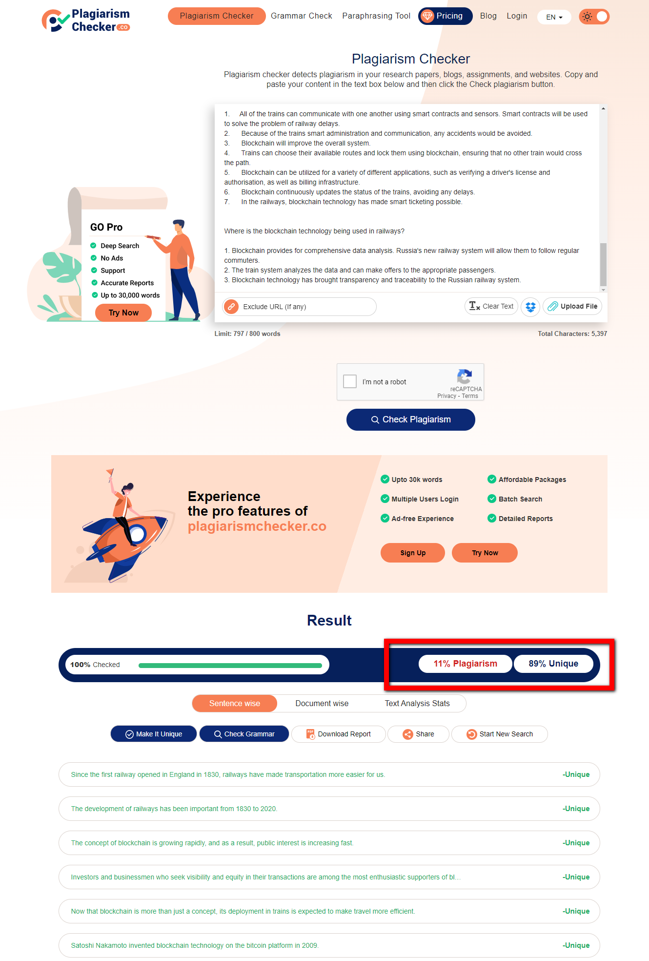**Appendix**

