## 4 minute speech (goes for 5:20)

# Welcome

Hi everybody here at Transform2020, welcome to our talk here at the conference hackathon! Our project was about encoding Continuous Wavelet Transforms to estimate lithology boundaries from downhole geophysical logs.

Change slide (2)

My name is Jared Armstrong, and our team includes Leo Dinendra, Martin Bentley and myself!

(show screen with everyone’s quick bio as per python notebook)

Background

I have been curious about automating picks from downhole geophysics for coal seams for a long time. We call them seam picks in the Australian coal industry. A couple of days before this conference I Read Evelyn Jun Hill's paper (which you can find in the slack channel). I though wow! Imagine if you could successfully do this on a stack of coal sediments! During the Hackathon opening address by Filippo, he encouraged us to still enter a project if we had an idea, so I decided to have a crack at putting a project up.

Move to third slide (synth log)

# Objective

Initially Our objective was to use python and python related libraries to generate boundary strength and mosaic plots in order to visually correlate geophysical traces with coal lithology boundaries, not knowing if this was possible or how hard this would be with such a short timeframe.

What I initially thought would be just interesting in coal, we are now thinking may have further usefulness for geologists working in other commodities all over the world.

The idea here is to try and pick the boundaries, not the lithologies.

Move to next slide, raw vs conditioned logs

# Process

We ended up using the following libraries

Numpy

Pandas

Matplotlib

Scipy

Pywt (for the CWT)

We had a strategy to start with, however this gone thrown out the window, and the project just developed organically, as folks had time, with a little guidance.

Early on, we realized the outputs were visually too busy and we were going to need to do something with the log. After playing around with a few options, we went with the savgol filter for log conditioning and used the gamma log. Later we switched to the density log.

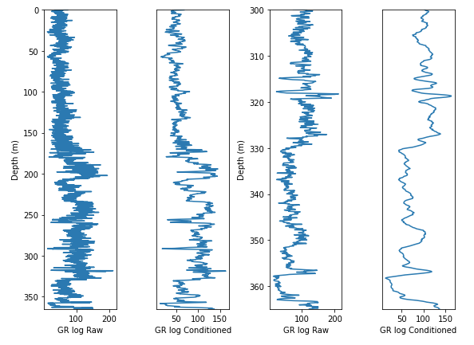

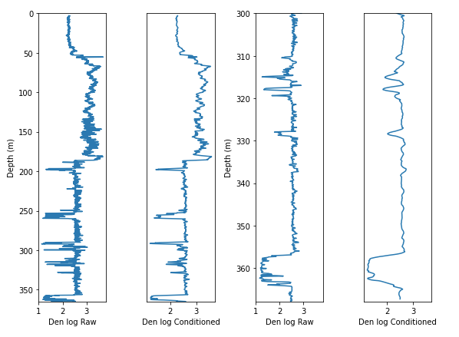

Move to next slide (5)

We then had success with generating both the CWT plot, the boundary strength plot ..

Move to next slide (6)

and finally the mosaic plot.

However we found a poor to average visual correlation between the gamma and lithological boundaries, coal seams are in red.

On changing to the density curve, correlation improved, but ultimately, we needed to try a multiscale correlation which means combine try and combine both gamma and density.

Move to next slide (7)

Martin built on Leo’s excellent work and added some interactive slider widgets.

# Future opportunity

There is much more that can be done here. Some ideas to help further mould these concepts into more usable applications available to other ..

* Correlate mathematically boundary strength with lithology.
* Use ML techniques to run multiple scenarios in order to improve the correlation between CWT boundary definition and lithology boundary.
* Play around a bit more with the amplitude and frequency settings to get a better correlation
* Combine several logs before generating CWT plots
* Incorporate mosaic plot as an option for subplots in Matlibplot library maybe?

# Conclusion

Tessellations can rapidly and reproducibly resolve subtle or subjective detail in the rocks that is not detectable by the human eye

The technique should therefore be considered an important addition to the toolkit of the mining and exploration geoscientist. This is particularly true where the only lithological data are derived from 1m composite intervals of rock chips,

On behalf of the team, a big thankyou to all that have been involved. Thankyou folks at software undergound, the organizers of the transform2020 conference, thankyou to Philippo for his guidance, and also the energy for this project generated by folks like DougMc, technical resources by Brendon and all of you that have contributed in some way, thankyou!

To the Software underground community, we bequeath to you, the code the ideas, the graphics generated by us in the lith_boundary_from_gamma hackathon project.

Martin might be around to field any questions later on.