Ameya Bahirat

Benjamin Droste

Peter McPadden

Kings and Creatures Project Part 3

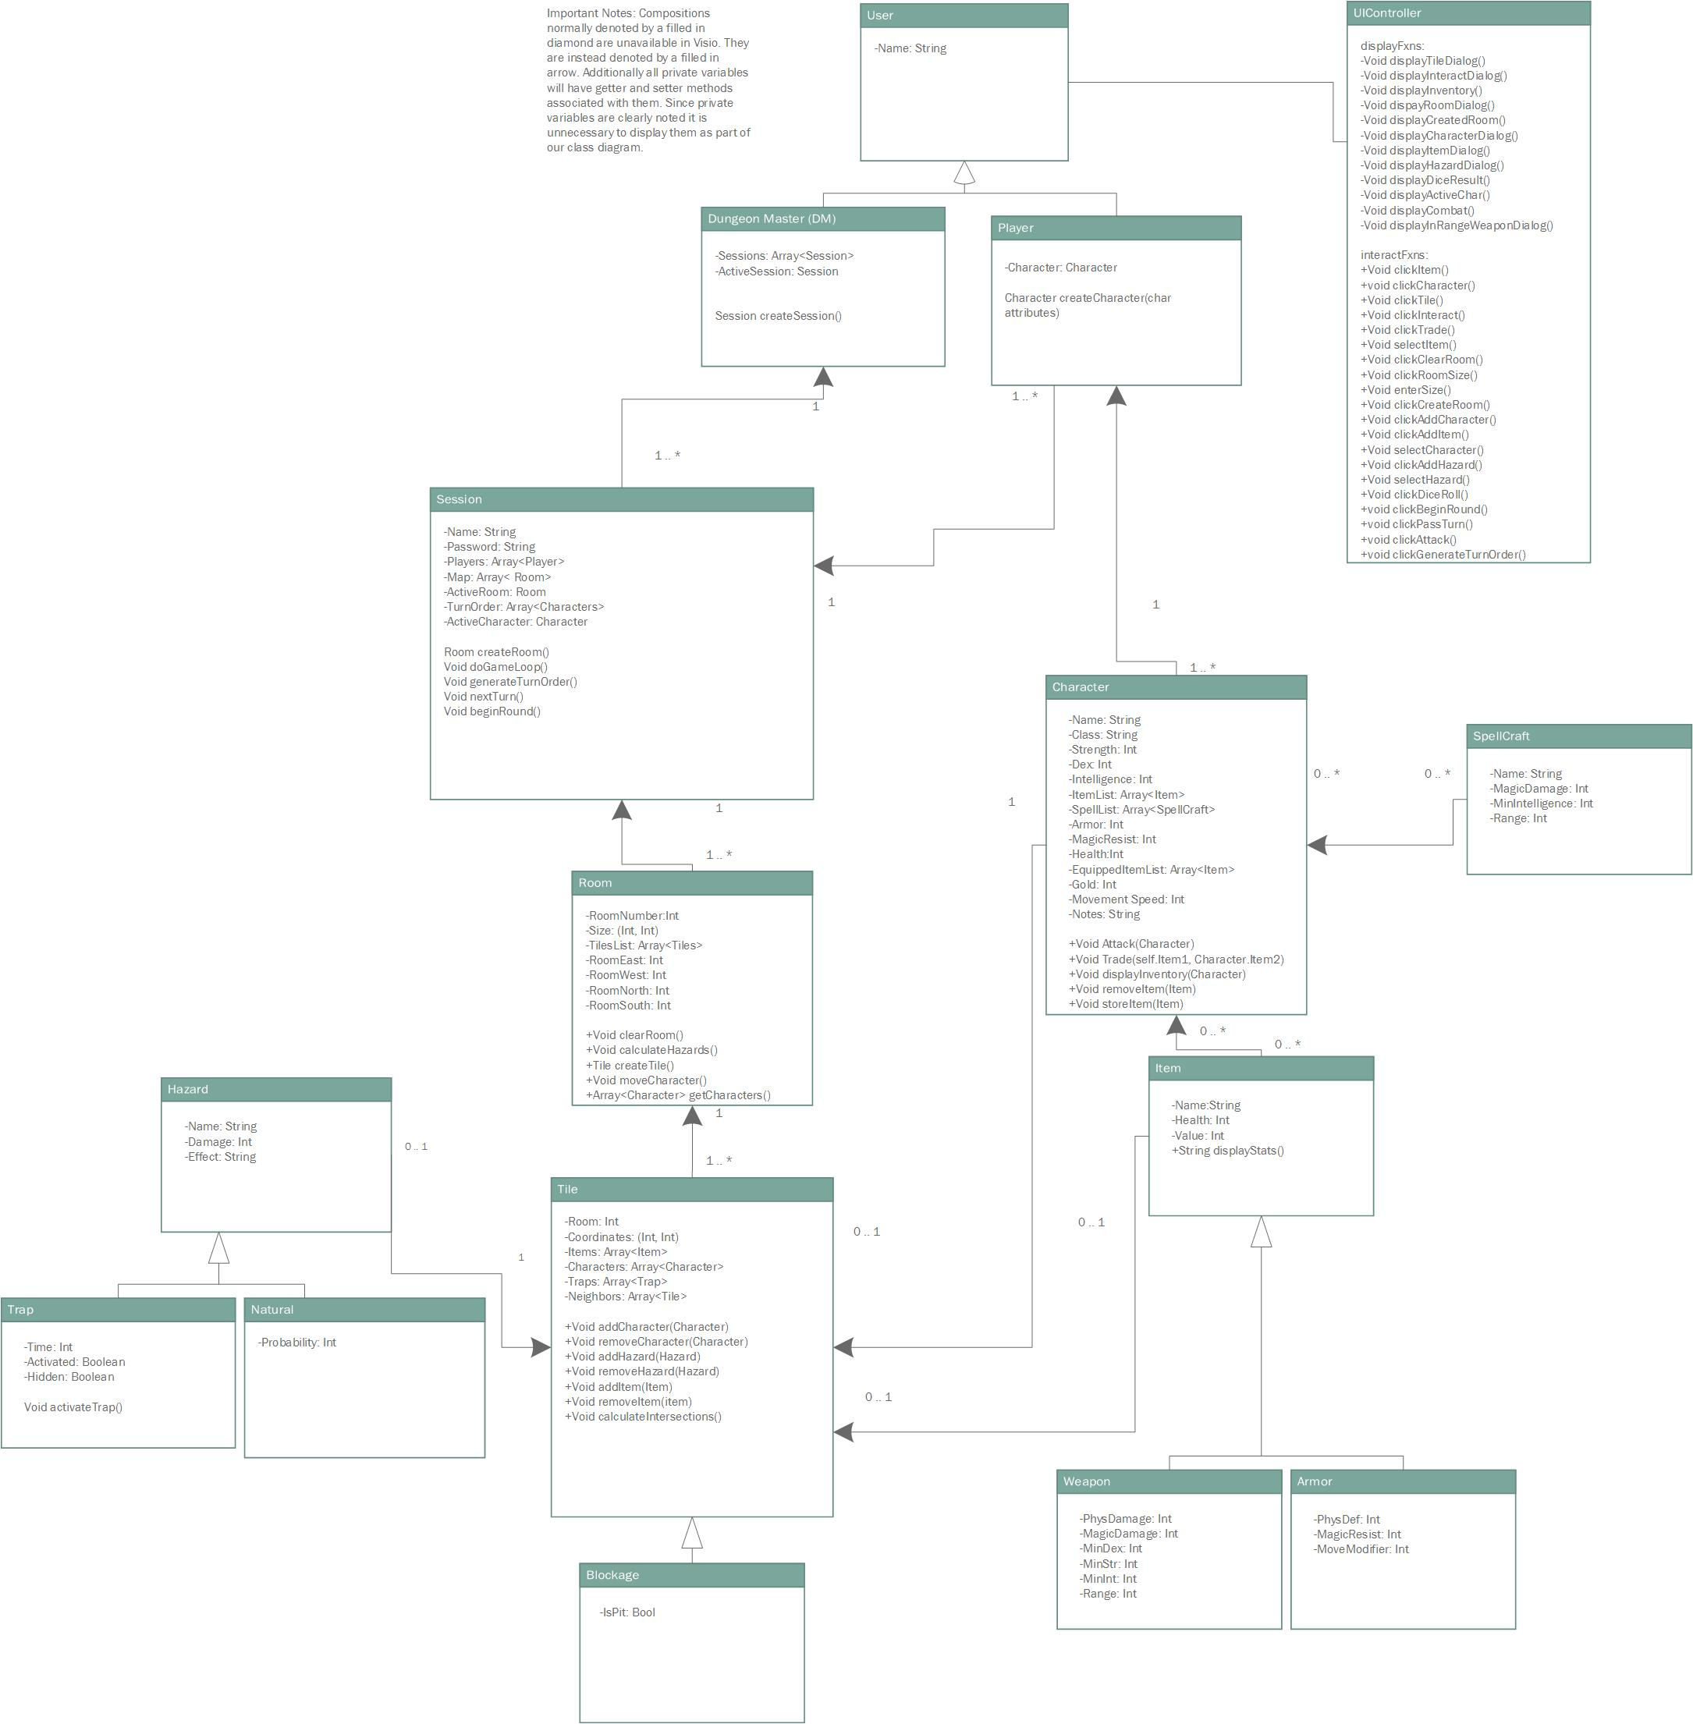

<Insert new class diag here>

For refactoring we chose to use a decorator pattern for tiles, with some tiles gaining a hazard or blockage type. We also followed an iterator design pattern for tile and characters. The character iterator is used for following the turn order, and the tile iterator will be used for hazard checks.

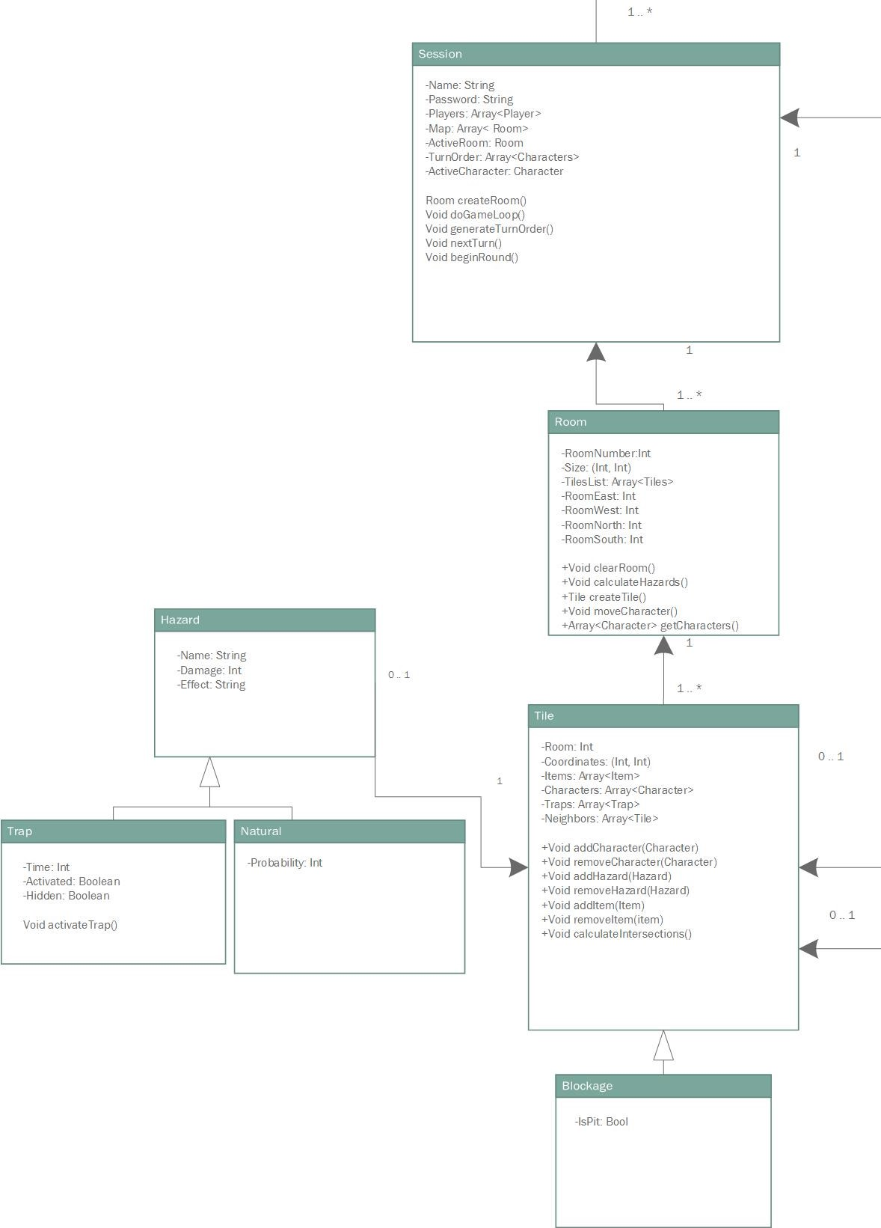

<insert zoomed in image of new subsection here>

For anti-pattern removal, we reworked our UI controller class to only include functions that would require information from multiple classes. Other display functions were moved to their respective classes. We also removed click events because with spring MVC the elements will know when they are being clicked and call the correct function from whatever class is needed.

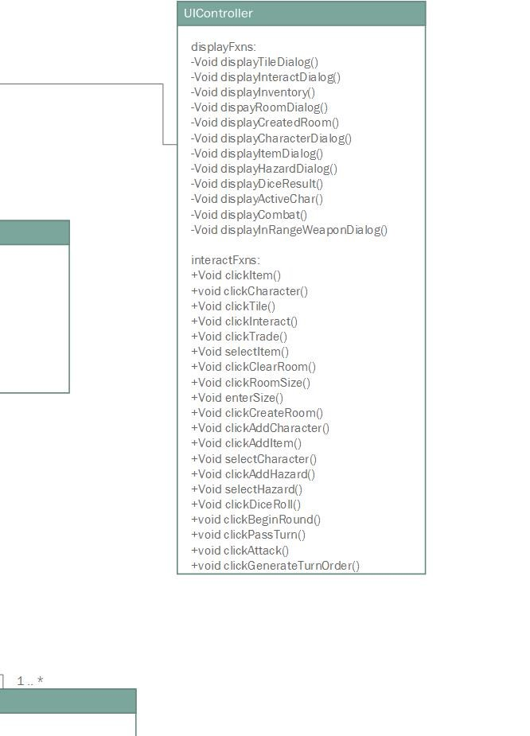

<insert zoomed in images of new subsections here>