Aaron Banson

Advanced Programming In Java

Dr Bama

Midterm

1. PostMan
   1. READ

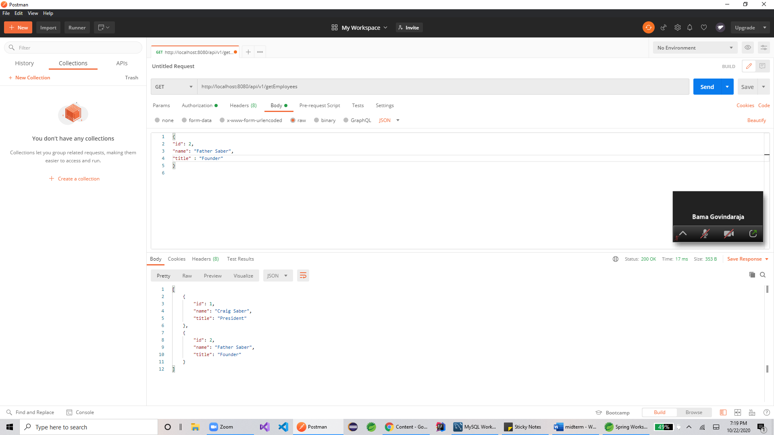

* 1. CREATE

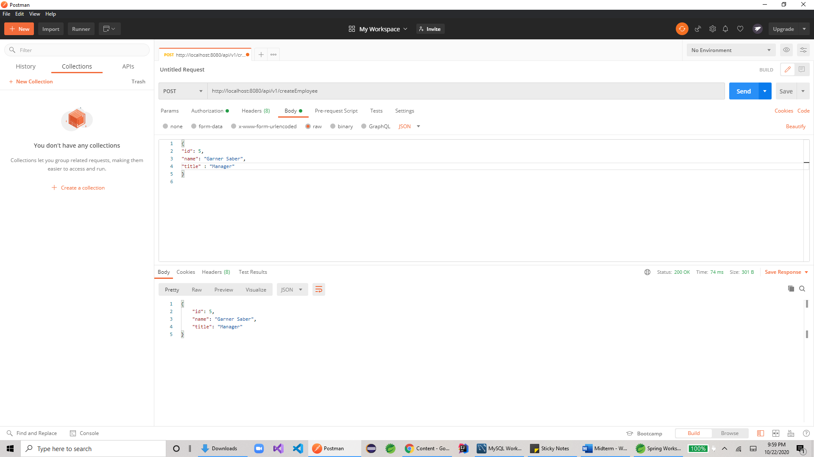

* 1. UPDATE

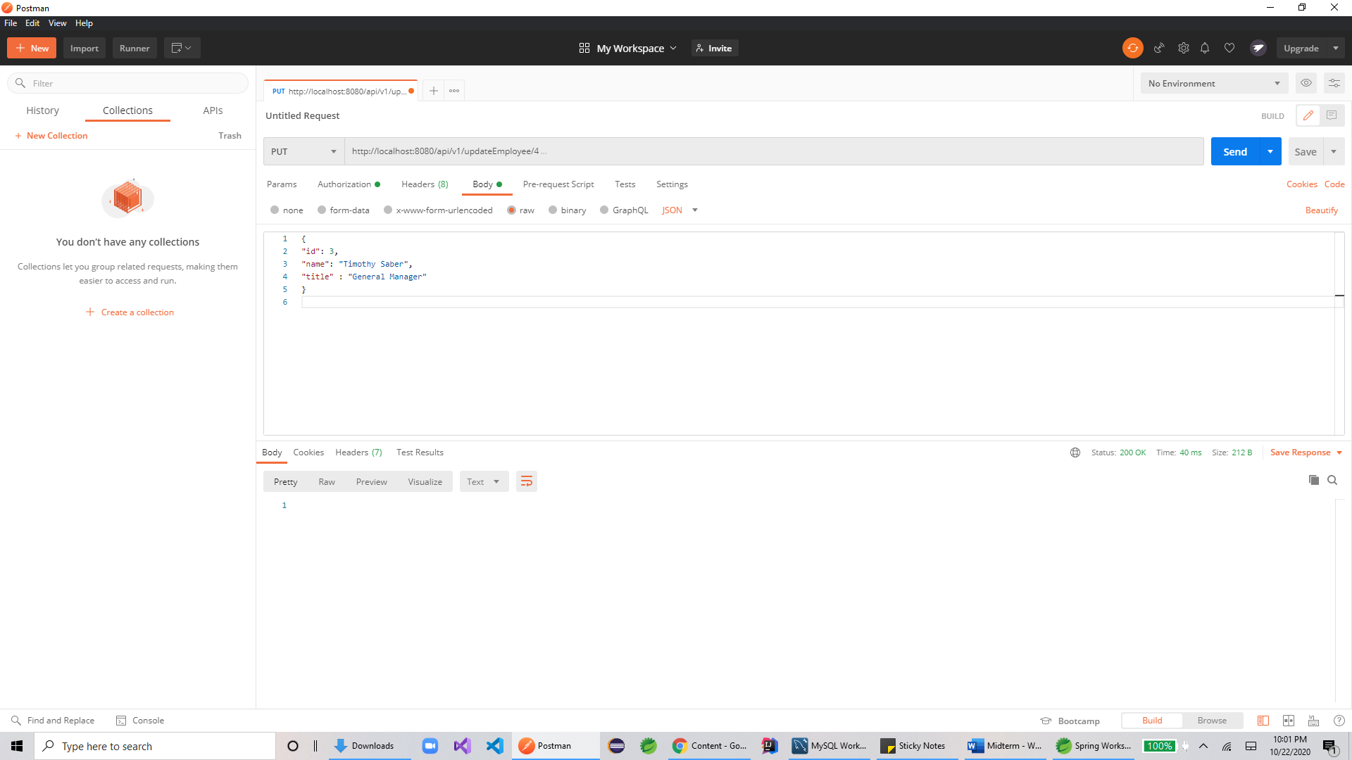

* 1. DELETE

