***Task 1:***

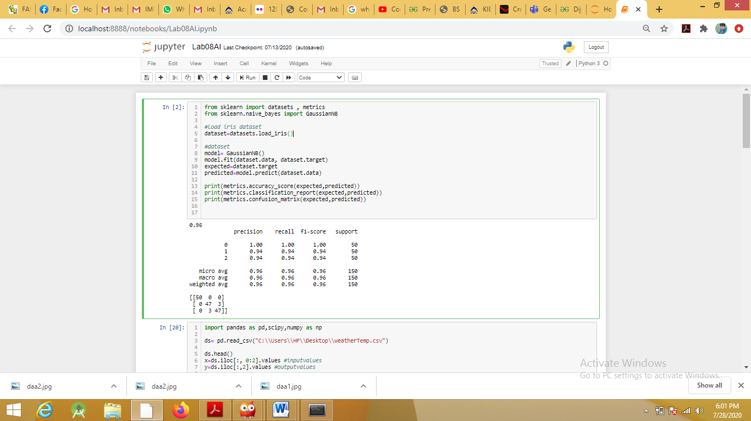

***Task2:***

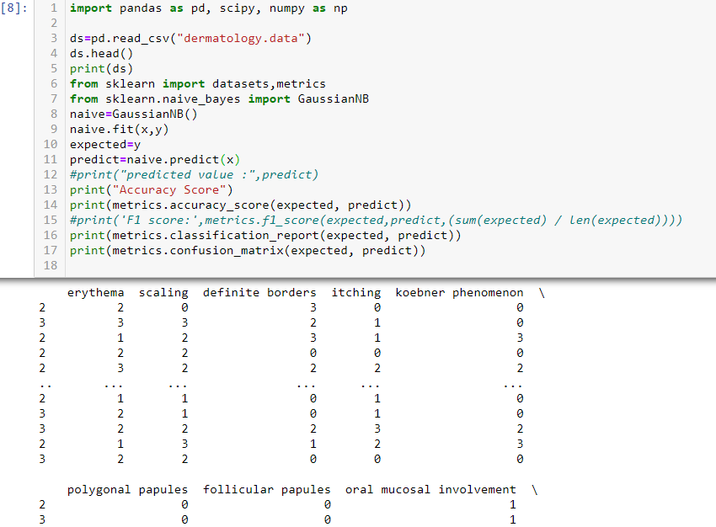

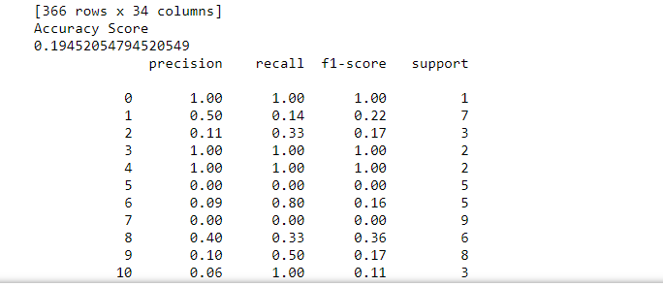

Source of dataset: <https://archive.ics.uci.edu/ml/datasets/Dermatology>

***Task 3:***

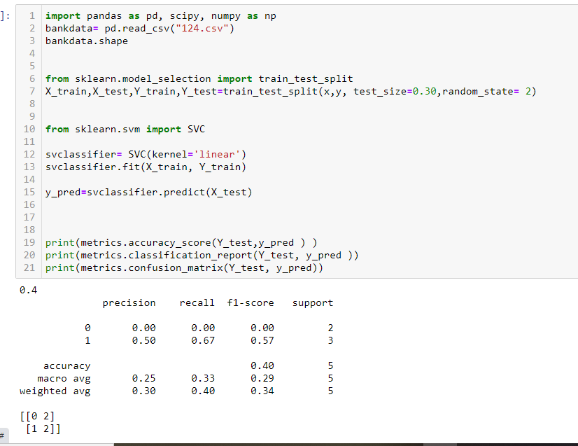

Source of dataset: <https://archive.ics.uci.edu/ml/datasets/banknote+authentication>

***Task 4:***

***Naïve Bayes:***

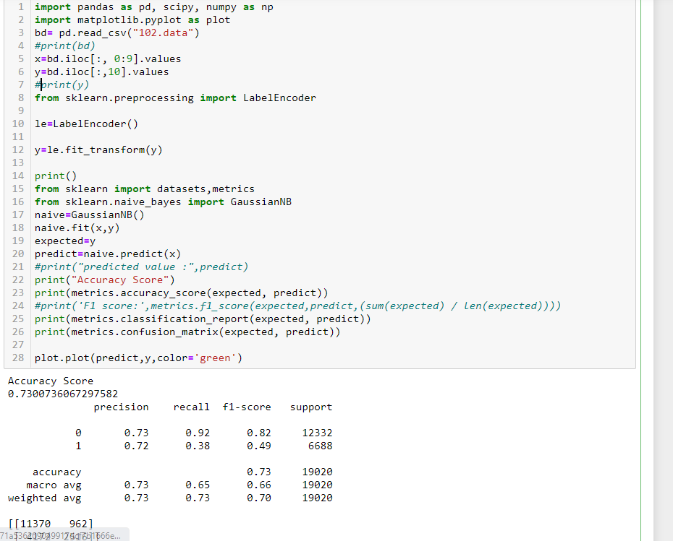

***SVM:***

