# **PRD: Peak Potential**

PRD: Peak Potential

Vision

Motivation

Key Path Scenarios

Detailed Design & Features Description

Design Principles

Features

Milestones / Timing

Unit Economics & Metrics

Resources Required & Projected Costs

Engineering Development Costs

Product Related / Sustaining Engineer Costs

Marketing Costs

Other Costs

Operational Needs & Risks

Team Members

## 

## 

## Vision

For college students and young professionals who struggle with staying consistent and disciplined in their fitness routines, Peak Potential is a new fitness accountability software that provides a science-based solution to make it easier for users to build the habit of going to the gym and stick to that habit. Unlike competitors that only focus on designing a gym exercise program, we offer a positive reinforcement strategy through gamification techniques, motivational quotes, and community support to make the user stick to the habit of exercising.

## Motivation

**Personas (appendix 1)**

### **Primary Persona: Ian**

* **Demographics**
  + Age: 21
  + Education: Economics student at NU
  + Fitness Habits: Goes to the gym three times per week
  + Current Priority: Staying healthy without letting fitness dominate his life
* **Goals**
  + Maintaining a consistent gym routine despite a busy schedule
  + Tracking progress effectively to stay motivated
  + Achieving a healthy lifestyle without spending too much time or money on fitness
  + Building accountability by connecting with friends who share similar fitness goals
* **Frustrations**
  + Struggling to stay consistent when life gets busy, often taking extended breaks
  + Finding it hard to balance fitness goals with academic and personal responsibilities
* **Needs**
  + Personalized fitness plans tailored to his goals of staying healthy
  + Simple and intuitive tracking features for workouts
  + A supportive community of like-minded peers for accountability and motivation
  + Solutions that adapt to his fluctuating schedule

### **Secondary Persona: Emily**

* **Demographics**
  + Age: 27
  + Education: Business Administration
  + Fitness Habits: doesn't have a specific routine
  + Lifestyle: Balances work, hanging out with friends and goes to the gym if there is nothing else to do.
* **Goals**
  + Staying active and reduce stress through fitness
  + Improving overall fitness and flexibility without pursuing a strict gym routine
  + Finding sustainable fitness routines that work with her bussy schedule
* **Frustrations**
  + Always postponing the gym start date
  + Her friends are not always available to go to the gyms with her
  + Overwhelmed about the fitness content, not knowing where to start.
  + Not resuming the gym after the holidays
* **Needs**
  + A blend of home-based and light gym workout options tailored to her fitness level
  + Motivational features like progress tracking and gentle reminders to stay on track

### **Early Adopters vs. Mainstream Users**

* **Early adopters** are:
  + More inclined to explore innovative features, such as virtual classes, analytics, or gamified fitness tracking, emphasizing interaction with cutting-edge solutions.
  + Likely to actively engage with the platform's community aspects, using tools for motivation and accountability.
* **Mainstream users**, in contrast, prefer:
  + Solutions that offer convenience with minimal interaction, focusing on straightforward functionality rather than advanced features.
  + Simple, user-friendly interfaces that require less effort to navigate and utilize.

This distinction highlights the interaction dynamics between user types and the solution, showcasing how early adopters delve into feature-rich experiences while mainstream users prioritize ease and efficiency.

**Unmet Needs**

### **Hypotheses for Primary Persona: Ian**

1. **Hypothesis:** I believe that college students like Ian experience difficulty maintaining a consistent gym routine because of their fluctuating academic and social schedules.
2. **Hypothesis:** I believe that students like Ian struggle to stay motivated in their fitness goals due to a lack of clear, measurable progress tracking.
3. **Hypothesis:** I believe that students like Ian need a fitness solution that adapts to their busy lifestyle without requiring constant attention and time commitment.

### **Hypotheses for Secondary Persona: Emily**

1. **Hypothesis:** I believe that users like Emily find it discouraging to stick to the gym because they don't see any progress.
2. **Hypothesis:** I believe that students like Emily find it overwhelming to start going to the gym again, so they delay the start date.
3. **Hypothesis:** I believe that students like Emily seek someone to hold them accountable if she misses more than one exercise session.

**Methods used to collect evidence:**

1. **Interviews** 
   1. Sample size: 12
   2. 32 questions across 5 categories: User Persona, Exercise Habits and Preferences, Challenges and Motivations, Goals and Achievements, Resources and Learning, Financial Planning, Nutrition and Supplements, and Professional Guidance and Metrics
   3. Link to [Interview Data](https://docs.google.com/spreadsheets/d/1MLA0R_zlbkyrvTXQitQ_yu13mS1S7vNIRyE-wzXzDZk/edit?usp=sharing)

**Existing Solutions**

Existing solutions that target customers currently rely upon include apps such as MyFitnessPal, Fitbod, and Strava. These platforms address various fitness needs but have notable shortcomings:

* **MyFitnessPal**: Offers comprehensive nutrition tracking but lacks strong community engagement and advanced analytics in its free version.
* **Fitbod**: Provides personalized workout plans but neglects the accountability component.
* **Strava**: Excels in outdoor activity tracking but offers limited functionality for gym-based or strength-focused users.
* **Habit tracker:** Offers an intuitive approach to tracking multiple habits, offering charts, reminder,s and social features.

To validate these hypotheses about their insufficiencies, the team has gathered evidence through discussions with consumers who have used these products. These conversations revealed common frustrations, such as the lack of integrated features that combine fitness tracking, nutrition planning, and social accountability. Based on this evidence, a competitor feature matrix was created to highlight these gaps and guide the development of a more comprehensive and user-centered solution.

| **Feature** | **MyFitnessPal** | **Fitbod** | **Strava** | **Habit Tracker** |
| --- | --- | --- | --- | --- |
| Ratings | 2M 4.7 | 232K 4.8 | 304K 4.8 | 118K 4.8 |
| Workouts plans | No | AI-driven workout recommendations | Limited to running/cycling | No |
| Community Engagement | low interactivity; forums only | no social features | leaderboards, challenges, activity feed | Yes |
| Analytics | Basic (calorie and weight tracking) | Moderate (workout performance) | Advanced (GPS-based performance and trends) | Yes, but generic |
| Cost Accessibility | Free version available; premium adds analytics | Paid subscription required | Free version available; premium unlocks advanced analytics | Free version available; premium adds analytics |

**Differentiation**

*Why are we best equipped to pursue this opportunity?*

1. **Exercise Habit-Building Focus:** Combines habit-tracking specifically targeted at achieving gym and fitness goals, rather than generic lifestyle tracking.
2. **Effortless Progress Tracking:** Simple UI to track the muscles trained, it can include weight or not.
3. **Community-Driven Motivation:** Fosters a supportive network for accountability, shared progress, weekly challenges, and scoreboards to increase motivation.
4. **Positive Reinforcement (view appendix 3)** : Daily fitness fun quotes, and progress notifications to keep the user motivated. Examples:
   1. “This month you have increased your gym attendance by 20%”
   2. "You don’t have to be great to start, but you have to start so you can look great."
   3. "Sweat is just fat crying."
   4. "Squats: because no one ever wrote a song about a small butt."
5. **Starting kit:** Science-based strategies and tips to increase habit adherence especially focusing on taking the first step.
6. **Freemium Model with Value-Added Premium Features:**
   1. Free Tier: Core tracking, habit-building tools, and community engagement
   2. Premium Tier: Advanced analytics, personalized workout plans, and AI-generated fitness recommendations.

**Why Now?**

*Has anything changed externally or internally that makes this opportunity available to us now?*

* **Rising Gym trends**: A survey by The Gym Group revealed that 37% of 18 to 24-year-olds view exercise as a social activity, with a 10% increase in gym visits among this age group over the past year.
* **Shift Toward Digital Fitness**: The global digital fitness market was valued at approximately $9.30 billion in 2022 and is projected to reach $64.46 billion by 2031, expanding at a compound annual growth rate (CAGR) of 24% (Growth Market Reports, 2023).
* **Technology Readiness**: Advances in AI, data analytics, and user-friendly app development make it easier to deliver personalized, engaging, and scalable solutions like Peak Potential.
* **Increase adoption of wearable technology:** ​​As of 2023, 34% of Americans use a wearable device, with fitness trackers accounting for a significant portion—65 million users in the U.S.—and this figure is expected to grow to 71 million by 2028 (Statista, 2023)

## Key Path Scenarios

**Product Modality & Tech Overview:**

* **Modality:** Native mobile app (iOS/Android).
* **Tech Stack:** Frontend built in Swift (iOS) and Kotlin (Android). Backend using Node.js/Express with a PostgreSQL database.
* **Key Improvement from Feedback:** Added an optional private-only check-in flow because many users were uncomfortable sharing photos publicly.

**Server-Side Overview:**

* **Authentication:** Managed via JSON Web Tokens (JWT). On each request, the server checks user credentials in the “users” table.
* **Database:** Main tables include “users,” “gym_checkins,” “workouts,” “community_posts,” and “activity_log” for reminders/streaks.
* **Notifications:** A background job checks for inactivity and triggers push notifications (via Firebase Cloud Messaging or APNs).
* **Improvements:** Optimized DB indexes for faster retrieval of user stats; introduced a caching layer for frequent leaderboard queries.

1. **Onboarding & Profile Setup (Ian):**

**App Launch**

* + **Client:** Ian opens the app for the first time; a splash screen welcomes him.
  + **Server:** Validates the app version. If outdated, prompts for update.

**Onboarding Questionnaire**

* + **Client:** Collects Ian’s fitness goals, schedule, preferences (e.g., community vs. personal-only).
  + **Server:** Upon submission, server stores the data in the user profile table and returns personalized default settings.
  + **Improvement:** Incorporated a “skip or refine later” feature to reduce friction, based on early feedback.

**Tutorial & Home Screen**

* + **Client:** Displays a brief tutorial showing icons/tabs: Exercises, Community, Progress.
  + **Server:** Loads default recommendations for the user’s home feed from the content database.

**Wireframe**

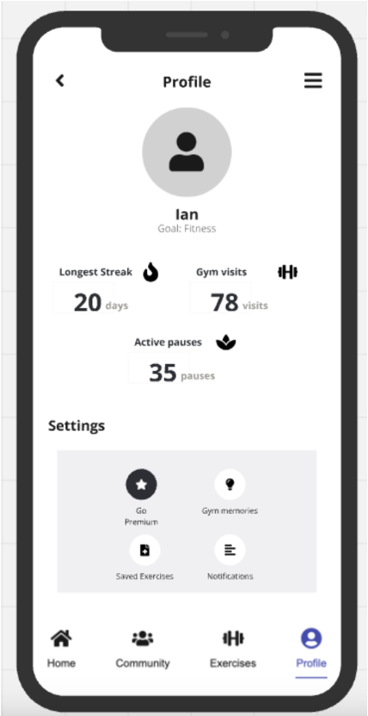

* **Improvements:** Include an ‘Onboarding’ wireframe. Incorporate features like “Questions”, “Skip Button”, “Proceed Button” etc. to reduce friction, based on early feedback.

1. **Checking Exercises & Starting a Workout (Emily):**

**Exercises Tab**

* + **Client:** Emily taps the “Exercises” icon; a filtered list or search bar appears (home workouts, gym workouts).
  + **Server:** Fetches exercise metadata from the DB, returning relevant categories based on Emily’s profile.

**Exercise Detail**

* + **Client:** Shows text steps, a quick demo video, and “Add to My Plan” or “Start Workout” buttons.
  + **Server:** If user taps “Add to My Plan,” the server writes an entry in the “user_workout_plans” table.

**Completing the Workout**

* + **Client:** After finishing, Emily taps “End Session” to log it.
  + **Server:** Creates a new workout record under Emily’s user ID; updates her streak count.

**Wireframe**

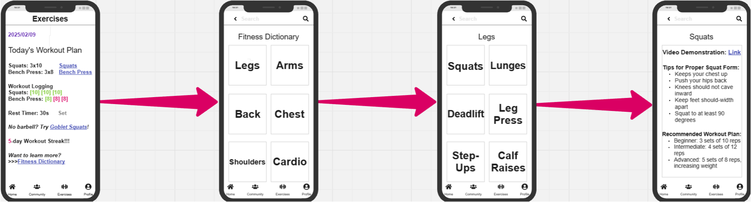

* **Improvements:** Add a filter setting.

1. **Gym Check-In & Photo Logging (Ian):**

**Arrival & Check-In**

* + **Client:** Ian scans a QR code or taps “Check In” (optional photo).
  + **Server:** Verifies user identity, records location/time in the “gym_checkins” table.

**Session Tracking**

* + **Client:** A status bar shows “Session in progress.”
  + **Server:** On completion, merges check-in data with any logged exercises to produce a summary.

**Confirmation & Motivational Stat**

* **Client:** Displays “Nice work!” with user’s total workouts for the week.
* **Server:** Sends updated streak data or progress stats to the client.

**Wireframe**

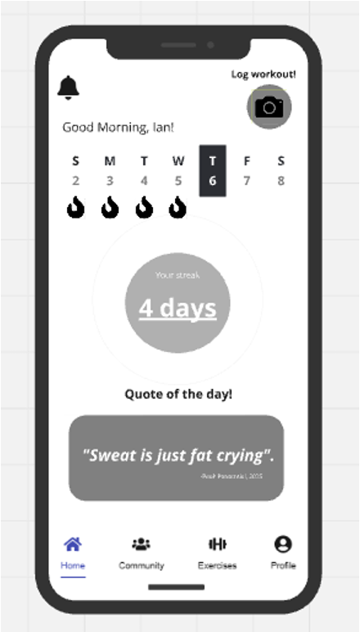

* **Improvements:** Users can choose “Private Only” or “Share to Community” for the photo, addressing privacy feedback.

1. **Community Engagement (Ian):**

**Community Feed**

* + **Client:** Shows friend posts, check-in photos, challenge updates.
  + **Server:** Retrieves the newest entries from “community_posts.”

**Interact & Post**

* + **Client:** Ian taps “like” or writes a quick comment on a friend’s post. Optionally shares his own check-in photo.
  + **Server:** Creates or updates “likes/comments” in the database; pushes real-time notifications to relevant friends.

**Leaderboard/Challenges**

* + **Client:** Displays weekly or monthly ranking.
  + **Server:** Aggregates user data to compute points or badges, returning them to the client.

**Wireframe**

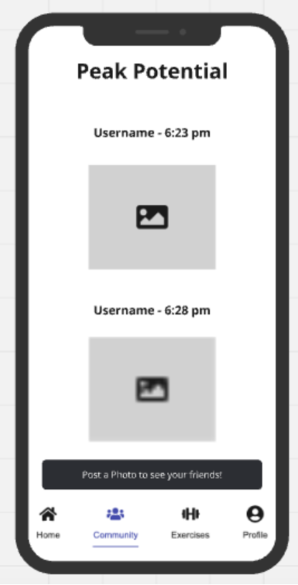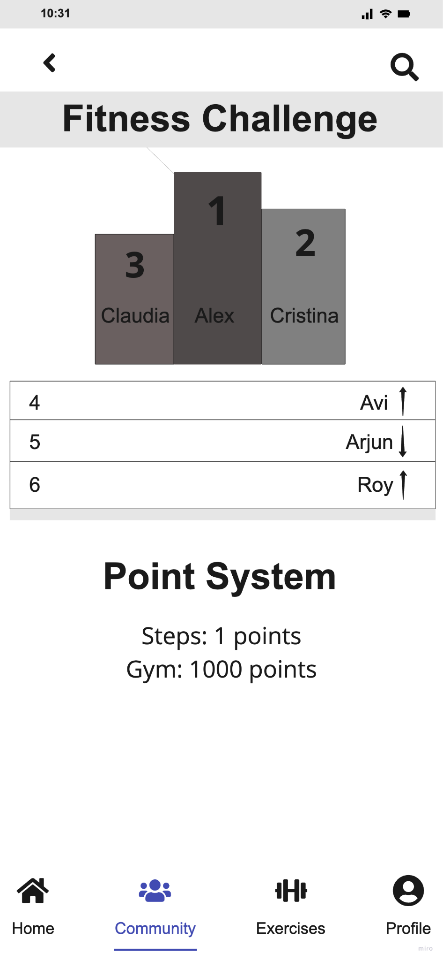

1. **Tracking Progress & Analytics (Ian):**

**Progress Dashboard**

* + **Client:** Renders graphs of weekly workouts, streak days, or weight-lift improvements.
  + **Server:** Summarizes data from “user_workouts” and “gym_checkins,” returning aggregates (e.g., 15% improvement in squat).

**Milestone Alerts**

* + **Client:** Ian sees a banner: “You’ve increased your gym attendance by 20%!”
  + **Server:** Runs scheduled tasks to identify users hitting milestones, triggers notifications.

**Adjust Goals**

* + **Client:** Ian taps “Edit Goals,” changes from 3 to 4 workouts/week.
  + **Server:** Updates user profile and modifies default reminders.

**Wireframe:**

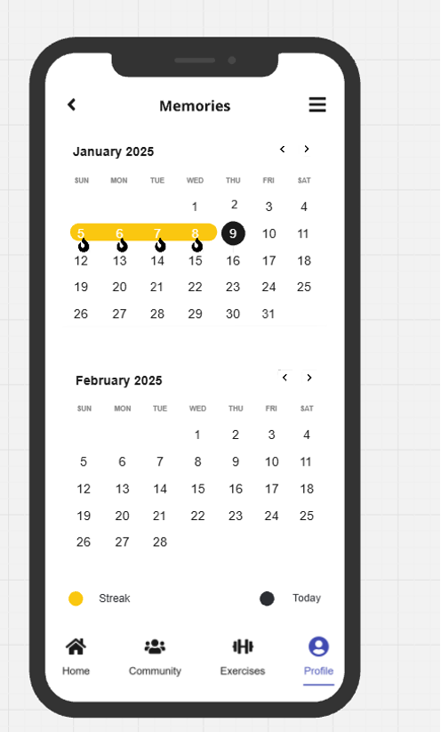

* **Improvements:** Need to design a frameworkfor visualised analytics, including milestone pop-ups or simplified graphs showing users’ workout data.

1. **Reminders & Habit Reinforcement (Emily):**

**Gentle Nudge**

* + **Client:** After a missed day, Emily receives a push: “Even 5 minutes counts!”
  + **Server:** Checks user inactivity daily. If user is flagged inactive, it queues a notification.

**Positive Feedback**

* + **Client:** Celebrates with confetti and message “Small steps, big results!”
  + **Server:** Writes to the “activity_log” table, noting each short session.

**Wireframe**

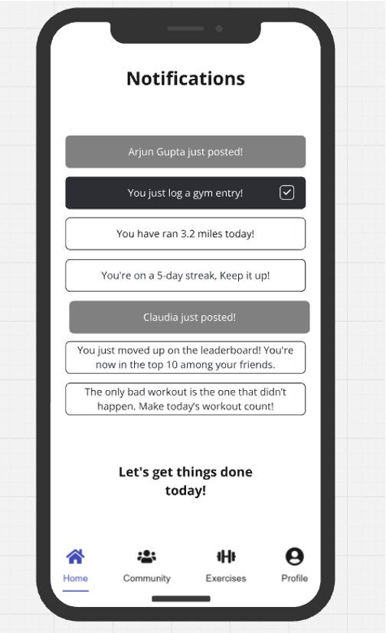

## 

## 

## 

## 

## 

## 

## 

## 

## Detailed Design & Features Description

### **Design Principles**

**Color Pallete**



**Tentative Logo**



**Design inspiration**

* Duolingo: we believe Duolingo is an app that has similar design values as the ones that Peak Potential wants to emulate, because of the following:
  + Unified: Duolingo has bright colors and a strong design guidelines that is present across all the app and social media platforms.
  + Clear: the design used is very minimalistic and looks very clear and clean across all platforms.
  + Intuitive: the design and UX makes it simple to navigate through the app.

### 

### **Features**

| **Feature Name** | **Description** | **Dependencies** | **Priority** |
| --- | --- | --- | --- |
| Exercise Search & Filtering | Users browse exercises by muscle group, equipment, and difficulty with AI-driven recommendations. | Exercise database, Video content, AI logic, UI/UX | V1 (MVP) |
| Profile Setup | Users establish their gym preferences and objectives. | User table, UI/UX | V1(MVP) |
| Step-by-Step Instructions | Text-based instructions with rep/set guidance, tips, and muscle activation details. | Exercise database, Text content | V1 (MVP) |
| Memories (Photo Tracking) | Users capture and share progress photos during workouts to track their journey over time. | Camera hardware access, Notification system, Privacy controls | V1 (MVP) |
| Notifications & Reminders | Automated reminders for streaks, missed workouts, goal achievements, and motivational nudges. | Workout history, AI logic, Push notification system | V1 (MVP) |
| Daily Fitness Quotes | Provides motivational fitness quotes tailored to user goals and workout history. | Workout history, AI logic, Push notification system | V1 (MVP) |
| Progress Tracking | Tracks workout consistency, streaks, strength gains, and attendance with visual analytics. | Workout logs, Gym check-ins, Wearable data | V1 (MVP) |
| Community Engagement (Basic) | Forums for users to discuss fitness, ask questions, and share experiences. | Community UI, Moderation tools, Basic User Profiles   |  | | --- |  |  | | --- | | V1 (MVP) |
| Video Demonstrations | Short-form video guides on proper exercise form and technique. | Video content, Hosting solution, UI integration | VNext |
| Exercise Routine Creation | The program will generate personalized workout plans based on goals (muscle gain, fat loss, strength, etc.). | Exercise database, Goal-setting algorithm, UI/UX | VNext |
| Workout Builder | Users create and save custom workouts by selecting exercises and structuring routines. | Exercise database, User workout history, UI/UX | VNext |
| Community Engagement (Advanced) | Adds leaderboards, challenges, and activity feeds for higher user engagement. | Challenge logic, User progress tracking, Social UI | VNext |
| Cost Accessibility | Freemium model: Free version available; premium unlocks analytics and coaching features. | Payment integration, Premium content segmentation | VNext |
| Gamification | Users earn XP points, badges, and streak rewards for completing workouts and engaging in the app. | Gamification logic, Progress tracking, Badge database | VNext |
| Step Tracking (Gamification Add-on) | Users can set daily step goals and earn rewards for meeting them, reinforcing daily movement habits. | Wearable integration, Step tracking algorithm, Gamification UI | VNext |
| AI-Powered Exercise Suggestions | Personalized workout recommendations based on past performance and progress tracking. | AI model, Workout history, User data | VLongterm |
| Corporate Gym Partnerships | Integration with gyms, trainers, and wellness programs for expanded accessibility. | Strategic gym partnerships based on company vision | VLongterm |

| Advanced Analytics | AI-powered deep workout insights injury prevention techniques. | AI model, Workout history, user data | VLongterm |
| --- | --- | --- | --- |
| Wearable Integration | Biometric tracking for health measurements through wearable tech. | Hardware, Software Compatability, Legality | VLongterm |
| AI Workout Coach | Conversational AI motivational coach to help keep users on top of their workout programs. | LLM Models, Conversational AI Technology | VLongterm |

**Roadmap**

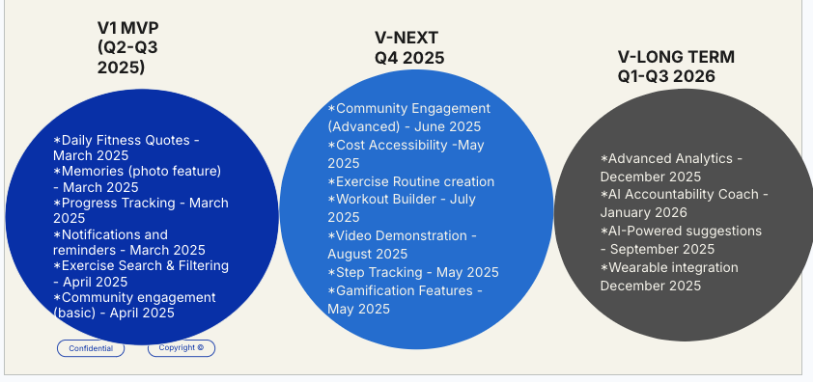

### 

| **Feature** | **V1** | **VNext** | **VLongterm** |
| --- | --- | --- | --- |
| **Daily Fitness Quotes** | Introduce daily fitness quotes to inspire and engage users. | Continue providing daily fitness quotes without changes. | Personalize quotes based on the user's most frequently performed fitness activities for a tailored motivational experience. |
| **Memories** | Introduce a Memories feature that allows users to view past workouts and achievements. | Maintain the same functionality, enabling users to revisit their progress over time. | Enhance the feature by integrating AI-driven insights and personalized highlights, showcasing key milestones and trends based on user activity. |
| **Progress Tracking Analytics** | Introduce basic progress tracking analytics, allowing users to log and monitor their fitness journey. | Expand tracking capabilities with enhanced data visualization and deeper insights into workout trends. | Implement **advanced AI-driven analytics,** providing predictive performance insights and personalized recommendations based on user trends and goals. |
| **Notifications and Reminders** | Introduce basic notifications and reminders to help users stay consistent with their workouts and fitness goals. | Maintain the same functionality, ensuring users receive timely workout and progress reminders. | Enhance notifications with AI-driven smart reminders, adapting based on user activity patterns and engagement levels for a more personalized fitness experience. |
| **Exercise Search and Filtering** | Implement basic exercise search and filtering, allowing users to find workouts by category, difficulty level, and equipment needed. | Expand the functionality by introducing:  **Exercise Routine Creation** – Enable users to save and organize their favorite exercises into structured routines.  **Workout Builder Plans** – Allow users to create custom workout plans tailored to their fitness goals.  **Video Demonstrations** – Provide exercise tutorial videos to ensure proper form and technique. | Enhance the experience with AI-driven capabilities:  **AI Coach** – Offer real-time feedback and personalized coaching based on user performance and progress.  **AI Suggestions** – Generate intelligent workout recommendations based on past activity, fitness goals, and user preferences. |
| **Comunity Engagement** | Establish basic community features, including user profiles, activity tracking, and workout sharing, allowing users to interact and stay motivated. | Expand community functionality with:  **Discussion Forums & Social Groups** – Enable users to connect, discuss fitness topics, and share progress within interest-based groups.  **Challenge & Leaderboards** – Introduce fitness challenges and competitive leaderboards to boost engagement and motivation.  **Peer-to-Peer Support & Messaging** – Allow users to exchange tips, support, and encouragement directly within the platform. | Enhance engagement through **Corporate Gym Partnerships** based on commercial Gym Business Models to offer special deals to users and participants. |
| **Cost Accessibility** | Introduce a tiered pricing model with a freemium plan offering basic features and a premium subscription for advanced functionalities. | Expand accessibility by implementing:  **Flexible Pricing Plans** – Offer monthly, quarterly, and annual subscription options to cater to different budget preferences.  **Student & Low-Income Discounts** – Provide special pricing for students and financially constrained users to increase accessibility.  **Referral & Loyalty Rewards** – Introduce discount incentives for user referrals and long-term subscriptions. | Further enhance affordability with:  **Corporate Partnerships** – Collaborate with corporations and health insurance providers to subsidize or offer fitness plans at reduced costs. Ad-Supported Free Plan – Introduce a fully free version supported by non-intrusive ads, ensuring fitness accessibility for all users. |
| **Step Tracking and Gamification** | Introduce basic step tracking, allowing users to monitor their daily steps and activity levels within the app. | Expand gamification with: Achievement Badges & Milestones – Reward users with badges for hitting step goals and consistency streaks. Daily & Weekly Step Challenges – Implement solo and group challenges to encourage movement and friendly competition. Leaderboard Integration – Display user rankings based on step counts to foster motivation and community engagement. | **Wearable Device Compatibility** – Seamlessly integrates with smartwatches and fitness wearables for real-time step tracking and goal adjustments. |

### *Each bold word is one of the features that will be integrated into the product.

## 

## Milestones / Timing

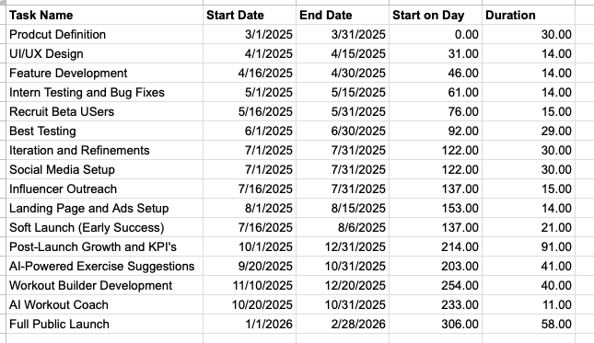

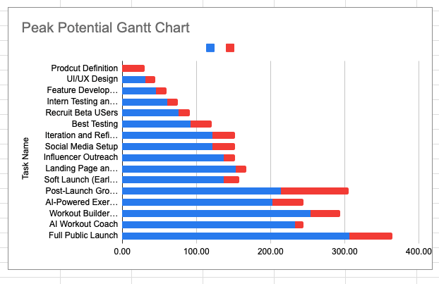

## **Pre-Launch Strategy (March – July 2025)**

### Objective: Build brand awareness, gather early adopters, and generate buzz before the launch.

### Key Tactics:

Community Building on Social Media

* Instagram, TikTok, and YouTube Shorts content focused on:
  + Fitness habit-building tips
  + Motivational success stories
  + Quick workout breakdowns (relating to the exercise dictionary)
* Consistent engagement with fitness influencers to build credibility.

Beta Tester Recruitment & Early Access Waitlist

* Target college students, young professionals, and fitness influencers for beta testing.
* Create a landing page for email sign-ups to collect early adopters.
* Offer exclusive perks (e.g., free premium access for 3 months) to early users.

Campus Ambassador Program

* Recruit college fitness enthusiasts to spread the word about Peak Potential.
* Ambassadors get referral bonuses (discounts, free membership, or exclusive workouts).

Fitness Challenge for Early Adopters

* “Consistency Challenge” where users log workouts for 7 days in a row for a prize.
* Creates habit formation and engagement before launch.

## **Launch Strategy (August – September 2025)**

### Objective: Drive user adoption, onboard early users, and optimize initial growth.

### Key Tactics:

Referral Program – “Accountability Partners”

* Users who invite 3+ friends get free premium access for a month.
* Encourages users to form workout accountability groups.

Influencer & Micro-Creator Collaborations

* Work with fitness influencers (10K-50K followers) to create real-life testimonials.
* Leverage TikTok trends & fitness transformation stories to go viral.

Peak Potential Launch Event (Virtual & In-Person)

* Host a live fitness session on YouTube/TikTok with well-known trainers.
* Give attendees free access to premium features for signing up.

Paid Ads Targeting Fitness Enthusiasts

* Meta (Facebook & Instagram) Ads targeted at young adults interested in fitness.
* Google Ads for “habit tracking + fitness” searches.

## **Post-Launch Growth Strategy (October 2025 – Beyond)**

### Objective: Retain users, increase engagement, and grow through organic & paid marketing.

### Key Tactics:

User Engagement & Gamification

* Implement weekly fitness challenges & leaderboards to keep users engaged.
* Introduce streak-based rewards (e.g., badges, discounts).

Exclusive Partnerships with Gyms & Trainers

* Offer discounts on gym memberships for Peak Potential users.
* Feature certified trainers for virtual coaching.

SEO-Optimized Fitness Content (Blog & YouTube)

* Publish fitness habit guides & workout breakdowns to increase organic traffic.
* Create searchable content for “best fitness tracking app” or “how to stay consistent with workouts”.

AI-Driven Personalized Workout & Nutrition Plans

* Introduce AI-powered fitness recommendations to enhance user experience.
* Offer customized habit-building pathways.

## 

## 

## **Unit Economics & Metrics**

### **Revenue Model: Subscription-based (Freemium + Premium Tiers)**

Why a Subscription-Based (Freemium + Premium) Revenue Model?

1. Encourages Habit Formation & Long-Term Engagement
   * Fitness is about consistency, and a subscription model incentivizes users to stay engaged with their fitness journey.
   * Recurring revenue allows us to continuously improve features, content, and personalization.
2. Low Barrier to Entry with Freemium
   * Offering a free tier lets users experience the platform, reducing friction in adoption.
   * Users build habits and trust in the product before upgrading to premium.
3. Premium Features Drive Monetization
   * Personalized fitness & nutrition plans, advanced analytics, and progress tracking tools provide significant value.
   * Community features, coaching, and exclusive content make the premium tier attractive.
4. Proven Success in the Fitness & Wellness Market
   * Popular fitness apps (e.g., MyFitnessPal, Strava, Noom) thrive on Freemium-to-Premium conversion models.
   * Data from similar apps show 5–10% free-to-paid conversion rates, ensuring a scalable monetization strategy.
5. Scalable & Predictable Revenue Model
   * Subscription revenue is more stable than one-time purchases, enabling long-term growth and expansion.
   * As the user base grows, revenue scales without requiring proportional increases in acquisition spending.

### **Price Point: $14.99/month (Premium) or $125/year (discounted annual plan)**

How did we arrive at this price point?

1. Competitive Benchmarking: We set our price at $14.99/month or $125/year by analyzing the market and ensuring we provide superior value compared to alternatives. Here’s how we compare:

| Competitor | Price | Features |
| --- | --- | --- |
| MyFitnessPal Premium | $19.99/month or $79.99/year | Calorie tracking, workout logging, and meal plans but lacks personalization, AI integration, reminders, and analytics |
| Future Fitness Coaching | $199/month | Personalized coaching and accountability but lacks meal plans, workout logging, and personalization |
| Fitbod | $12.99/month or $79.99/year | AI-powered workout plans but lacks full nutrition and community features |
| Whoop (wearable + analytics) | $30/month | Advanced fitness tracking but no workout plans or nutrition guidance |

Our pricing is justified because we combine multiple services (workout plans, nutrition, analytics, and community support) at a lower cost than hiring a personal trainer or subscribing to multiple apps.

1. Value Proposition & ROI for Users:
   1. Holistic Approach: Personalized fitness, nutrition, and habit-building support in one platform.
   2. Higher Retention = Higher Value: Users often struggle with consistency, and our app focuses on habit reinforcement through AI-driven analytics and accountability features.
   3. Community & Gamification: Unlike static fitness apps, our engaging community and streak-tracking features increase user motivation and long-term retention.
2. Pricing Psychology & Annual Discount Incentive:
   1. $14.99/month positions us as a premium, high-value service without overpricing.
   2. $125/year (~$10.41/month, 30% savings) encourages users to commit long-term, reducing churn and increasing lifetime value (LTV).

### **Cost of Goods Sold (COGS)/Cost of Service (COS):**

Direct costs associated with the service/production of the product:

* Cloud Hosting (AWS/GCP/Azure)
* Data & AI Processing Costs: Machine learning or API integrations
* Support & Customer Service: Chat support, email inquiries, and issue resolution
* App Store Fees: in-app purchases, fees change over time

| **Expense Category** | **Estimated Cost per User per Month** |
| --- | --- |
| Cloud Hosting & Infrastructure | $0.50–$1.50 |
| AI Processing & Data Costs | $0.50–$1.50 |
| Customer Support | $0.50–$1.00 |
| App Store Fees (15–30%) | $1.50–$3.00 |
| Total Estimated COGS | **$3–$7 per user/month** |

### **LTV (Lifetime Value):**

Expected customer retention: 12-24 months → Estimated LTV: $180 - $300

How did we arrive at the estimated retention rate of 12–24 months?

* Industry Benchmarks: Fitness apps typically have a retention rate between 6–24 months, with the most engaged users sticking around longer. For example, MyFitnessPal and Strava have reported high user retention among premium subscribers.
* Justification: Since Peak Potential provides personalized fitness plans, community engagement, and progress tracking, our retention is expected to be higher than general fitness apps. The lower bound (12 months) assumes some churn, while the upper bound (24 months) accounts for loyal users who fully integrate the app into their routine.
* Data Reference: Looked at retention stats ([link](https://www.businessofapps.com/data/health-fitness-app-benchmarks/)) ([link 2)](https://www.exercise.com/grow/fitness-app-statistics/) from apps like Fitbod, Freeletics, and MyFitnessPal for similar user engagement patterns.

LTV References:

* Monthly Users: Expected retention of 12–24 months at $14.99/month → LTV = $180–$360
* Annual Users: If customers choose the $125/year plan, we estimate a blended LTV of $250 per user based on an average 2-year retention.
* Therefore, our estimated LTV is $180-$300

### **CAC (Customer Acquisition Cost):**

CAC encompasses estimated paid ads, influencer partnerships, and referral incentives.

CAC for Peak Potential: ~$60 per user at launch, $~30 per user after 12 months of launch, and after 2 years $15-$20 per user. Therefore, we expect CAC to go down over time.

* Breakdown of CAC Calculation:
  + Paid Ads (Google, Meta, TikTok): $5–$10 per user acquisition
    - During the early months of product launch, we plan to spend more money as we have not built any organic traffic. Therefore, we approximate $12-$15 per user acquisition which will decline as organic traffic is built. ([link](https://www.tribe.fitness/blog/the-rising-cost-of-customer-acquisition-in-connected-fitness))
    - According to the Business of Apps, the average app marketing cost can range from $5-$15 depending on the different marketing strategies. ([link](https://www.businessofapps.com/marketplace/app-marketing/research/app-marketing-cost/))
    - According to the Business of Apps, average cost per install (CPI) via ads for apps within North America is $4.74. While the CPI differs from CAC, it provides insight into baseline acquisition costs related to paid ads. ([link](https://appetiser.com.au/blog/customer-acquisition-cost-for-apps/))
  + Influencer Partnerships: Estimated cost per acquired user through micro-influencers = $4–$8 ([link](https://adparlor.com/blog/influencer-marketing-cost-guide/#:~:text=Performance%2Dbased%20pricing:%20Paid%20based,Other%20common%20KPIs%20include:))
    - Based on information available on collaborations with micro-influencers, an average fitness app promotion cost around $6 per acquired customer.
    - We plan to have fitness/gym partnerships early on to build a reputation: Estimated cost per acquired user through fitness related business = $5–$10.
    - Collaborating with bigger fitness influences early on: Estimated cost per acquired user = $10–$15. ([link](https://inbeat.agency/blog/how-much-content-creators-cost#:~:text=YouTube%20Video%20Sponsorship%20Rates,000%20to%20$49%2C%20000+.))
  + Referral Incentives: Offering free trial months or discounts for referrals (~$5 per referred user) ([link](https://blog.talkable.com/referral-marketing-most-efficient-strategy#:~:text=According%20to%20a%20study%20conducted,return%20on%20investment%20(ROI).))
* Industry Benchmark: Fitness apps like Fitbod, Freeletics, and MyFitnessPal typically spend $10–$30 per user on acquisition, making our estimate reasonable.

### **LTV:CAC Ratio:**

3:1 initially, expected to improve over time as organic growth increases

Initial LTV:CAC Calculation

* Customer Acquisition Cost (CAC): ~$60 initially then $15-$20 after 2 years (see above in CAC section)
  + Based on estimated paid ads, influencer and fitness partnerships, and referral incentives (benchmarked from similar fitness apps).
* Lifetime Value (LTV): $180–$300 (see above in LTV section)
* LTV:CAC Ratio: 3:1 initially to 9:1 after 2 years (worst case ratio)
  + This indicates strong profitability, as a ratio above 3:1 is generally considered sustainable in SaaS models.

### **Projected Changes Over Time:**

LTV is expected to increase as features improve retention. CAC expected to decrease as organic acquisition (word-of-mouth, organic search, referrals) grows.

* Phase 1: Early Growth (0–6 months)
  + CAC is slightly higher ($55-$60) due to initial brand awareness efforts.
  + LTV stabilizes around $180–$240, leading to a temporary dip in LTV:CAC (~3:1 to 4:1).
* Phase 2: Scale & Optimization (6–18 months)
  + CAC decreases ($25–$30) as organic growth, referrals, and community engagement reduce paid acquisition reliance.
  + Retention improves with data-driven habit reinforcement, increasing LTV (~$250-$275), pushing LTV:CAC toward 5:1.
* Phase 3: Mature Growth (18+ months)
  + CAC stabilizes at $15–$20 due to strong word-of-mouth and partnerships. However, we do expect CAC to rise as we continue to scale.
  + Higher engagement and expanded features increase upsell/cross-sell opportunities (e.g., coaching add-ons), boosting LTV to $300+.
  + Long-term LTV:CAC target: 15:1+, ensuring strong profitability and sustainable user acquisition.

### **Key Metrics for Tracking Success**

| **Metric Name** | **Definition** | **How It’s Measured** | **Hypotheses (Initial Targets)** |
| --- | --- | --- | --- |
| New User Signups | Users who create an account | # of accounts created per week | 1,000 new users in first 3 months |
| Activation Rate | % of signups who complete their first workout plan | (Activated Users / Signups) * 100 | 50% activation within 7 days |
| Retention Rate (30/90 days) | % of users still active after 30 and 90 days | (# of retained users / initial cohort size) * 100 | 40% at 30 days, 25% at 90 days initially, improving to 50% (30-day) and 35% (90-day) by Month 12 |
| Churn Rate | % of paying users who cancel per month | (Lost subscribers / total subscribers) * 100 | 5% monthly churn at launch, reducing to 3% by Month 9 |
| Avg. Revenue Per User (ARPU) | Total revenue / total users | Subscription revenue ÷ user base | $6 per user by Month 3, increasing to $8 by Month 12 |
| Customer Acquisition Cost (CAC) | Cost to acquire one paying customer | Total marketing spend ÷ # of new subscribers | $50 per user in first 3 months, dropping to $35 by Month 9 |
| LTV:CAC Ratio | Expected lifetime value vs. acquisition cost | LTV ÷ CAC | 2:1 at launch, 3:1 by Month 6, improving to 4:1+ by Year 2 |
| Workout Completion Rate | % of users who log workouts weekly | (# of users completing 3+ workouts per week) ÷ total active users | 60% by Month 3, rising to 70%+ by Month 9 |
| Referral Rate | % of new signups from existing users | (# of referred signups / total signups) * 100 | 20% of new signups from referrals by Month 3, increasing to 35% by Month 12 |

## **Resources Required & Projected Costs**

### **Engineering Development Costs**

**Developing Peak Potential as a smartphone application with core functionality will require a streamlined engineering team. To optimize costs, we will focus on core cloud storage and essential app features:**

* **Frontend & Backend Development: 2 engineers for 12 weeks at $100/hour  
  Total Cost: $192,000 (2 engineers × 40 hours/week × 12 weeks × $100/hour)**
* **Cloud Storage & Database Management: 1 engineer for 12 weeks at $90/hour  
  Total Cost: $43,200 (1 engineer × 40 hours/week × 12 weeks × $90/hour)**
* **Basic AI Features (Photo Analysis & Habit Tracking): 1 engineer for 16 weeks at $110/hour  
  Total Cost: $70,400 (1 engineer × 40 hours/week × 16 weeks × $110/hour)**
* **QA & Testing: 1 engineer for 8 weeks at $80/hour  
  Total Cost: $25,600 (1 engineer × 40 hours/week × 8 weeks × $80/hour)**
* **Cloud Storage & Compute Resources: Estimated at $1,000/month for development and $3,000/month post-launch Total Cost: $12,000 (for 12 months)**

**Total Estimated Engineering Costs: $343,200**

### **Retention Rate & Customer Acquisition Cost (CAC) Assumptions**

**To estimate Peak Potential’s retention rate (12–24 months) and Customer Acquisition Cost (CAC) of $18–$22, we analyzed comparable fitness and habit-tracking apps:**

* **Retention Rate Justification:**
  + **Health and fitness apps have a 12-month retention rate of ~25% and 24-month retention rate of ~10% for engaged users (Sensor Tower report).**
  + **Subscription-based habit-tracking apps such as Fabulous and Strides indicate that premium users often remain subscribed for 12–24 months.**
  + **Given Peak Potential’s focus on long-term fitness habits, we assume our premium users will exhibit similar retention patterns.**
* **Customer Acquisition Cost (CAC) Justification:**
  + **Mobile fitness apps typically have CAC between $12–$30 per user depending on marketing efficiency.**
  + **Competitors like MyFitnessPal and Strava have CACs around $18–$22 for freemium models.**
  + **Given our community-driven and referral-based organic marketing, we estimate our CAC at $18–$22 per user.**

**(Sources: Sensor Tower, App Annie, Business of Apps reports on Health & Fitness App Retention & CAC)**

### **Product-Related / Sustaining Engineer Costs**

**Since Peak Potential is a SaaS product, ongoing costs will be incurred for maintaining and improving the application:**

* **Customer Support & Bug Fixes: 1 engineer for ongoing maintenance at $60/hour  
  *Total Cost: $124,800/year (1 engineer × 40 hours/week × 52 weeks × $60/hour)***
* **Server & Hosting Costs: Cloud storage and backend services  
  *Total Cost: $50,000/year post-launch***
* **API & Data Integrations: Third-party fitness tracking APIs  
  *Total Cost: $15,000/year***

**Total Sustaining Engineer Costs: $189,800/year**

### 

### **Cost of Sales (COS) Adjustments**

**Although Peak Potential has low direct costs, sustaining the product will still incur some Cost of Sales (COS):**

* **Cloud computing usage per user: Estimated at $0.50/user/month**
* **API request costs from third-party fitness integrations**
* **Customer service costs for handling user inquiries**

**Assuming 10,000 active users in Year 1, estimated COS is:**

* **Cloud Compute & API Calls: $70,000/year**
* **Support & Payment Processing Fees: $30,000/year**

**Total COS: $100,000/year**

### **Marketing Costs**

**Given our focus on organic growth and word-of-mouth marketing, paid advertising will be limited:**

* **Pre-Launch Awareness: Social media campaigns, influencer outreach  
  *Total Cost: $30,000***
* **Referral & Retention Programs: Minimal cash incentives, community engagement  
  *Total Cost: $15,000***
* **SEO & Content Marketing: Blog content, organic search visibility  
  *Total Cost: $15,000/year***

**Total Marketing Costs: $60,000 for the first year**

### **Other Costs**

**To minimize expenses, additional costs include:**

* **Cloud Storage & Security Compliance: Data privacy measures  
  *Total Cost: $35,000/year***
* **Customer Support & Community Moderation: Part-time support team  
  *Total Cost: $25,000/year***
* **Legal & Compliance: Privacy policies and terms  
  *Total Cost: $15,000/year***

**Total Other Costs: $75,000/year**

**Total Estimated Costs for First Year**

| Cost Category | Estimated Cost |
| --- | --- |
| Engineering Development Costs | $343,200 |
| Sustaining Engineer Costs | $189,800 |
| Cost of Sales (COS) | $100,000 |
| Marketing Costs | $60,000 |
| Other Costs | $75,000 |
| Grand Total (First Year) | $768,000 |

## Operational Needs & Risks

**Operational Needs**

1. **Customer Support & Maintenance**
   * Offer in-app self-help (FAQ), email/chat support, and a community forum to address user questions.
   * Regularly update the app to fix bugs, improve performance, and add new features based on feedback.
   * Collect ongoing user feedback (e.g., in-app surveys) to inform enhancements and maintain user engagement.
2. **Data Security & Privacy**
   * Adhere to regulations (e.g. GDPR, CCPA), implement strong encryption, and provide clear data privacy options.
   * Allow flexible sharing settings (e.g., private mode, friends-only) to respect user comfort levels.
3. **Infrastructure & Scalability**
   * Ensure back-end systems can handle increasing traffic and new feature rollouts (e.g., AI-based recommendations).
   * Conduct regular stress testing and maintain contingency plans to safeguard service availability.

**Risks & Mitigations**

Identified in MRD

| Risk | Description | Potential Mitigants |
| --- | --- | --- |
| Privacy & Data Security | Collecting gym check-in photos and storing users’ fitness data may raise privacy concerns. Users might fear misuse or unauthorized access of their personal information. | - Encrypt data at rest and in transit (SSL/TLS).  - Comply with data protection laws (GDPR, CCPA).  - Provide granular controls for photo sharing (private, friends-only, public).  - Conduct frequent security audits and penetration testing. |
| Legal/Patent Risks | Fitness-tracking or gamification methods might conflict with existing patents, or similar legal challenges could arise regarding proprietary algorithms. | - Conduct thorough patent searches with legal advisors.  - Develop unique solutions where possible.  - File for patents on proprietary technologies or novel processes. |
| User Engagement & Retention | Users may lose motivation if they dislike forced social interactions or fail to see tangible progress, leading to app abandonment. | - Offer small “quick-win” exercises (5-minute workouts, streaks).  - Provide robust progress tracking (graphs, milestones, notifications).  - Personalize notifications and reminders to user preferences.  - Collect feedback often and iterate. |
| Technology & API Dependencies | Reliance on third-party data sources (e.g., Apple Health, Google Fit) or wearable integrations could lead to service disruption if APIs change or become unavailable. | - Offer multiple data-import methods (manual input, alternate APIs).  - Monitor partner APIs for updates/deprecations.  - Maintain a fallback system that stores crucial data locally if external syncing fails. |
| Market Competition & Differentiation | Competing fitness and habit apps may have established user bases or quickly introduce similar features, risking user churn if they find more appealing incentives elsewhere. | - Highlight unique selling points (habit-building + optional social features + short daily exercises).  - Engage the community via challenges/gamification and frequent updates.  - Build partnerships (e.g., fitness influencers) to widen brand awareness. |
| Scaling & Infrastructure | Rapid growth may cause performance bottlenecks, slow load times, or increased support demands, impacting user experience and retention. | - Employ a scalable cloud architecture (microservices).  - Use caching/CDNs for heavy content (e.g., workout videos).  - Automate Level-1 support tasks (chatbots, help center).  - Monitor performance metrics and address bottlenecks early. |

Newly Identified

| Risk | Description | Potential Mitigants |
| --- | --- | --- |
| User Discomfort with Social Features | Some users may feel pressured or self-conscious about sharing gym selfies or progress publicly, leading to disengagement if the social aspect feels too intrusive or forced. | - Make photo and social features optional.  - Provide “solo tracking” / “private-only” modes.  - Let users choose between “individual goals” or “community challenges” during onboarding.  - Allow changing privacy settings at any time. |
| Feature Overload & Onboarding Complexity | New or casual users might be overwhelmed by too many advanced features (AI-based plans, analytics, etc.) early on, causing confusion and drop-off. | - Use tiered onboarding (start with basics, unlock advanced features as users progress).  - Provide in-app tutorials / guided walkthroughs.  - Maintain a simple UI; gather feedback regularly to improve user flow. |
| Community Management | Unmoderated social spaces may lead to toxic behavior, misinformation, or harassment, deterring new users and harming the overall community experience. | - Set clear community guidelines and actively enforce them.  - Implement a reporting system for inappropriate content.  - Assign moderators to address flagged issues rapidly.  - Use automated filters to detect spam or repeat violations. |

## Team Members

* Avi Bedi → CEO
  + avinashbedi2024@u.northwestern.edu
  + **Leadership and Vision:** Avi has demonstrated strong leadership skills and a clear vision for projects, making him ideal for steering the company's strategic direction.
  + **Communication Skills:** Excellent at communicating and negotiating with stakeholders, ensuring the company's message is effectively conveyed.
* Arjun Gupta → CFO
  + arjungupta2025@u.northwestern.edu
  + **Financial Expertise:** Strong background in economics and finance, crucial for managing the company’s financial strategy and operations.
  + **Analytical Skills:** Proficient in financial modeling and analysis, enabling effective budget management and financial forecasting.
* Aly Maknojia → CTO
  + alymuhammadmaknojia2025@u.northwestern.edu
  + **Technical Skills:** Deep understanding of software development and system architecture, vital for leading the technological development of the product.
  + **Innovation:** Proven track record in innovative tech solutions, aligning with the company's mission to create cutting-edge fitness technology.
* Claudia → CMO
  + claudiabenitesantonio2025@u.northwestern.edu
  + **Marketing Acumen:** Extensive experience in digital marketing and branding, crucial for driving the company's marketing strategy and user acquisition.
  + **Creative Strategy:** Demonstrates creative insight into market trends and consumer behavior, essential for tailoring effective marketing campaigns.
* Ziduo (Alex) Sui → CDO
  + ZiduoSui2025@u.northwestern.edu
  + **Design Expertise:** Profound skills in UX/UI design, critical for ensuring the product is user-friendly and aesthetically pleasing.
  + **User-Centric Approach:** Focuses on creating designs that meet user needs and enhance user satisfaction.
* Ruoyu → CIO
  + ruoyuxiong2026@u.northwestern.edu
  + **Information Systems Management:** Strong background in managing information systems, vital for overseeing the company's IT infrastructure.
  + **Strategic IT Planning:** Ability to plan and implement strategic IT initiatives that support the company's overall goals.

Appendix

**Appendix 1: User Personas**

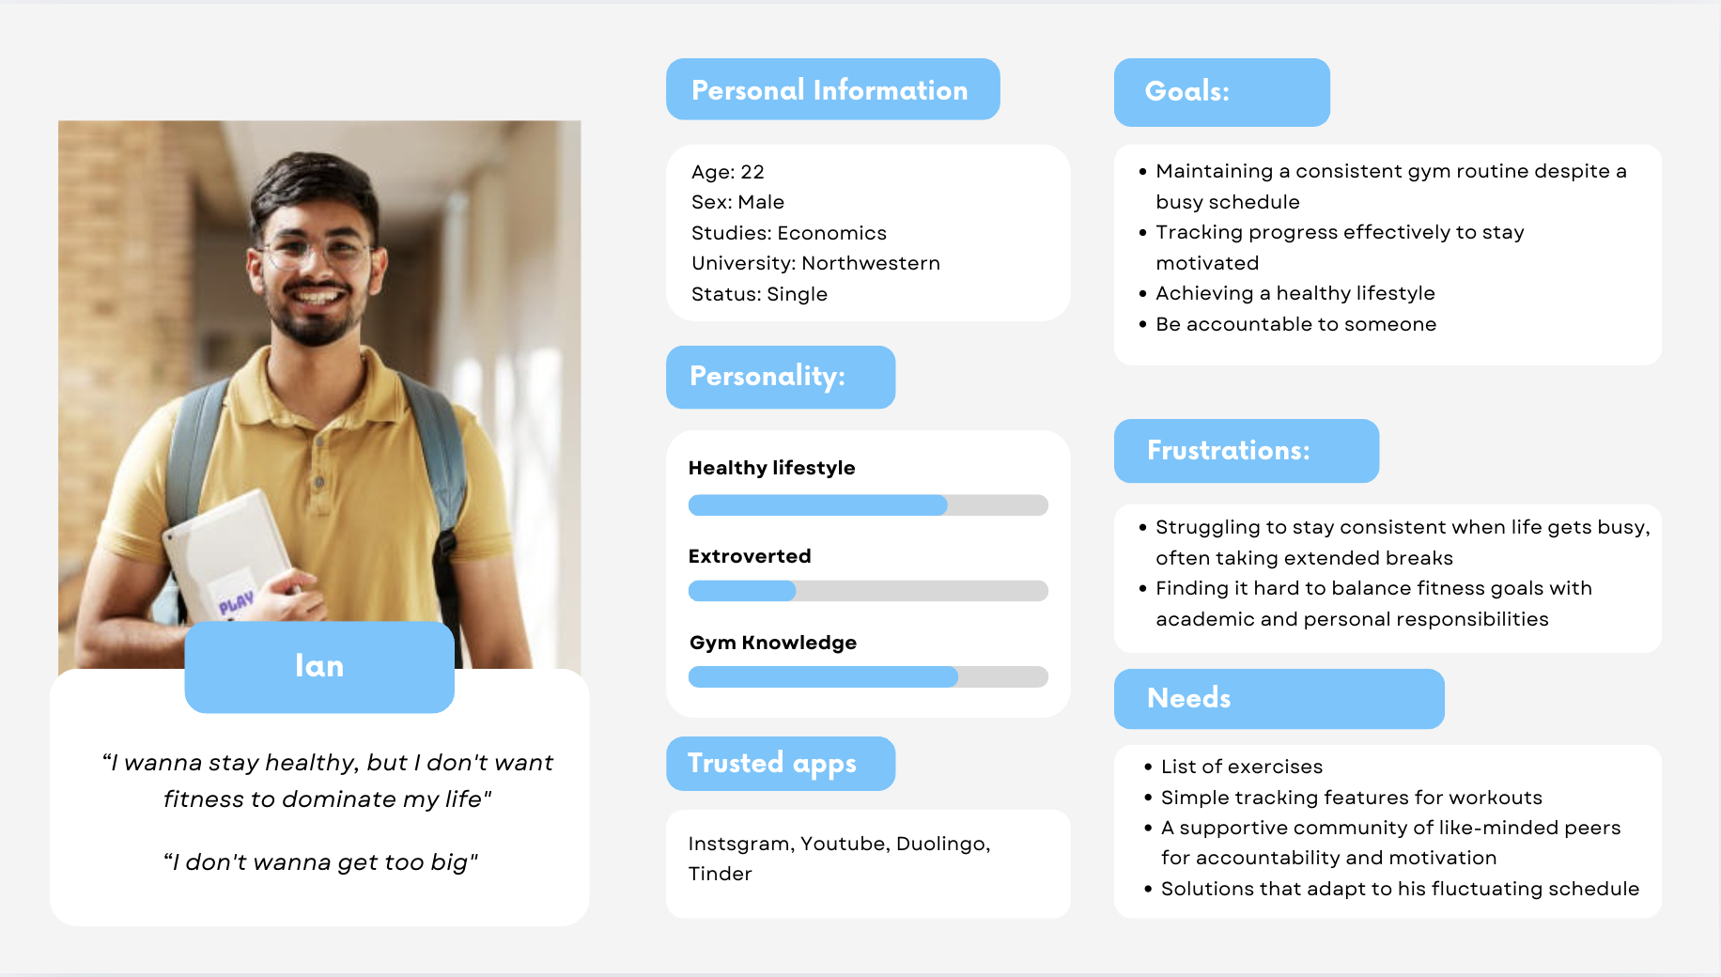

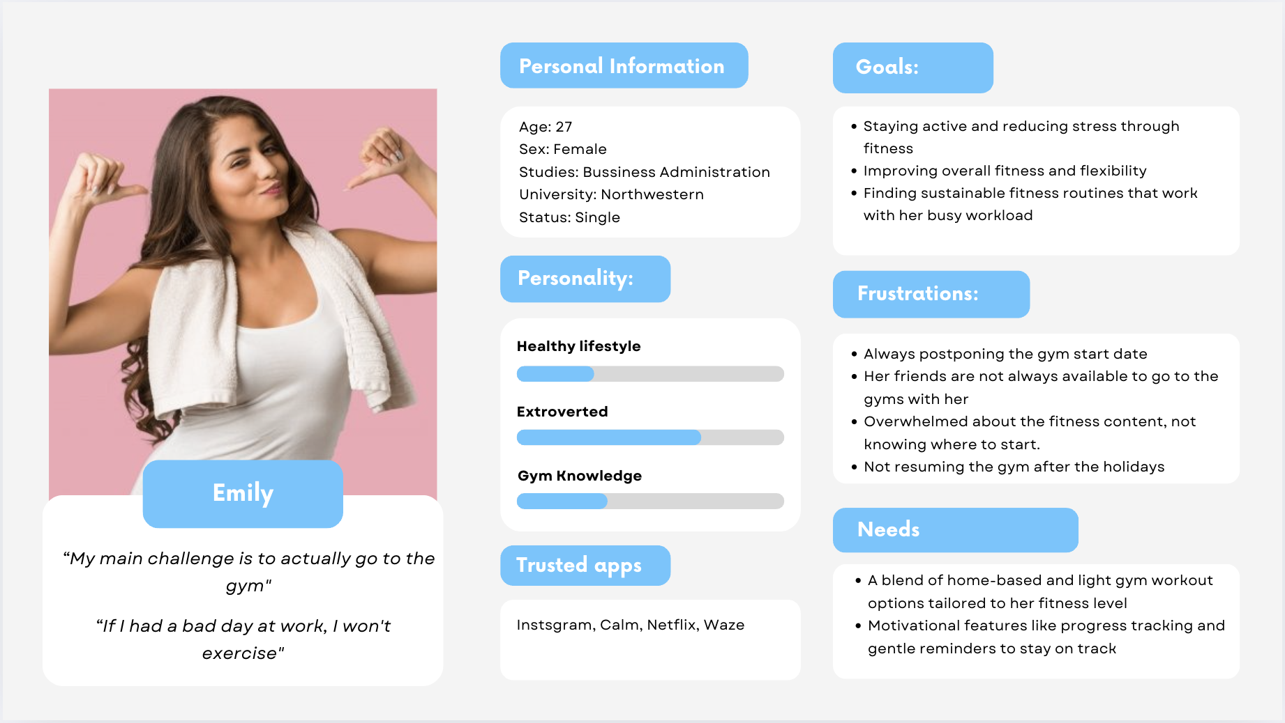

**Appendix 2: Habit tracking apps:**

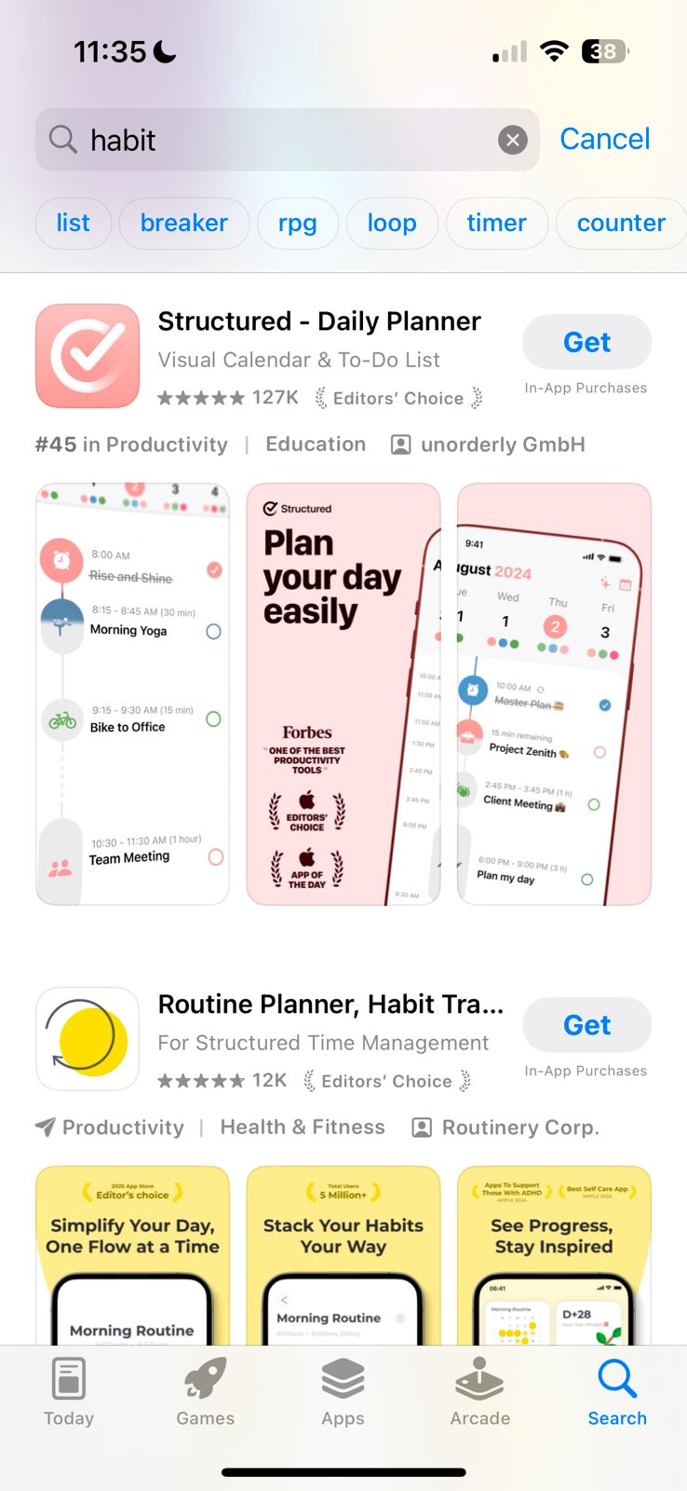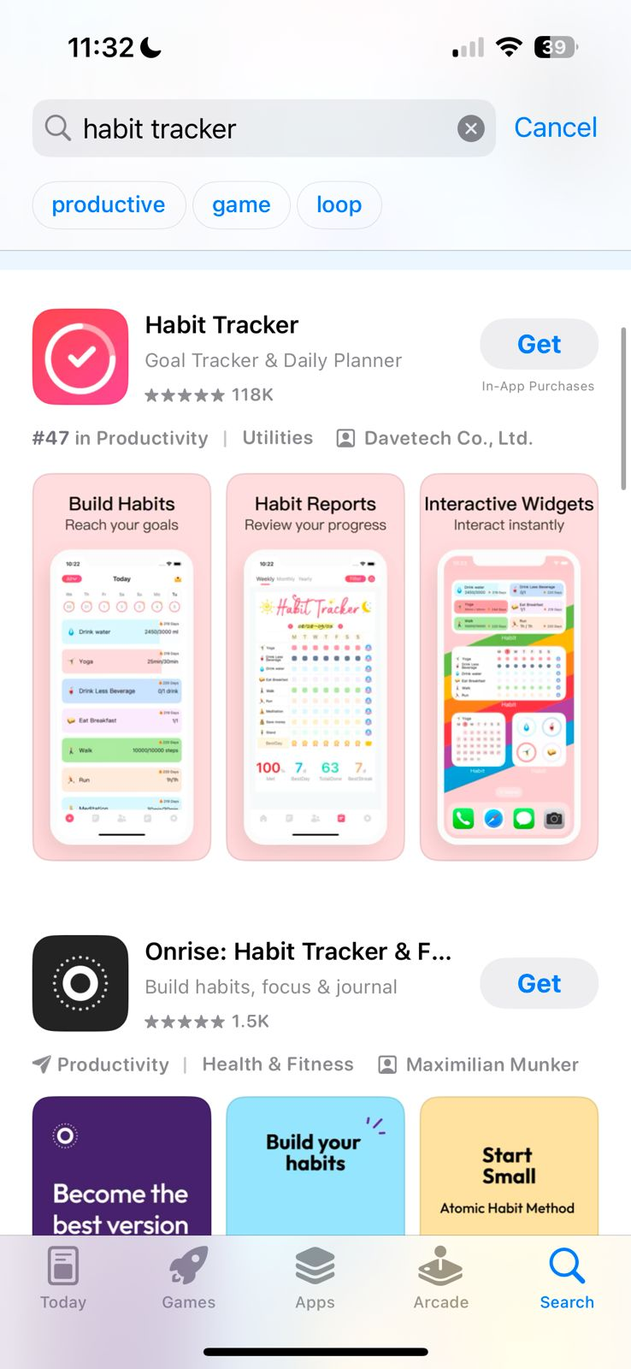

**Appendix 3: Motivational quotes**

