**Peak Potential Announces Platform to Empower Individuals to Help Individuals Acheive Discipline in the Gym**

Peak Potential: A comprehensive fitness and nutrition solution designed to transform physical, mental, and emotional well-being for college-aged individuals of all fitness levels.

**Chicago, IL - Friday, January 17th, 2025**

CHICAGO - Peak Potential is revolutionizing the fitness industry with a comprehensive platform that combines personalized fitness, nutrition plans, advanced analytics, professional coaching, and a vibrant community. Designed for college-aged individuals of all fitness levels, this innovative solution empowers users to achieve their health and wellness goals while fostering mental and emotional resilience. Launching today, Peak Potential offers tailored resources and expert guidance to make fitness a sustainable and enjoyable lifestyle. Whether you’re a beginner or an advanced fitness enthusiast, Peak Potential ensures you have the tools to succeed.

Thousands of college-aged individuals struggle to maintain consistent fitness and nutrition routines due to the following challenges:

1. Lack of Personalization: Generic fitness programs and meal plans fail to address unique goals, fitness levels, and lifestyles, leaving users unmotivated and unable to achieve sustainable results.
2. Financial Barriers: The high costs of gym memberships, equipment, coaching, and healthy meals make fitness inaccessible for many individuals.
3. Absence of Community Support: Many people lack a supportive network to stay accountable and motivated, leading to isolation and difficulty in staying on track.

Peak Potential addresses these issues with a multi-faceted approach:

* Personalized Fitness & Nutrition Plans: Tailored regimens are created based on individual goals, fitness levels, available time, and budget. Advanced metrics and analytics track progress, ensuring users stay on track.
* Community Connection: An inclusive online platform fosters motivation, accountability, and camaraderie by connecting users with like-minded individuals, workout partners, and small fitness groups.
* Affordability Tools: By providing budget management tools and cost-effective solutions, Peak Potential ensures fitness is accessible to everyone.
* Expert Guidance: Certified coaches offer one-on-one virtual sessions, leveraging analytics to adjust plans and ensure consistent progress.

The company seeks to help and empower young adults like never before. “At Peak Potential, we believe fitness is not just about aesthetics; it’s about creating a holistic way of life that empowers individuals mentally, emotionally, and physically. Our mission has been defined by listening to our users and turning their challenges into opportunities. The success we see today is a testament to the power of combining technology, personalization, and community to transform lives,” said Avi Bedi, Co-founder and CEO of Peak Potential.

Getting started with Peak Potential is simple and seamless. Users can sign up on Peak Potential’s website (peakpotential.com) or mobile app (on App/Google store), answer a few questions about their goals and preferences, and immediately access personalized plans, video resources, and community features. Coaches can be booked directly through the platform, and progress tracking begins from day one.

The early user launch (beta testing) had phenomenal reactions and validated the demand for Peak Potential. “I’ve always struggled to find a fitness plan that fits my busy schedule and limited budget. Peak Potential changed that completely. The personalized workout plans, nutritional guidance, and affordable resources have helped me stay consistent and finally see real progress. I’ve never felt more confident or energized in my life,” said Alex Huynh, a Peak Potential user.

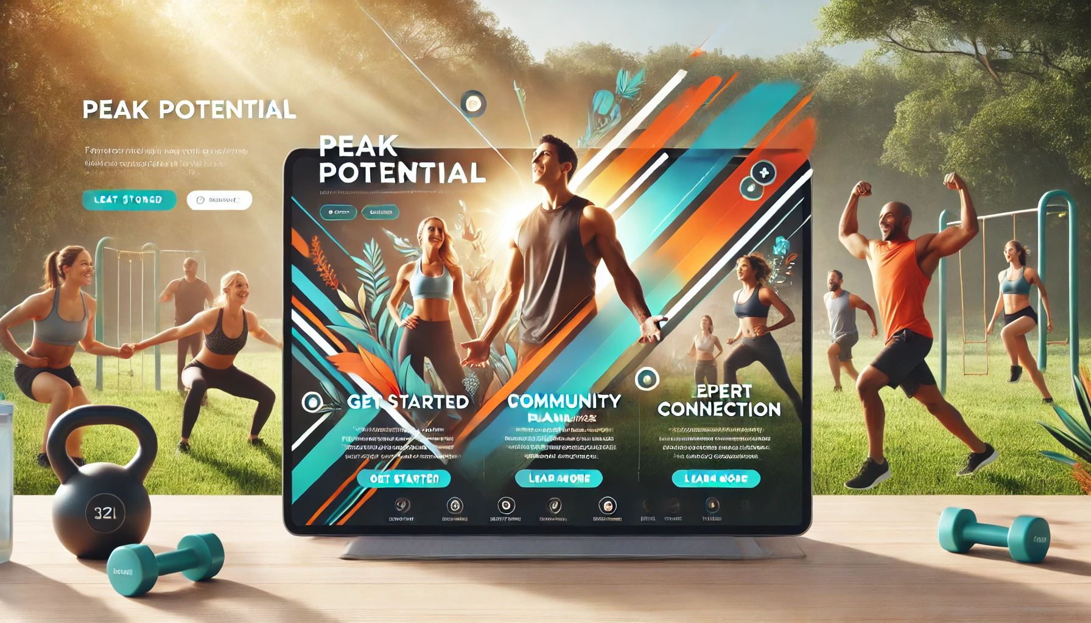

Discover how Peak Potential can transform your health and wellness journey today. Visit peakpotential.com or download the mobile app to sign up and start unlocking your full potential. Join the vibrant community and take the first step toward a healthier, happier you!

### **FAQs for Peak Potential**

1. **Q:** How does Peak Potential create personalized fitness plans?  
   **A:** Peak Potential’s platform uses data-driven insights to design fitness and nutrition plans tailored to your unique goals, fitness level, schedule, workout environment, and budget. By tracking your progress, Peak Potential continuously optimizes your plan to ensure you stay on track and achieve measurable results.
2. **Q:** What makes Peak Potential different from other fitness platforms?  
   **A:** Unlike other platforms, Peak Potential integrates fitness, nutrition, mental well-being, and financial guidance into a single, comprehensive ecosystem. With advanced analytics and a vibrant community, Peak Potential redefines fitness as a lifestyle, not just a goal.
3. **Q:** How does Peak Potential ensure affordability?  
   **A:** Peak Potential understands that fitness can be expensive. Peak Potential offers budgeting tools to help you manage costs related to gym memberships, equipment, healthy meals, and supplements, ensuring fitness remains accessible to everyone.
4. **Q:** Is Peak Potential suitable for beginners?  
   **A:** Yes, Peak Potential caters to all fitness levels. Peak Potential’s personalized plans and instructional videos ensure beginners can start safely and effectively while building confidence and knowledge.
5. **Q:** How do I get started with Peak Potential?  
   **A:** Getting started is easy! Simply sign up on our website or app, set your fitness goals, and complete a quick questionnaire about your preferences and needs. From there, your personalized plan will be ready, and you’ll gain access to all the features Peak Potential has to offer.
6. **Q:** Is there a free trial for Peak Potential?  
   **A:** Yes, Peak Potential offers a free trial so you can experience our features and benefits firsthand. After the trial, you can choose a plan that best fits your needs and goals.

**Heading:** *Name the product in a way the reader (i.e. your target customers) will understand. Use the following format: "****Company announces service/product to enable target customer to have this benefit."***

**Sub-Heading:** *The subtitle reframes the headline solution, adding additional points of information. Describe who the market for the product is and what benefit they get. One sentence only underneath the title.*

**Summary / Intro Paragraph:** *Give a summary of the product and the benefit. In 3-4 sentences, expand upon the solution, details the target customer and benefits, and what is launching. Assume the reader will not read anything else so make this paragraph good.*

**Problem:** *Describe the problem your product solves. Describe the top 2-3 problems for the customers you intend to serve, briefly describing the problem and its negative impact. Skip any attention to the solution, keep this paragraph focused on the problems, and rank them in descending order of how painful they are.*

**Solution:** *Describe how your product elegantly solves the problem. Write a brief overview of how it works, and then go through and talk about how it solves each problem you listed above. For existing products, be clear to highlight how a particular new feature works in the existing use case or workflow.*

**Quote from You/Company Leader:** *A quote from a spokesperson in your company. Pick a leader in your company/team and write a quote that talks about why the company decided to tackle this problem and (at a high level) how the solution solves it.*

**How to Get Started:** *Describe how easy it is to get started. How will a customer start using the solution, and how does it work? Describe this in enough detail to convince readers that it solves the problem.*

**Customer Quote:** *Provide a quote from a hypothetical customer that describes how they experienced the benefit. This imaginary customer quote should be one that appears genuine because it represents the target persona. The customer should explain their pain or goal and how the product helps them achieve their desired outcome. By choosing the right name and problem, you give your audience an implicit idea of the total addressable market. While hypothetical, the person and problem should feel real to the audience.*

**Closing and Call to Action:** *Wrap it up and give pointers where the reader should go to next - describe how anyone can get started today and where they can start.*