**Mobil App Development : Assignment 2**

**Text Adventure Game**



# Introduction :

The objective of this assignment was to develop a mobile text adventure game application. This app had to contain a menu system, in which you can navigate. You can access to an About and Help Activity, start a new game or load one or play a mini game which consists in a fight. In the game, the player is able to navigate between rooms which are all unique (different description, items, events, images…) and to save his position to continue the game later. There is also an inventory that you have to manage well to finish the game more easily. There is also a fight activity at the end of the game which is based on the scissor-leaf stone principle, and therefore on luck. All activities are accompanied by music to enhance the atmosphere.

# JSP Diagram

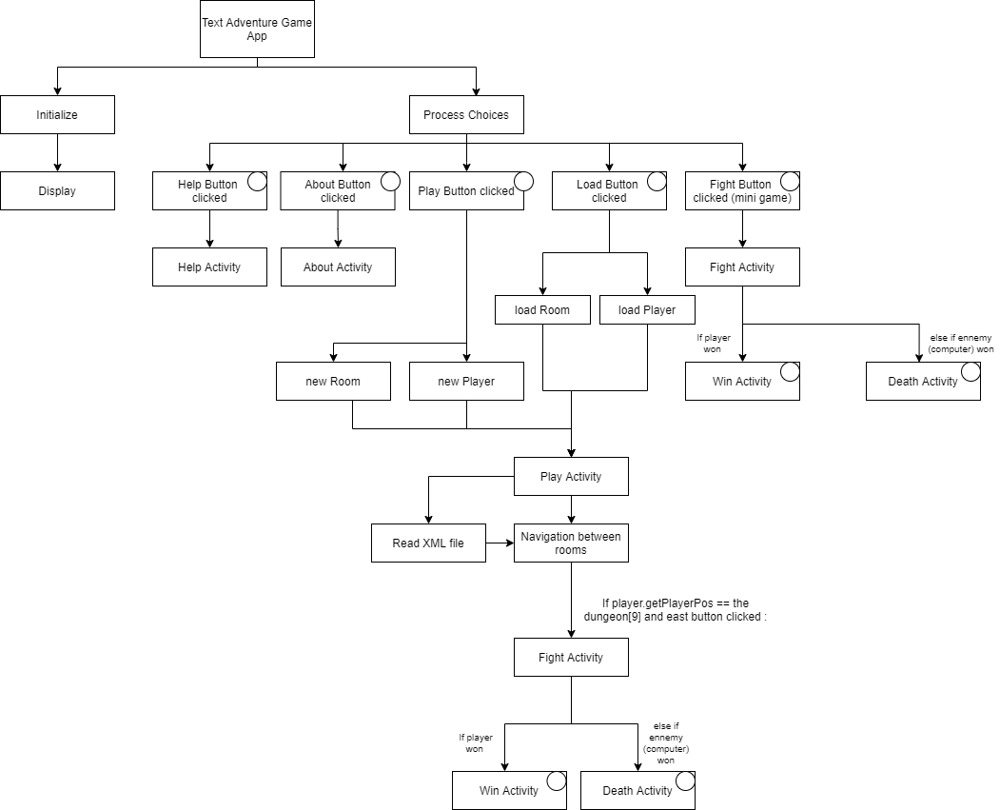

# Room Navigation Diagram

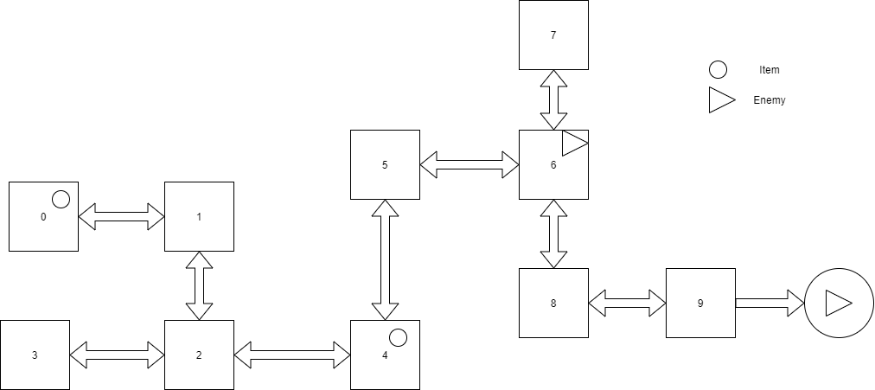

# Screenshot of the app

# Reports and testing

During the development of the application, I encountered some problems that I had to test properly to resolve.

One of the first issue was the management of the music, which was solved by simply stopping the music at the end of an activity and start another one on the new activity. I also encountered few errors when I had to display different images at each room, but it was just an unfortunate mistake which was quickly recovered.

The biggest challenge was the unveiling of the two fight scenes (which are different in their functioning). After several tests I obtained a result that suited me and that allows me to provide an application, which I think, and hope is sufficiently completed and accomplished to be used.