Annie Beyer

IT FDN A

Assignment 06

5/24/20

Functions and GitHub

# Introduction

This week as killer. I finished all the video lectures, websites, and textbook with ease. Everything made perfect, logical sense. But, when I attempted to do the coding in the assignment, I hit wall after wall, which I describe below.

# Topic 1: Working Through Module 06

Functions and classes made perfect sense to me as I watched the video lecture and read through the textbook. They are a way to break up the code into more organized chunks, and I love organization. Last week’s homework assignment was long and although it was organized, I looked forward to a way to break it up even easier for myself to read and for others to read. The way functions worked, with parameters and arguments also made logical sense to me. Calling a function that was within a class, seemed very doable as well. Nothing seemed to stump me as I was working through the Module and I was looking forward to applying what I had learned.

# Topic 2: Assignment 06

I began assignment 06 with much enthusiasm and excitement. I brought up my past code from assignment 5, Randal’s assignment 5 code, and the starter file. I arranged everything to test code in a starter file, and then transfer it to the final PyCharm file when it worked. I started by copying Randal’s code into the starter file, and worked with just the first function (inputting a new task). I divided the code between processing and input, and then clicked to run the program. I was able to type in the task and priority, but to my disappointment, only () returned back to me. I tried changing the code many many times to get it to worked, but nothing I did helped. I moved on to attempt to try the other functions to see if I had any better luck, but I only got similar results.

I attempted watching both the video assignment review and TA office hours video, but still could not figure out what was going wrong in my code. Finally, after three days of trying and failing, I discovered what I had done wrong.

I had wrongly assumed Randal required me to call both the IO function and the Processor function in the main body of the script, but this is what was causing my error. I realized this when I tried putting ALL of my code under the processing function to see if it would run, and it did. Refer to Figure 6-1 below for an example of this code:

**Figure 6-1 Nested Function**

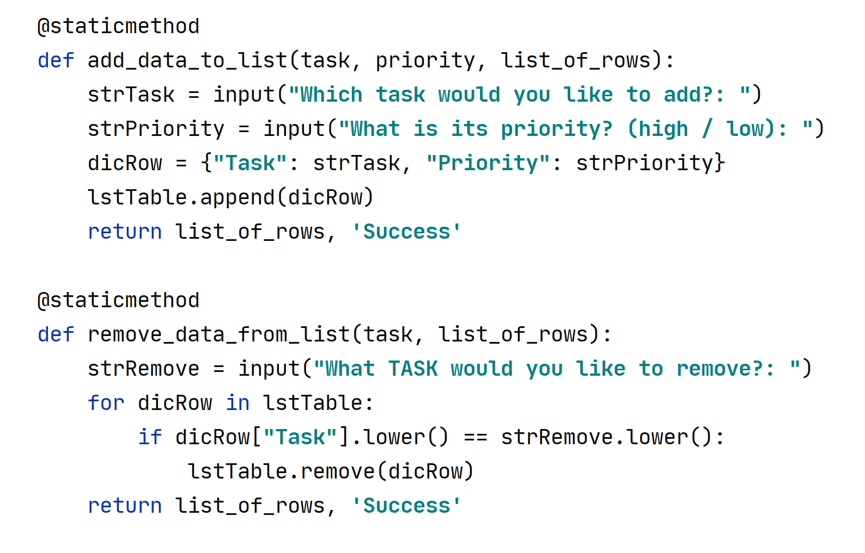

This led me to believe that there needed to be some connection between the two functions. So instead I nested my IO function within my processor function, and it worked! From there it was easy to complete the rest of the assignment.

My main error was incorrectly assuming the requirements that professor Randal expected. Once I got it up and running, I recorded pictures of it working on both PyCharm **(Figure 6-2),** my command prompt **(Figure 6-3),** and the saved text file **(Figure 6-4).**

**Figure 6-2 PyCharm Example**

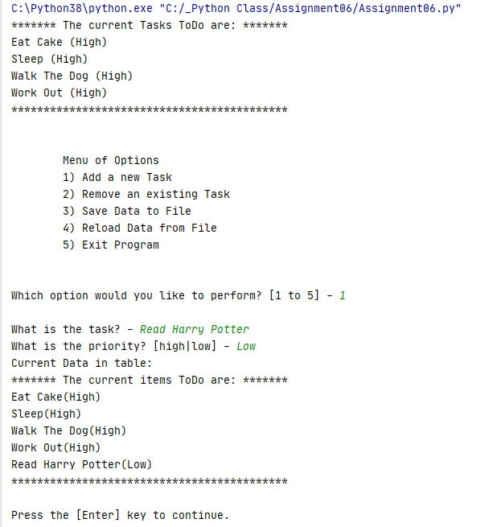

**Figure 6-3 Command Prompt Example**

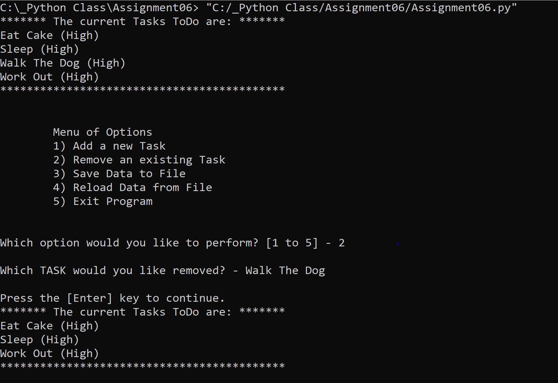

**Figure 6-4 Text File Example**

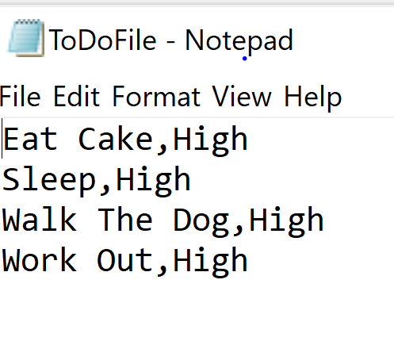

# Conclusion

In conclusion, this week’s learning objectives were easy for me to comprehend logically, but the assignment itself was confusing. I had wrongly assumed what professor Randal’s expectations and requirements were for the assignment, which led me down incorrect paths. Eventually, I was able to figure out a way to make the functions work.