Annie Beyer

5/16/2020

ITFDN 100 A

Assignment 05

Creating and Updating a To-do List

# Introduction

In this paper I review the process of completing Module 05 and the homework assignment associated with it. Each week gets progressively harder than the next, as I mention below.

# Topic 1: Working Through Module 05

This weeks topics were much easier for me to grasp intuitively. Lists were reviewed in the previous module so the videos and textbook readings about them didn’t feel difficult to understand. Dictionaries usage also made intuitive sense to me, since the analogy of a dictionary is adequate to help me understand how to write a dictionary in code. The other handy bits I enjoyed were learning things like script templates to improve efficiency. Overall, working through Module 05 made intuitive sense and didn’t seem too confusing. This all changed when I began assignment 05.

# Topic 2: Assignment 05

As I opened up Pycharm to begin assignment 05, I realized that I didn’t really know where to start. Despite learning all that I needed to know, this was the first real practice I had and most of what I had learned was not at the top of my brain, ready to use. It took me awhile to get started, even with the prompts. Although nice at times, I realized I don’t like using other people’s variable names, because they often to align with what I typically do. Once I got used to that however, it was fine.

This was a very slow going assignment. I copied a lot from module 04 and began to add and tweak the code to use a dictionary row instead of a list row, and put those rows into a list table. I then added code to remove the row, which took me a very long time to figure out. I got stuck a few times because I accidentally created infinite while loops for the remove portion of my script. Once I realized that I had too many if else statements within the while loop that were unnessecary, I then corrected my error.

I also stumbled through saving the objectFile to the test, but again, was eventually successful in figuring out what was going on in my code. Professor Randal’s tip to select parts of your code one at a time in order to hone in on the error really was helpful in this case.

Afterwards, I went on Github and reviewed someone elses homework assignment and compared it to my own. A fellow student gave me the idea to write in “[dictionary row] have been saved to memory” instead of just saying “Data saved!”. This way the user will know for sure what has been written to the text file, which I liked better.

Below in figures 5-1, 5-2, 5-3, and 5-4, you will see my code working in PyCharm, the Command Prompt, and being written to the text file for homework assigment 05.

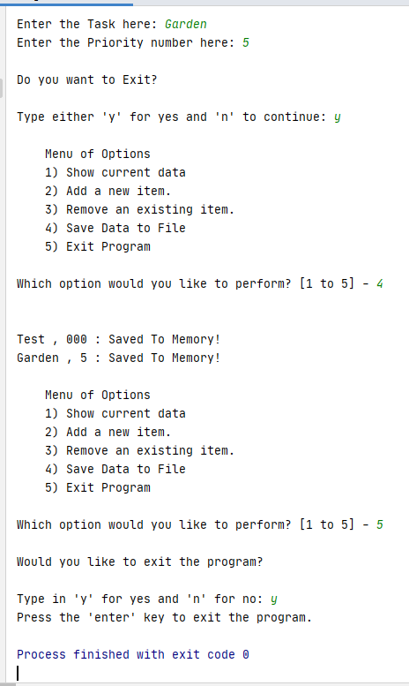

**Figure 5-1: PyCharm demo**

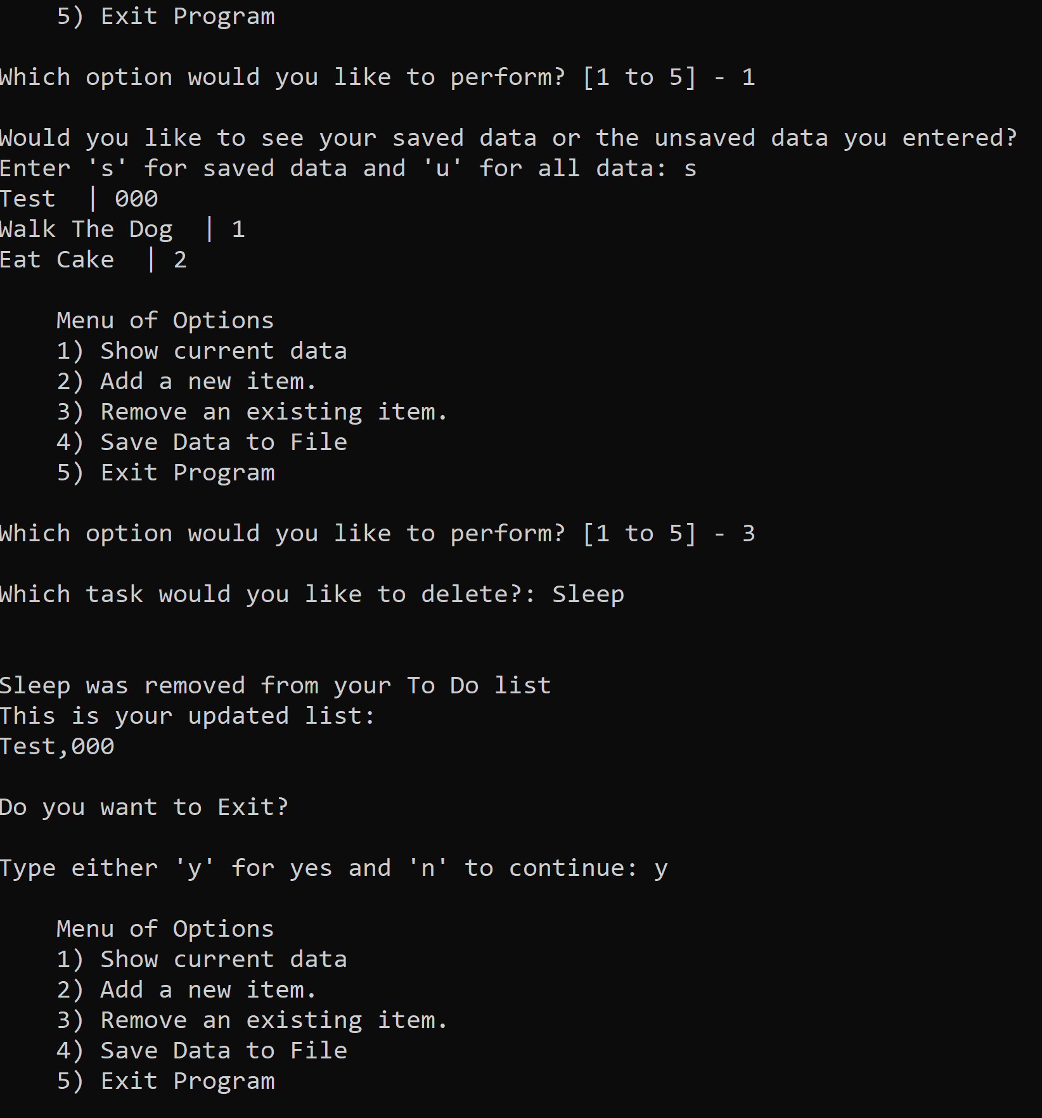

**Figure 5-1: CMD prompt demo**

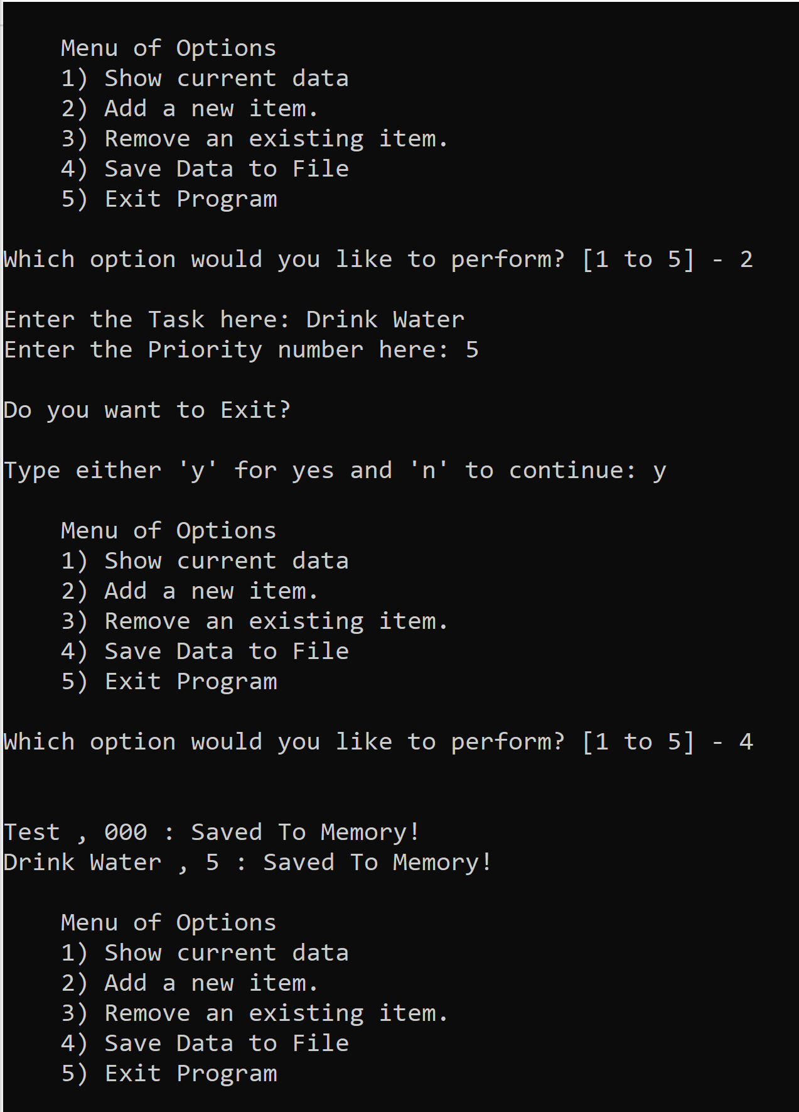

**Figure 5-3: CMD prompt demo continued**

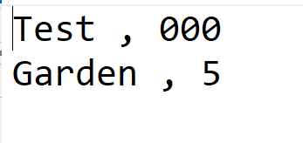

**Figure 5-4: ToDoList Text file after the CMD prompt demo**

# Conclusion

In conclusion, this weeks module was easier to understand while working through the lectures and textbooks, but when it came to using the new material and putting it into practice, it was still a challenge.