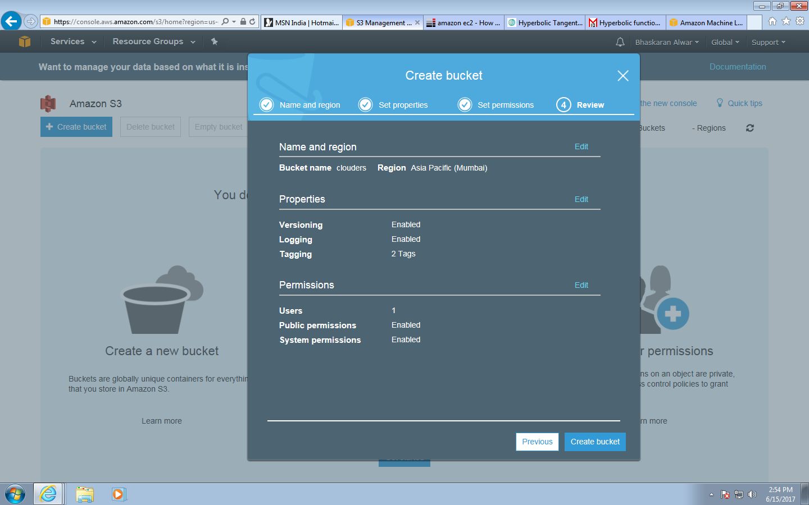

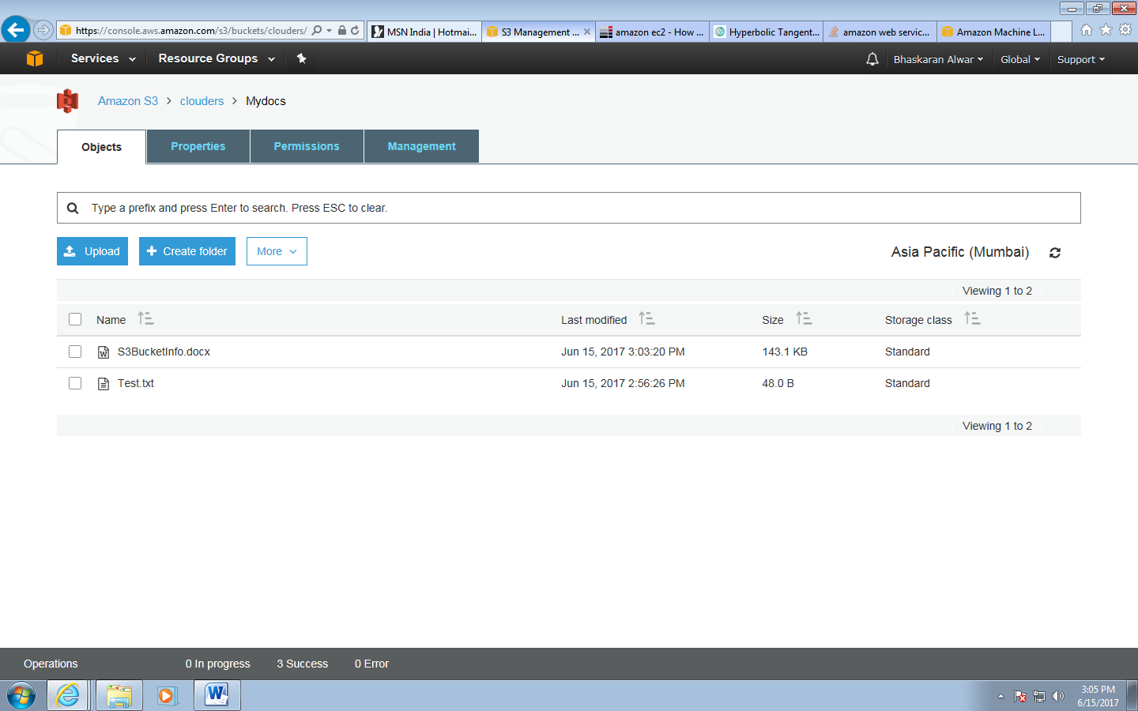

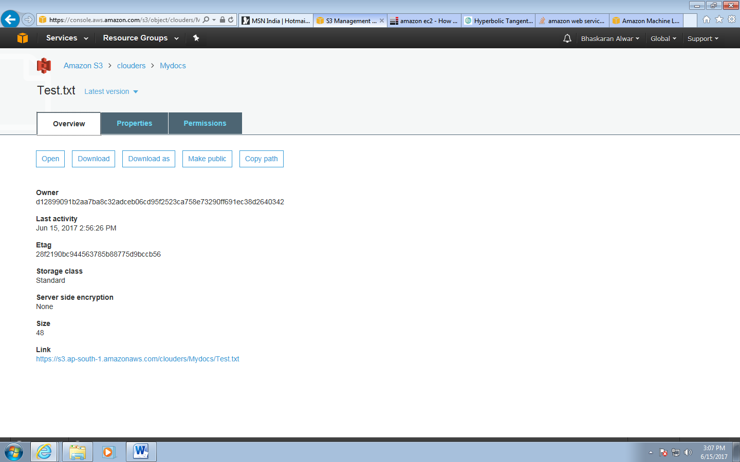

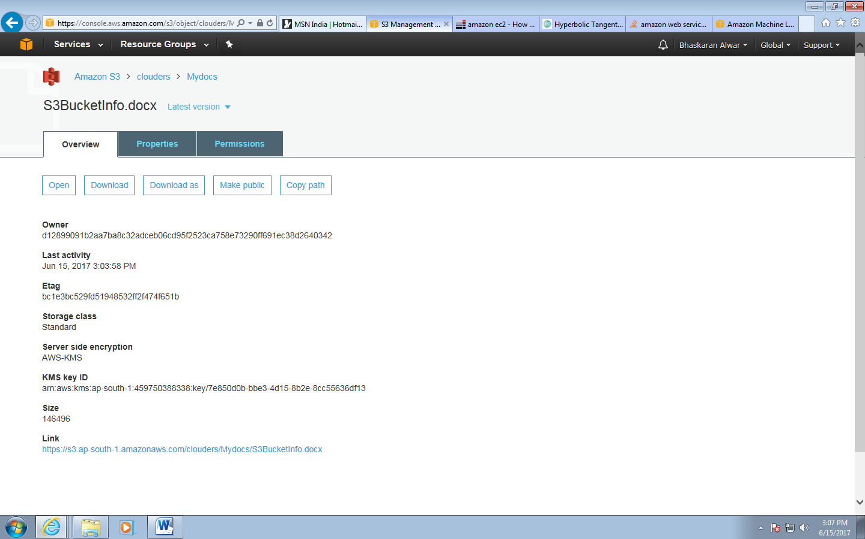

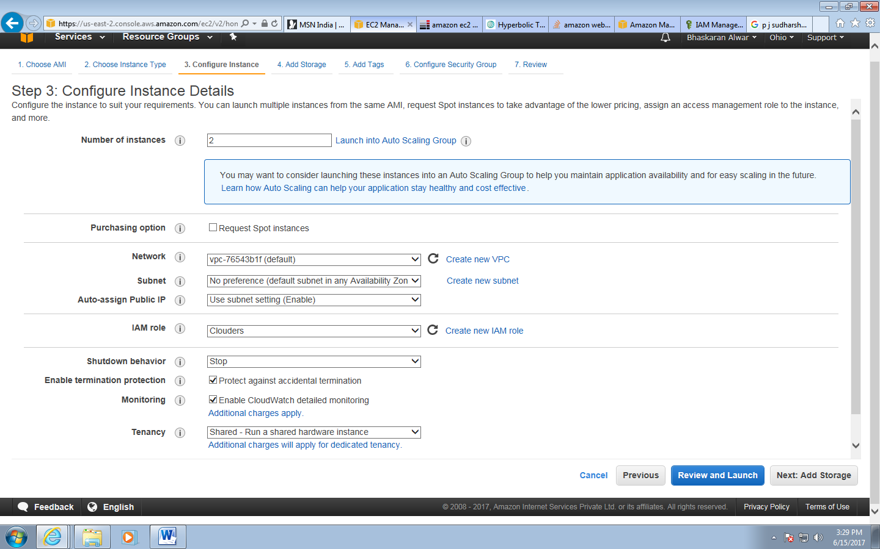

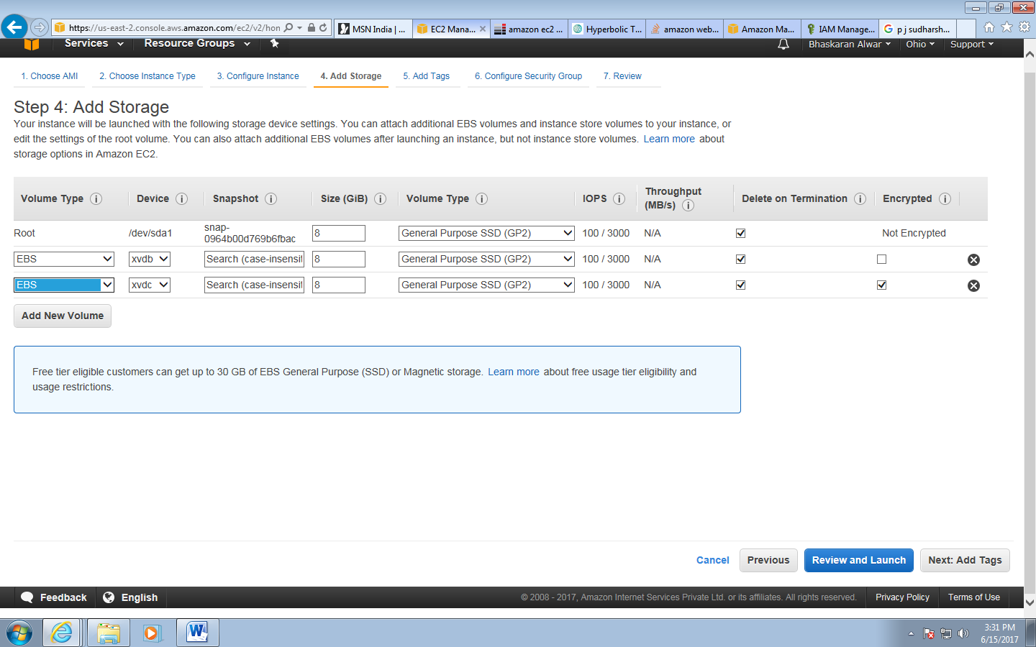

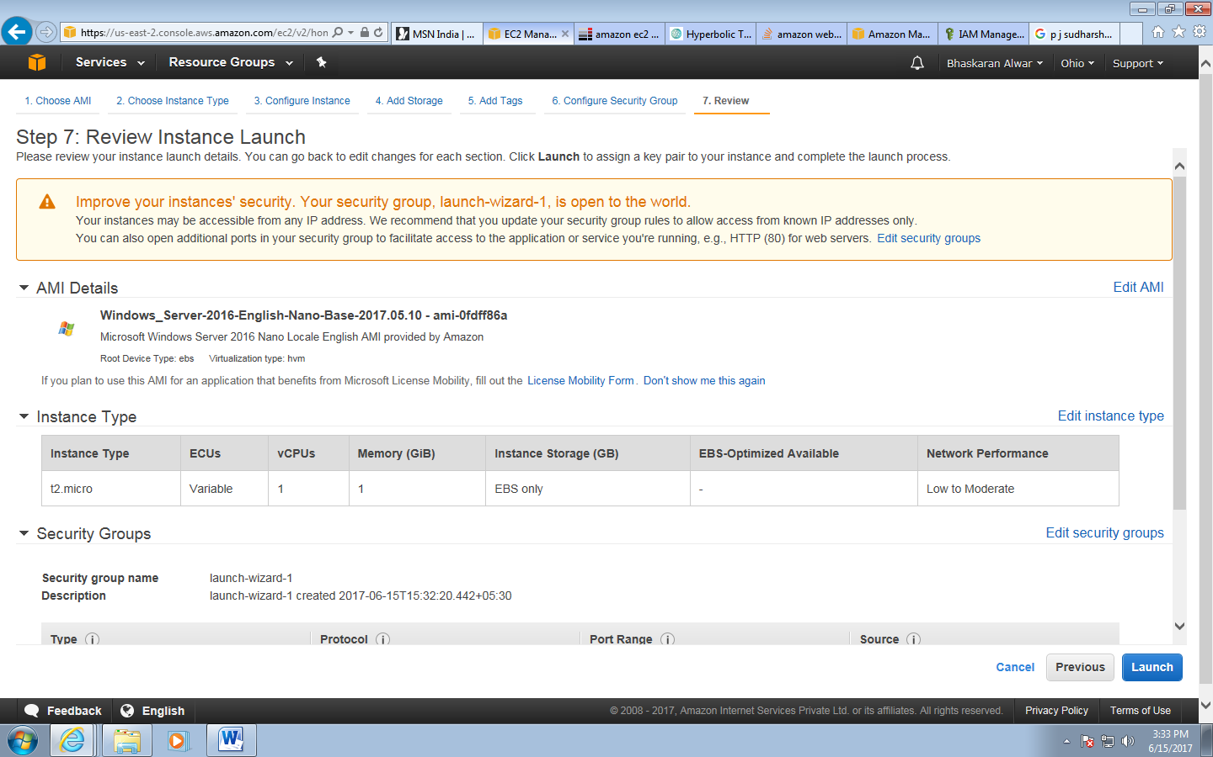

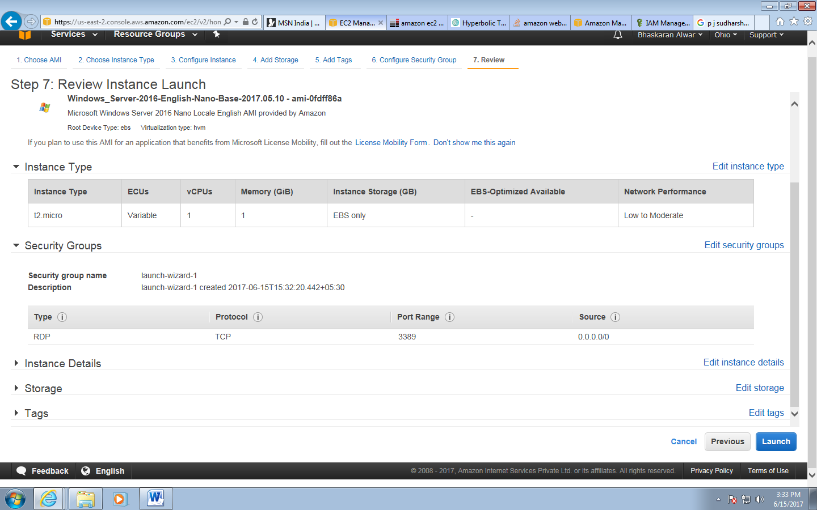

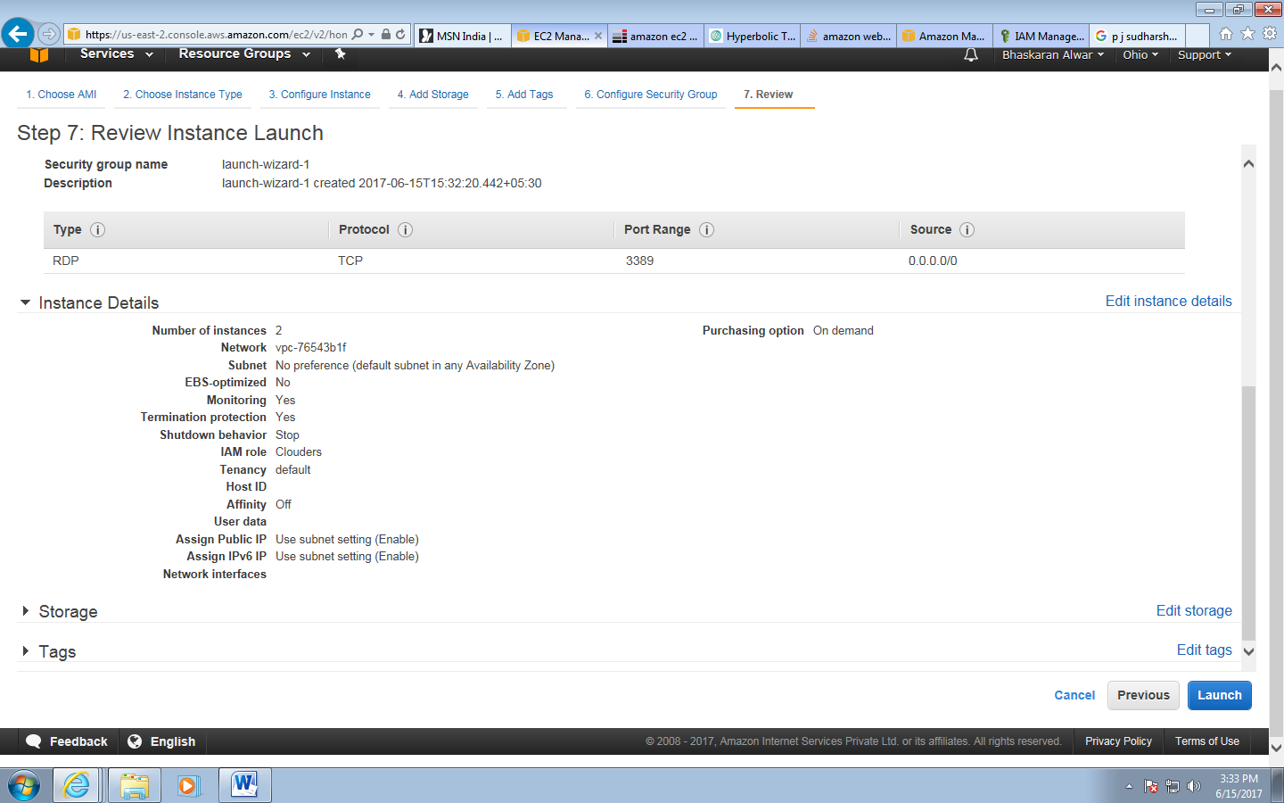

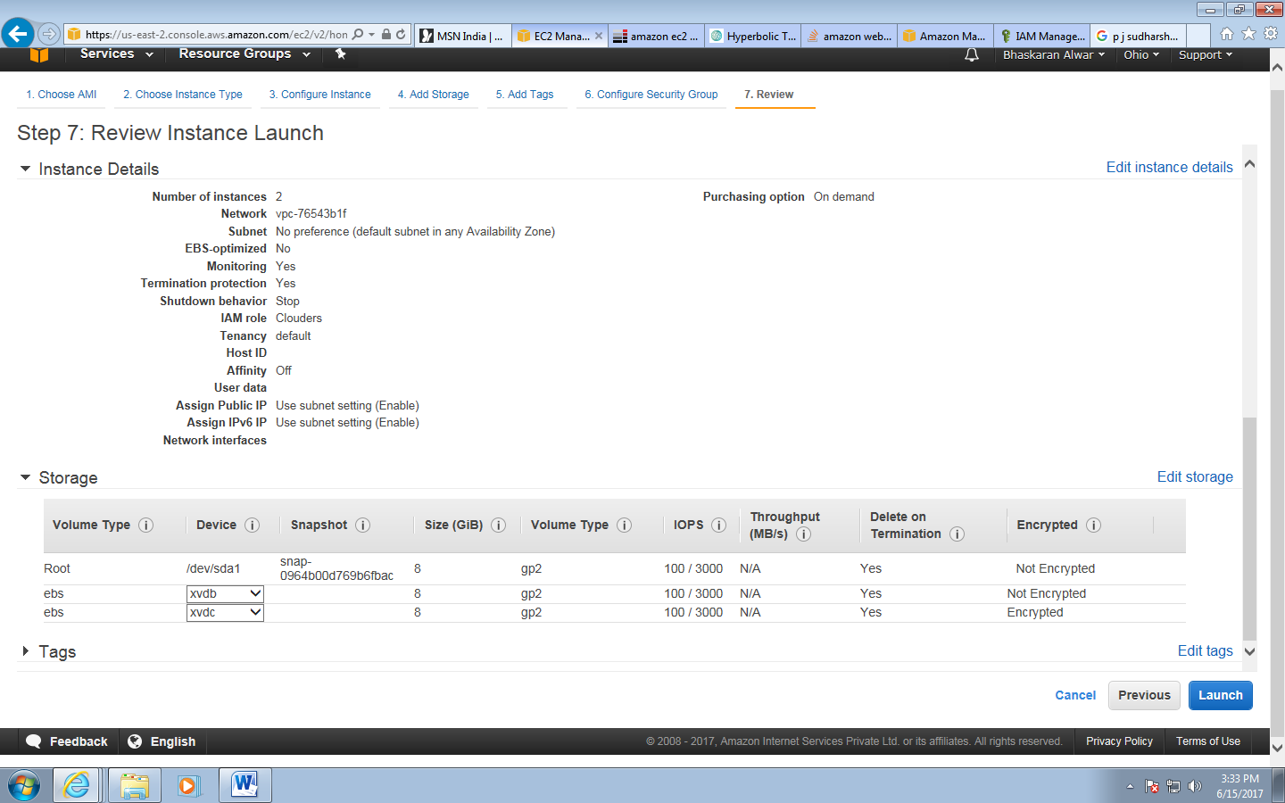

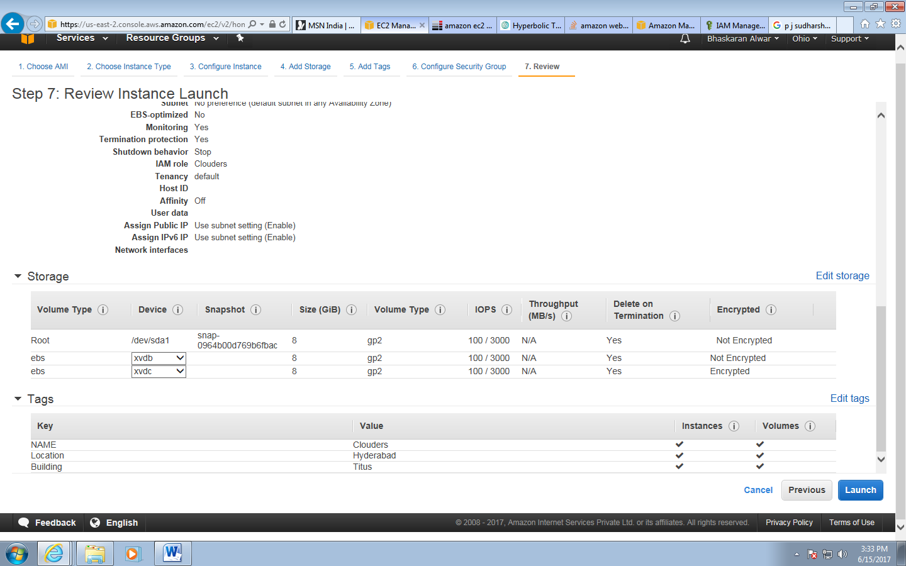

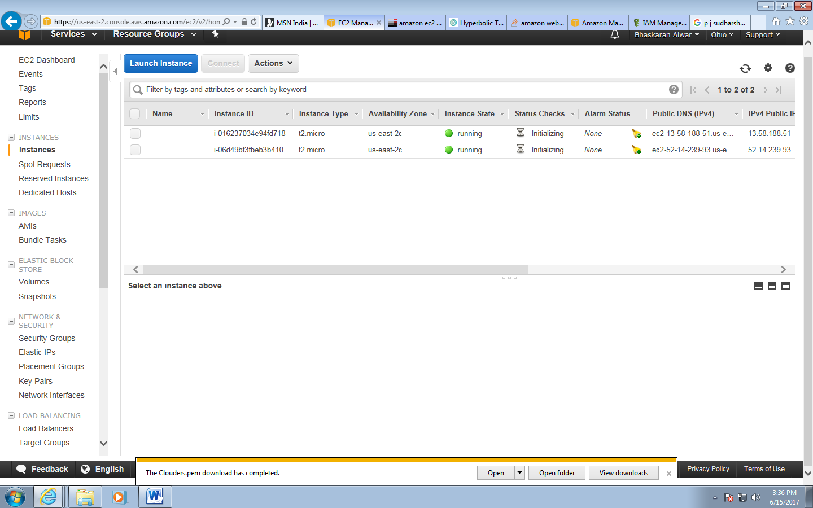

|  |  |
| --- | --- |
| Instance ID  i-016237034e94fd718 | Public DNS (IPv4)  ec2-13-58-188-51.us-east-2.compute.amazonaws.com |
| Instance state  running | IPv4 Public IP  13.58.188.51 |
| Instance type  t2.micro | IPv6 IPs  - |
| Elastic IPs | Private DNS  ip-172-31-41-13.us-east-2.compute.internal |
| Availability zone  us-east-2c | Private IPs  172.31.41.13 |
| Security groups  [launch-wizard-1](https://us-east-2.console.aws.amazon.com/ec2/v2/home?region=us-east-2#SecurityGroups:groupId=sg-3b5f6152;sort=groupId). view inbound rules | Secondary private IPs |
| Scheduled events  [No scheduled events](https://us-east-2.console.aws.amazon.com/ec2/v2/home?region=us-east-2#Events:) | VPC ID  vpc-76543b1f |
| AMI ID  Windows_Server-2016-English-Nano-Base-2017.05.10 (ami-0fdff86a) | Subnet ID  subnet-b61ad2fb |
| Platform  windows | Network interfaces  eth0 |
| IAM role  [Clouders](https://us-east-2.console.aws.amazon.com/iam/home?region=us-east-2#roles/Clouders) | Source/dest. check  True |
| Key pair name  Clouders |  |
| Owner  459750388338 | EBS-optimized  False |
| Launch time  June 15, 2017 at 3:33:19 PM UTC+5:30 (less than one hour) | Root device type  ebs |
| Termination protection  True | Root device  /dev/sda1 |
| Lifecycle  normal | Block devices  /dev/sda1  xvdb  xvdc |
| Monitoring  detailed |  |
| Alarm status  *None* |  |
| Kernel ID  - |  |
| RAM disk ID  - |  |
| Placement group  - |  |
| Virtualization  hvm |  |
| Reservation  r-0757ff7d40daea6db |  |
| AMI launch index  1 |  |
| Tenancy  default |  |
| Host ID  - |  |
| Affinity  - |  |
| State transition reason  - |  |
| State transition reason message  - |  |

Instance/User Name – clouders

clouders123!

DB Name – cloud_hyd

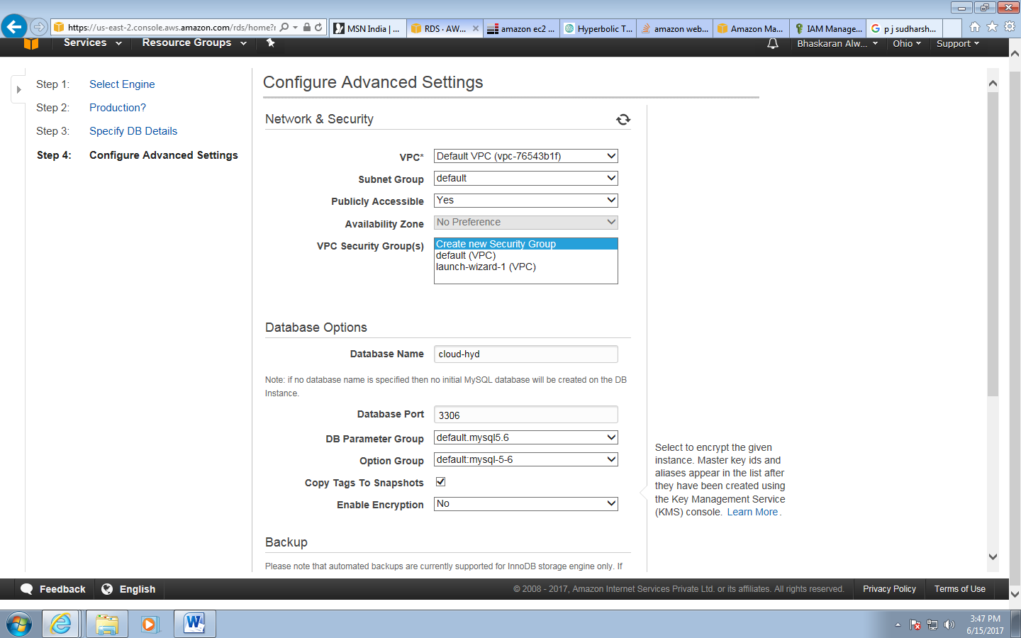

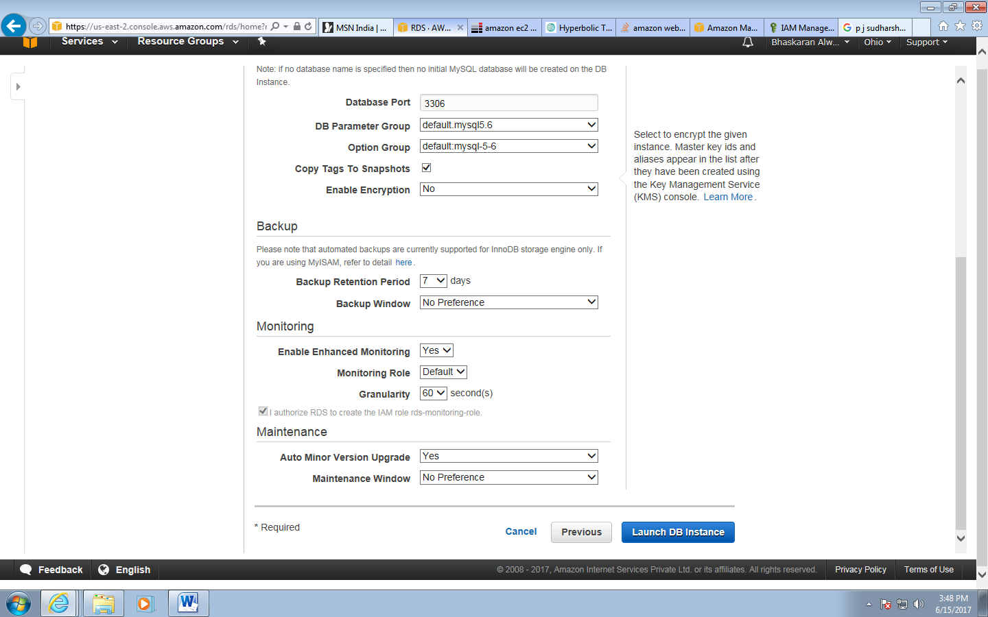

13.58.188.51

VqzWAVSWrouikHvSen8Iq6pzd5)p2Uhx

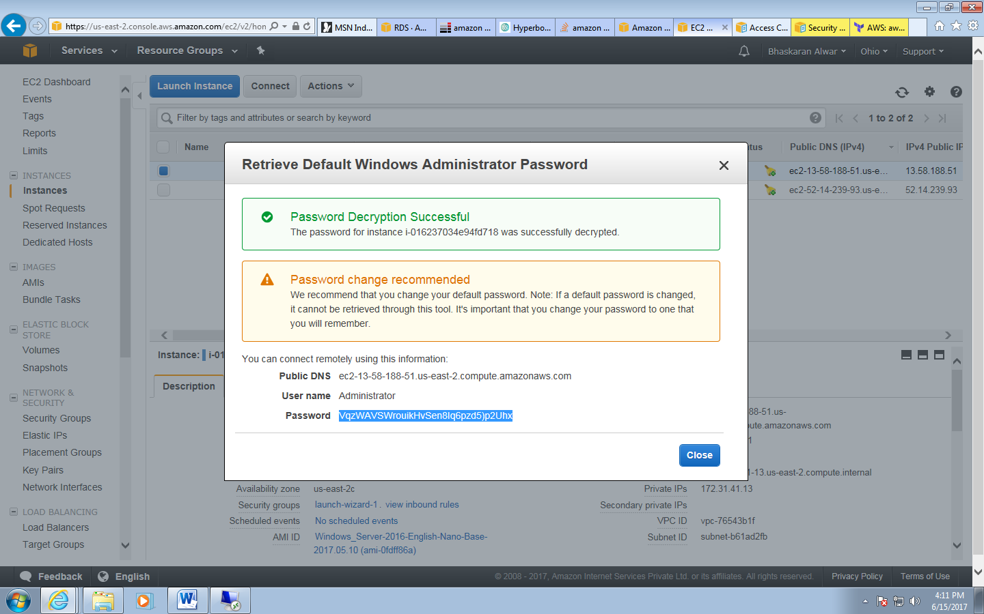

52.14.239.93

[x.f&7eFiOmX@lJ)!AVmIf7@(W!qG!W5p](mailto:x.f&7eFiOmX@lJ)!AVmIf7@(W!qG!W5p)

viKqeFfiyp*n=jo5r3EhHarL4I*$cZMh

