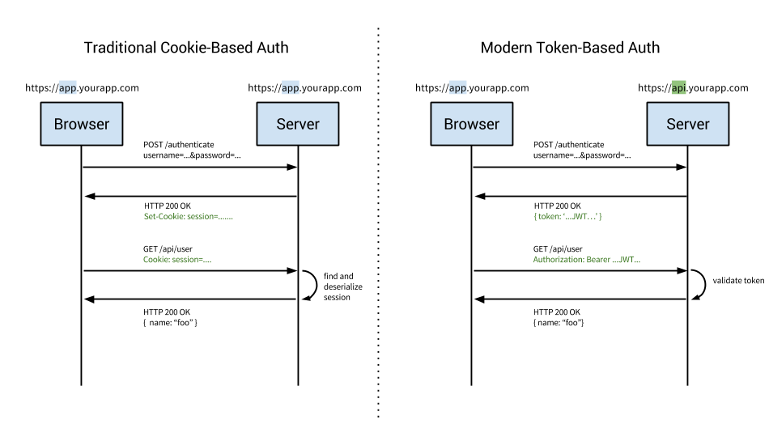

https://dzone.com/articles/cookies-vs-tokens-the-definitive-guide