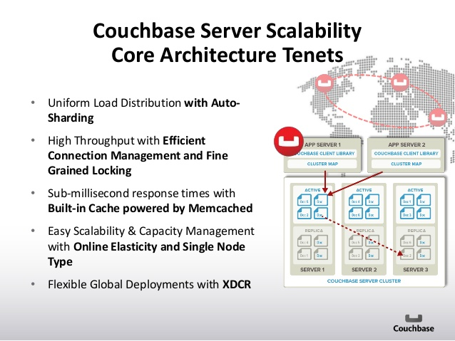

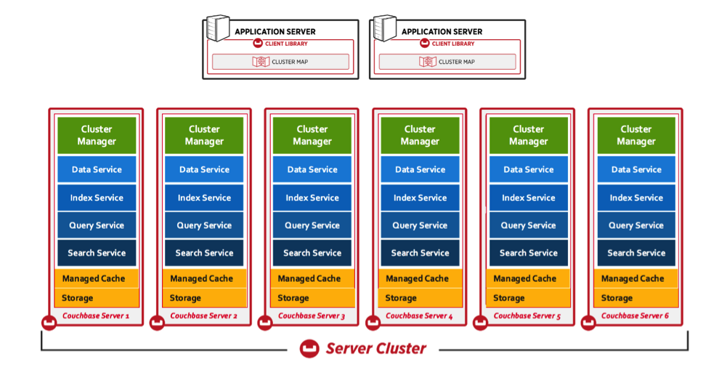

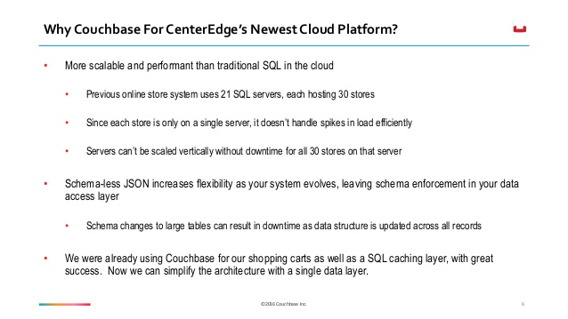

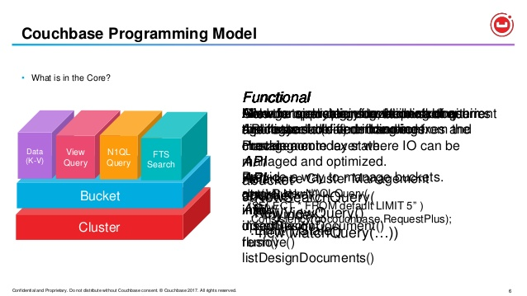

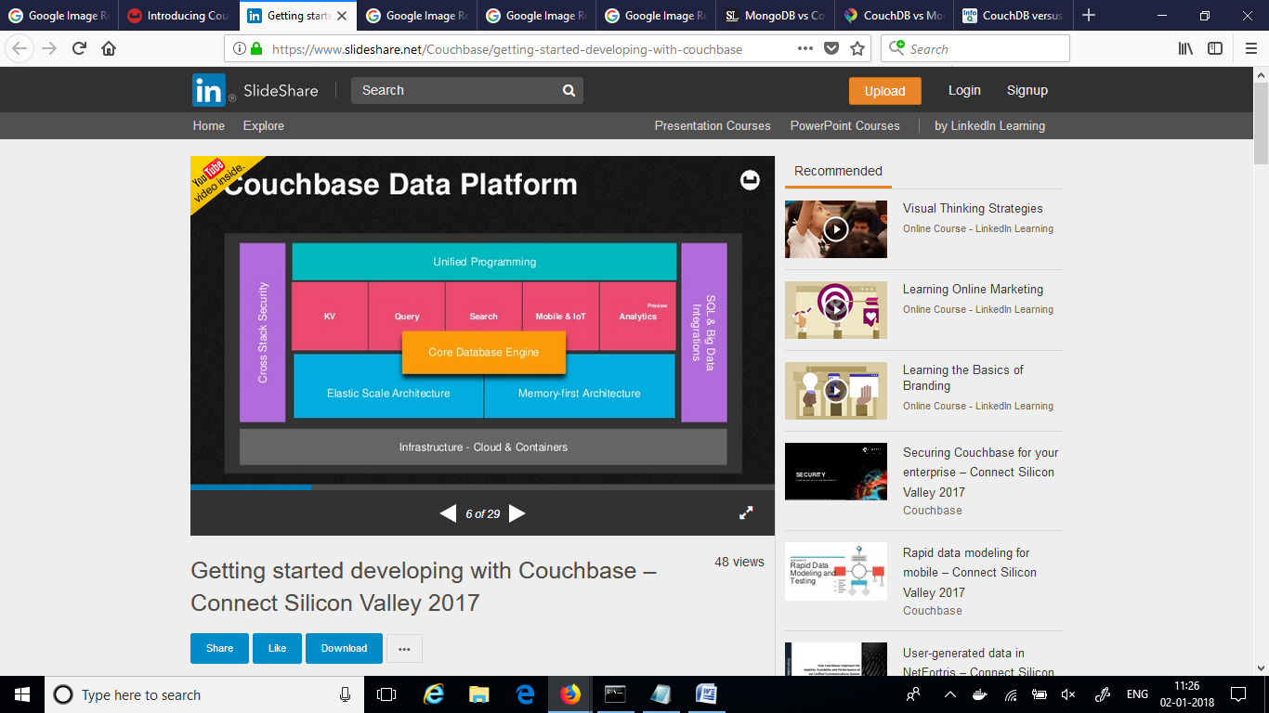

Confidential and Proprietary. Do not distribute without Couchbase consent. © Couchbase 2017. All rights reserved. 7
On Dev...

Confidential and Proprietary. Do not distribute without Couchbase consent. © Couchbase 2017. All rights reserved. 8
Most R...Confidential and Proprietary. Do not distribute without Couchbase consent. © Couchbase 2017. All rights reserved. 9
New De...Confidential and Proprietary. Do not distribute without Couchbase consent. © Couchbase 2017. All rights reserved. 10
Addin...Confidential and Proprietary. Do not distribute without Couchbase consent. © Couchbase 2017. All rights reserved. 19
Desig...Confidential and Proprietary. Do not distribute without Couchbase consent. © Couchbase 2017. All rights reserved. 21
Durab...Confidential and Proprietary. Do not distribute without Couchbase consent. © Couchbase 2017. All rights reserved. 22
Flexi...Confidential and Proprietary. Do not distribute without Couchbase consent. © Couchbase 2017. All rights reserved. 24
Couch...