**Practical - 9**

**Aim:- Create a simple keylogger using python**

**Step - 1: Open file explorer and create a new folder with any valid name. (example:practical9)**

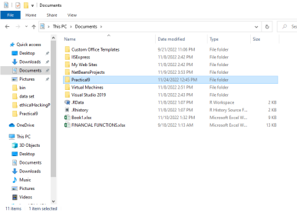

**Step - 2 :Open VS code or any code editor in your system and click on Open Folder.**

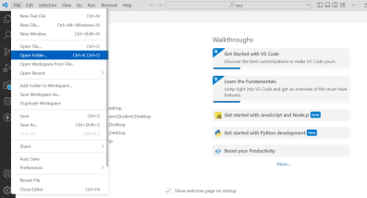**Step - 3 : Open the same folder that you had created in step 1.**

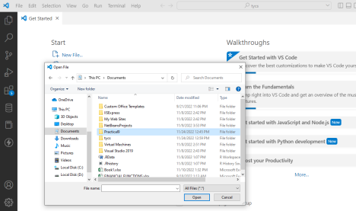**Step - 4 : Create a python file with a valid name (example:index.py )**

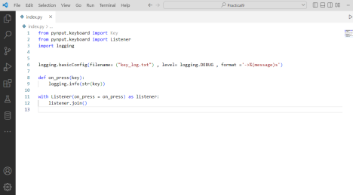

**Step - 5 :**

**Run the program and you will get Microsoft defender prompt for the first time. It will be by default disabled and you need to enable it. Here is the screenshot that contains settings after it was allowed.**

**Note: [ The file will be deleted when you will run your program for the first time and after you allow the threats you have to create a new file again and put the same code inside it. ]**

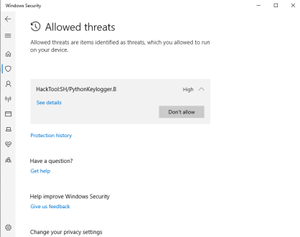

**Step - 6 : Run python file.**

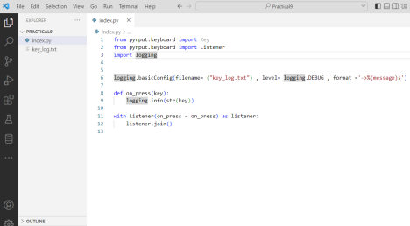

**Step-7: A text file will be generated that will contain the information.**