Q1.

Code:

|  |
| --- |
| **package Q1;**  **import javax.swing.*;**  **public class Main_Q1 {**  **public static void main(String[] args) {**  **JFrame NewWindow = new JFrame();**  **NewWindow.setSize(800,600);**  **NewWindow.setTitle("Welcome to Java");**  **NewWindow.setVisible(true);**  **}**  **}** |

Output:

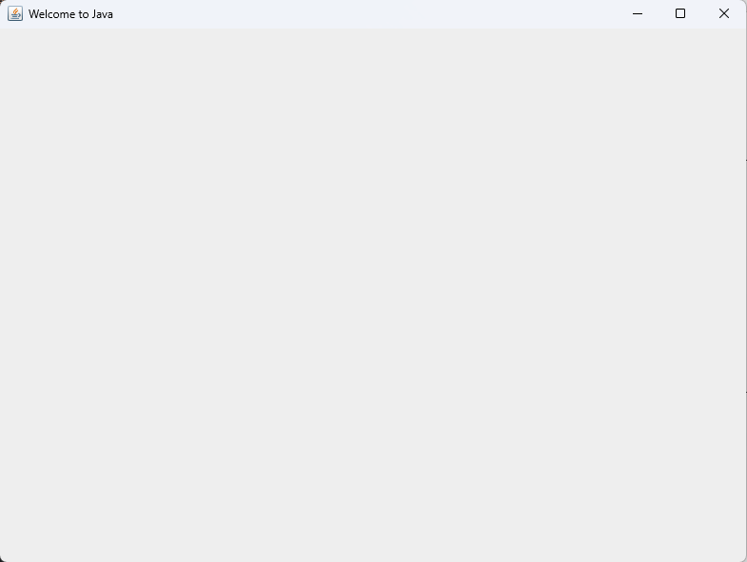

Q2.



Code:

|  |
| --- |
| **package Q2;  import javax.swing.*; import java.util.Scanner;  public class Main_Q2 {  public static void main(String[] args) {  Scanner NewScanner = new Scanner(System.*in*);   System.*out*.println("Enter First Name : ");  String FirstName = NewScanner.nextLine();   System.*out*.println("Enter Last Name : ");  String LastName = NewScanner.nextLine();   JFrame NewWindow = new JFrame();  NewWindow.setTitle(FirstName + " " + LastName);  NewWindow.setSize(200,200);  NewWindow.setVisible(true);  } }** |

Output (Console ):

|  |
| --- |
| **Enter First Name :**  Lakshan  **Enter Last Name :**  Chamod |

Output (Window ):

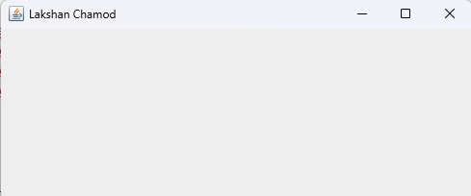

Q3.



Code:

|  |
| --- |
| **package Q3;  import java.util.Scanner;  public class Main_Q3 {  public static void main(String[] args) {  Scanner NewScanner = new Scanner(System.*in*);   System.*out*.println("Enter First Name : ");  String FirstName = NewScanner.nextLine();   System.*out*.println("Enter Middle Name : ");  String MiddleName = NewScanner.nextLine();   System.*out*.println("Enter Last Name : ");  String LastName = NewScanner.nextLine();   System.*out*.println(FirstName + " " + MiddleName.charAt(0) + ". " + LastName );  } }** |

Output (Console ):

|  |
| --- |
| **Enter First Name :**  **Lakshan**  **Enter Middle Name :**  **Chamod**  **Enter Last Name :**  **Kumara**  **Lakshan C. Kumara** |

Q4.



Code:

|  |
| --- |
| **package Q4;  import java.text.DateFormat; import java.text.SimpleDateFormat; import java.util.Date;  public class Main_Q4 {  public static void main(String[] args) {  Date CurrentDate = new Date();  SimpleDateFormat DateFormat = new SimpleDateFormat("dd MMMM yyyy");  System.*out*.println(DateFormat.format(CurrentDate));  } }** |

Output (Console ):



Q5.



Code:

|  |
| --- |
| **package Q5;  import java.text.SimpleDateFormat; import java.util.Date;  public class Main_Q5 {  public static void main(String[] args) {  Date CurrentDate = new Date();  SimpleDateFormat DateFormat = new SimpleDateFormat("EEEE, MMMM dd, yyyy");  System.*out*.println(DateFormat.format(CurrentDate));  } }** |

Output (Console ):

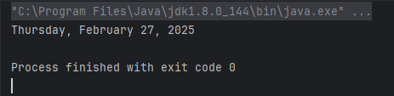

Q6.



Code:

|  |
| --- |
| **package Q6;  import javax.swing.*; import java.util.Scanner;  public class Main_Q6 {  public static void main(String[] args) {  int Width;  int Height;  String Title;   Scanner NewScanner = new Scanner(System.*in*);   System.*out*.println("Enter Width : ");  Width = NewScanner.nextInt();   System.*out*.println("Enter Height : ");  Height = NewScanner.nextInt();   NewScanner.nextLine();   System.*out*.println("Enter Title : ");  Title = NewScanner.nextLine();   JFrame NewWindow = new JFrame();  NewWindow.setSize(Width,Height);  NewWindow.setTitle(Title);  NewWindow.setVisible(true);  } }** |

Output (Console ):

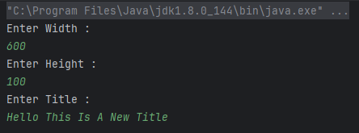

Output (Window ):

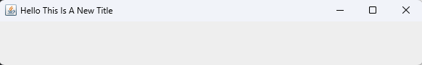

Q7.



Code:

|  |
| --- |
| **package Q7;  import java.text.SimpleDateFormat; import java.util.Date;  public class Main_Q7 {  public static void main(String[] args) {  Date CurrentDate = new Date();  SimpleDateFormat DateFormat = new SimpleDateFormat("hh:mm:ss a");  System.*out*.println(DateFormat.format(CurrentDate));  } }** |

Output (Console ):

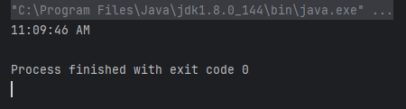

Q8.



Code:

|  |
| --- |
| **package Q8;  import java.util.Scanner;  public class Main_Q8 {  public static void main(String[] args) {  Scanner NewScanner = new Scanner(System.*in*);  System.*out*.println("Enter Phrase : ");  String UserInput = NewScanner.nextLine();  String[] Parts = UserInput.split("!");  System.*out*.println(Parts[0]);  System.*out*.println(Parts[1]);  } }** |

Output (Console ):

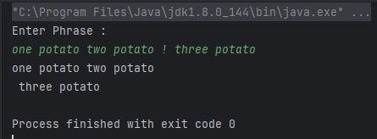

Q9.



Code:

|  |
| --- |
| **package Q9;  import java.util.Scanner;  public class Main_Q9 {  public static void main(String[] args) {  Scanner NewScanner = new Scanner(System.*in*);  System.*out*.println("Enter Phrase : ");  String UserInput = NewScanner.nextLine();   int InputLength = UserInput.length();  System.*out*.println(InputLength);  System.*out*.println(UserInput.charAt(0));  System.*out*.println(UserInput.charAt(InputLength-1));  } }** |

Output (Console ):

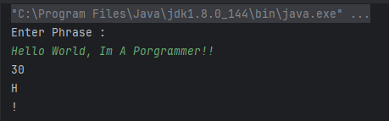

Q10.



Code:

|  |
| --- |
| **package Q10;  import java.util.Scanner;  public class Main_Q10 {  public static void main(String[] args) {  Scanner NewScanner = new Scanner(System.*in*);  String UserInput = NewScanner.next();  int InputLength = UserInput.length();  if (InputLength % 2 == 0) {  System.*out*.println("Error : Program Only Accepts Odd Length Words!");  return;  }   System.*out*.println(UserInput.charAt( (int)(InputLength/2)));  } }** |

Output (Console ):

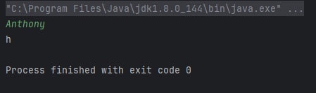

Q11.



Code:

|  |
| --- |
| **package Q11;  import java.util.Scanner;  public class Main_Q11 {  public static void main(String[] args) {  Scanner NewScanner = new Scanner(System.*in*);  System.*out*.println("Enter Your Name In Format (F M L) : ");  String UserName = NewScanner.nextLine();   String[] NameParts = UserName.split(" ");   System.*out*.println(NameParts[2] + " " + NameParts[0] + " " + NameParts[1].charAt(0) + ".");  } }** |

Output (Console ):

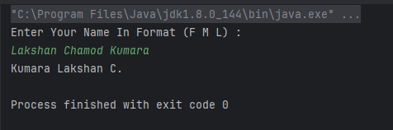

Q12.



Code:

|  |
| --- |
| **package Q12;  import javax.swing.*;  public class Main_Q12 {  public static void main(String[] args) {  JFrame NewWindow = new JFrame();  NewWindow.setTitle("My First Frame");  NewWindow.setSize(300,200);  NewWindow.setLocation(100,50);  NewWindow.setVisible(true);  } }** |

Output (Console ):

