Q1.

Code:

|  |
| --- |
| **package Q1; import java.lang.Math;//Didn't need to incude this but included anyway.  public class Main_Q1 {  public static void main(String[] args) {  //a.  double A = 2,B = 23,C = 2.5;  double AnswerA = Math.*pow*(B,2) + ( 4 * A * C);  System.*out*.println("Answer1 = " + AnswerA);   //b.  double X = 2,Y = 5;  double AnswerB = X + (4 * Math.*pow*(Y,3));  System.*out*.println("Answer2 = " + AnswerB);   //c.  double AnswerC = Math.*cbrt*(X * Y);  System.*out*.println("Answer3 = " + AnswerC);   //d.  double Radius = 2;  double AnswerD = Math.*PI* * Math.*pow*(Radius,2);  System.*out*.println("AnswerD = " + AnswerD);  } }** |

Output:

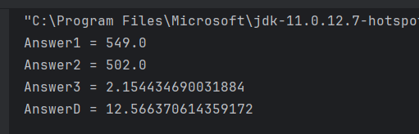

Q2.

Code:

|  |
| --- |
| **package Q2;  import java.util.Scanner;  public class Main_Q2 {   public static void main(String[] args) {  Scanner sc = new Scanner(System.*in*);  System.*out*.println("Enter the Centimeter value: ");  double Centimeters = sc.nextDouble();  double Feet = Centimeters / 30.48;  double Inches = Centimeters / 2.54;  System.*out*.println("Centimeters in Inches: " + Inches);  System.*out*.println("Centimeters in Feet: " + Feet);  } }** |

Output:

Q3.

Code:

|  |
| --- |
| **package Q3;  import java.util.Scanner;  public class Main_Q3 {  public static void main(String[] args) {  Scanner sc = new Scanner(System.*in*);  System.*out*.println("Enter the Celsius value: ");  double Celsius = sc.nextDouble();  double Fahrenheit = (Celsius * 1.8) + 32;  System.*out*.println("Fahrenheit: " + Fahrenheit);  } }** |

Output:

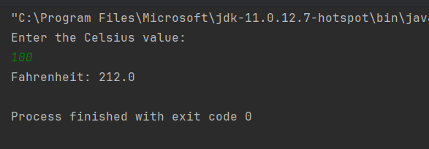

Q4.

Code:

|  |
| --- |
| **package Q4;**  **import java.util.Scanner;**  **public class Main_Q4 {**  **public static void main(String[] args) {**  **Scanner sc = new Scanner(System.in);**  **System.out.println("Enter The Weight In Pounds: ");**  **double Weight = sc.nextDouble();**  **double Calories = Weight * 19;**  **sc.close();**  **System.out.println("Calories Need : " + Calories);**  **}**  **}** |

Output:

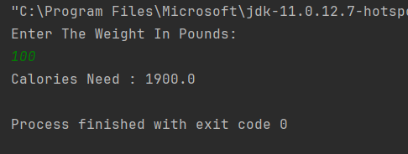

Q5.

Code:

|  |
| --- |
| **package Q5;  import java.util.Scanner;  public class Main_Q5 {  public static void main(String[] args) {  Scanner sc = new Scanner(System.*in*);  System.*out*.println("Enter Fahrenheit: ");  double Fahrenheit = sc.nextDouble();  double Celsius = (Fahrenheit - 32) * 5 / 9;  System.*out*.println("Celsius: " + Celsius);  } }** |

Output:

Q6.

Code:

|  |
| --- |
| **package Q6;  import java.util.GregorianCalendar; import java.util.Scanner;  public class Main_Q6 {  public static void main(String[] args) {  Scanner sc = new Scanner(System.*in*);  GregorianCalendar Calendar = new GregorianCalendar();  System.*out*.println("Enter Born Year : ");  int BornYear = sc.nextInt();  int Age = Calendar.get(Calendar.*YEAR*) - BornYear;  System.*out*.println("Your Age is: " + Age);  } }** |

Output:

Q7.

Code:

|  |
| --- |
| **package Q7;  import java.util.Scanner;  public class Main_Q7 {  public static void main(String[] args) {  Scanner sc = new Scanner(System.*in*);  System.*out*.println("Enter Your Weight in kilograms: ");  double Weight = sc.nextDouble();  System.*out*.println("Enter Your Height in centimeters: ");  double Height = sc.nextDouble();  double BMI = Weight / Math.*pow*(Height/100.0, 2);  System.*out*.println("Your BMI is: " + BMI);  } }** |

Output:

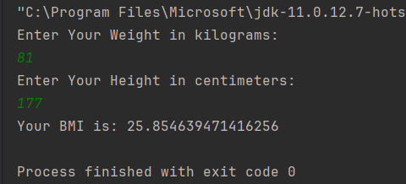

Q8.

Code:

|  |
| --- |
| **package Q8;  import java.util.Scanner;  public class Main_Q8 {  public static void main(String[] args) {  Scanner sc = new Scanner(System.*in*);  System.*out*.println("Enter Radius: ");  double Radius = sc.nextDouble();  double Volume = (4/3) * (Math.*PI* * Math.*pow*(Radius, 3));  System.*out*.println("Volume is: " + Volume);  } }** |

Output:

Q9.

Code:

|  |
| --- |
| **package Q9; import java.util.Scanner; import java.lang.Math;  public class Main_Q9 {  public static void main(String[] args) {  Scanner sc = new Scanner(System.*in*);  System.*out*.println("Enter Dollar Value : ");  double DollarValue = sc.nextDouble();  System.*out*.println("Enter Interest Rate Percent : ");  double InterestRatePercent = sc.nextDouble();  System.*out*.println("Enter Years : ");  int Years = sc.nextInt();  double MoneyEarned = DollarValue * Math.*pow*(1 + (InterestRatePercent / 100), Years);  System.*out*.println("Your Money earned is: " + MoneyEarned);  } }** |

Output:

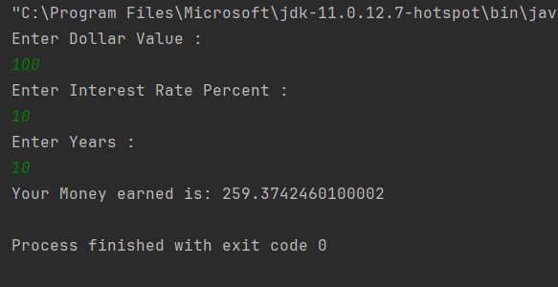

Q10.

Code:

|  |
| --- |
| **package Q10;  import java.util.Scanner;  public class Main_Q10 {  public static void main(String[] args) {  final int MONTHS_IN_YEAR = 12;   Scanner sc = new Scanner(System.*in*);  System.*out*.println("Enter The Loan Amount: ");  double loanAmount = sc.nextDouble();  System.*out*.println("Enter The Annual Interest Rate: ");  double annualInterestRate = sc.nextDouble();  System.*out*.println("Enter The Loan Period: ");  double loanPeriod = sc.nextDouble();   double monthlyInterestRate = annualInterestRate / 100.0/ MONTHS_IN_YEAR;  double numberOfPayments = loanPeriod * MONTHS_IN_YEAR;  double monthlyPayment = (loanAmount * monthlyInterestRate) / (1 -  Math.*pow*(1/(1 + monthlyInterestRate),numberOfPayments));  double totalPayments = monthlyPayment * numberOfPayments;   System.*out*.println("Monthly payment is: " + monthlyPayment);  System.*out*.println("Total Payments: " + totalPayments);  } }** |

Output:

