Q1

Code:

|  |
| --- |
| package Q1; import java.util.Scanner;  public class Q1_Main {  public static void main(String[] args) {  int min = 0;  Scanner scanner = new Scanner(System.in);  for(int i = 0;i<3;i++)  {  System.out.println("Enter Number " + (i+1) + " : " );  int input = scanner.nextInt();   if(i == 0) {min = input; continue;};  if (min > input) min = input;  }  System.out.println("Min Number Is " + min);  } } |

Output:

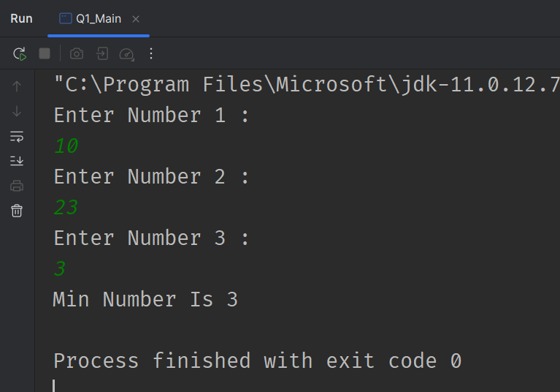

Q2

Code:

|  |
| --- |
| package Q2; import java.util.Scanner;  public class Q2_Main {  public static void main(String[] args) {  Scanner scanner = new Scanner(System.in);  System.out.println("0.Magenta");  System.out.println("1.Cyan");  System.out.println("2.Red");  System.out.println("3.Blue");  System.out.println("4.Green");  System.out.println("Select one color from the above list:");  int selection = scanner.nextInt();   switch (selection)  {  case 0:  System.out.println("You selected Magenta");  break;  case 1:  System.out.println("You selected Cyan");  break;  case 2:  System.out.println("You selected Red");  break;  case 3:  System.out.println("You selected Blue");  break;  case 4:  System.out.println("You selected Green");  break;  default:  System.out.println("Invalid selection");  break;  }  } } |

Output:

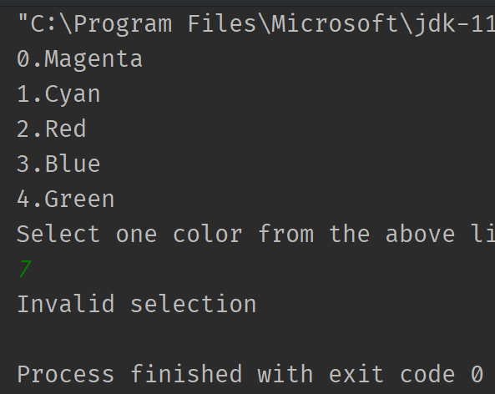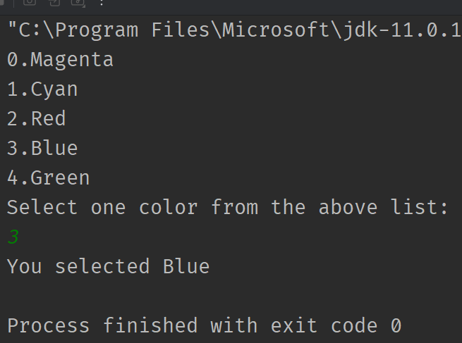

Q3

Code:

|  |
| --- |
| package Q3; import java.util.*;  public class Q3_Main {  public static void main(String[] args) {   HashMap<Integer,String> info = new HashMap<>();  info.put(6,"Million");  info.put(9,"Billion");  info.put(12,"Trillion");  info.put(15,"Quadrillion");  info.put(18,"Quintillion");  info.put(21,"Sextillion");  info.put(30,"Nonillion");  info.put(100,"Googol");   Scanner scanner = new Scanner(System.in);  System.out.println("Enter Power : ");  int inputPower = scanner.nextInt();  String message = "";  if(info.containsKey(inputPower))  message = info.get(inputPower);  else  message = "No Common Word For 10^" + inputPower;   System.out.println(message);  } } |

Output: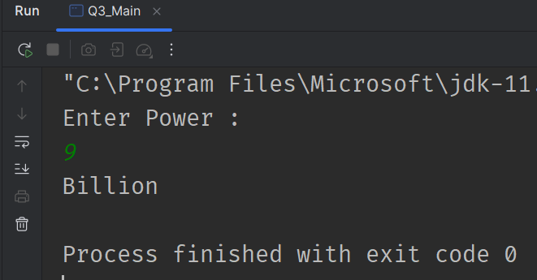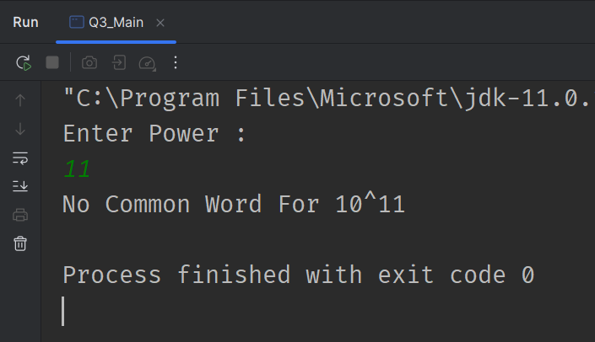

Q4

Code:

|  |
| --- |
| package Q4; import java.util.Scanner;  public class Q4_Main {  public static void main(String[] args) {  Scanner scanner = new Scanner(System.in);  System.out.println("Enter Target Year : ");  int year = scanner.nextInt();  boolean IsLeapYear = false;   IsLeapYear = ((year % 4 == 0) && (year % 100 != 0 || year % 400 == 0));  System.out.println(IsLeapYear ? "Leap Year": "Not a Leap Year");  } } |

Output: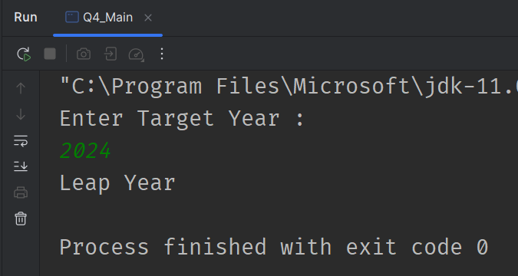

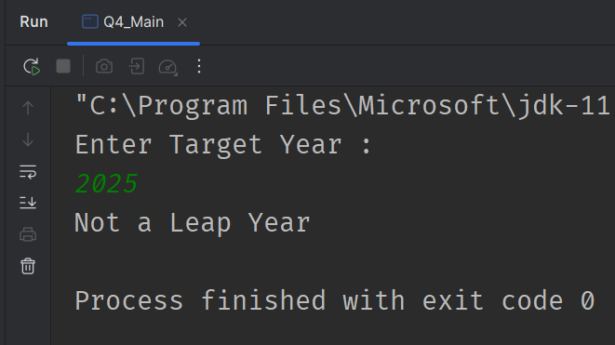

Q5

Code:

|  |
| --- |
| package Q5; import java.util.LinkedHashMap; import java.util.Scanner;  public class Q5_Main {  static void DisplayMenu(String menuName,LinkedHashMap<String, Float> list)  {  System.out.println("-------[" + menuName + "]-------");  list.forEach((itemName,price) -> {  System.out.println(itemName + " $" + price);  });  System.out.println("--------------------------------");  }   public static void main(String[] args)  {  LinkedHashMap<String,Float> EntreeList = new LinkedHashMap<>();  EntreeList.put("Tofu Burger", 3.49f);  EntreeList.put("Cajun Chicken", 4.59f);  EntreeList.put("Buffalo Wings", 3.99f);  EntreeList.put("Rainbow Fillet", 2.99f);   LinkedHashMap<String,Float> SideDishList = new LinkedHashMap<>();  SideDishList.put("Rice Cracker", 0.79f);  SideDishList.put("No-Salt Fries", 0.69f);  SideDishList.put("Zucchini", 1.09f);  SideDishList.put("Brown Rice", 0.59f);   LinkedHashMap<String,Float> DrinkList = new LinkedHashMap<>();  DrinkList.put("Cafe Mocha", 1.99f);  DrinkList.put("Cafe Latte", 1.90f);  DrinkList.put("Espresso", 2.49f);  DrinkList.put("Oolong Tea ", 0.99f);   Scanner scanner = new Scanner(System.in);  System.out.println("Choose Section ");  System.out.println("1) Entrees");  System.out.println("2) Side Dishes");  System.out.println("3) Drinks");   int selection = scanner.nextInt();  switch (selection)  {  case 1:  DisplayMenu("Entrees",EntreeList);  break;  case 2:  DisplayMenu("Side Dishes",SideDishList);  break;  case 3:  DisplayMenu("Drinks",DrinkList);  break;  default:  System.out.println("Invalid Selection!");  break;  }   } } |

Output:

