Q1

Code:

|  |
| --- |
| package Q1; public class Q1_Main {  public static void main(String[] args) {  int lineNumbers = 0;  for(int i = 10;i<50;i++)  {  System.out.print( (lineNumbers % 10 == 0 ? "\n" : "") + i + " ");  lineNumbers += 1;  }   } } |

Output: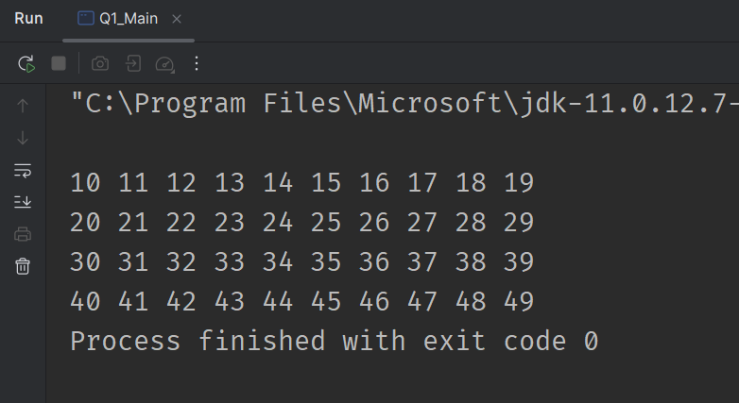

Q2

Code:

|  |
| --- |
| package Q2; import java.util.Scanner;  public class Q2_Main {  public static void main(String[] args)  {  Scanner scanner = new Scanner(System.in);  while (true)  {  System.out.print("Enter Number : ");  int inputNumber = scanner.nextInt();  if(inputNumber < 0)  break;   String numberString = Integer.toString(inputNumber);  System.out.println("Number Length Is : "+ numberString.length());  }  } } |

Output: 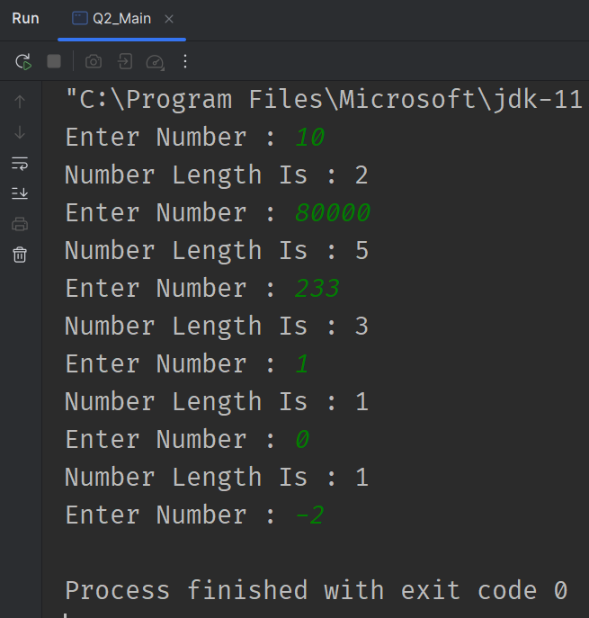

Q3

Code:

|  |
| --- |
| package Q3; import java.util.Scanner;  public class Q3_Main {  public static void main(String[] args) {  Scanner scanner = new Scanner(System.in);  System.out.println("Enter Number : ");  int number = scanner.nextInt();  for(int row = 0; row < 10; row++)  System.out.println(row == 0 ? "Multiplication Table Of "+ number : "(x"+row + ") " + (number * row));  } } |

Output:

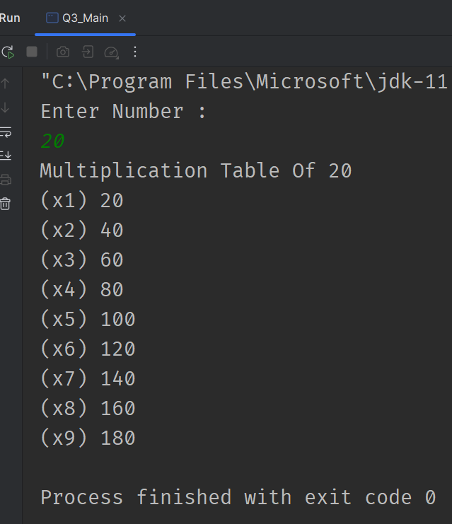

Q4

Code:

|  |
| --- |
| package Q4;  import java.util.Scanner;  public class Q4_Main {  public static void main(String[] args) {  Scanner scanner = new Scanner(System.in);  System.out.println("Enter Rows : ");  int inputRows = scanner.nextInt();  int Gaps = (inputRows - (inputRows % 2 == 0 ? 2 : 1));  while (Gaps != 0 - 2)  {  System.out.println(  new String(new char[Gaps/2]).replace("\0"," ")+  " " + new String(new char[(inputRows - Gaps)]).replace("\0","*") + " " +  new String(new char[Gaps/2]).replace("\0"," ")  );  Gaps -= 2;  }  } } |

Output: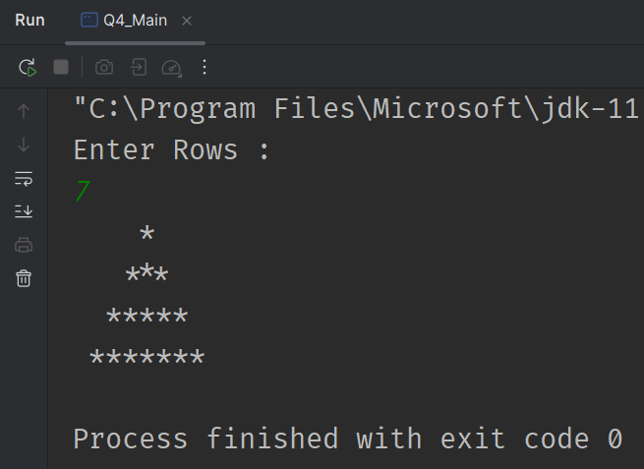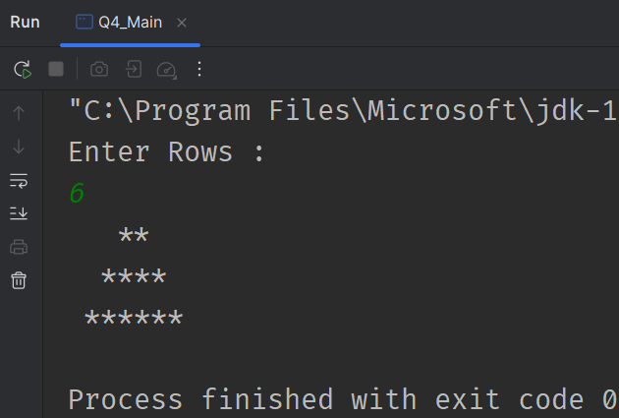

Q5

Code:

|  |
| --- |
| package Q5; import java.util.Scanner;  public class Q5_Main {  public static void main(String[] args) {  Scanner scanner = new Scanner(System.in);  System.out.println("Enter Phrase : ");  char[] phrase = scanner.nextLine().toCharArray();  boolean isPalindrome = true;  for(int front = 0,back = phrase.length - 1; front < phrase.length; front++,back--)  {  if(phrase[front] != phrase[back])  {  isPalindrome = false;  break;  }  }  System.out.println("Word Is " + (isPalindrome ? "" : "NOT ") + "Palindrome!");  } } |

Output:

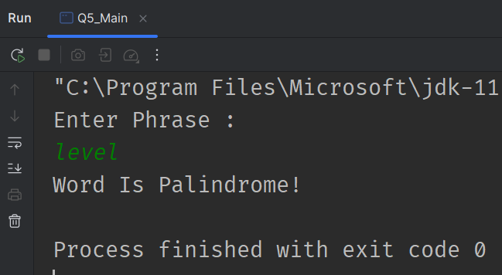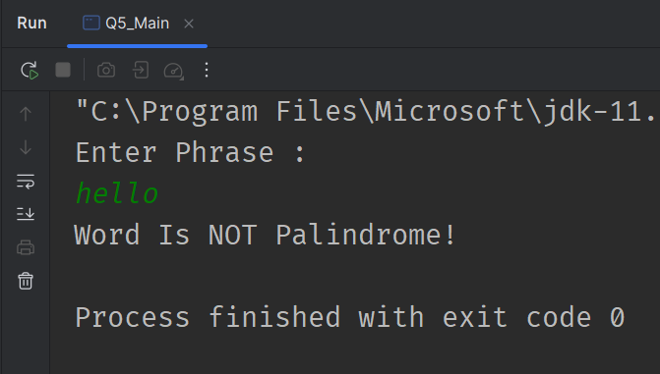

Q6

Code:

|  |
| --- |
| package Q6;  import java.util.Random; import java.util.Scanner;  public class Q6_Main {   public static void main(String[] args) {  Scanner scanner = new Scanner(System.in);  int userGuess = -1;  Random random = new Random();  int randomNumber = random.nextInt(100);  while(true)  {  System.out.println("Enter Your Guess : ");  userGuess = scanner.nextInt();  if(userGuess == randomNumber)  break;  System.out.println("Wrong.. Correct One Is " + ((userGuess < randomNumber) ? "Higher!" : "Lower!"));  }  System.out.println("Correct " + randomNumber + " Is The Correct Number!");  } } |

Output:

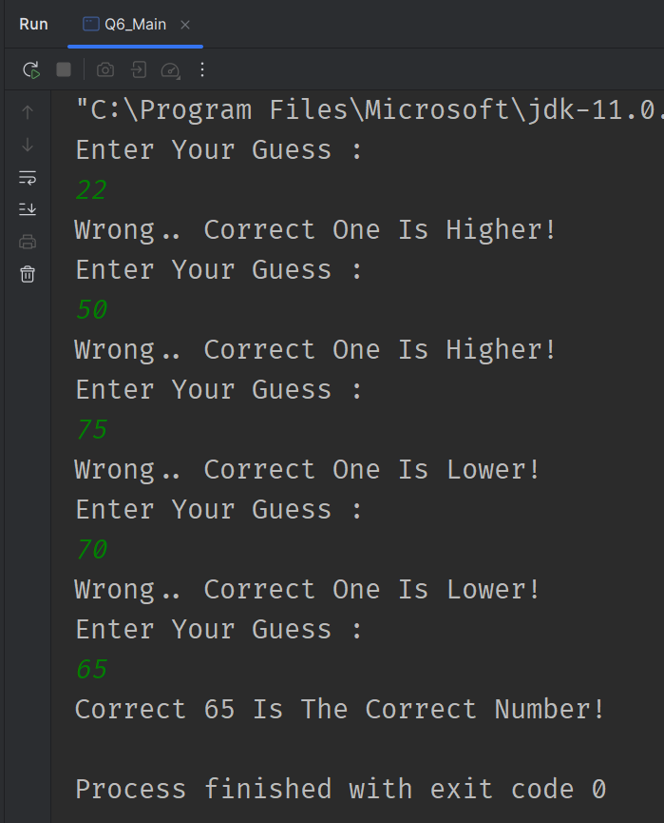

Q7

Code:

|  |
| --- |
| package Q7; import java.util.Scanner;  public class Q7_Main {  public static void main(String[] args) {  Scanner scanner = new Scanner(System.in);   System.out.println("Enter Phrase : ");  String phrase = scanner.nextLine();   System.out.println("Enter Target Word : ");  String target = scanner.nextLine();   System.out.println("Enter Replacement Word : ");  String replace = scanner.nextLine();   String output = phrase.replaceAll(target,replace);  System.out.println("Replaced Output Is ");  System.out.println(output);  } } |

Output:

