CSI 2132 [A] Deliverable One  
February 2nd, 2020

Paula Branco

University of Ottawa, Ontario, Canada

Abdullah Morrison ||300057314|| [amorr128@uottawa.ca](mailto:amorr128@uottawa.ca)   
Aiden Stevenson Bradwell || 300064655 || [abrad060@uottawa.ca](mailto:abrad060@uottawa.ca)

**Part One: E - R Diagram**

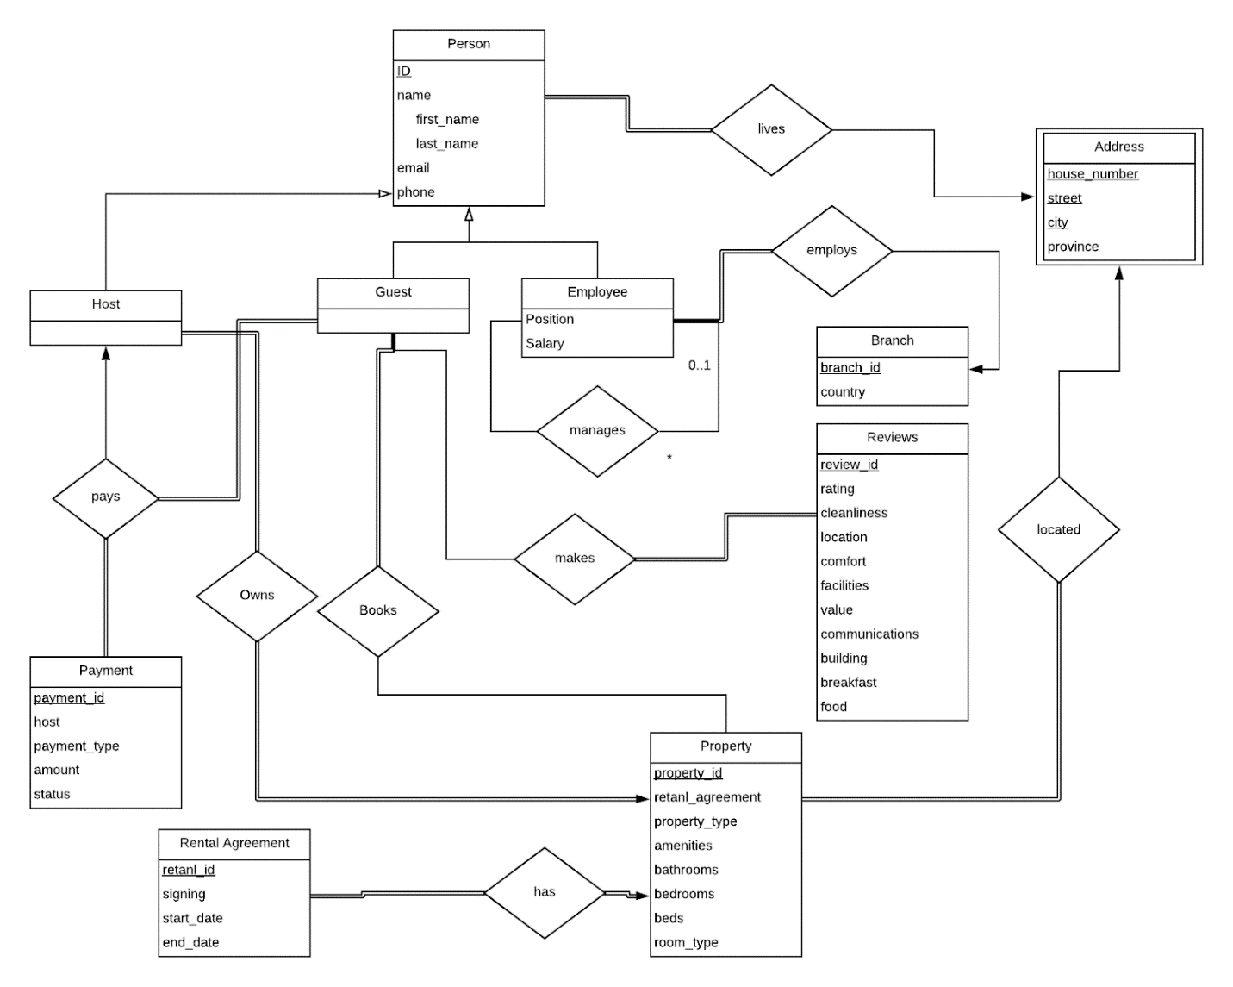

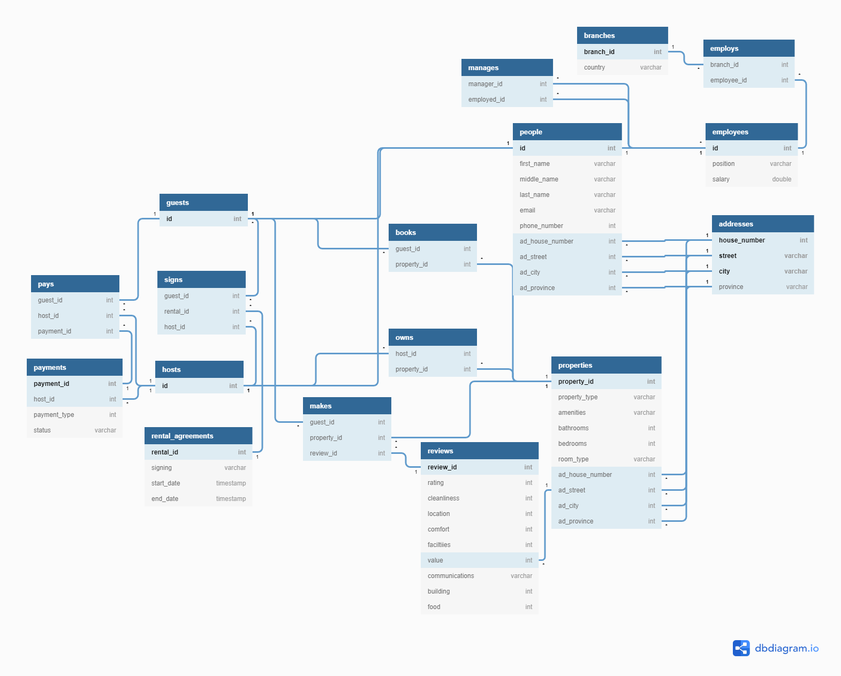**Part Two: Relational Schema**

**Part Three: Constraints**

 Person:

* Phone number must be 10 digits

Reviews:

* All ratings from 1-10, as during our research we saw this is the system which TravaGo uses

Property:

* Bathrooms must be >= 1
* Bedrooms >= 1
* Beds >= 1