**Fitness.com**

**Design Document**

Introduction

This document covers the main design issues in building the fitness.com website. This document will outline the user requirements and how by using sound interface design principles the website will be implemented to meet these requirements for the best user experience. Usability issues will also be a major factor in the design and as such this document also describes how such issues will be circumvented through the design process.

Objective

The objective of this website is to give the client an online presence where they can advertise and display their business in a more professional manner than the way in which they’re already doing via social media. This will include professional pictures of the gym, what they are about, class information, prices, relevant contact information including a map of their location and a link to their social media pages.

After consultation with our client we will aim to keep the simplistic approach to our design as is already used in their gym. We will also keep to the three main colours that are used throughout their gym.

Background Information

Fitness.com is a new website for a gym that has opened recently in Naas the company has a simplistic approach to fitness and training their clients and they want this to be reflected in the design of their website.

Target Audience

* Who is your target audience?
  1. Anyone hoping to find and use a "Fitness.com" strength and conditioning gym.
  2. Users that are already a client looking for new classes on offer
  3. As the user profiles used above are so broad the design of the site will reflect this as it will be designed for the mainstream.
  4. These users want to find this information as well as anything else that will make them believe that they are getting good value for their money, that there isn’t anything better out there and that they should stay with "Fitness" and not go elsewhere.

Website

The website allows users to see pictures of the gym, read about the gym and its owner, find out prices for the different classes, see contact information and a map of the gym’s location. This can be done by navigation through four pages, Home, Prices, About and Contact. A slider is located on the home page and displays three pictures in rotation.

Prototype and Testing

We created a working prototype after consultation with our client. This comprised of a basic website with only 3 pages. The layout was very basic and we only had one picture given to us by our client to use. After our next consultation we received more pictures and a better idea as to what our client really wanted. This led us to produce what you see now with the exception of the colour yellow. This was only introduced after we tested our website with five users using a talk out load test. We found that the original colour did not aid in viewing the site as our client originally thought. Other testing we carried out was to give the users tasks such as navigate from home to about to prices to home and many other variations of this navigation.

We also asked the users to find out specific information and asked them how easy they thought it was to find and with how many clicks.

**Storyboard**

|  |
| --- |
|  |
|  |

**Index.html(home Page)**

**Prices (memberships)**

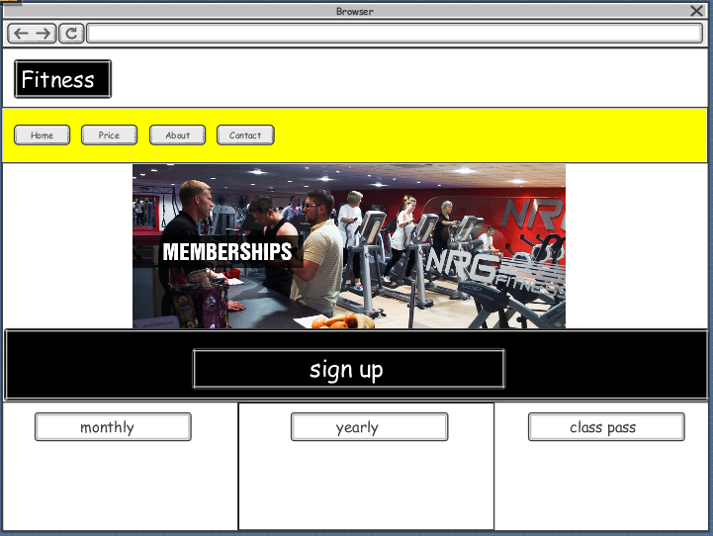

**Contact page**

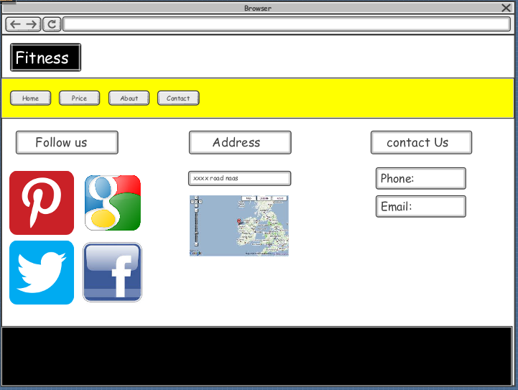

**About page**

