CSE 7320/5320
Assignment A5
Due Sunday Oct 6
Polynomial Basis Function Regression
The following code creates a polynomial model of degree 3 to predict values from an underlying sin curve model that has noise added using rng.rand() see line 8
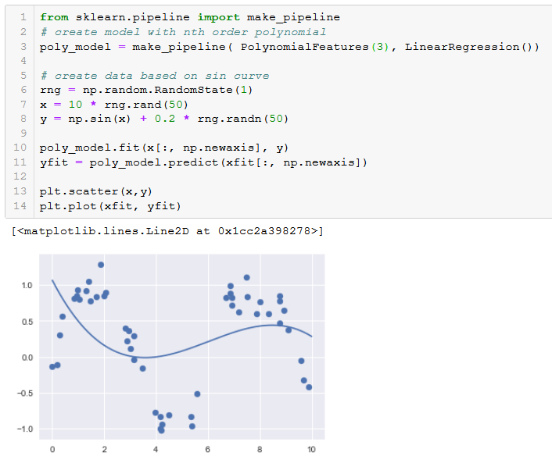
Experiment with different values of n (degree of polynomial) and show a combined scatter plot and line plot. Then, test your models with new random values of x using the same formula on line 8. This will be your test data set.
Make your case for which polynomial model produces the best fit using the testing data that is a balance between BIAS and Variance as outlined in the slide set handout on Bias and Variance.
Note: Given a model that overfits the data, we can use Lasso or Ridge Regression to compute a more balanced model between bias and variance. For this exercise, you will attempt to do this visually.

