Passenger Car Lubricants for Passenger Vehicles
Proof-of-concept DOCX with mixed content: narrative text, bullets, table, image, and sources

Overview
Passenger car motor oils are formulated to lubricate moving engine parts, manage heat, reduce wear, and help control sludge and deposits. Modern products are selected not just by viscosity, but also by performance standards such as API and ILSAC, along with specific OEM approvals.
- API identifies oils for gasoline vehicles with “S” service categories, while diesel heavy-duty oils use “C” categories.
- The API “Starburst” marks oils meeting current ILSAC GF-7A requirements, and the API “Shield” marks GF-7B oils for SAE 0W-16.
- SAE viscosity grades such as 0W-20 or 5W-30 indicate low-temperature flow and operating-temperature viscosity.
- Recent passenger-car categories emphasize LSPI protection, fuel economy, oxidation control, and timing-chain wear protection.
Why the category keeps evolving
The latest passenger-car specifications were updated to support modern turbocharged and direct-injection gasoline engines, which operate at higher thermal loads and are more sensitive to pre-ignition and deposit formation. Lower-viscosity grades can improve efficiency, but only when the oil still preserves film strength and engine protection.
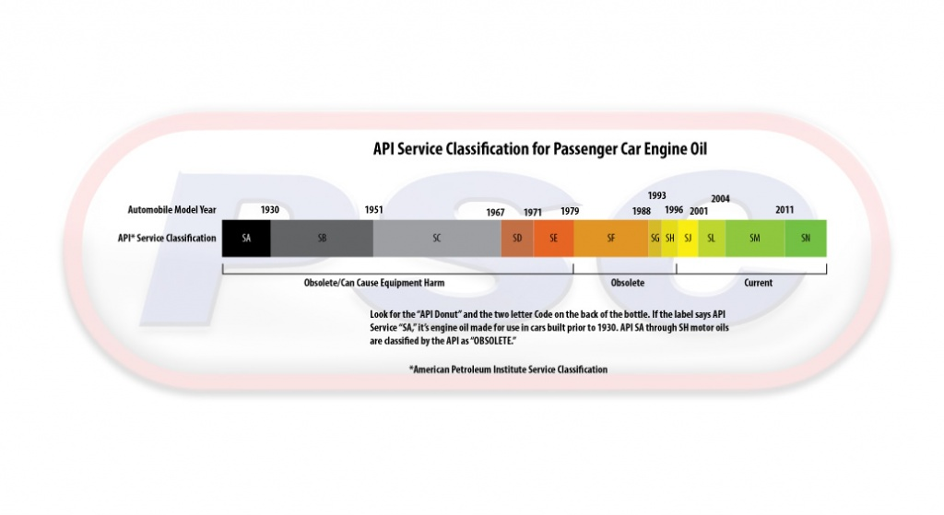
Quick reference table
Topic | Example / label | What it indicates | Practical implication
API passenger-car category | API SQ / “S” series | Gasoline-engine performance category | Use vehicle maker recommendation first
ILSAC fuel-economy category | GF-7A / GF-7B | Current passenger-car protection and fuel-economy standard | Helps identify oils intended for modern passenger vehicles
Certification mark | Starburst or Shield | Visible API certification mark on compliant oils | Quick screening signal for many North American passenger cars
Viscosity | 0W-20, 5W-30 | Cold-start flow plus operating-temperature thickness | Must match climate, engine design, and OEM guidance
Source notes
- American Petroleum Institute (Motor Oil Guide, 2025 update)
- API / MOTOR reporting on ILSAC GF-7A and GF-7B launch in March 2025
- ADDINOL overview of SAE viscosity grading and engine-oil specifications
- Chevron product data sheet for fully synthetic passenger-car motor oil
- Chevron Oronite summary of ILSAC GF-7 drivers and performance focus

