RFA Monitoring System
User Manual
DOLE Regional Office V · SEnA (Single Entry Approach)
This manual walks through the system in the order work actually happens: the Administrator imports the RFA records from a CSV file, a case is assigned to an Interviewer, the Interviewer records the interview, the case is assigned to a SEADO, the SEADO holds the conference and records the disposition, and everyone monitors deadlines and prints reports along the way.
Each step has a screenshot. A red arrow points to what you click or fill in; numbered labels (1, 2, 3 …) give the order. A red box marks a larger area to look at.
Note: The screenshots use sample records. Docket numbers, names and counts on your screen will differ.

Contents
Before you start 3
Who does what 3
The process at a glance 3
The five PCT checkpoints 3
1. Signing in 4
2. Importing the CSV file (Administrator) 5
2.1 Open CSV Import 5
2.2 Prepare the file 6
2.3 Upload 6
2.4 Check the result 7
3. Reviewing the records 9
3.1 Dashboard 9
3.2 RFA Listing 9
3.3 Open a case 10
4. Assigning the Interviewer 12
5. Recording the interview (Interviewer) 15
5.1 Open the assignment from the notification bell 15
5.2 Workflow Progress 15
5.3 Case Timeline 16
6. Assigning the SEADO 18
6.1 (Optional) Random draw 18
6.2 Assign the case 18
7. SEADO: completing missing intake dates 22
8. SEADO: recording the conference 24
My Conference Schedule 24
9. SEADO: recording the disposition 26
10. Monitoring deadlines (PCT) 28
10.1 Notifications & Audit 28
10.2 PCT Monitoring 29
10.3 Process Cycle Time 30
11. Reports 31
12. My Account and signing out 33
Troubleshooting 34

Before you start

Who does what
Your account has one role. The role decides which menu items and buttons you see.
Role | Main tasks in this manual | Sections
Administrator | Imports the CSV file, assigns Interviewers and SEADOs, runs PCT scans, manages users | 1–4, 6, 10–12
Interviewer | Receives assignments, records the interview, validation and turnover dates | 1, 5, 10–12
SEADO | Fills in missing intake dates, holds conferences, records the disposition | 1, 7–12
Viewer | Reads the dashboard, listing, PCT monitoring and reports | 1, 3, 10, 11

The process at a glance
- CSV Import — the Administrator uploads the RFA records.
- Review — the records appear on the Dashboard and in the Listing.
- Interviewer assignment — an Interviewer is assigned to the case.
- Interview — the Interviewer records the interview, validation and turnover dates.
- SEADO assignment — the case is assigned to a SEADO.
- Intake check — the SEADO completes any dates the import left blank.
- Conference — the SEADO records the 1st (and if needed 2nd) conference.
- Disposition — the SEADO records how the case was closed.
- Monitoring and reports — everyone tracks PCT deadlines and prints or exports reports.

The five PCT checkpoints
PCT (Prescribed Case Time) is the deadline for each step. The system counts working days (Monday to Friday, skipping holidays) and rates every step as Within, Nearing, On (deadline day — still on time) or Beyond PCT.
# | From → To | Limit
1 | Date Filed → Date Assigned to Interviewer | On-site: 1 day · Online: 2 days
2 | Date Assigned to Interviewer → Date Interviewed | 3 days
3 | Date Interviewed → Date Assigned to SEADO | 3 days
4 | Date Assigned to SEADO → 1st Conference | 10 days
5 | 1st Conference → Date Disposed | 30 days

1. Signing in
- Open the system address in your browser (for example http://127.0.0.1:8000).
- Type your Email and Password.
- Click Sign In.

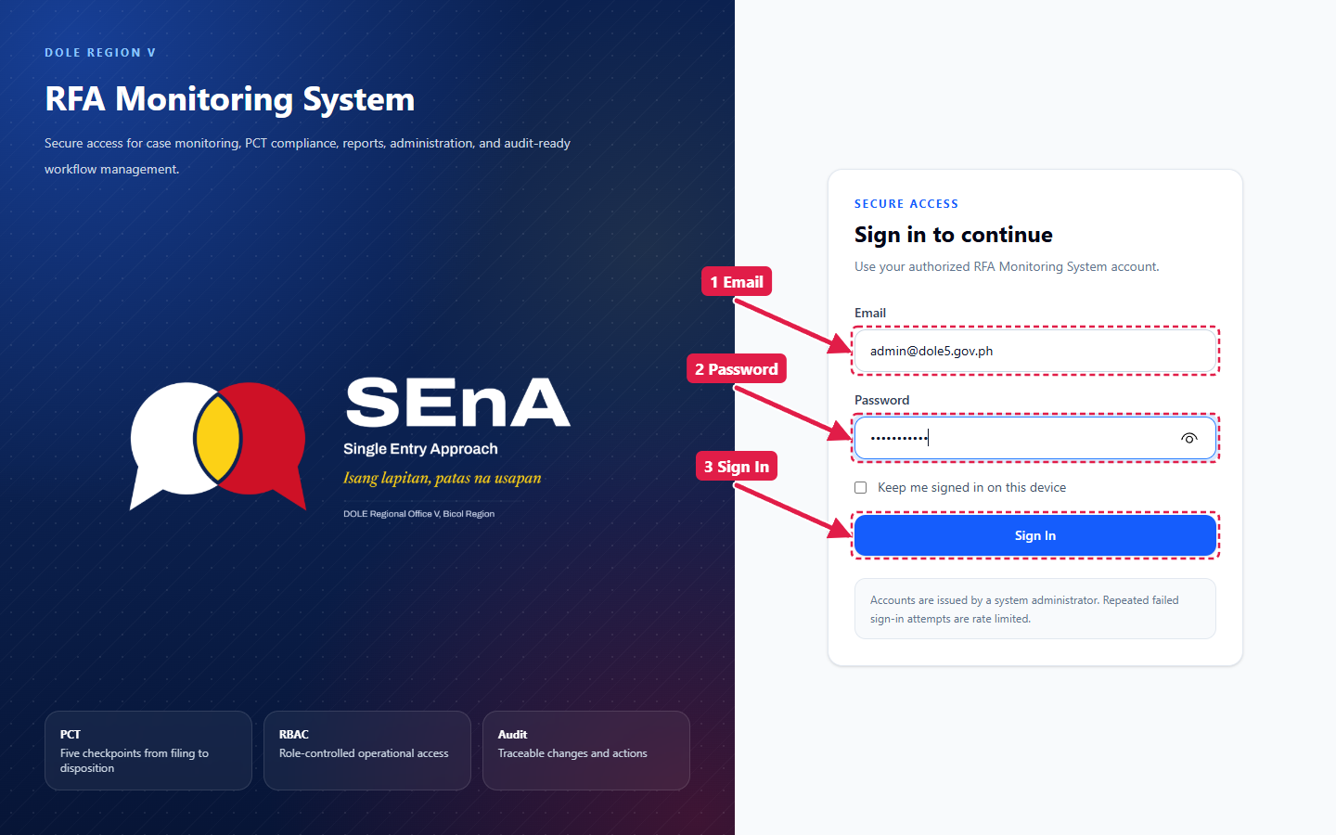
Figure 1. Sign-in page
Note: A new account, or one whose password was reset by the Administrator, is taken straight to My Account to set a new password. After five failed attempts, wait one minute before trying again.

2. Importing the CSV file (Administrator)
Only the Administrator sees CSV Import. The imported records are visible to every user who can view RFAs.

2.1 Open CSV Import
After signing in you land on the Dashboard. The main menu is on the left. Click CSV Import.
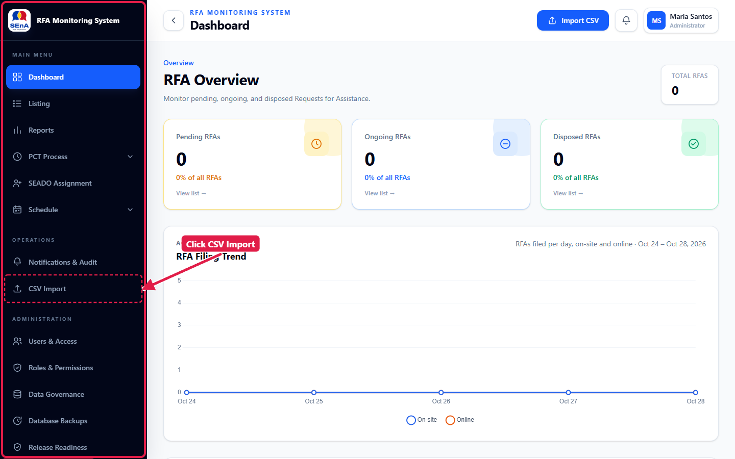
Figure 2. Dashboard before any import — click CSV Import in the left menu
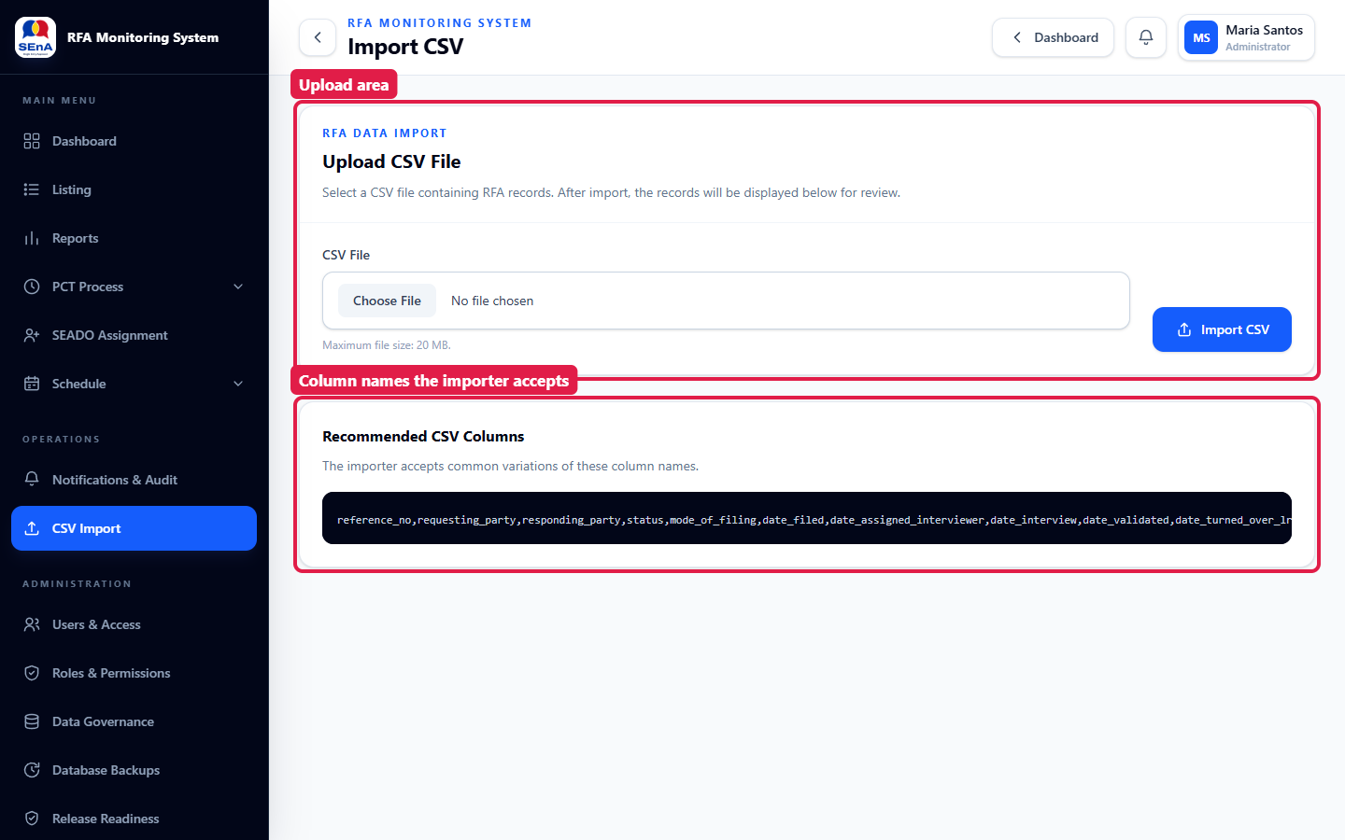
Figure 3. The Import CSV page: the upload area and the column names the importer accepts

2.2 Prepare the file
Save the spreadsheet as CSV (comma delimited). The first row must hold the column names. Columns the importer recognises include:
Information | Column name(s)
Office, docket | office, docket_no
Parties | requesting_party, responding_party, company_address, industry
Filing | mode_of_filing (Onsite / Online), date_filed, date_ta_nores
Interviewer stage | interviewer, date_assigned_interviewer, date_interview, date_validated, date_turned_over_lr
SEADO stage | seado, date_assigned_seado, date_initial_conference, date_both_parties_appeared
Closure | disposition_status, mode, date_disposed, monetary_benefit, workers_benefited
Status from the source sheet | case_status

Dates may be written as 2026-10-19, 10/19/2026 or Oct 19, 2026.

2.3 Upload
- Click Choose File and select the CSV file (maximum 20 MB).
- Click Import CSV.

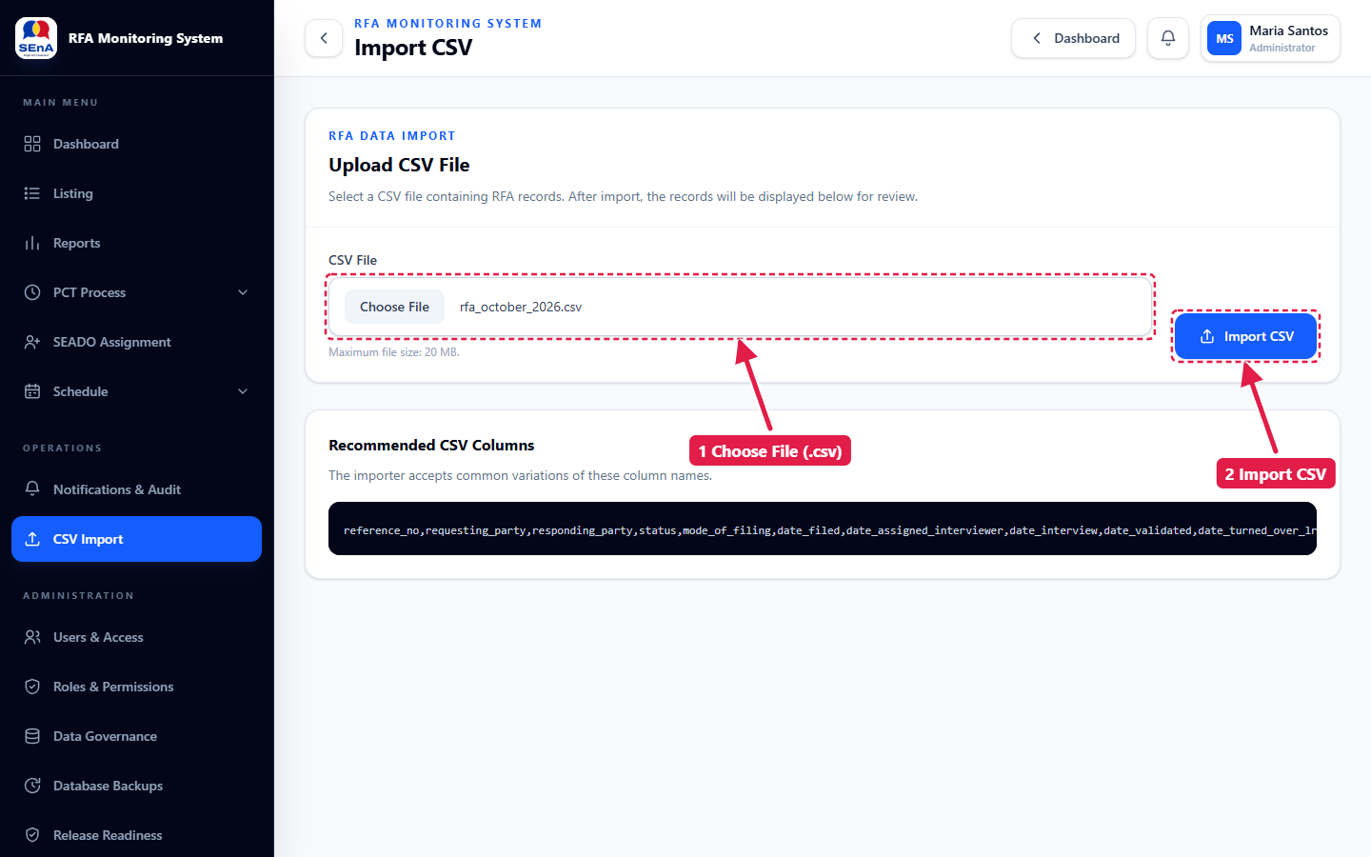
Figure 4. Choose the file, then click Import CSV

2.4 Check the result
A green message summarises the import: rows processed, records created, records updated and duplicate rows skipped. The Imported Records table below lists the records in this batch.
- Importing the same file again updates the existing records — it does not duplicate them.
- Identical rows inside one file are imported once and counted as "duplicate row(s) skipped".
- If anything goes wrong, nothing is saved and a red message explains why. Fix the file and import again.
- For an on-site filing, the system sets the interviewer assignment and interview dates to the filing date (on-site complainants are interviewed the same day).

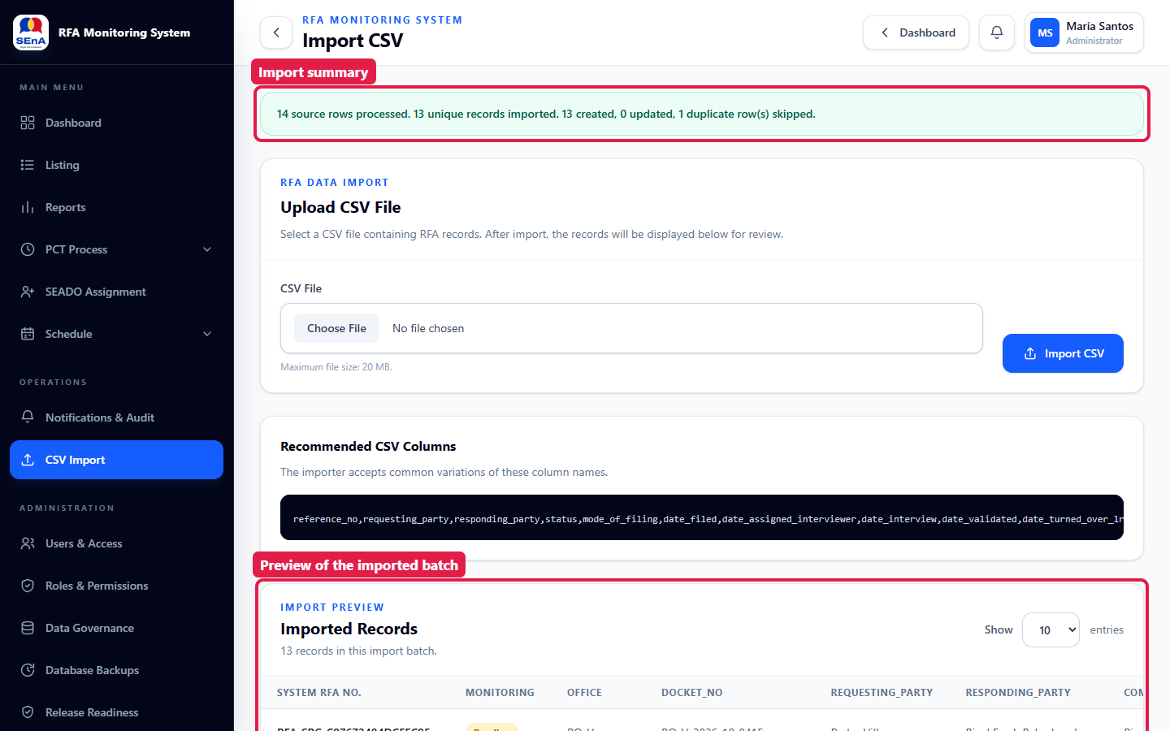
Figure 5. Import summary message and the preview of the batch
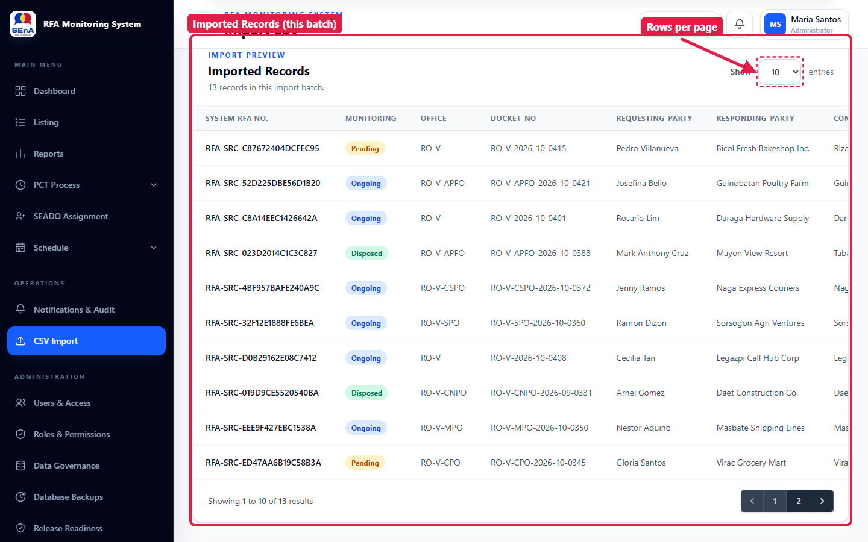
Figure 6. Imported Records — use Show … entries to change the rows per page

3. Reviewing the records

3.1 Dashboard
Click Dashboard in the left menu. The three status cards count Pending, Ongoing and Disposed RFAs; click a card to open the Listing filtered to that group. The RFA Filing Trend chart shows on-site and online filings over the last five days.
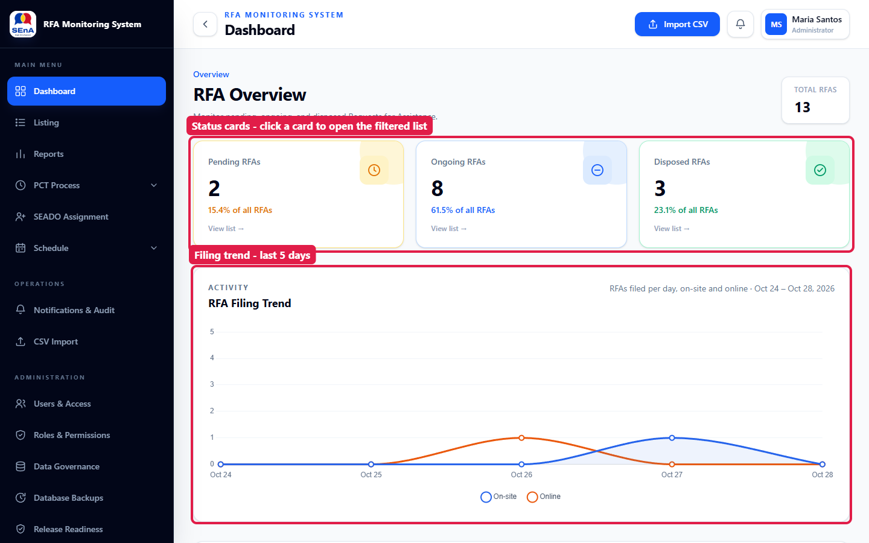
Figure 7. Dashboard after the import

3.2 RFA Listing
Click Listing in the left menu to see every record. Use Search & Filters to narrow the list by office, SEADO, monitoring group, workflow status, mode of filing, disposition or filing date, then click Apply Filters.
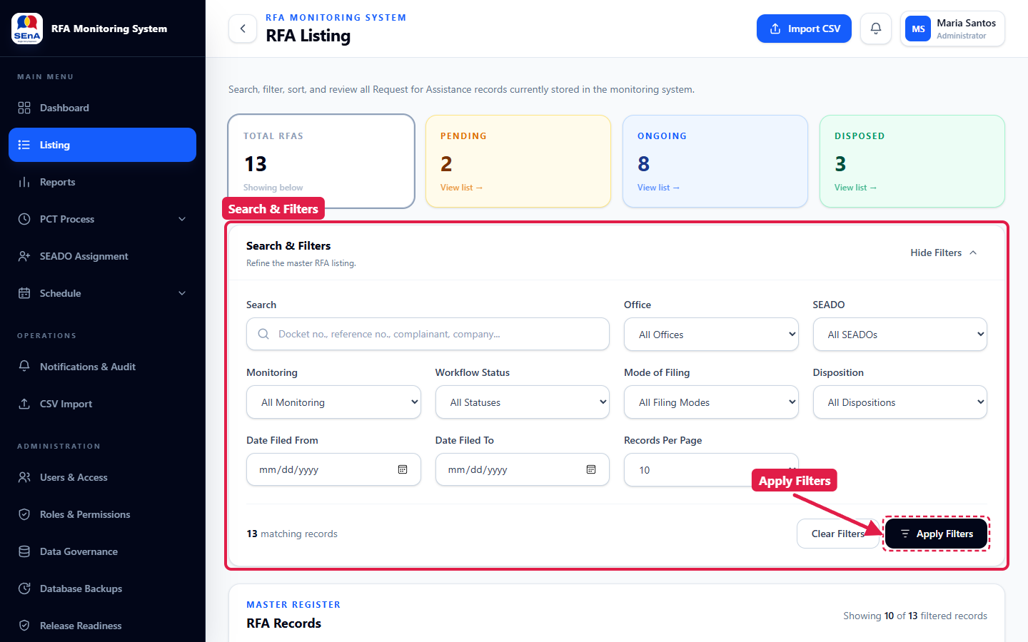
Figure 8. RFA Listing with the Search & Filters panel

3.3 Open a case
- Type the docket number, reference number, complainant or company in Search, then click Apply Filters.
- Click Open at the end of the row.

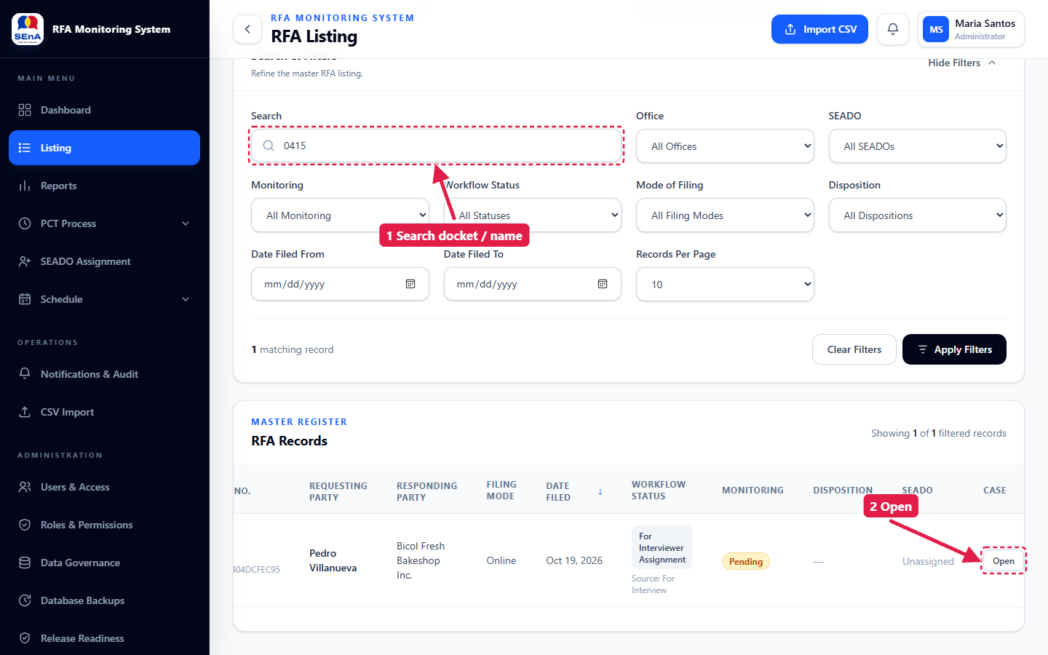
Figure 9. Search for the case, then click Open

4. Assigning the Interviewer
The case page shows the case header and the five PCT checkpoints at the top. Each section below it (Assignments, Workflow Progress, Conference, Disposition, Case Information) has its own Save button and saves on its own.
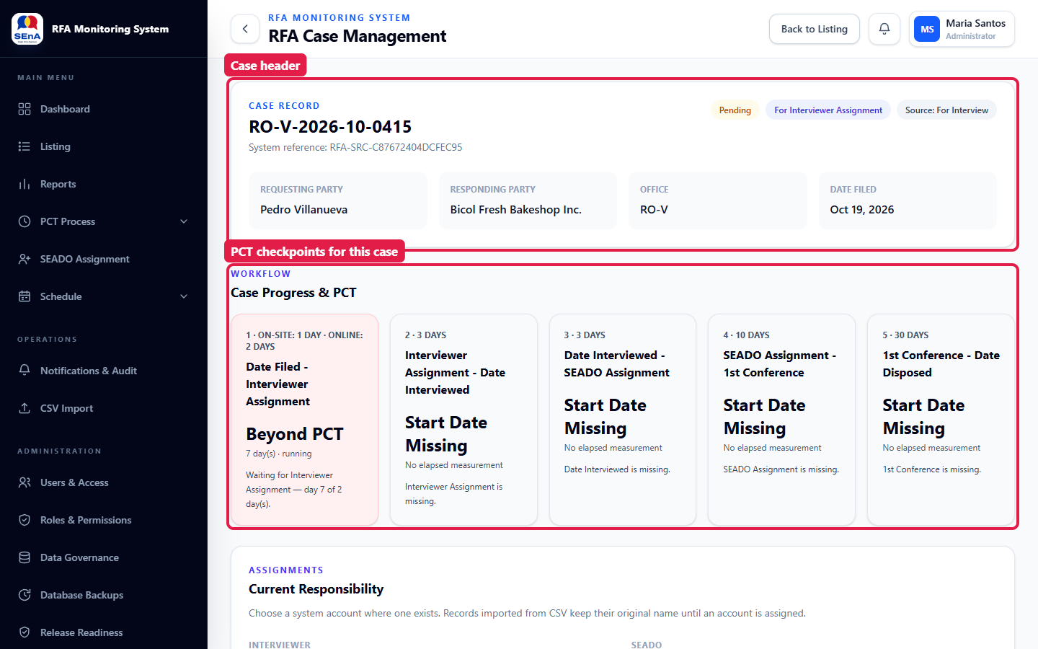
Figure 10. Case header and the PCT checkpoints for this case
Scroll to Assignments (Current Responsibility):
- Under Interviewer → System Account, choose the Interviewer.
- Enter the Date Assigned to Interviewer.
- Click Save Assignment.

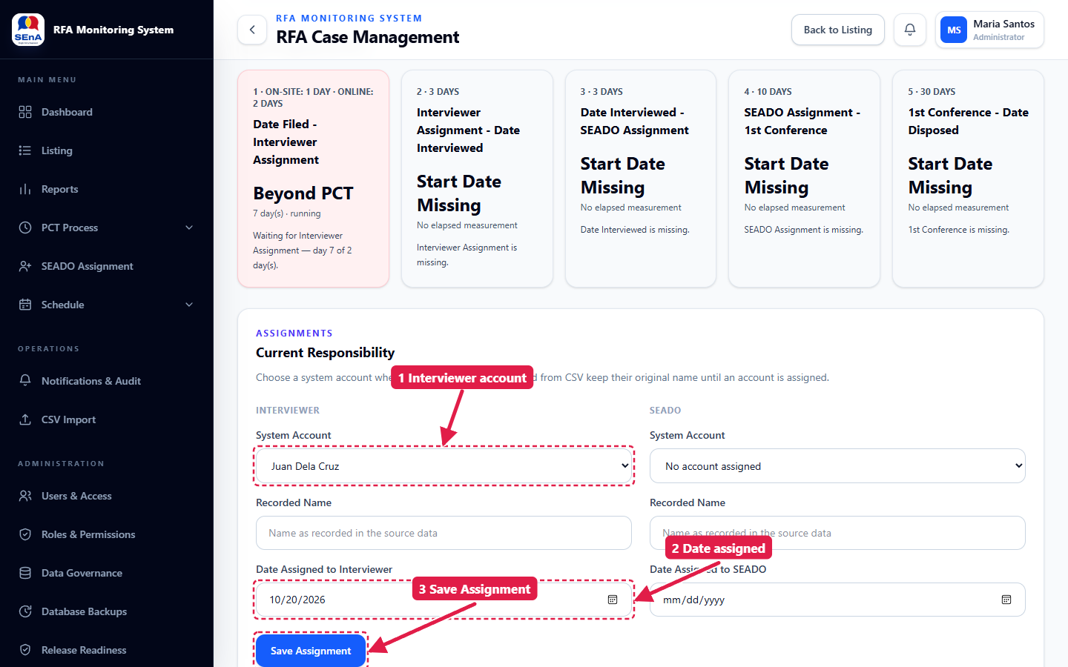
Figure 11. Assign the Interviewer and save
A green Success — Assignment saved message appears and checkpoint 1 is now completed. The Interviewer receives an in-app notification.
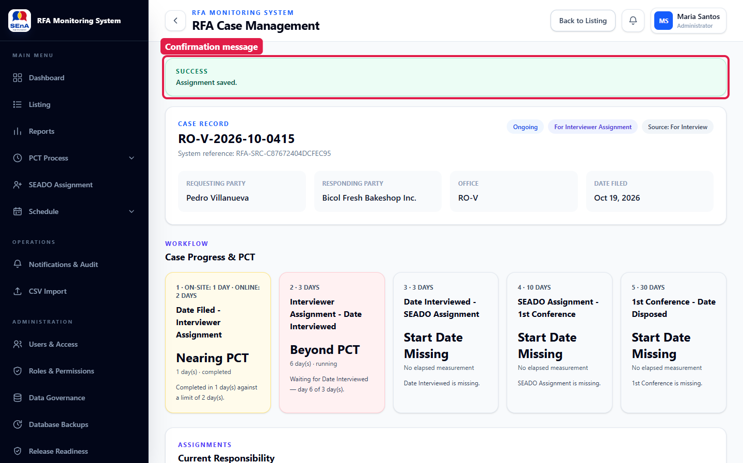
Figure 12. Assignment saved; the PCT checkpoints update immediately
Note: Choose a System Account whenever the person has one — that is what sends them notifications. Recorded Name keeps the name exactly as it came from the CSV.

5. Recording the interview (Interviewer)

5.1 Open the assignment from the notification bell
Sign in with your Interviewer account. A red dot on the bell (top right) means you have new alerts.
- Click the bell.
- Click the alert ("Assigned as Interviewer — …") to open the case.

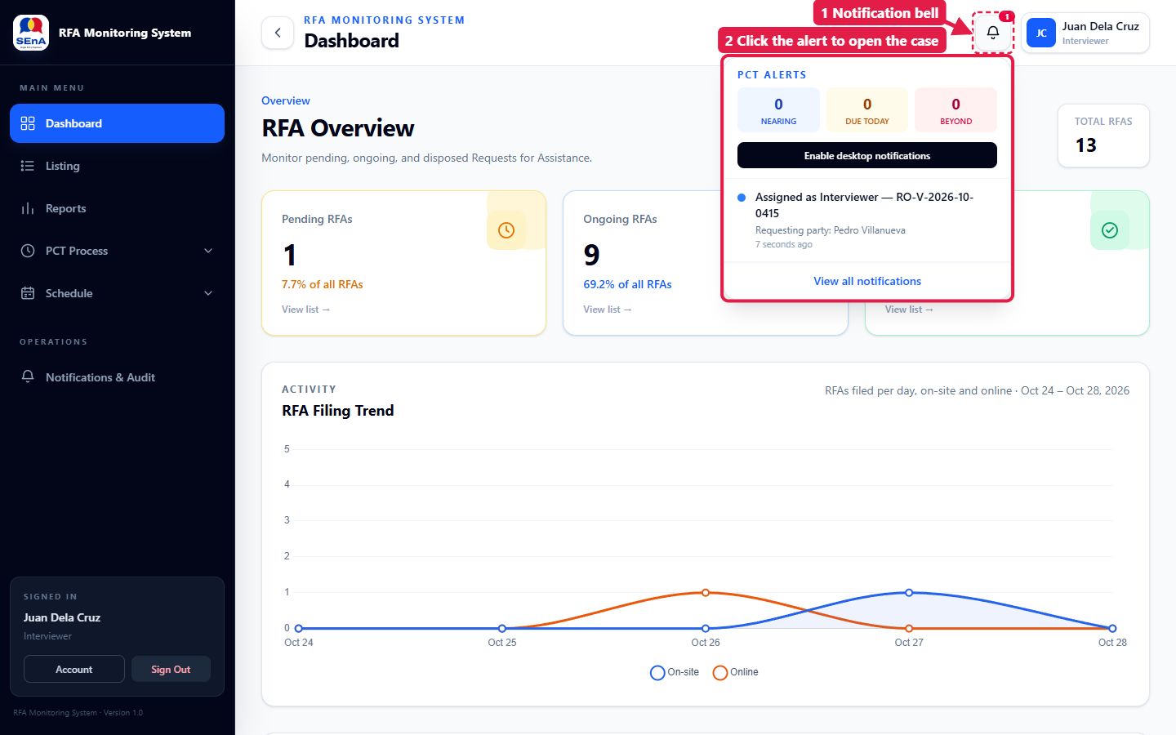
Figure 13. The notification bell lists your new assignment

5.2 Workflow Progress
Scroll to Workflow Progress:
- Set the Workflow Status (for example, For SEADO Assignment once the case is turned over).
- Enter the dates as they happen: Date TA/NORES, Date Interviewed, Date Validated and Date Turned Over to LR.
- Click Save Workflow Progress.

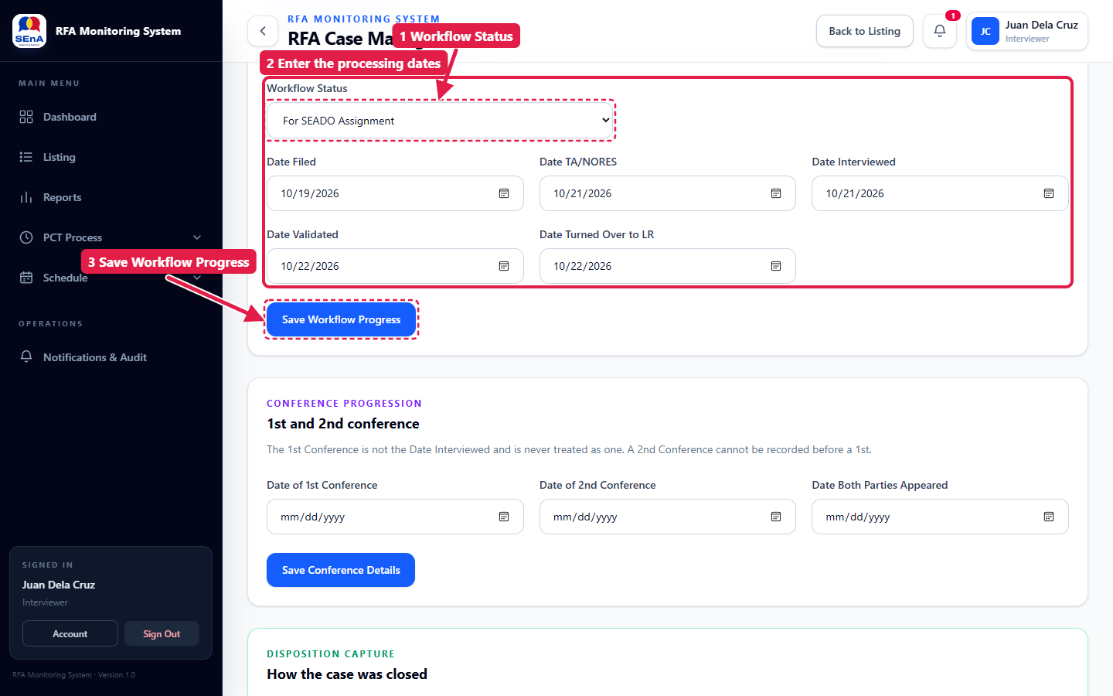
Figure 14. Enter the processing dates and save
Note: The system refuses dates that are out of order (for example, an interview before the assignment) or in the future, and the message names both dates. Correct the date and save again.

5.3 Case Timeline
Every save is recorded in the Case Timeline at the bottom of the case page — who changed what, and the old and new values. Use Add a note for anything the form does not capture.
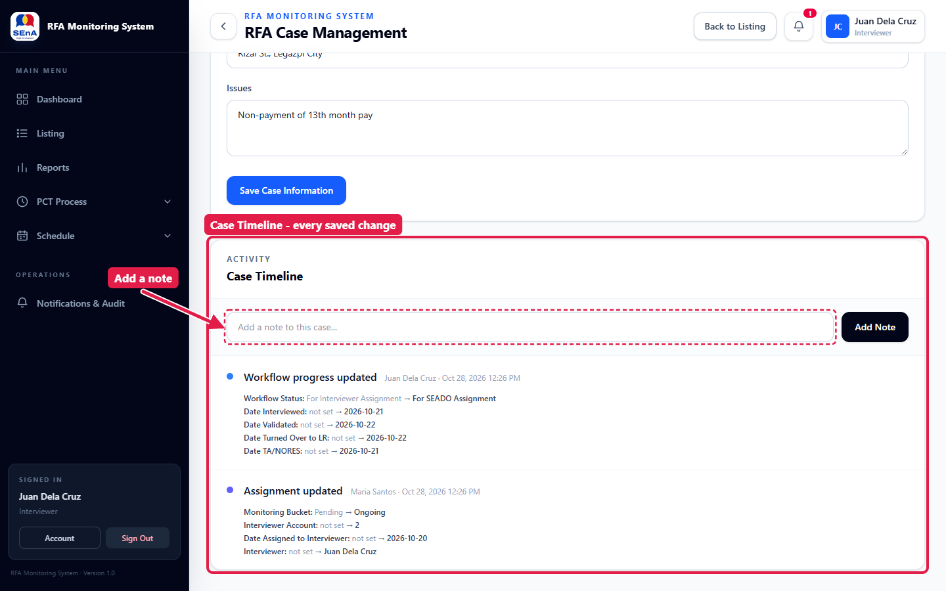
Figure 15. Case Timeline and the Add a note box

6. Assigning the SEADO
Users who can assign cases (Administrator, or a role with assignment rights) click SEADO Assignment in the left menu.

6.1 (Optional) Random draw
The Random SEADO Draw picks one SEADO at random from those who have handled the fewest RFAs. SEADOs on leave can be added to Excluded from the draw. The draw is a suggestion only — it does not assign anything.
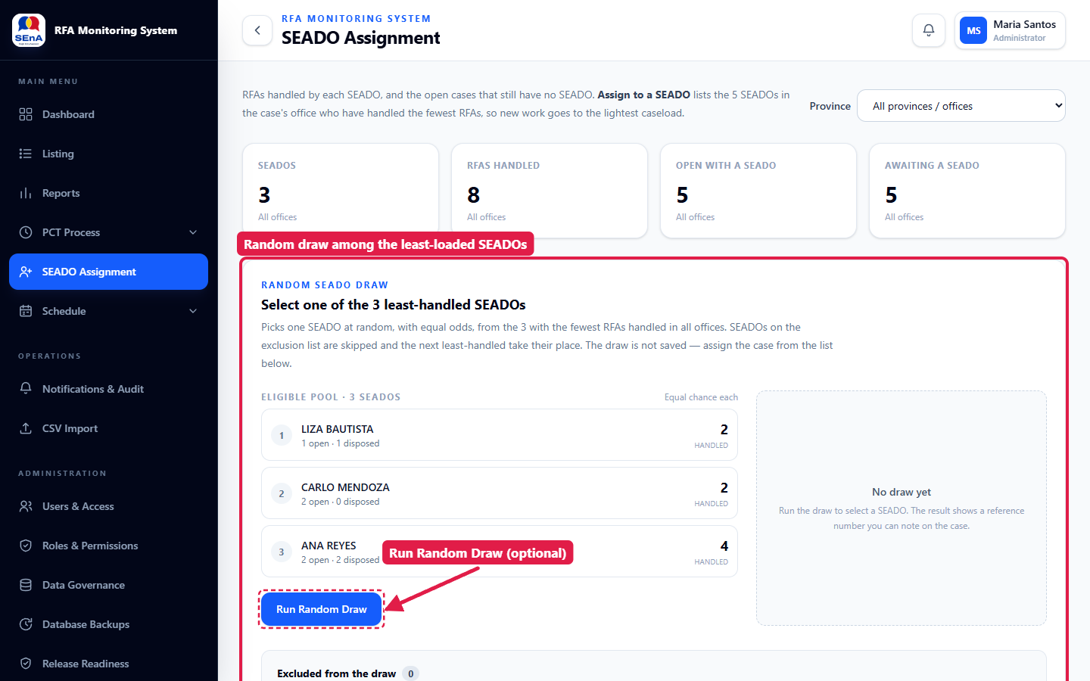
Figure 16. SEADO Assignment page and the random draw

6.2 Assign the case
Scroll to Open RFAs awaiting a SEADO and click Assign to a SEADO on the case row.
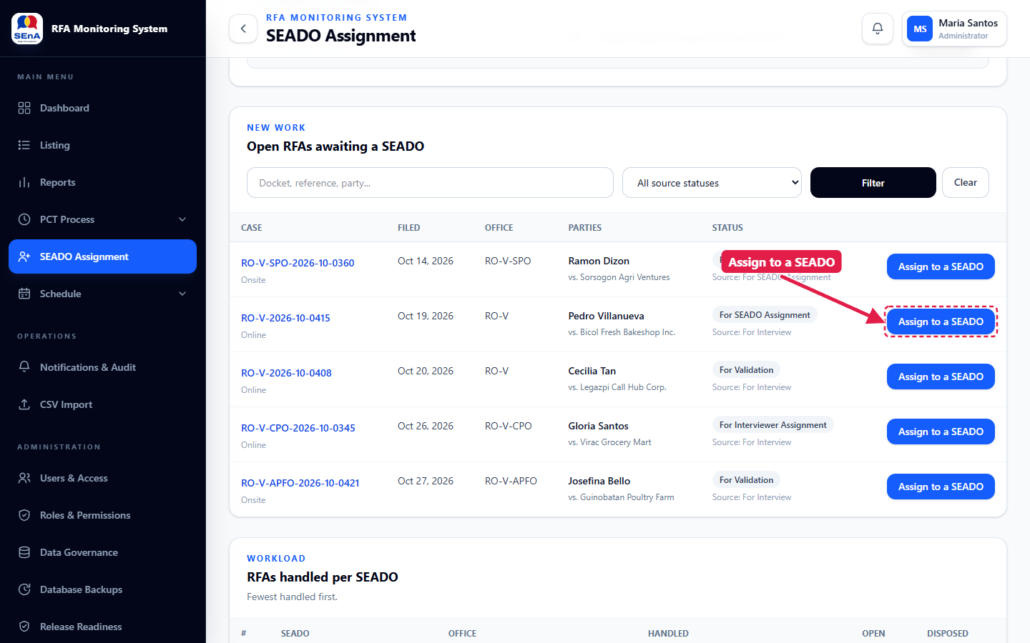
Figure 17. Click Assign to a SEADO on the case
- Choose the SEADO (the list shows the SEADOs with the lightest caseload in that office).
- Enter the Date assigned.
- Click Assign.

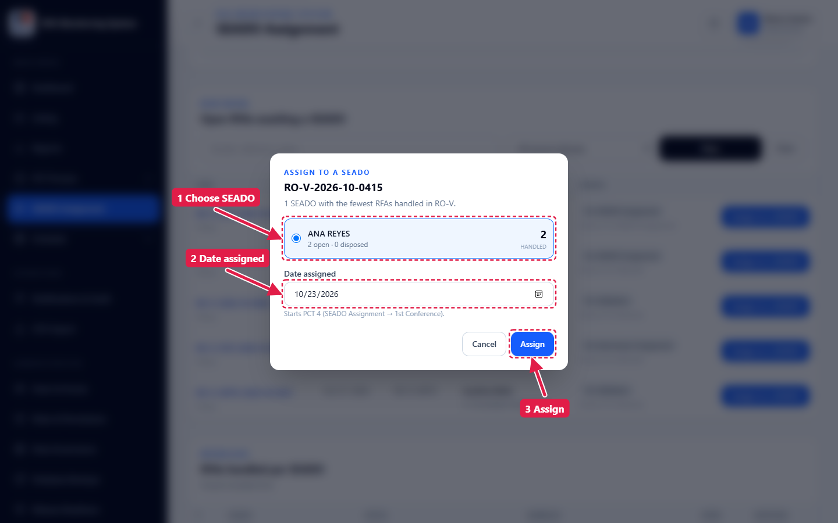
Figure 18. Choose the SEADO and the date, then click Assign
A green message confirms the assignment and the case leaves the waiting list. The SEADO receives a notification.
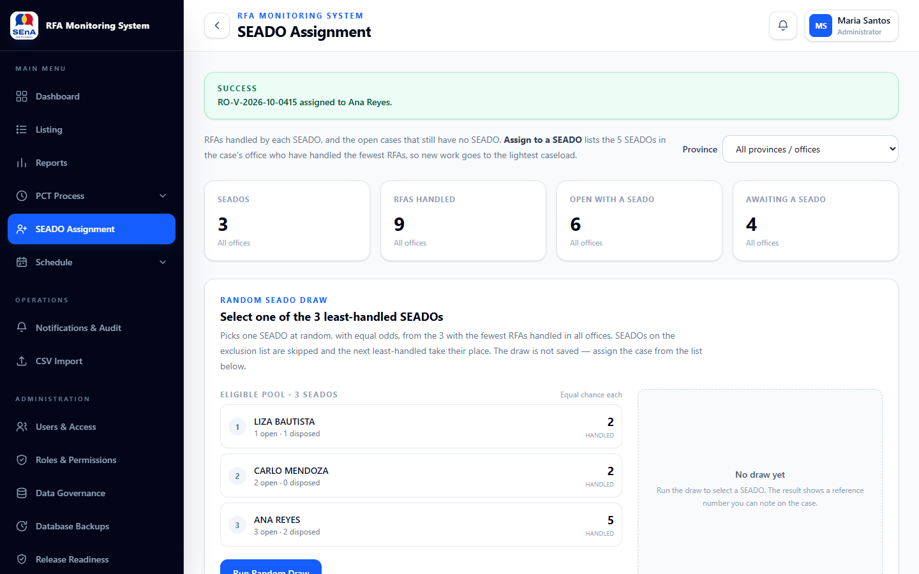
Figure 19. Assignment confirmed
Note: A SEADO can also be assigned or changed from the case page, in the Assignments section (Section 4).

7. SEADO: completing missing intake dates
When a SEADO signs in and one of their cases is missing the Date Interviewed or Date TA/NORES, a reminder appears at the bottom right of the screen.
- Click the case in the reminder to fix it now, or
- click the × to be reminded at your next sign-in.

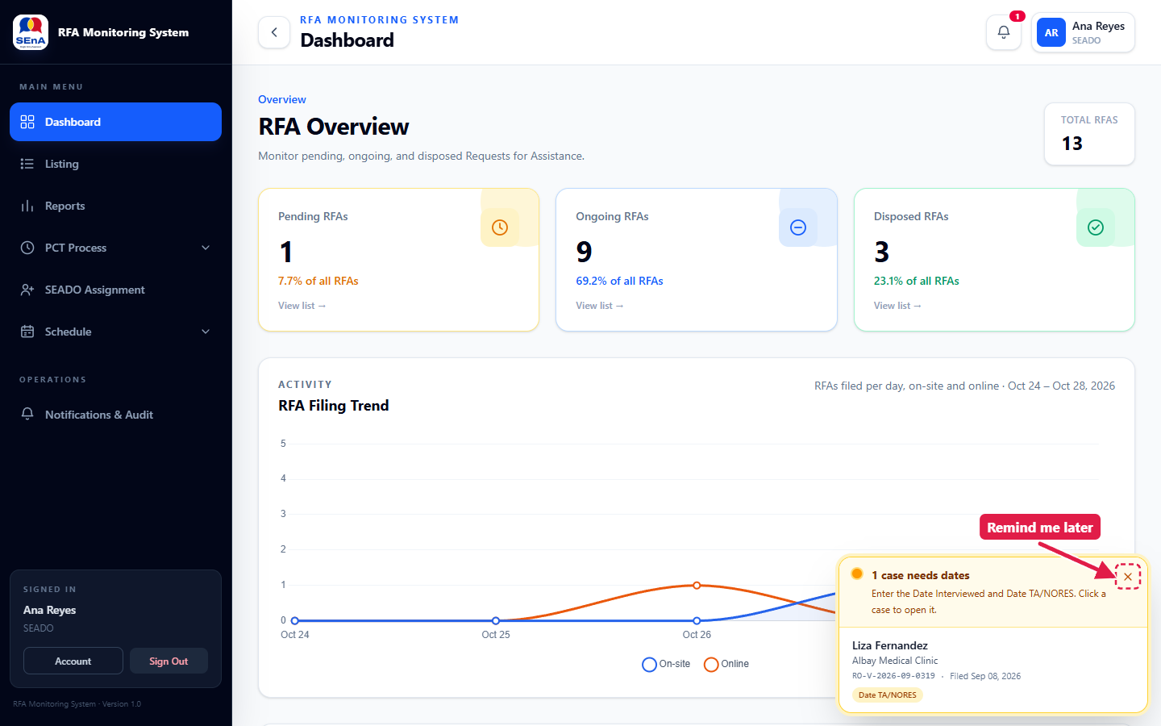
Figure 20. Reminder: a case needs its intake dates
Opening such a case shows a required form. Enter the missing dates and click Save Dates. The case page opens after the dates are saved.
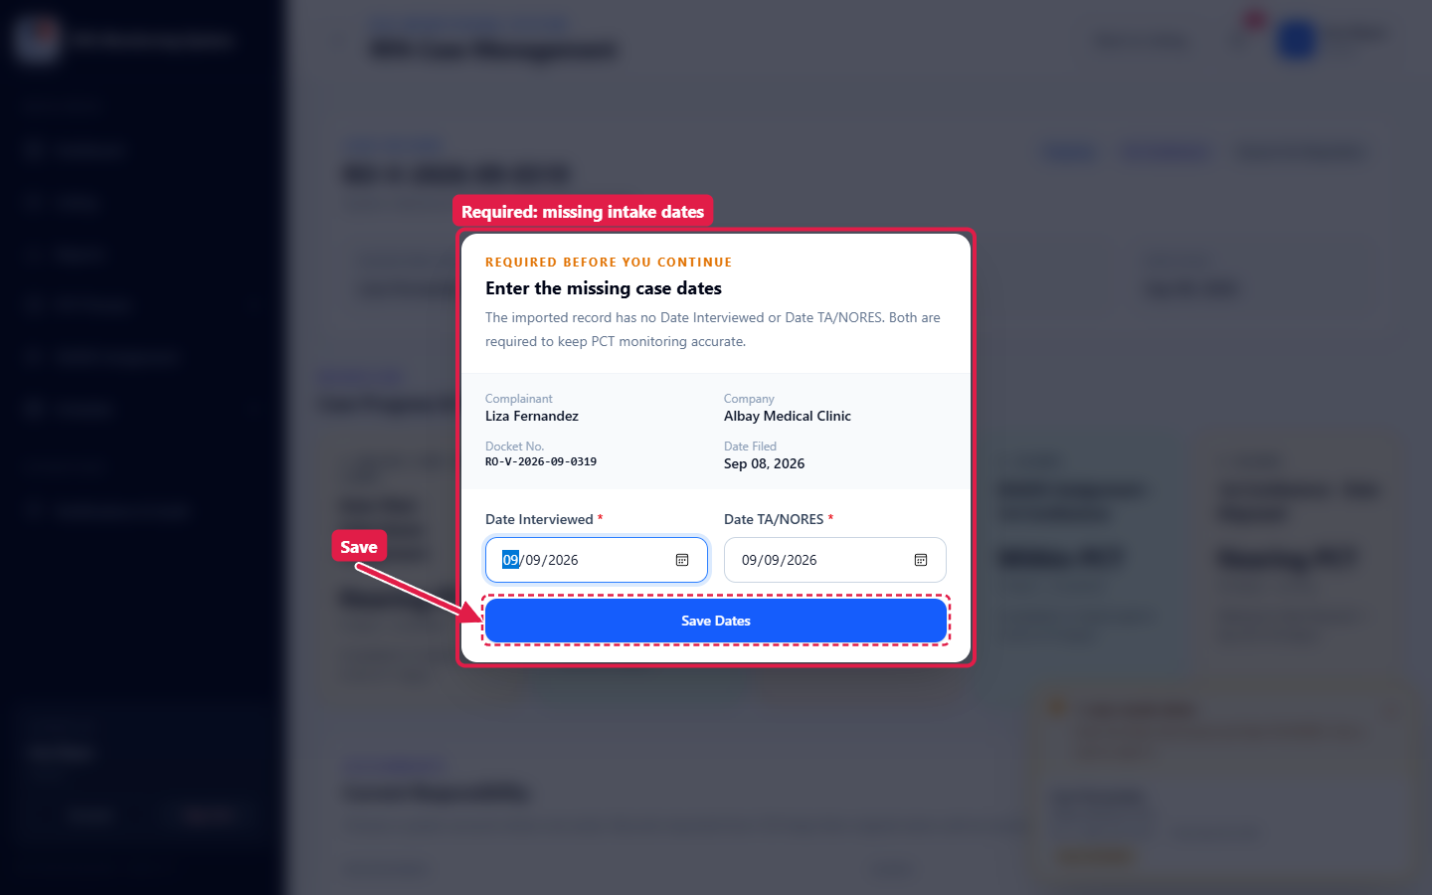
Figure 21. Required form for the missing intake dates
New assignments arrive in the bell, the same way as for Interviewers. Click the alert to open the case.
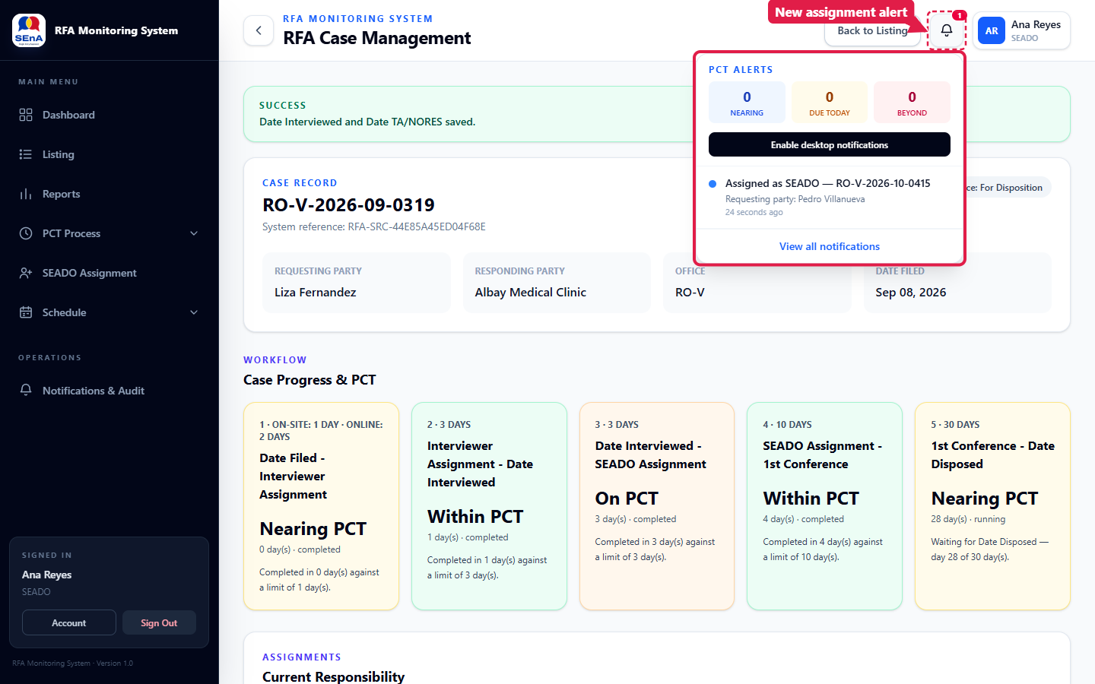
Figure 22. The SEADO's new assignment alert

8. SEADO: recording the conference
On the case page, scroll to Conference Progression:
- Enter the Date of 1st Conference. Add Date of 2nd Conference and Date Both Parties Appeared when they apply.
- Click Save Conference Details.

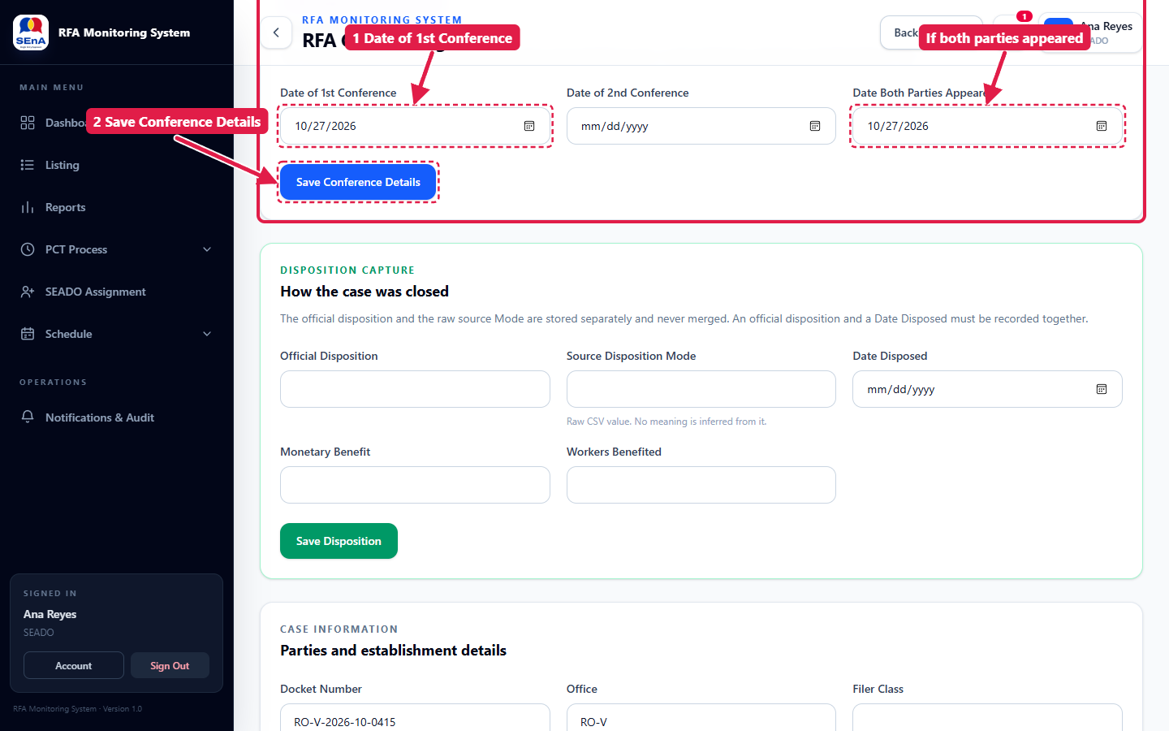
Figure 23. Conference Progression
Note: A 2nd conference cannot be saved without a 1st. The 1st conference is not the interview date.

My Conference Schedule
Click Schedule → My Conference Schedule in the left menu to see your conferences for the week. Use Previous, Next or the date box to move between weeks, and Open case to jump to a case.
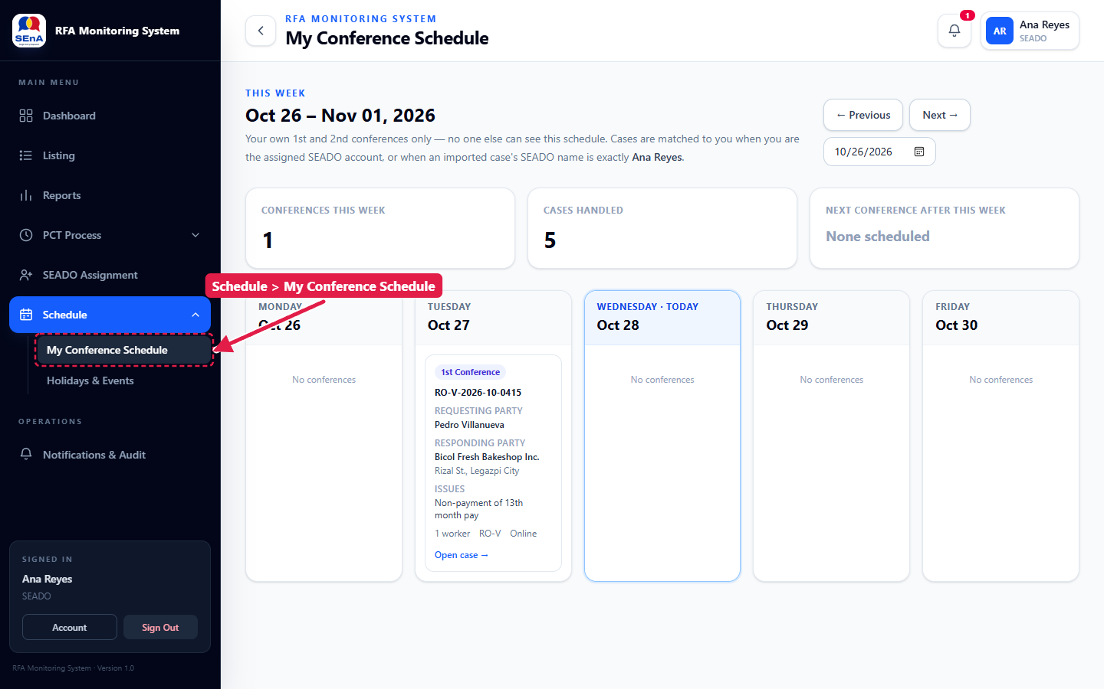
Figure 24. My Conference Schedule

9. SEADO: recording the disposition
On the case page, scroll to Disposition Capture:
- Enter the Official Disposition (for example, Settled).
- Enter the Date Disposed. Add Monetary Benefit and Workers Benefited if any.
- Click Save Disposition.

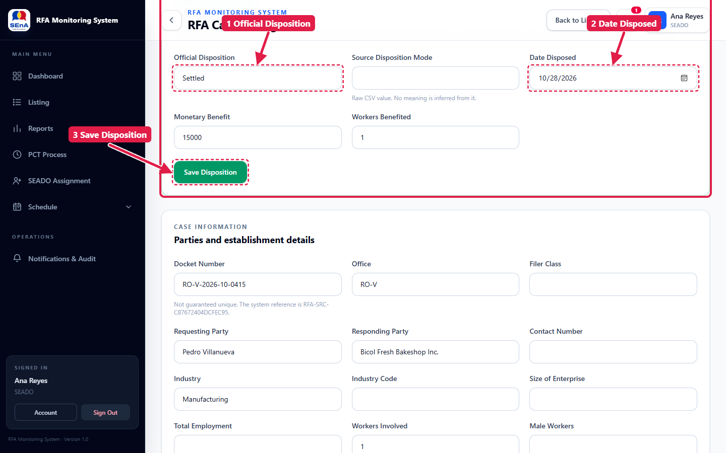
Figure 25. Disposition Capture
The case is now Disposed and all five PCT checkpoints show their final rating.
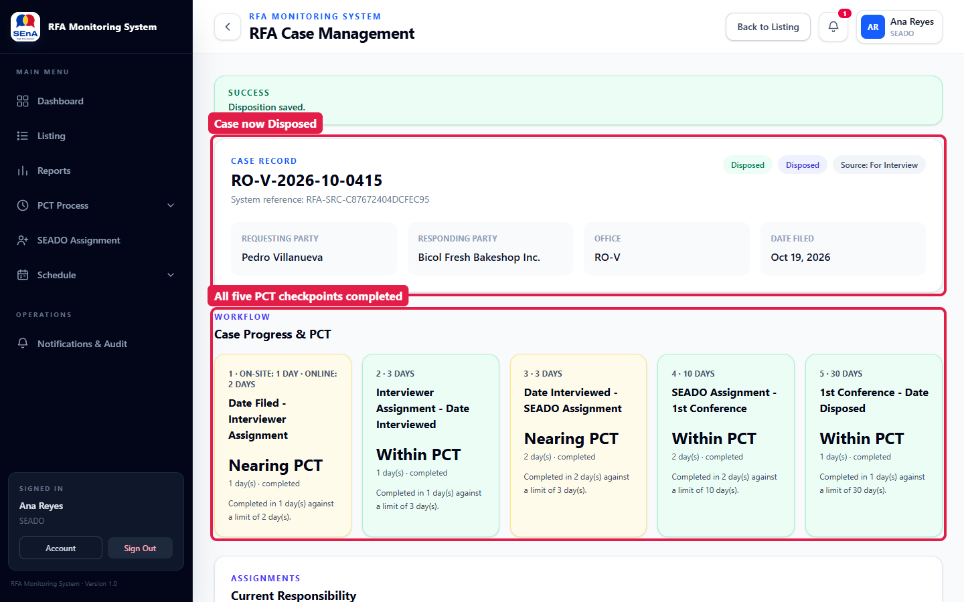
Figure 26. The disposed case
- The Official Disposition and the Date Disposed must be entered together; one without the other is refused.
- Source Disposition Mode keeps the raw "Mode" value from the CSV. It is never treated as the official disposition.
- To correct a closed case, use Reopen Case in the same section and give a reason. The previous disposition stays visible in the Case Timeline.

10. Monitoring deadlines (PCT)

10.1 Notifications & Audit
Click Notifications & Audit in the left menu. The cards count your unread, due-today, overdue and assignment alerts. Click Run PCT Scan to check every open case against its deadlines now (the scan also runs automatically every day at 7:00 AM when the scheduler is set up).
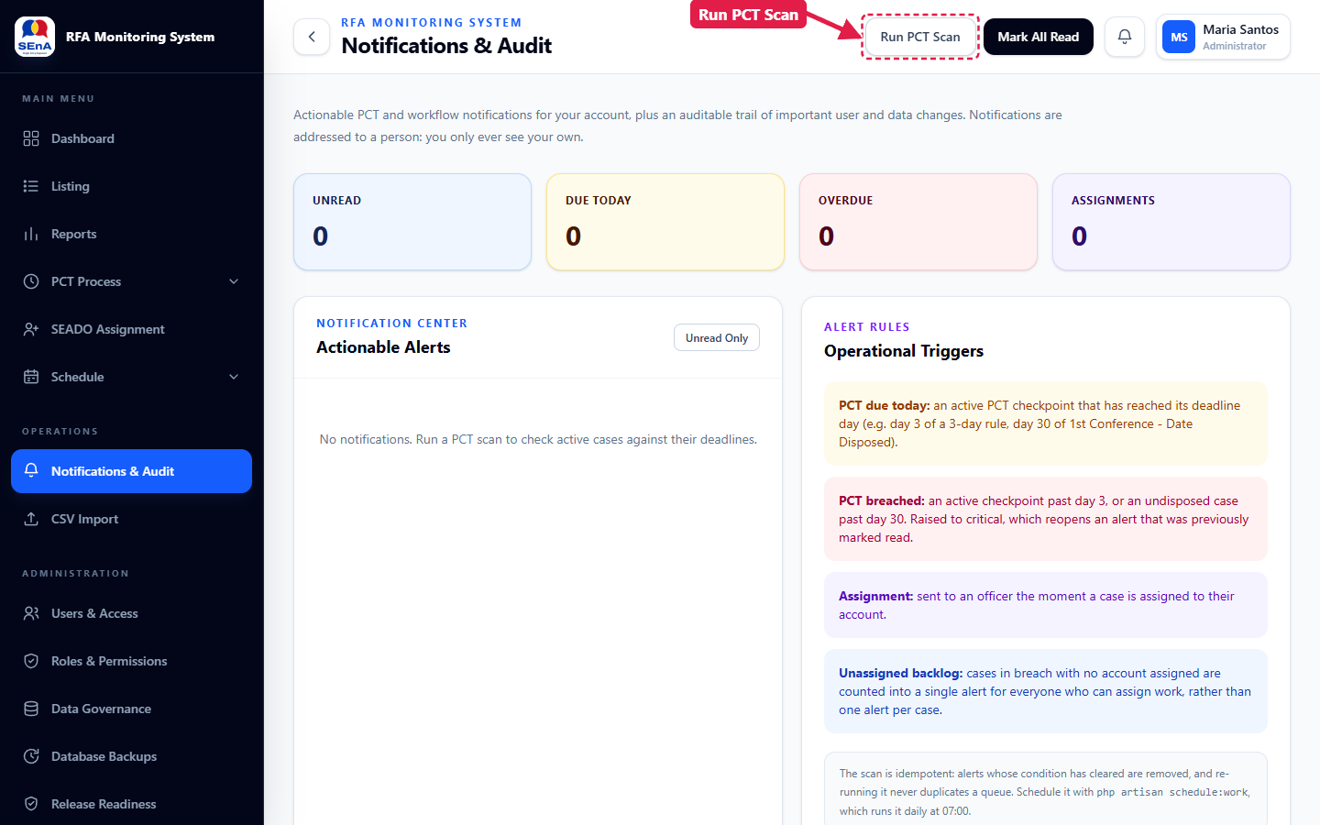
Figure 27. Run PCT Scan
Your alerts appear under Actionable Alerts. Use Open case, Mark read or Dismiss on each one, or Mark All Read at the top.
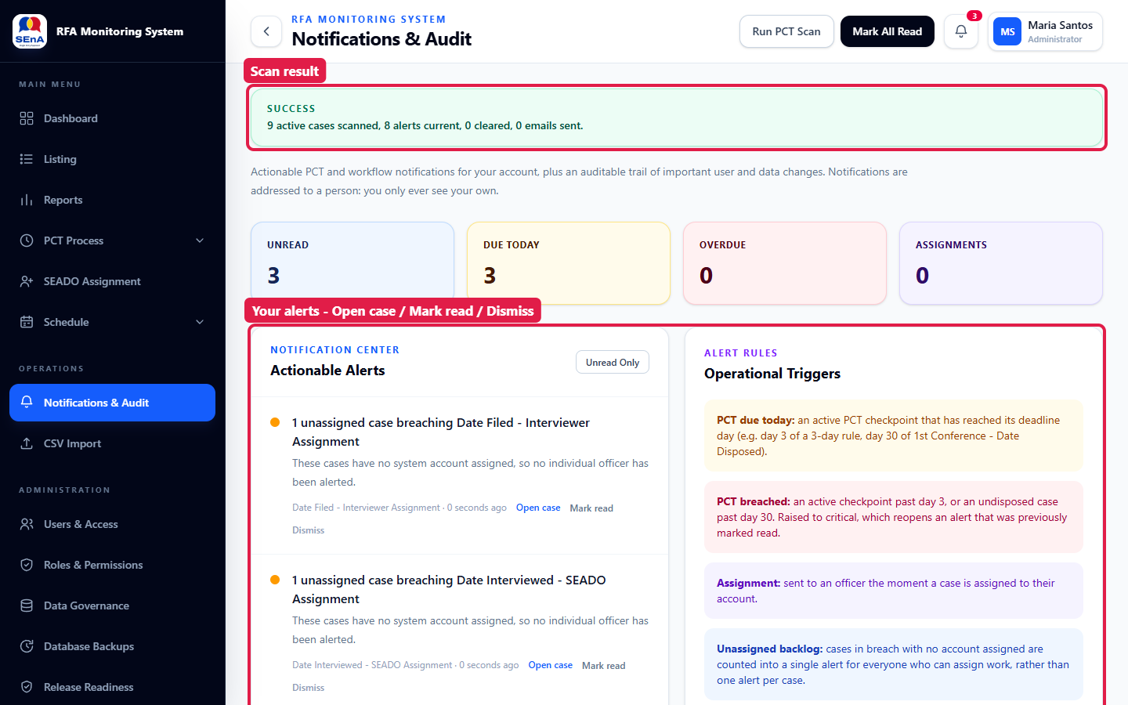
Figure 28. Scan result and your alerts

10.2 PCT Monitoring
Click PCT Process → PCT Monitoring. The summary cards count the running timers by rating; click a card to filter the table. Use Office, Checkpoint, PCT Status and Search to narrow it further. Cases most at risk are listed first.
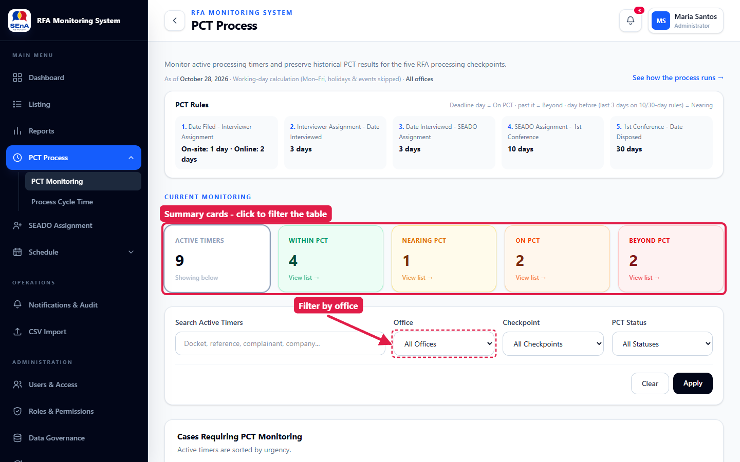
Figure 29. PCT Monitoring

10.3 Process Cycle Time
Click PCT Process → Process Cycle Time for one card per checkpoint (where the clock starts and stops, running and late counts, average days and on-time rate) and a timeline for each case.
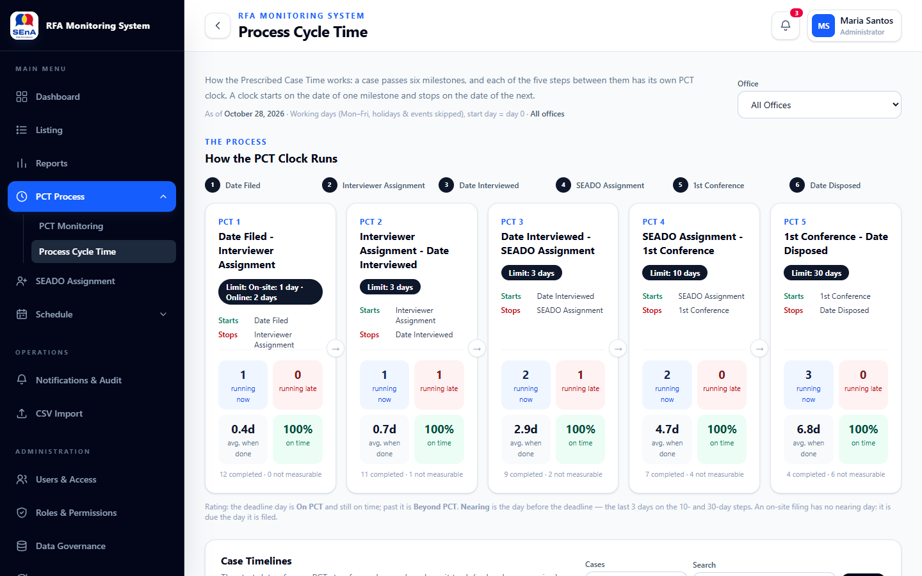
Figure 30. Process Cycle Time

11. Reports
Click Reports in the left menu.
- Set the filters (search, filing dates, office, SEADO, conference level, status, disposition) and click Generate Report. The summary, PCT compliance, breakdowns and record table update.
- Click Export CSV to download the filtered records as a spreadsheet, or Print Report to open the printable report.

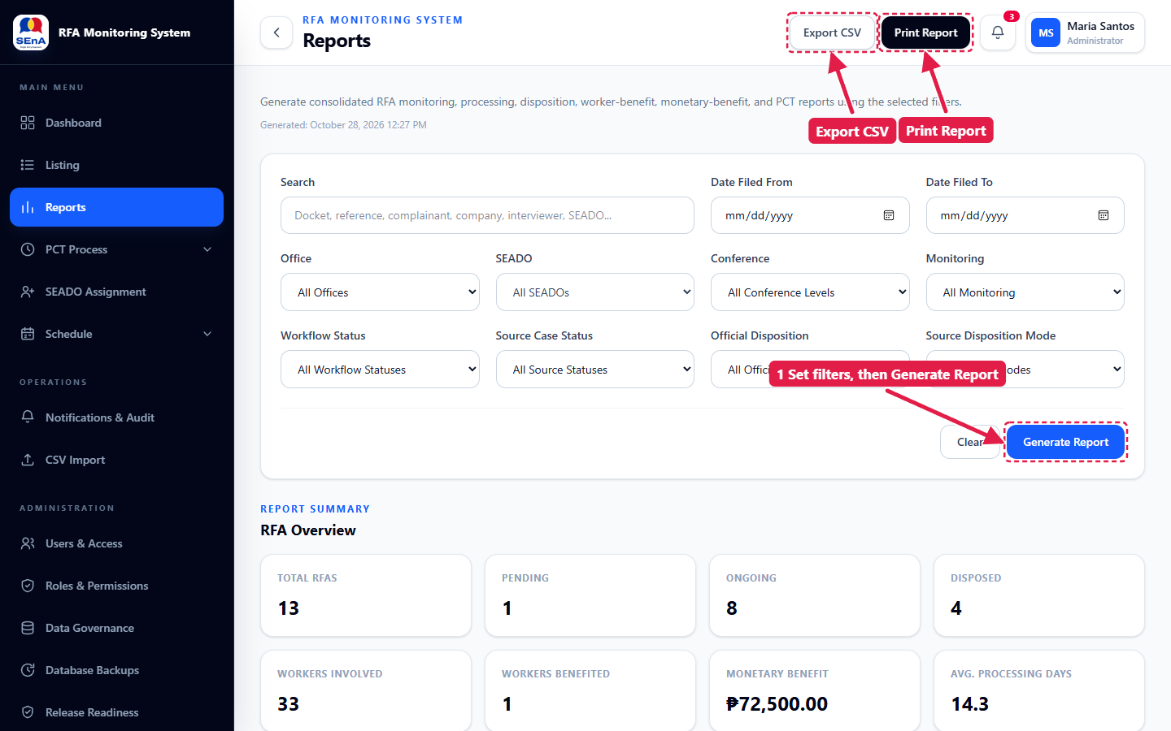
Figure 31. Reports: filters, Export CSV and Print Report
The print report is laid out for 13 × 8 inch landscape (long bond / folio) paper and includes every matching record. Click Print Report at the top right of that page, choose the paper size, or save it as PDF.
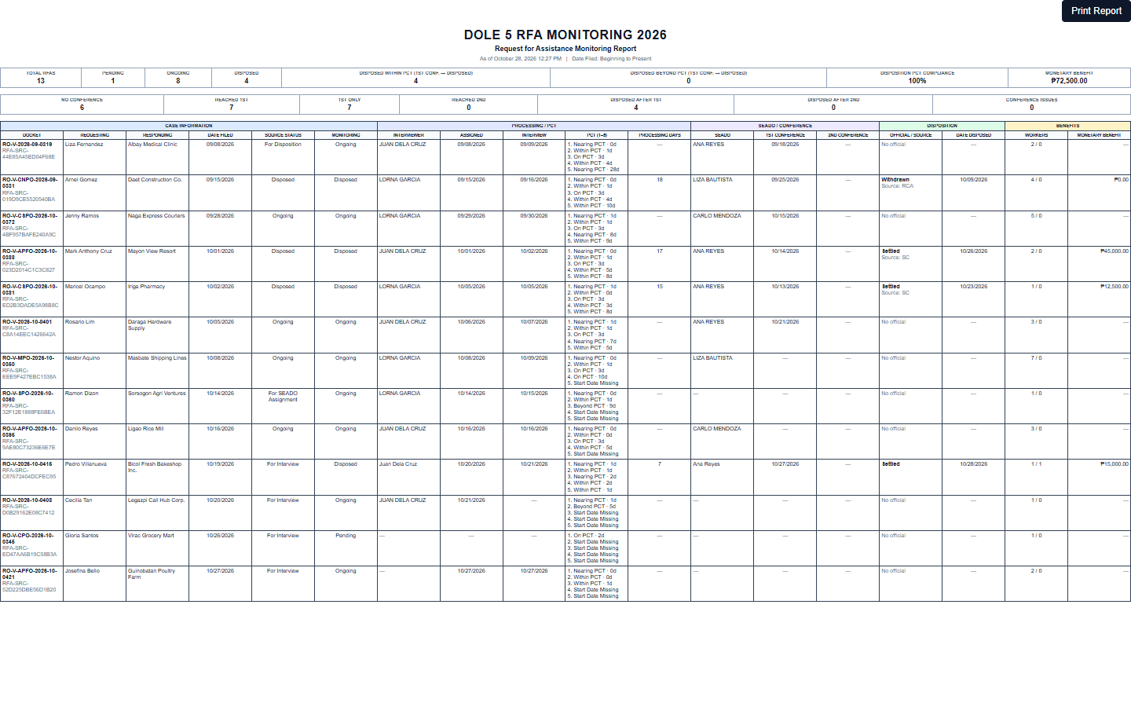
Figure 32. Printable report

12. My Account and signing out
Click your name at the top right:
- My Account — update your details or change your password.
- Sign Out — end your session. You can also use Sign Out at the bottom of the left menu.

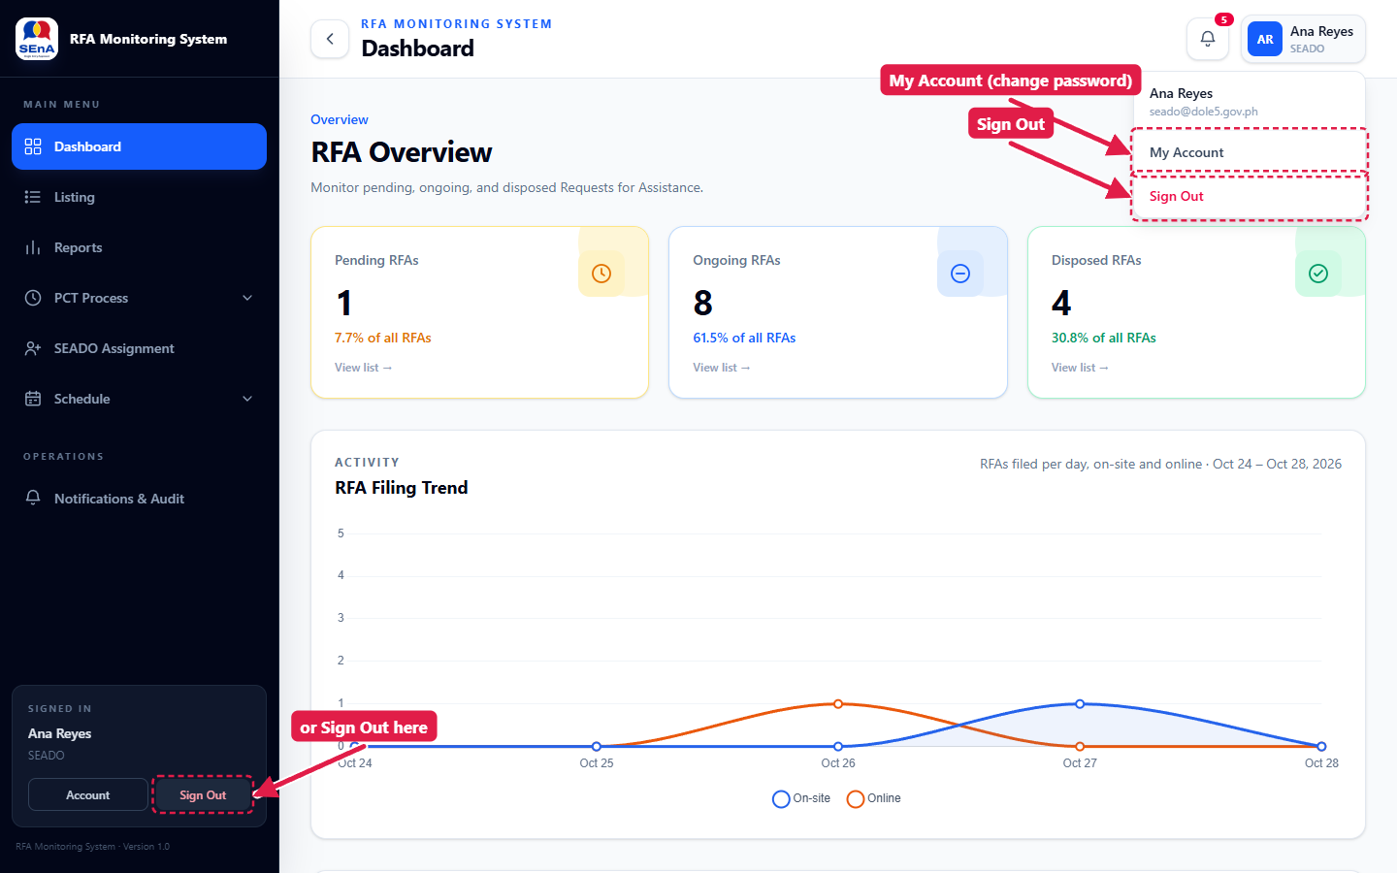
Figure 33. My Account and Sign Out
Note: Always sign out on a shared computer.

Troubleshooting
What you see | What to do
"The CSV contains duplicate column names." | Two columns have the same name. Rename or remove one, save as CSV and import again.
"The CSV import failed. No records were saved." | Nothing was imported. Check the dates and that the file is a real CSV, then import again.
A date is refused when saving | The message names the conflicting dates. Dates must follow the case order and cannot be in the future.
A menu item or button is missing | Your role does not include it. Ask the Administrator.
Checkpoint 1 shows "Mode of Filing Missing" | Open the case and set the mode of filing so the deadline can be computed.
You are signed out unexpectedly | The account may have been deactivated. Contact the Administrator.

