# 27th April

Start working on project. Started setting up variables and constants. This involved looking over the template code and adding definitions for distance where appropriate.

I have also been researching quaternions. These appear frequently in game engines and I am curious about their feasibility in this project.  
<https://www.youtube.com/watch?v=zjMuIxRvygQ>

Ok this video has given me a migraine I will just use an array to store position information.

# 29th April

While messing around in my test planets project I have discovered that by not pushing the matrix, the translation begins to compound. This is useful for putting complex models together from basic shapes as the origin moves with each call to the translate function.

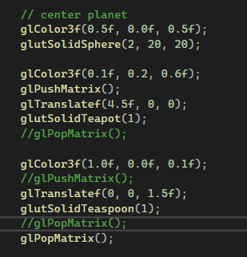

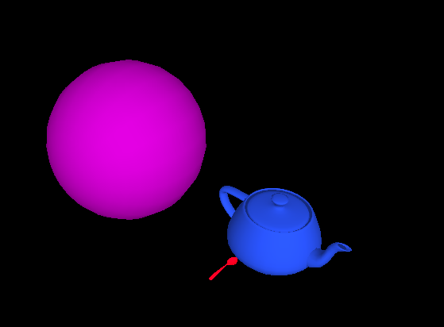

# 5th May

It’s time to get something done. New camera structure with lockon features. This allows me to move the camera around the scene without always having it locked to a certain object at a fixed distance.   
Observe the camera structure below.

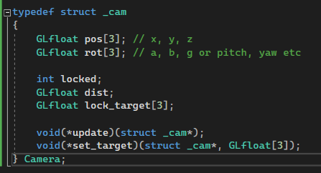In the update function, depending on whether the camera is locked, a different update is called.

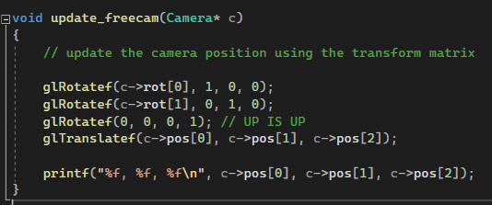However, movement is still janky because the keys move the camera in relation to the world, not the direction that the camera is moving.

So I have devised a method to get the forward vector

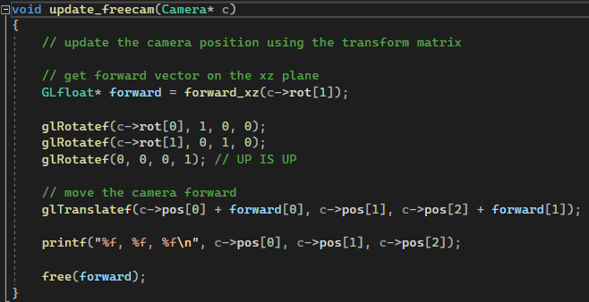  
Which doesn’t work.

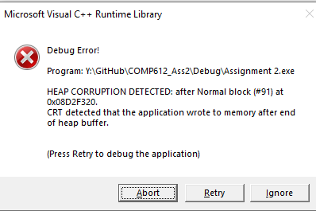

So, at this point I’ve given up making the free camera and have decided to implement the helicopter. For now, it’s just an off-white cylinder. I can’t for the life of me get the fucking thing to work like what the hell is wrong it’s just trig fucking work

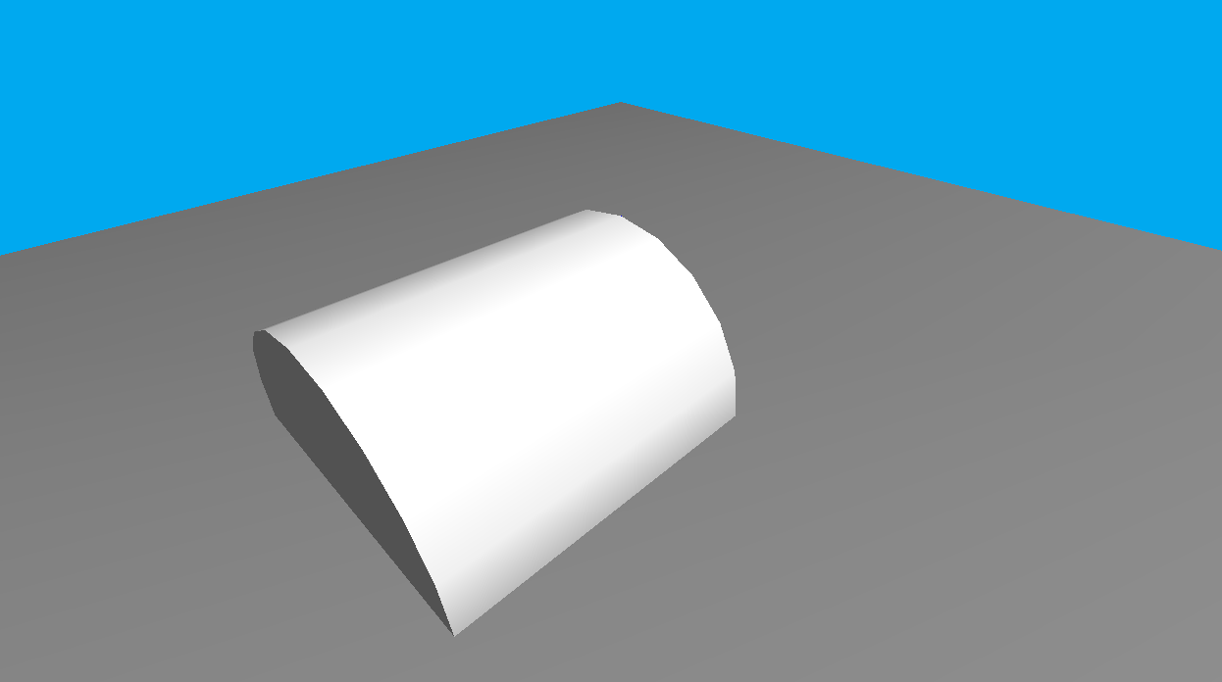  
So the solution was to actually add not subtract the movement vectors. This is because funny things happen when negatives are subtracted from each other. Using trial and error I have completed the movement of the teapot. That’s enough headache for today.

# 8th May

Finished helicopter model. It now looks like a helicopter constructed out of afternoon tea objects.

# 13th May

Implemented simple sound system.

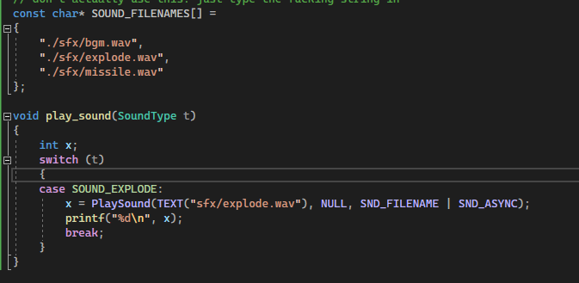

The current camera movement is a bit dodgy. It only moves up and down once per keypress. My solution is to implement a camera controller along with the keyboard controller, using the same logic.

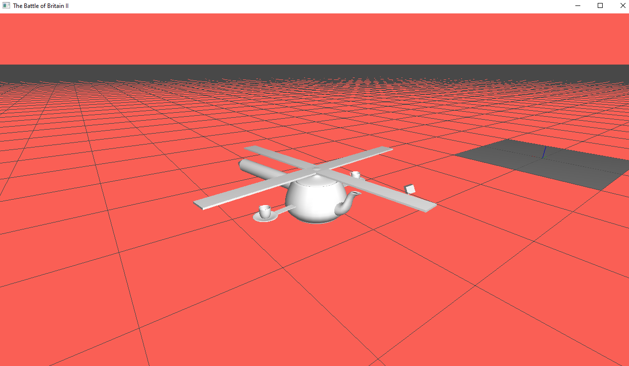

Camera zoom and tilt functions now move smoothly, instead of a fixed distance per keypress.

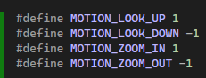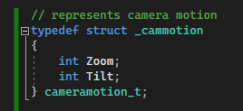

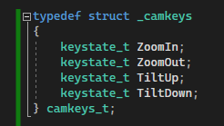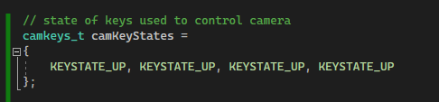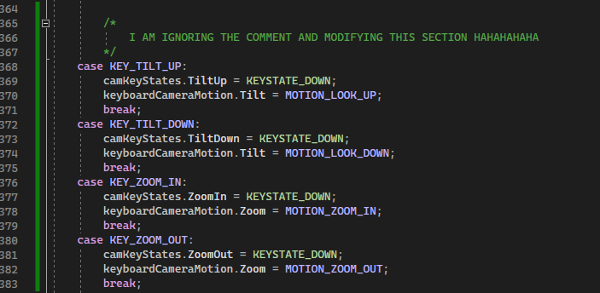

Etc..

# 14th may

Got started on textures. This first attempt didn’t go as planned.

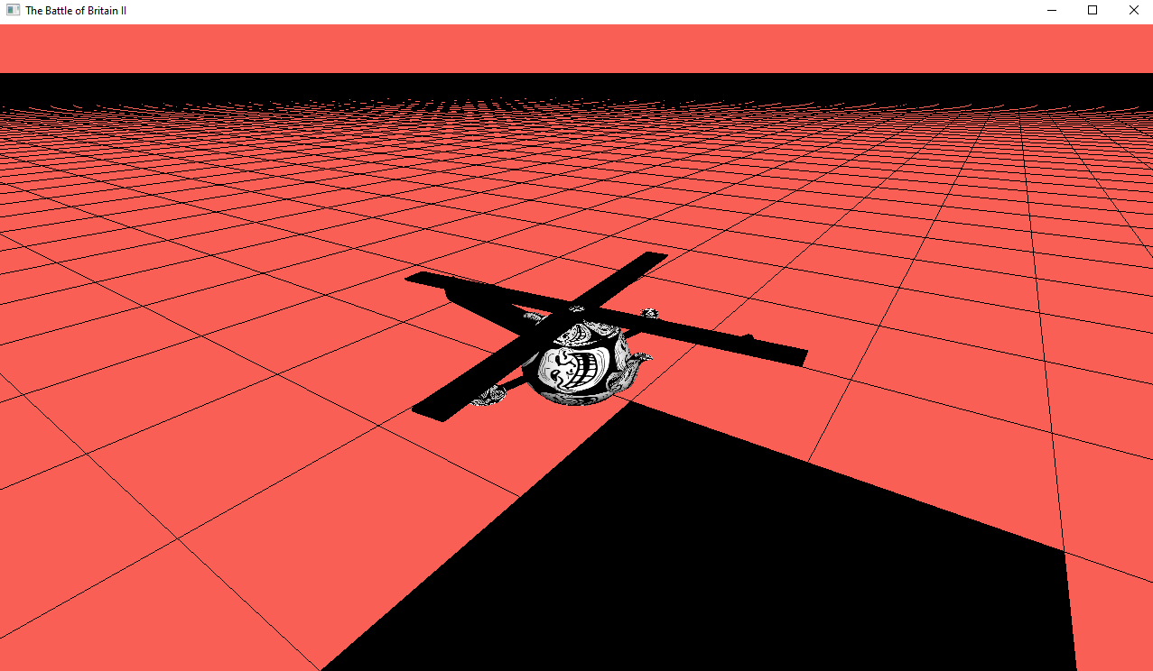

After a bit of faffing about with texture functions, I created this masterpiece.

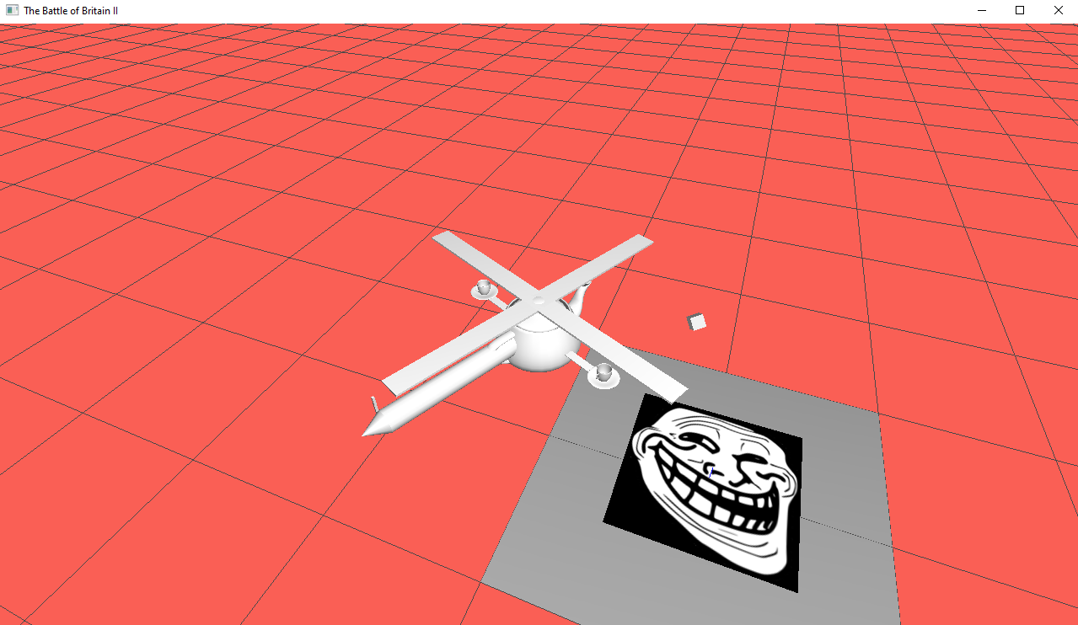

And here’s some code to prove I know what I’m doing

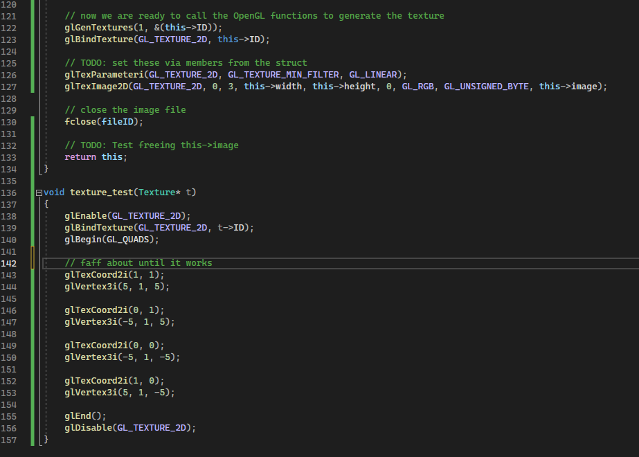

# 21st May

Ground is now a grid of quads inside a display list. Lighting also working. Ground is causing significant issues on lower end hardware. However, even on university computers which are running NVIDIA RTX2060 SUPERs are struggling. My home pc, which is sporting an RTX 3060 is having no trouble at all.

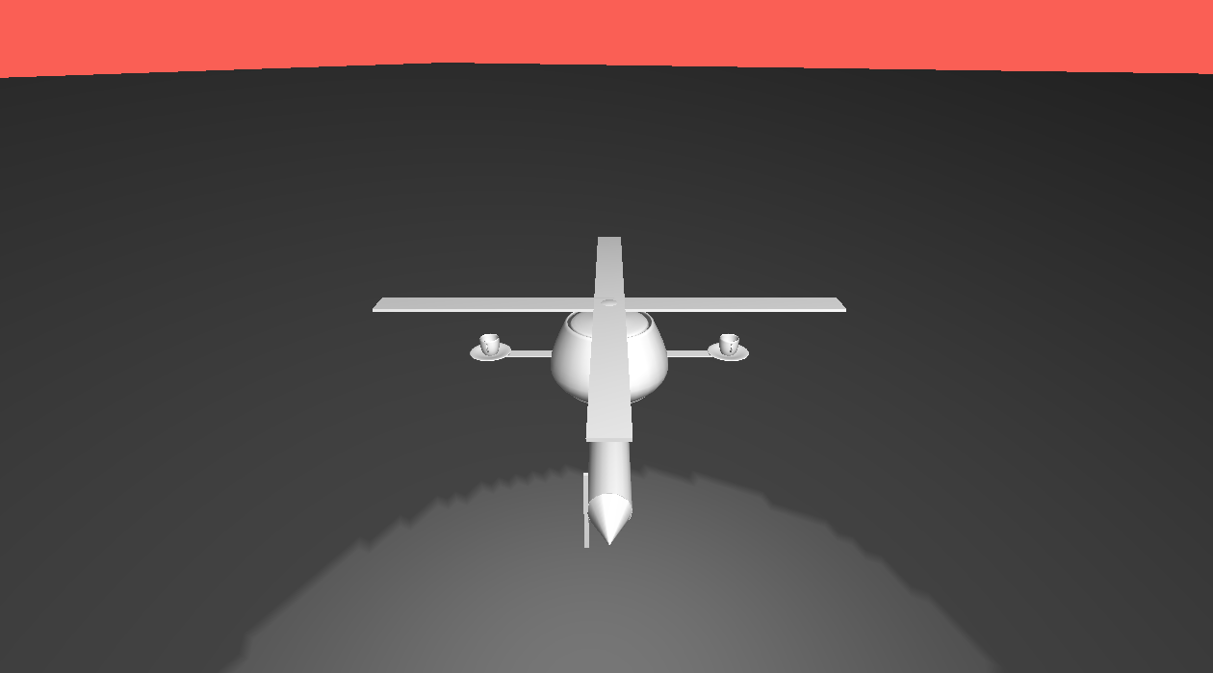

## Performance table

|  |  |  |
| --- | --- | --- |
| **Name** | **Specs** | **Comment** |
| Saggy | Ryzen 7 3800x, RTX 3060 | Yeah, it runs |
| Alessandra | Intel i5-10210U, Intel UHD Graphics | It is running like shit |
| Aidan | Ryzen 7 7600x, RTX 3060 | It runs?? |
| Aidan | Intel i7 10th gen, RTX 2060 SUPER | Runs, but not very well |
| Aidan | Intel i5 (U), Intel UHD Graphics | Seconds per frame. |

# 29th May

Disabled colour materials. Instead, I use this funny function that sets the default materials on all objects currently in the scene.

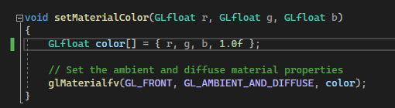

Objects from now on will use their own materials.

I have created a renderlist which is just an arraylist. However, it seems to be causing some problems. Read: Access violation errors. This comes from the fact that it’s still trying to render objects that have expired.

Using the planets project, I can quickly preview material settings since I can’t seem to find the browser version.

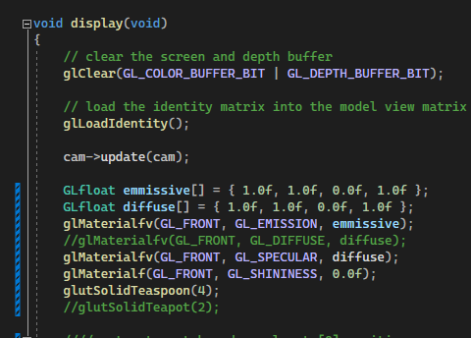

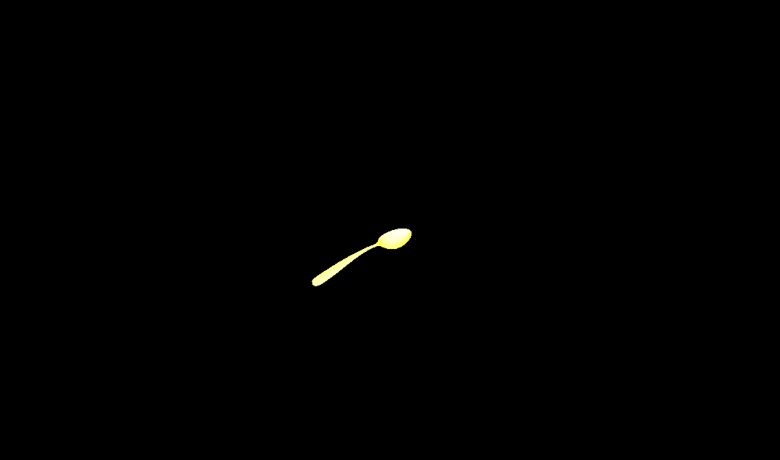

This is useful for creating the correct missile material.



