**How to run Prediction_algorithm.py on a Windows x64 Computer**

1 – Download and install python

* Go to the link <https://www.python.org/downloads/release/python-2714/>, download the file [Windows x86-64 MSI installer](https://www.python.org/ftp/python/2.7.14/python-2.7.14.amd64.msi) and execute it.

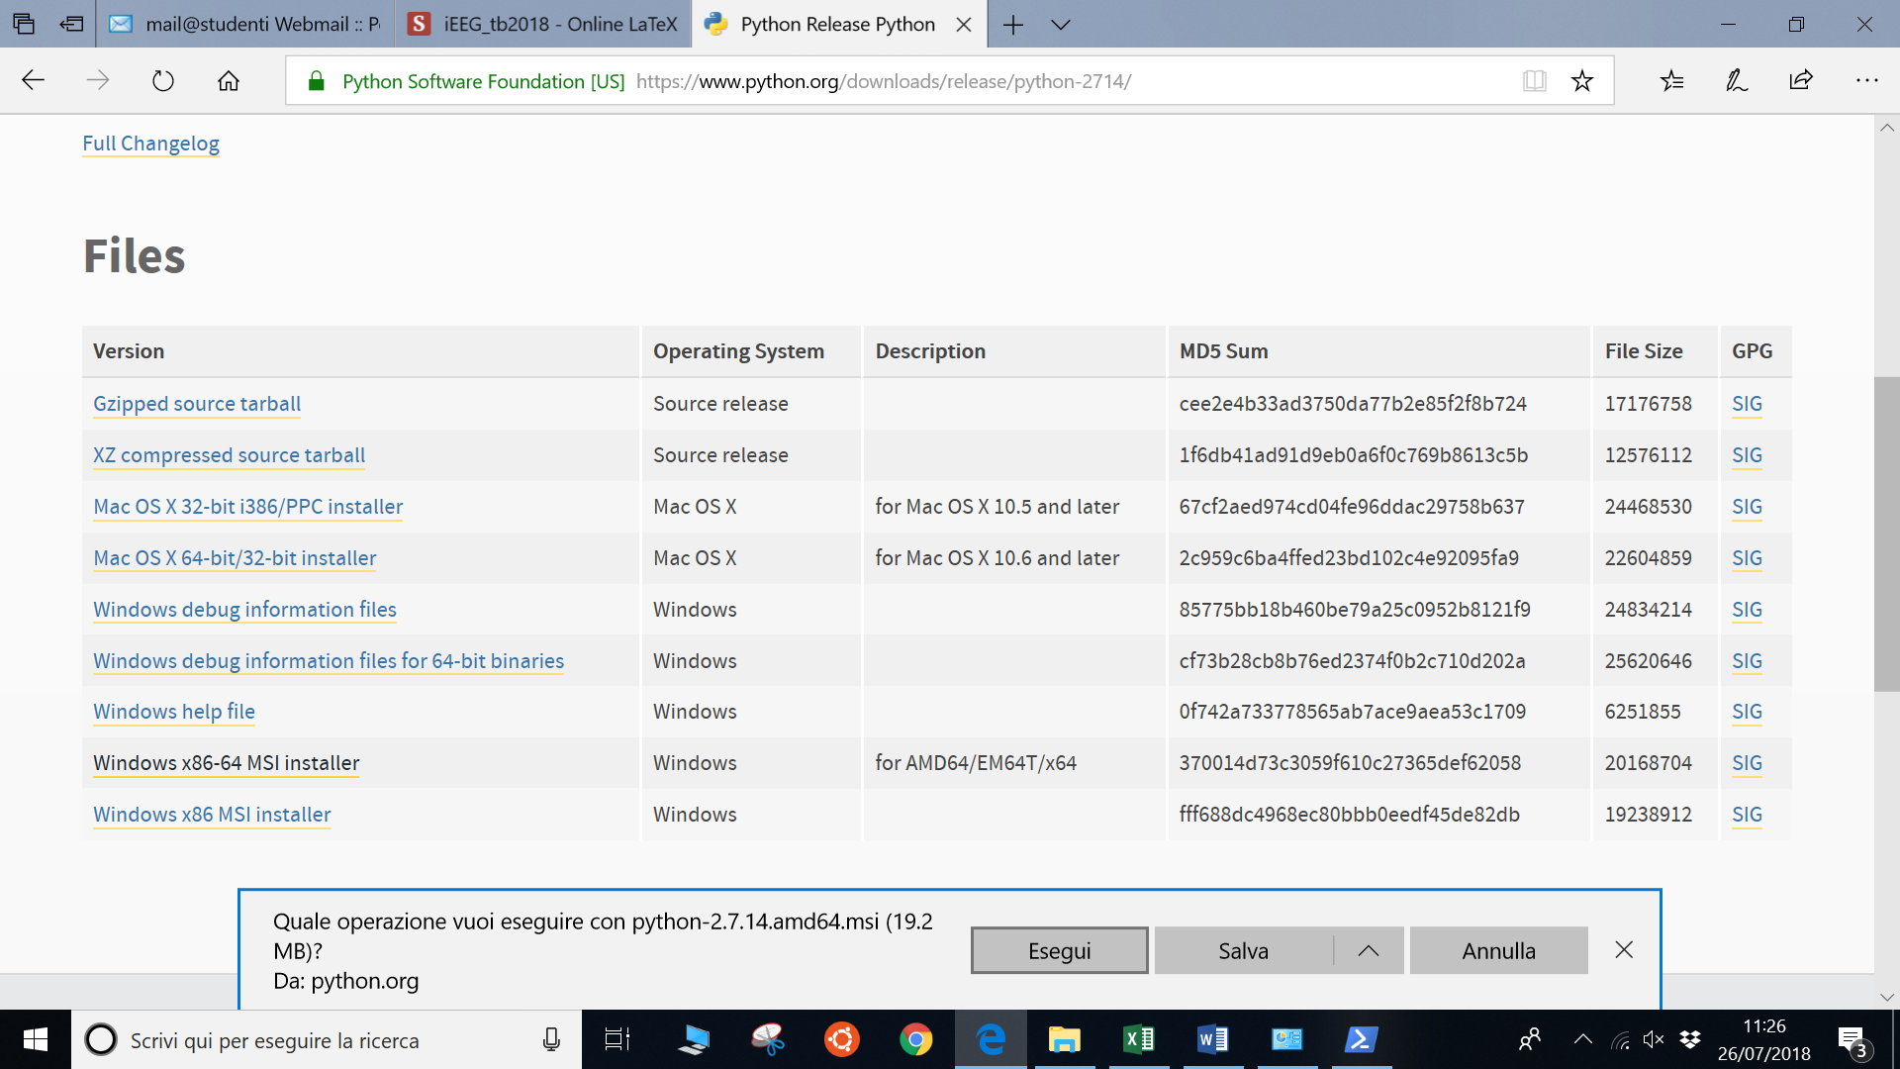

* Follow the installation steps:
  + Install for all users and press Next;
  + Leave the default directory and press Next;
  + Make sure that ‘Add python.exe to Path’ is selected (not with the cross on it) and then press Next;
  + The installation should start;
  + Press Finish when installation complete. The program is installed.

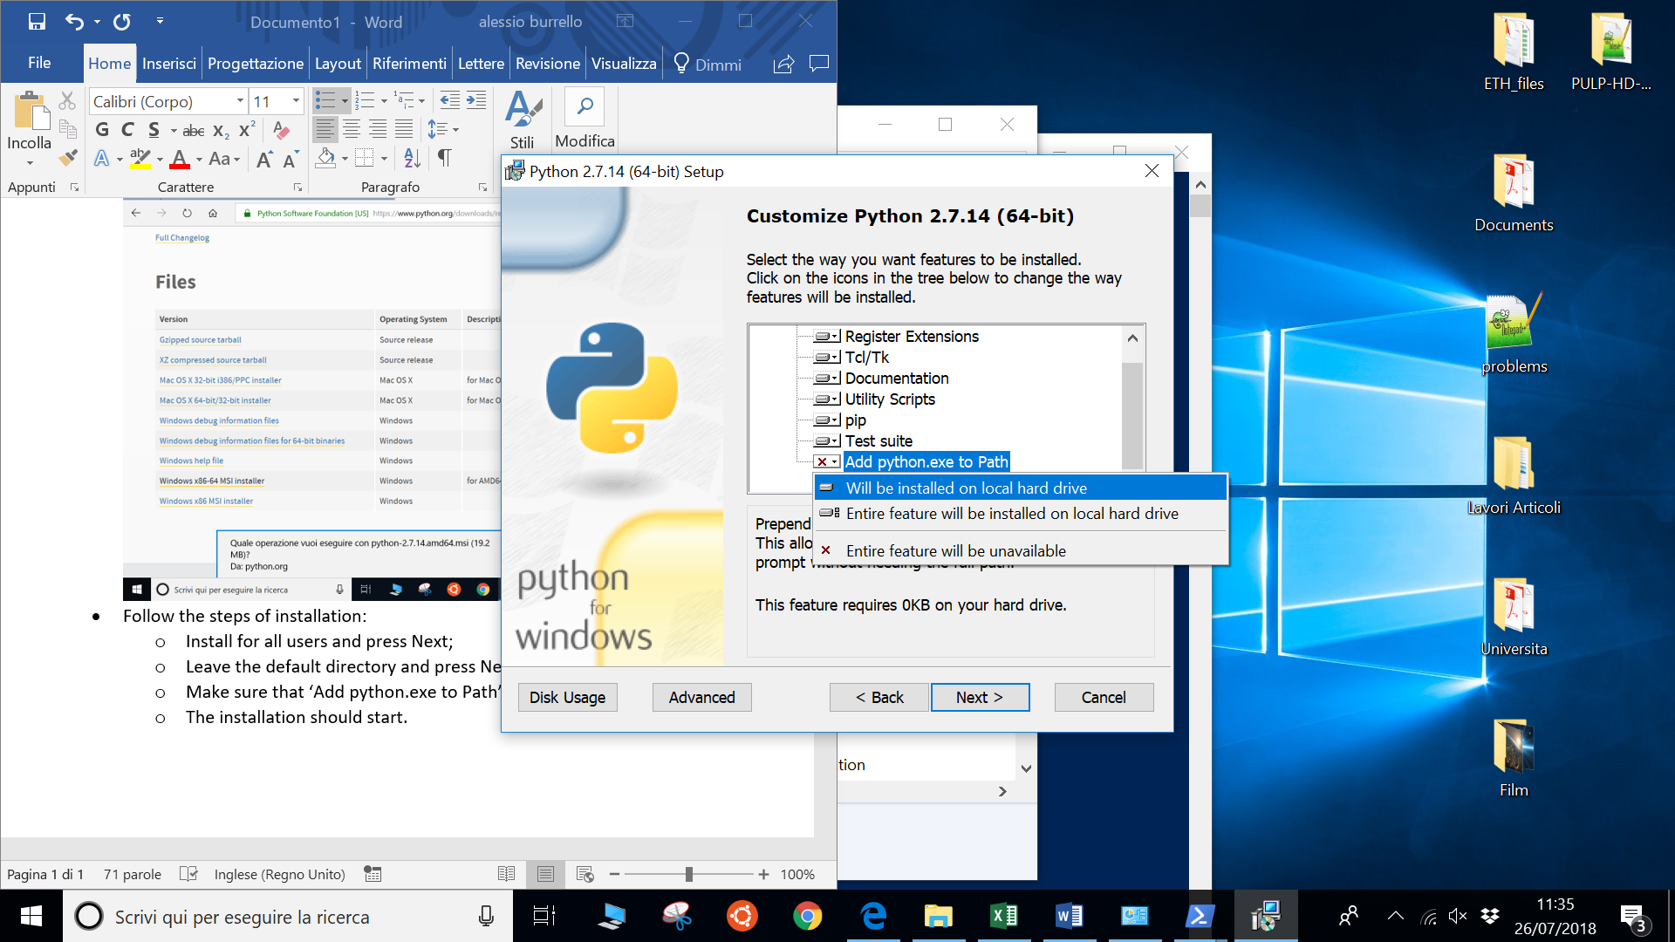

* Download the folder with the program Prediction_algorithm.py and the model and move the downloaded folder under C:\

2 – Prepare the environment:

* Open the Windows PowerShell: go to the search menu on the left-bottom corner and type Windows PowerShell and launch it;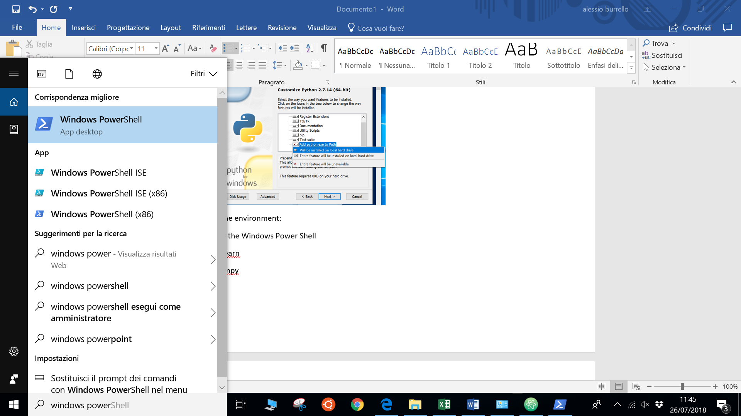
* On the power shell type cd \ and press enter, than cd FolderName (the name of the downloaded folder) and press enter again.

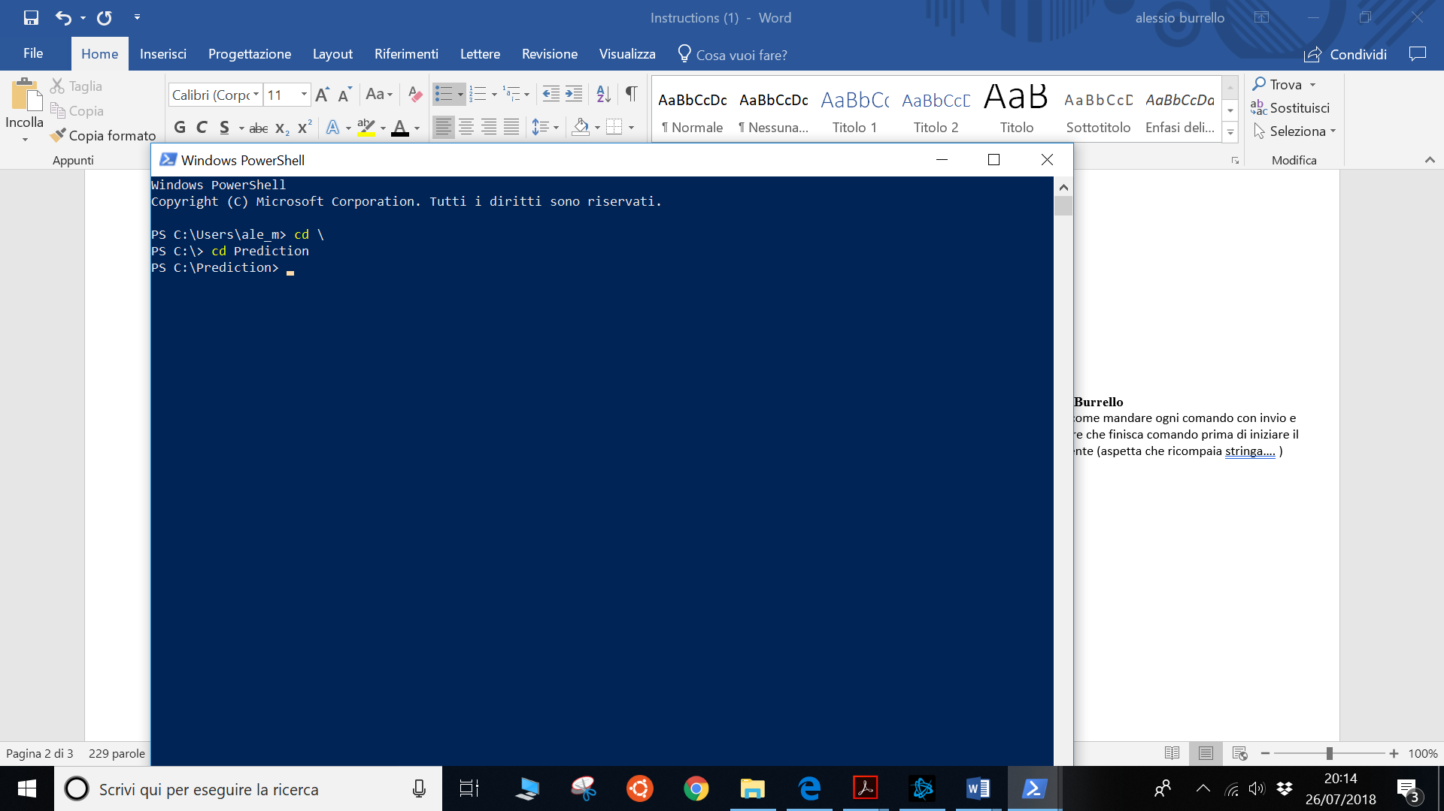

* Install the packages needed by the algorithm, using the following three commands:
  + *pip install sklearn* and then press enter and wait the process to finish, waiting that PS C:\Predicion> is shown again;
  + *pip install numpy* and then press enter and wait the process to finish, waiting that PS C:\Predicion> is shown again;
  + *pip install scipy* and then press enter and wait the process to finish, waiting that PS C:\Predicion> is shown again.

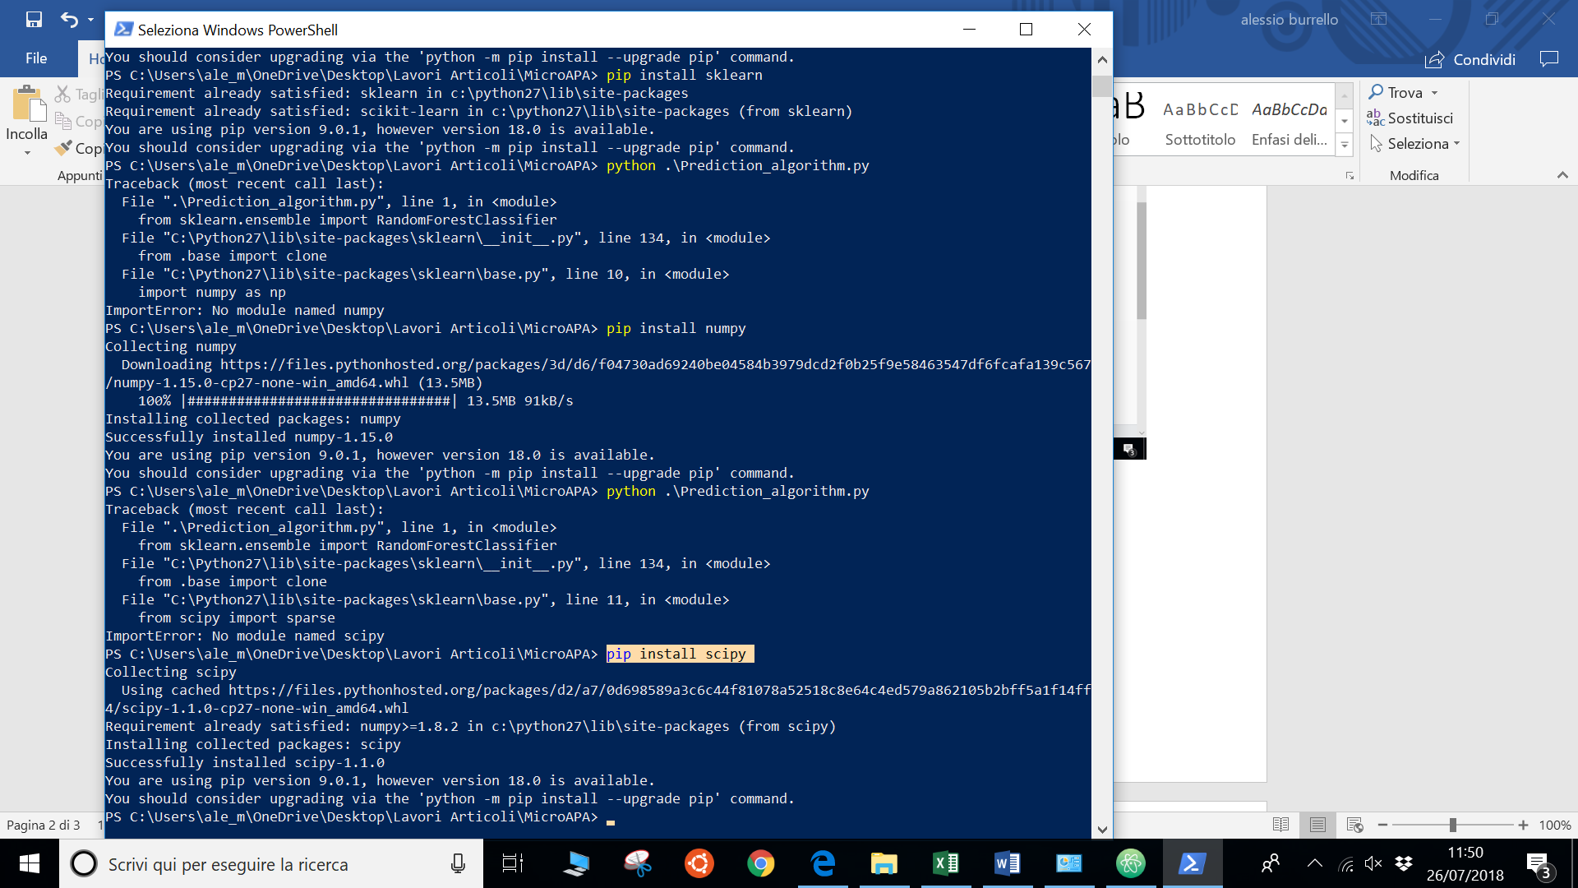

3- Run the program using the command *python .\Prediction_algorithm.py* and press enter.

Then, follow the instructions.

To re-start the program, repeat the command *python .\Prediction_algorithm.py* and press enter;