Supplementary Information
AutoVisco: Physics-Informed Autonomous Rheometry of Liquids, Gels, and Pastes for Self-Driving Laboratories
Mohammad M Rastegardoost^{a*}, Ian Ngunga^{b}, Koketso Gaborekwe^{c}, Zeqing Baoª, Hani Naguib^{d}, Frantz Le Devedec^{a*}
ª Acceleration Consortium, University of Toronto, Toronto, ON, Canada
^{b} Department of Biological Sciences, University of Toronto Scarborough, Toronto, ON, Canada
^{c} Department of Mechanical and Mechatronics Engineering, University of Waterloo, Waterloo, Canada
^{d} Department of Materials Science and Engineering, University of Toronto, Toronto, ON, Canada

* Corresponding authors: frantz.ledevedec@utoronto.ca and m.rastegardoost@utoronto.ca
Data availability: All data, control software, firmware, analysis notebooks, and figure scripts supporting this work are openly available in a public GitHub repository at https://github.com/AC-Formulations-SDL5/AutoVisco (data portal: https://ac-formulations-sdl5.github.io/AutoVisco/).
Contents
S1. Bill of materials (Table S1)
S2. Washing-protocol evaluation (Fig. S1)
S3. Dimensionless collapse of silicone drag curves (Fig. S2)
S4. Washing-subsystem electronics (Fig. S3)

S1. Bill of Materials
Table S1 lists the components of the automated viscometry platform. Apart from the rotational torquemeter, the platform is built from low-cost commercial and 3D-printed parts.
Table S1. Bill of materials for the automated rheology platform.
Component | Specification/Model | Manufacturer/Source | Material/Notes | Cost (USD)
Robotic Motion | 4040-PRO Desktop CNC | Genmitsu (SainSmart) | Cartesian coordinate system | 700.00
Torque Sensor | Torquemeter (Max: 7,187.0 dyne·cm) | AMETEK Brookfield | Real-time torque-displacement | 14,500.00 new (3,000.00 used); incl. spindle
Rotational Spindle | Cone-shaped (3° angle, 12.0 mm radius) | AMETEK Brookfield | Stainless steel construction | 14,500.00 new (3,000.00 used); incl. spindle
Sample Containers | Flat-bottom, high-clearance cylinders | Custom/Commercial | Stainless steel; resistant to deformation | 30.00
Platform Layout | T-Slotted Aluminum Rails | McMaster-Carr | Modular design for scalable layout | 530.00
Container Holders | Custom fitting for T-slotted rails | Fabricated (FDM) | PETG filament (Bambu 3D Printer) | 100.00
Washing Module Housing | Motor container and driving spinner | Fabricated (FDM) | PETG filament (Bambu 3D Printer) | 100.00
Washing Container | High-chemical resistance vessel | Fabricated (SLA) | Rigid 10K Resin (Formlabs) | 100.00
Washing Drive System | DC Motor (12 mm, 1,000:1 gear ratio) | Various | Driving/Driven spinners with magnetic repulsion | 10.00
Fluid Management | Peristaltic Pumps | Chi.Bio (Univ. of Oxford) | Regulates media input and waste removal | 100.00
Cleaning Interfaces | Smooth contact mat and weatherstrip brush | Various | Contact mat and brush lining container holder | 20.00

S2. Washing-Protocol Evaluation
Four spindle-cleaning protocols of increasing mechanical complexity were benchmarked on high-viscosity samples: a static spindle, synchronous co-rotation, lateral oscillation, and a multi-modal combination of rotation, oscillation, and brushing. Only the multi-modal protocol left no detectable high-viscosity residue on the cone, and it was adopted as the platform default.
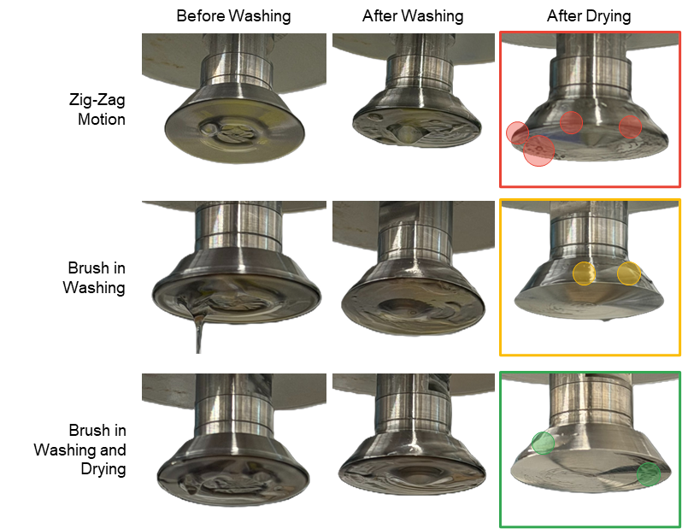
Figure S1. Comparison of washing protocols for the cone-shaped spindle.

S3. Dimensionless Collapse of Silicone Drag Curves
Normalizing each silicone drag sweep by its own maximum and plotting it against the common gap axis collapses the traces onto a single master shape. This supports factorizing the drag into a geometry-governed shape function F(h) and a viscosity-dependent amplitude A(μ), which is the assumption that allows one silicone calibration to transfer to other fluids (main text, Section 2.3.3).
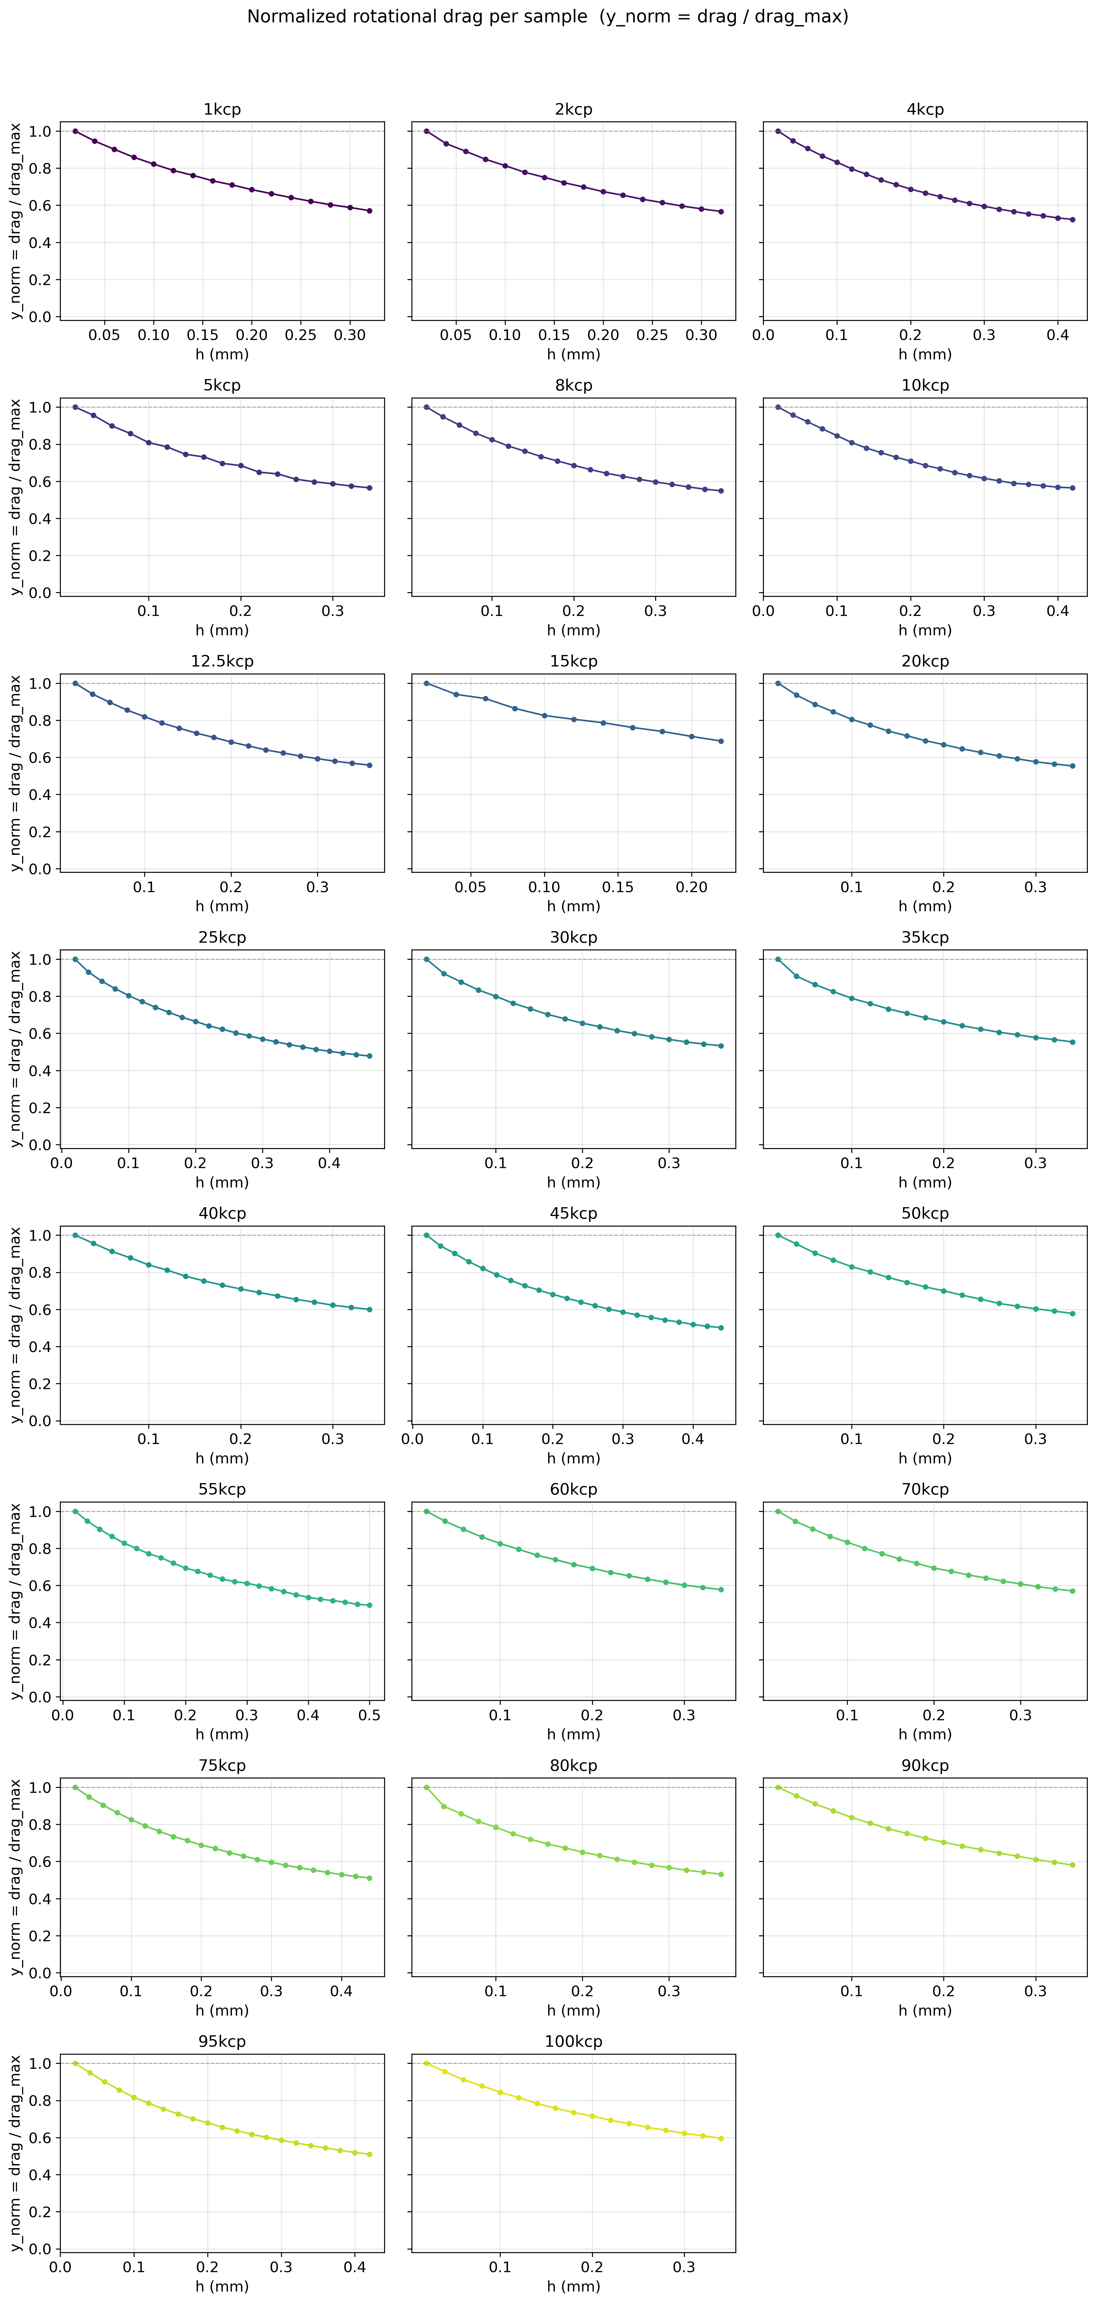
Figure S2. Dimensionless collapse of silicone drag curves, supporting factorization into geometry shape and viscosity amplitude.

S4. Washing-Subsystem Electronics
The washing subsystem is controlled by an ESP32 microcontroller on a custom PCB. PWM-driven L298N motor drivers actuate six pumps and three agitation motors through a multiplexed, diode-isolated channel-sharing configuration, and detergent, water, and isopropanol rinse cycles are triggered from a minimal host command interface.
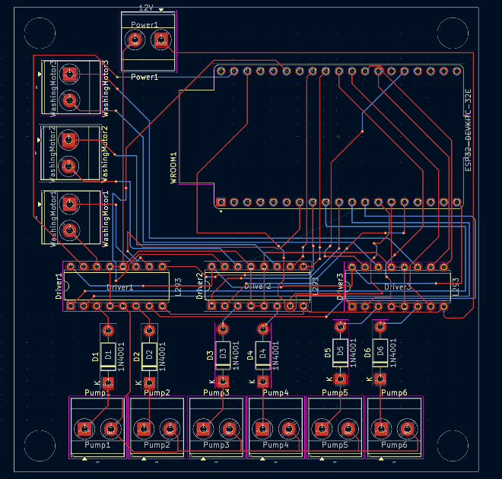
Figure S3. PCB layout and embedded motor-control architecture of the washing subsystem.

