A Self-Driving Rheometer: Physics-Constrained Signal Interpretation for Autonomous High-Viscosity Characterization of Newtonian and Non-Newtonian Fluids
Mohammad M Rastegardoost^{a*}, Ian Ngunga^{b}, Koketso Gaborekwe^{c}, Zeqing Baoª, Hani Naguib^{d}, Frantz Le Devedec^{a*}
ª Acceleration Consortium, University of Toronto, Toronto, ON, Canada
^{b} Department of Biological Sciences, University of Toronto Scarborough, Toronto, ON, Canada
^{c} Department of Mechanical and Mechatronics Engineering, University of Waterloo, Waterloo, Canada
^{d} Department of Materials Science and Engineering, University of Toronto, Toronto, ON, Canada

* Corresponding authors: frantz.ledevedec@utoronto.ca and m.rastegardoost@utoronto.ca

Abstract
Rheological characterization of viscous formulations is central to lubricants, coatings, adhesives, and polymer processing. Conventional cone-and-plate and parallel-plate rheometry require controlled loading and gap setting, complicating robotic operation. We present an automated viscometry platform that reframes viscosity acquisition as a signal-interpretation problem rather than a geometric-precision one. A cone-shaped rotational torquemeter, Cartesian motion stage, and dual-stage washing module operate under an asynchronous multi-runtime control architecture. The spindle's descent generates torque–displacement signatures decoded by a physics-constrained pipeline. On Newtonian silicone-oil standards, viscosity recovery has a mean absolute error of 3.4%, with 95.7% of calibration samples within ±10%. The pipeline interprets multi-speed descent measurements as calibrated stress–shear-rate relationships and fits the power-law model τ = Kγ̇ⁿ, where n = 1 denotes a Newtonian response and n < 1 indicates shear thinning. Across six material families spanning 0.001–125 Pa·s (1–125,000 cP), the platform reproduces reference rheology within ±2×, and recovers flow-behaviour indices from n = 1.00 (Newtonian) to n = 0.39 (strongly shear-thinning). The platform processes 18 samples in approximately 5 hours with less than 20 minutes of hands-on effort; an equivalent manual characterization-and-washing workflow requires 4.7 times as long. Both outputs come from one fixed pipeline with no per-chemistry retuning, reducing reliance on precision gap-setting hardware. The platform is positioned as the measurement layer for closed-loop rheology-discovery campaigns, where Bayesian optimization and active learning propose formulations that it characterizes autonomously.
Keyword: automated rheology, cone-and-plate viscometry, physics-constrained inference, power-law fluids, self-driving laboratory, high-throughput characterization.

1. Introduction
Precise control of precursor viscosity is essential for the processing of functional materials. For example, the fabrication of porous and fibrous polymer components for triboelectric energy harvesters [1–5] depends on controlling the flow of electrospinning solutions and foam- or aerogel-forming precursors to obtain target fiber and pore morphologies. The same processing challenges arise in other energy-harvesting materials and functional coatings, yet viscosity measurements are often performed manually and outside a formulation feedback loop. The challenge spans the high-viscosity regime (1–100 Pa·s; 1,000–100,000 cP) underpinning lubricants [6], specialty coatings [7,8], pharmaceutical/injectable formulations [9], personal-care emulsions [10,11], and adhesives [12], where rheology dominates processability and resolving even one composition landscape can demand hundreds of measurements. Manual rotational rheometry is fundamentally limited by operator-controlled gap setting, loading, cleaning, and pacing. Standard metrology guidelines specify gap and zero-point tolerances at the tens-of-micrometre scale [13]. A trained operator routinely maintains this level of precision by feel [14]. An unmodified positioning stage may not provide the contact sensing and effective gap control routinely used by an experienced operator. Because of these constraints, characterizing even a modest design-of-experiments campaign routinely costs days of skilled labor. Furthermore, inter-operator variance often degrades data comparability across trials.
A common response substitutes experimentation with empirical mixing models (e.g., the logarithmic blending rule, Grunberg–Nissan [15], Ramírez-de-Santiago [16], and Redlich–Kister [17]) interpolating multi-component viscosity from pure-component or binary references. These are accurate in dilute, near-ideal regimes [18], but break down at industrially relevant concentration extremes [19,20]: hydrogen-bonding, associative interactions, polymer entanglement, and microgel structuring produce non-ideal behaviour the empirical kernels cannot capture [21,22]. Blending-rule error for hydrocarbon mixtures rises from near zero to over 13% under colder, more complex conditions [19], and in a comparison of seventeen mixing rules for petroleum blends only four remained acceptable, with no single rule generalizing across the full range [21]. The absence of a reliable computational surrogate keeps physical measurement central to any rigorous formulation programme that is the cost of measurement, not its elimination, that must be reduced.
Self-driving laboratories offer a pragmatic solution to long development timelines [23,24]. These systems combine closed-loop robotic handling, automated characterization, and machine learning-guided decision-making. This integration successfully compresses development cycles from years to weeks. These benefits have been demonstrated in reaction optimization [25–30], materials discovery [31–33], catalysis [34,35], and polymer processing [36]. The approach even includes mobile robots that independently choose their own experiments [37]. The rate-limiting step in this workflow is rarely the decision algorithm. Active learning techniques already routinely outperform standard grid or random search methods [38–43]. Instead, the true challenge is finding characterization methods that are fast enough to keep pace with the software [44,45]. Automated viscometry mostly repurposes liquid-handling robots as proxies to estimate viscosity. For example, Opentrons (OT-2) platforms calibrated against dispense rates recover Newtonian viscosity over a range of 1,500–12,000 cP with a 6.5% error [46]. This window was later widened to 20–20,000 cP at approximately 8% error by using a simple non-Newtonian extension [47]. Additionally, open-hardware digital pipettes have successfully pushed dispensing accuracy below 1% [48]. In another approach, a camera-based inverted-vial method spans a wide range of 0.01–1,000 Pa·s with an error of ±15-25%, completely eliminating the need for a physical contact sensor [49]. These methods, alongside commercial microfluidic RheoSense-type viscometers, are admittedly fast and inexpensive. However, they only return a single, largely Newtonian viscosity value. None of these options can autonomously recover a full non-Newtonian constitutive curve. Because of this limitation, rotational rheometry remains underrepresented among existing self-driving characterization layers.
To automate this measurement, we analyze the torque signal generated as the rotating cone approaches the stationary plate instead of relying on manual adjustment of an absolute gap. Torque rises as the clearance narrows; a regularized, lubrication-motivated fit to the drag–displacement trace yields a viscosity-sensitive amplitude while accommodating uncertainty in the effective gap offset. Measurements at multiple rotation rates then give a stress–shear-rate relation: a power-law index n ≈ 1 describes near-Newtonian behaviour, whereas n < 1 indicates shear thinning [50]. Yield-stress effects [51,52] may produce departures from a pure power law and cannot be confirmed from n alone. The calibrated analysis reduces sensitivity to mechanical backlash and gap-zero uncertainty while still requiring repeatable motion and valid torque data.
In this work we present an end-to-end automated viscometry platform delivering, for the viscous formulations accessible to its torque and speed ranges, a calibrated stress–shear-rate flow curve and the fitted power-law equation τ = Kγ̇^{n}. A Cartesian motion stage, cone-shaped rotational torquemeter, and magnetically-driven washing station are integrated into one workstation for autonomous measurement and cleaning across a multi-cell deck. We treat the spindle's descent as a physically structured signal: lubrication theory constrains the drag's functional form, while a data-driven inference layer absorbs the stage's mechanical and geometric uncertainties into nuisance parameters, recovering viscosity and flow-behaviour index without per-chemistry retuning. This one-shot calibration transfers unmodified across six chemistries spanning five orders of magnitude in viscosity (1–125,000 cP), reproducing reference rheology within ±2× and identifying Newtonian and shear-thinning responses and flagging behaviour not adequately described by a simple power law, while completing 18-sample runs in ~5 h of robot time with under 20 min (7%) of human involvement. This positions the platform as the measurement layer for closed-loop rheology-discovery campaigns driven by Bayesian optimization and active learning.
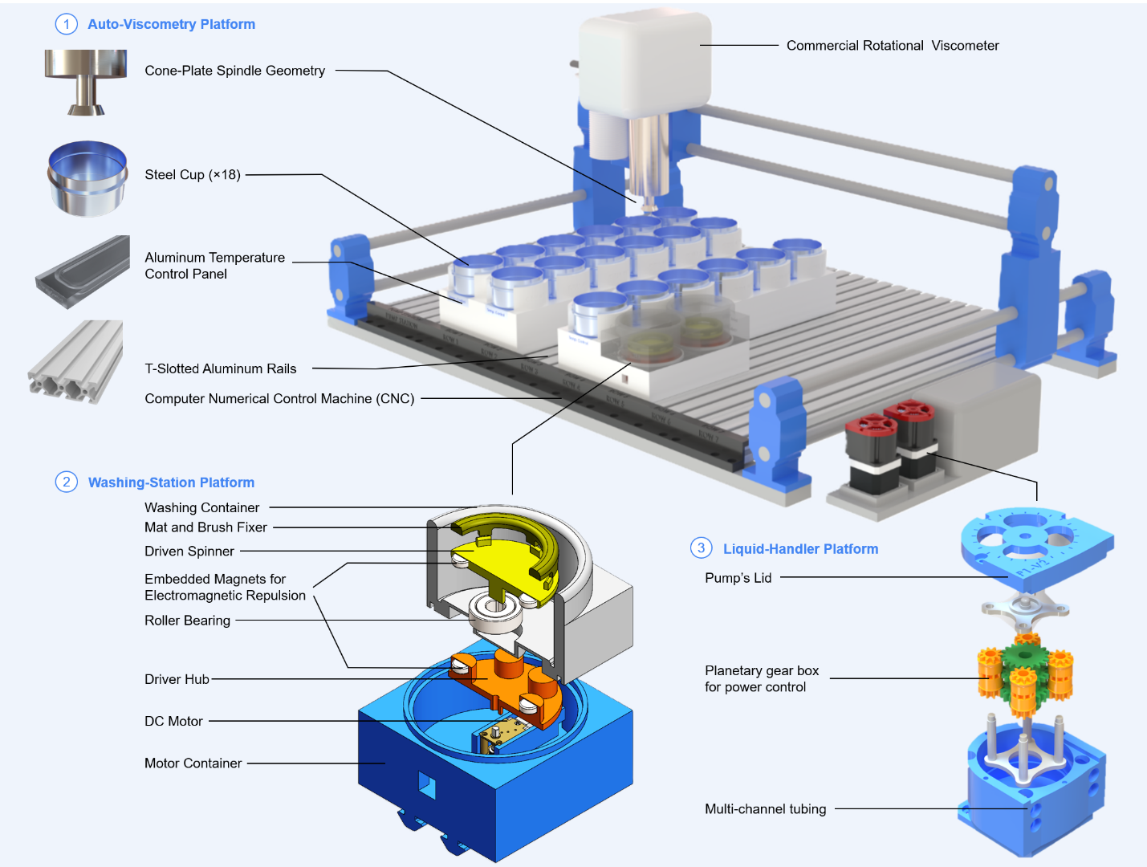
Figure 1. Schematic of the automated viscometry platform showing the Cartesian motion stage, the cone-shaped rotational torquemeter, the multi-cell sample deck, and the integrated dual-stage washing station.

2. Methods
Every measurement modality in rheology answers a different question about how a material flows, so the choice of modality is itself a design decision with direct consequences for automatability. Rheology spans extensional, oscillatory, and steady-shear deformation, each yielding a distinct descriptor (Table 1), but this work targets steady-state shear rheology acquired through a rotational, torque-based measurement for three converging reasons: it is (i) directly automatable on a Cartesian motion stage, (ii) able to estimate apparent viscosity and, with multi-speed measurements, the power-law exponent describing Newtonian or shear-thinning response, and (iii) compatible with the dimensional footprint of a multi-cell sample deck. A manual execution of this modality reduces to three operator-controlled steps, including loading the sample into a flat-bottom cell, aligning the spindle precisely against the cell floor, and acquiring torque under a programmed angular velocity. The platform therefore automates sample positioning, controlled descent, and torque acquisition while preserving feedback on the safe stopping position.
Parallel-plate rotational rheometry can also measure shear-thinning formulations, while capillary rheometry probes pressure-driven flow and can access different shear-rate ranges. Cone-and-plate rheometry is not restricted to high-viscosity systems. Here, a cone-shaped spindle was chosen because it integrates with the compact robotic stage and approaches a nearly uniform shear-rate geometry at small tip clearances. The intended application is automated screening of viscous polymer-containing formulations across multiple sample cells; reproducible positioning, sample loading, and especially removal of residual high-viscosity material between cells are the central engineering constraints. This geometry is therefore a platform-design choice rather than a claim that alternative rheometers cannot characterize these fluids.
Table 1. Rheology Principles and Methods
Category | Principle/Method | Key Metric
Deformation Type | Shear Rheology | Shear Stress, Shear Rate
 | Extensional Rheology | Extensional Viscosity
Flow Regime | Steady-state Flow | Apparent Viscosity
 | Oscillatory (Dynamic) | Storage (G') & Loss (G'') Moduli
Measurement Method | Rotational (Torque-Based) | Torque-Displacement
 | Capillary/Pipe Flow | Pressure Drop
 | Microfluidics | Shear-thinning profiles
Material Response | Newtonian | Linear Stress-Strain relationship
 | Non-Newtonian | Power-law index
 | Viscoelastic | Phase Angle
The idea to drive the spindle through a continuous descent originated directly from manually collected data (Fig. 2A). This approach replaced the older method of seating the spindle once at a fixed gap. Torque was first recorded by hand as a function of spindle height. This manual step produced a torque–displacement trace for each material (Fig. 2B). Recasting this torque through the governing viscosity equation yields a rotational-drag quantity. This quantity is calculated as the ratio of measured torque to angular speed. This calculation turned the raw trace into a drag–displacement signature. The shape of this signature varied systematically and distinguishably between materials of different viscosity (Fig. 2C-D). Every parameter of the underlying viscosity equation is encoded in this drag–displacement relationship. Because of this, the drag amplitude at a given gap correlated directly with viscosity. Observing this correlation by hand motivated a shift in strategy. Instead of a single measurement at one gap, the full descent is treated as the true information-bearing signal. The automated platform later exploited this exact relationship. To establish this relationship, a scientist manually lowered the spindle in discrete increments of 13 µm. This process spanned increment 33 down to increment -3 relative to the container floor. At each height, the scientist tested a series of spindle speeds. They recorded the resulting torque and back-calculated viscosity using the standard cone-and-plate relation. The full manual procedure required approximately 4.5 hours to characterize a single material. It yielded a small dataset of 37 rows, representing one row per tested spindle height, and four columns. These columns tracked the increment number, spindle speed, measured torque, and measured viscosity.
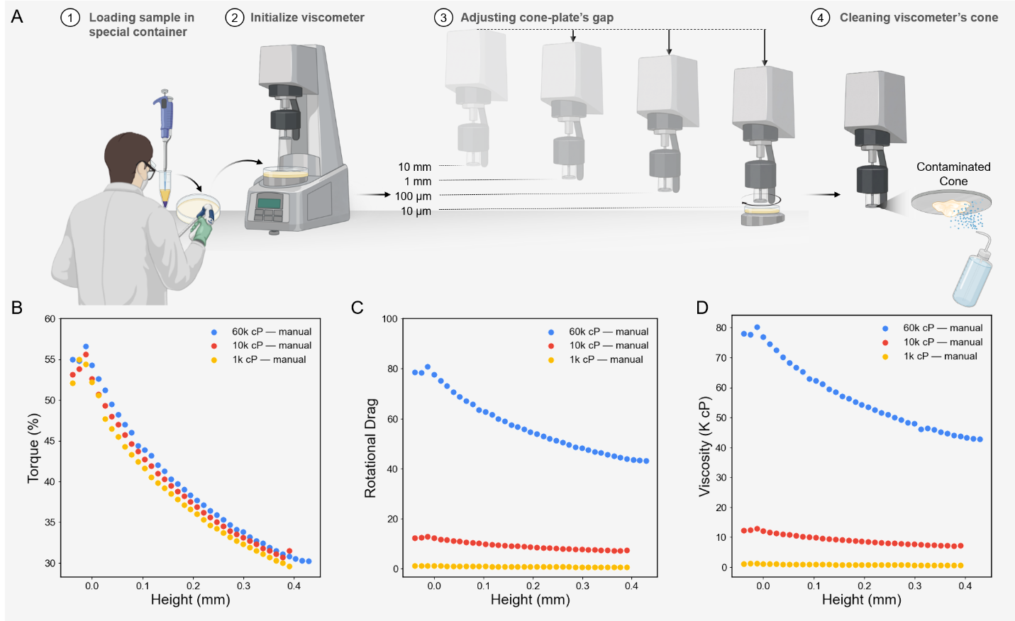
Figure 2. (A) Manual rheology-data acquisition procedure (Biorender.com). Manually recorded data points through descent of the spindle generates (B) torque–, (C) drag–, and (D) Viscosity–displacement signatures of material.

2.1 Hardware Architecture and Automated Workflow
The complete list of materials is summarized in Table S1, and the integrated layout appears in Figure 1. Sample containers are stainless-steel, flat-bottom, high-clearance cylinders held in a modular platform of T-slotted aluminium rails (McMaster) with PETG (FDM-printed) container holders. The rotational sensing element is a 3°-cone-angle, 12.0 mm-radius stainless-steel spindle coupled to a precision rotational torquemeter (AMETEK Brookfield; full-scale torque M_{full} = 7,187.0 dyne·cm), referred to hereafter simply as the rotational torquemeter, with its manufacturer-quoted flow curves referred to as the reference rheology. Three-axis motion is supplied by a Cartesian CNC stage (Genmitsu 4040-PRO, SainSmart) on NEMA 17 steppers and T10 lead screws, with dedicated peristaltic pumps (Chi.Bio, University of Oxford) metering the washing station's cleaning fluids.
A major challenge in repeated automated measurements of viscous formulations is preventing carryover between samples: residue on the spindle can bias subsequent torque readings. A dedicated washing station cleans the spindle after every cycle using a bespoke magnetic-repulsion drive. A motor-driven, magnet-embedded spinner sits inside a PETG housing. This component actuates a driven spinner across a 3.0 mm gap inside a separate SLA washing vessel. Because of this design, the motor electronics never contact the cleaning fluids. For the cleaning process itself, detergent, water, and isopropanol are sequentially routed through the pumps. Of four benchmarked protocols of increasing mechanical complexity (static spindle, synchronous co-rotation, lateral oscillation, and a multi-modal rotation + oscillation + brush combination), only the multi-modal protocol left no detectable high-viscosity residue; it was adopted as the platform default and runs concurrently with CNC travel, keeping washing off the critical path (Fig. S1).
The full workflow operates as a closed, operator-free loop (Fig. 3). After initialization, the system performs a per-cell calibration of the safe spindle-to-container height. Next, the platform runs an automated characterization cycle. During this cycle, the spindle descends incrementally while torque is recorded under a programmed RPM sweep. A physics-constrained feedback layer monitors this process to identify the liquid-contact transition and the optimal termination point. This layer combines rotational-drag tracking, statistical trend analysis, confidence-weighted hit-point detection, and second-derivative anomaly detection. These automated steps successfully protect the sensor from overload. Each measurement ends with a washing sequence. This sequence launches concurrently with travel to the next cell. Finally, the resulting torque–displacement record passes to the analysis pipeline. This entire process integrates robotic positioning, rheometry, feedback, washing, and data collection.
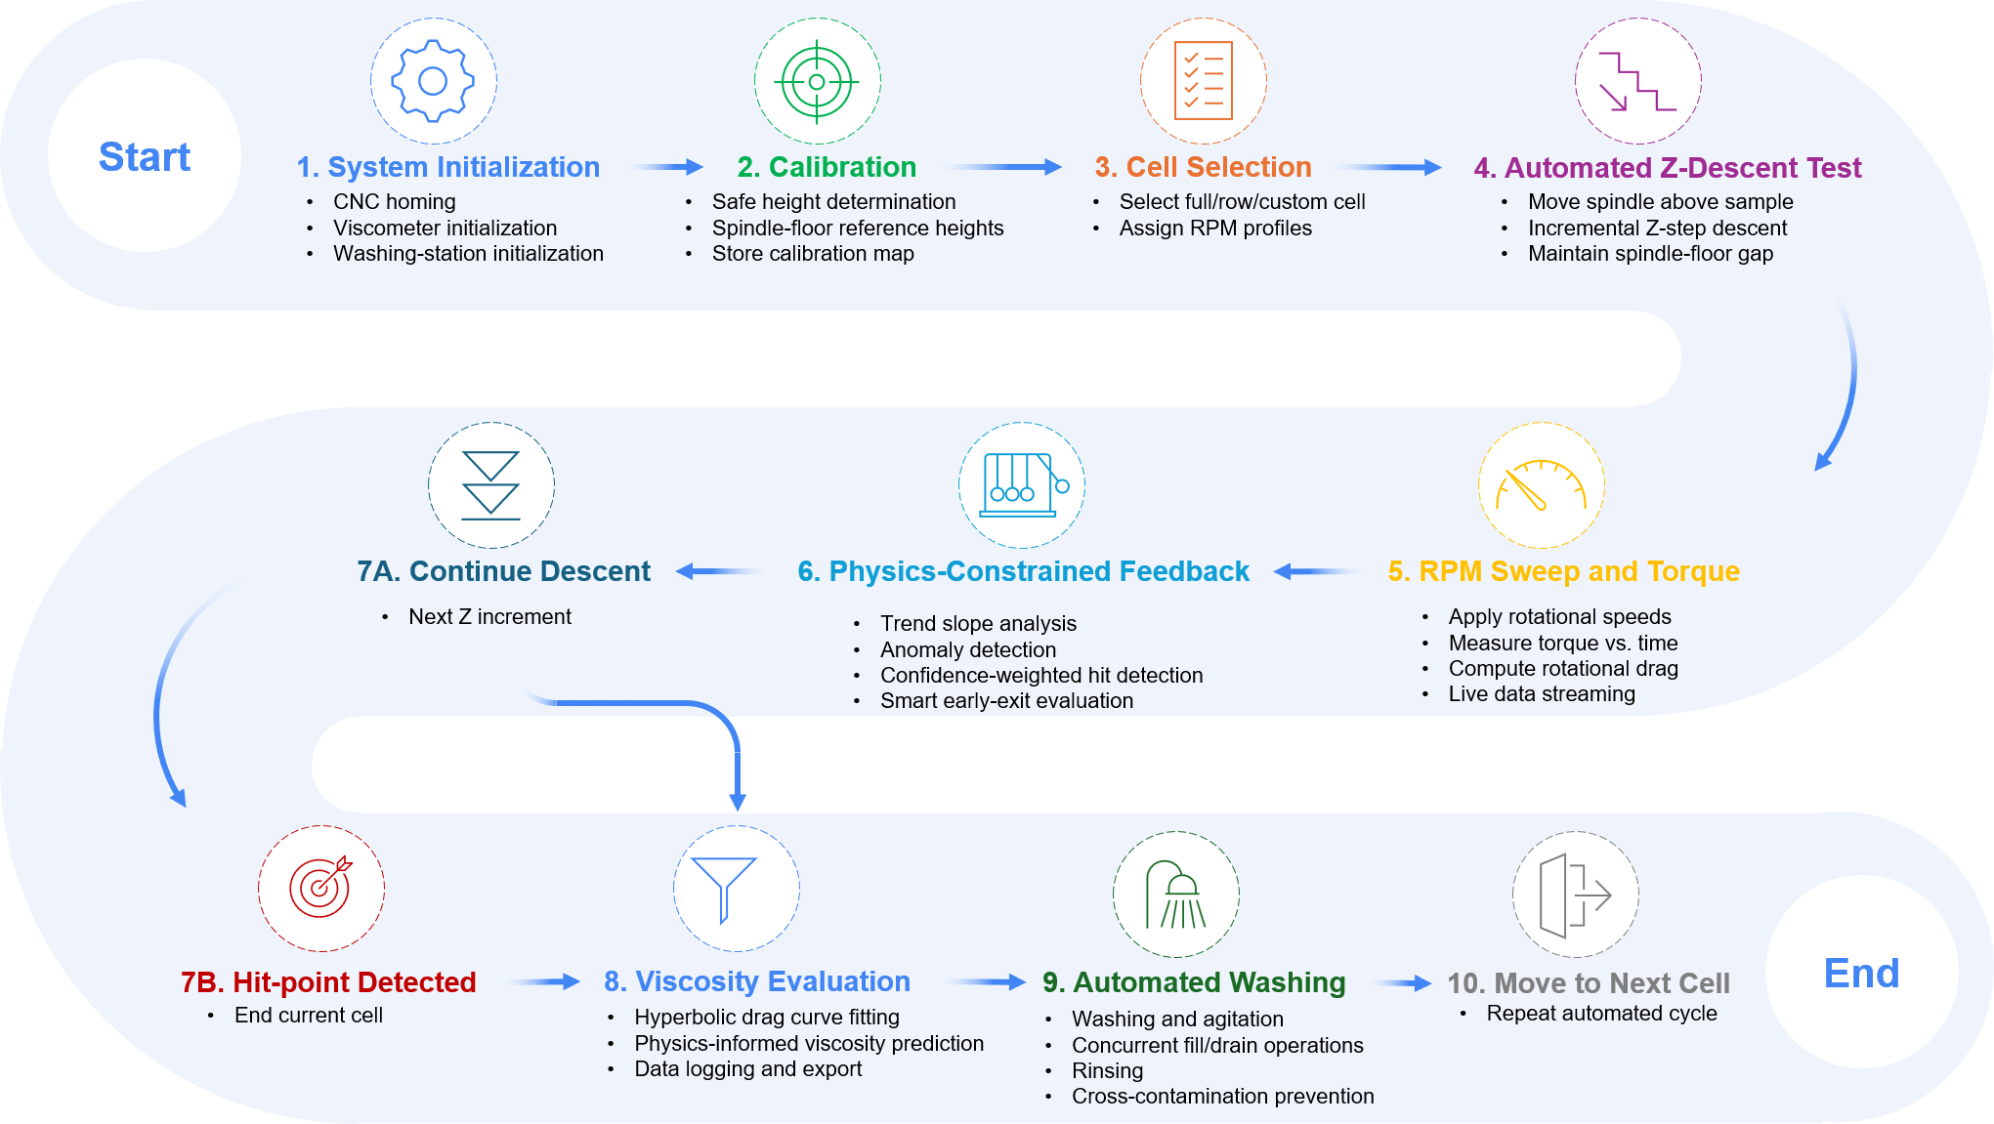
Figure 3. Full workflow of the automated viscometry platform. CNC-controlled positioning, torque-based rotational rheometry, physics-informed descent feedback, autonomous hit-point detection, predictive viscosity estimation and rheological profile characterization, and concurrent washing operations form a unified high-throughput experimental loop.

2.2 Physics-Informed Rheological Framework
The platform operates as a modified cone-and-plate configuration in which the cone spindle approaches a stationary plate while torque is monitored as a function of vertical displacement. An automated descent, unlike a manual one (Fig. 2B-D), inevitably sweeps a far wider gap range than a human operator would ever program, so the torque trace does not stay within a single hydrodynamic regime: it samples parallel-plate-dominated, transition, and cone-and-plate-dominated behaviour in succession, and no single closed-form solution captures all three at once. We therefore adopt a generalized lubrication-theory framework, in the classical tradition of cone-and-plate and parallel-plate rotational rheometry [14], that interpolates continuously between the two asymptotic limits (Fig. 4A).
The local liquid thickness between the rotating cone and the stationary plate is
$H(r) = h + r tan(α)$ | Eq. 1
where h is the minimum tip clearance, r is the radial coordinate, and α is the cone half-angle. For large spindle separations (h ≫ r tan(α)), the gap thickness becomes nearly uniform throughout the radius (H(r) = h). In this regime, the system approaches classical parallel-plate rotational rheometry, where the torque scales approximately as:
$$T∝\frac{μωR^{4}}{h}$$ | Eq. 2
Here, the viscous resistance is strongly governed by the global spindle-to-substrate distance. Conversely, for very small clearances (h→0), the radial contribution dominates the gap profile (H(r) ≈ r tan(α)) and the system converges toward the classical cone-and-plate rheometer limit with nearly uniform shear rate across the radius. The analytical torque expression becomes:
$$T=\frac{2π}{3}\frac{μωR^{3}}{\tan{α}}$$ | Eq. 3
Between these two asymptotic limits lies a transition regime in which the finite tip clearance and the cone geometry jointly set the shear field, and neither the parallel-plate approximation nor the ideal cone-and-plate solution describes it accurately on its own. A generalized lubrication-theory framework was therefore used to capture the evolution of shear stress and torque continuously across the entire displacement range.
Under incompressible, laminar, axisymmetric, low-Reynolds-number conditions, the dominant fluid motion is azimuthal, and radial and axial inertia are neglected, so the governing momentum equation reduces to:
$$μ\frac{∂^{2}u_{θ}}{∂z^{2}}=0$$ | Eq. 4
Using no-slip boundary conditions at the rotating cone and stationary plate, the azimuthal velocity distribution becomes:
$$u_{θ}\left(r,z\right)=ωr\frac{z}{H\left(r\right)}$$ | Eq. 5
which yields the local shear stress:
$$τ\left(r\right)=μ\frac{ωr}{H\left(r\right)}$$ | Eq. 6
The total torque was then obtained through radial integration of the local viscous moment contributions:
$$T=2πμω\int_{0}^{R}{\frac{r^{3}}{H\left(r\right)}}dr$$ | Eq. 7
Equation 7 provides a unified, physics-informed descriptor that is continuous across the parallel-plate, transition, and cone-and-plate regimes traversed by the automated descent.
Moving from manual to autonomous rheometry does not remove the platform's dependence on gap height; instead, it relocates the burden of controlling it. The Cartesian stage is built around NEMA 17 stepper motors and T10 lead screws with a manufacturer-quoted running accuracy of ±0.01 mm. However, cumulative mechanical uncertainties can push the effective positional variance to nearly 0.1 mm in the worst case, which is an order of magnitude beyond the nominal specification (Fig. 4B). This variance is driven by backlash, thermal expansion of the metallic guides, structural compliance of the 3D-printed PETG fixtures, and load-dependent sag caused by the ~9 kg torque transducer deflecting the vertical guide rails. Rather than chase this uncertainty at the hardware level, we exploit the physical structure encoded in equations (1)–(7): because the shape of the torque-versus-gap signature is a strong function of fluid viscosity, a real-time, feedback-driven analysis of the descent can detect both the liquid-contact transition and the safe termination point of the motion without ever needing the absolute value of h. The physics-informed feedback layer therefore (i) absorbs the residual positional uncertainty as a fitted parameter rather than a calibration error, (ii) protects the torque sensor from collision-induced overload, and (iii) limits each downward motion by stopping the spindle when the contact-detection criteria have been satisfied, before a collision can compromise the measurement.
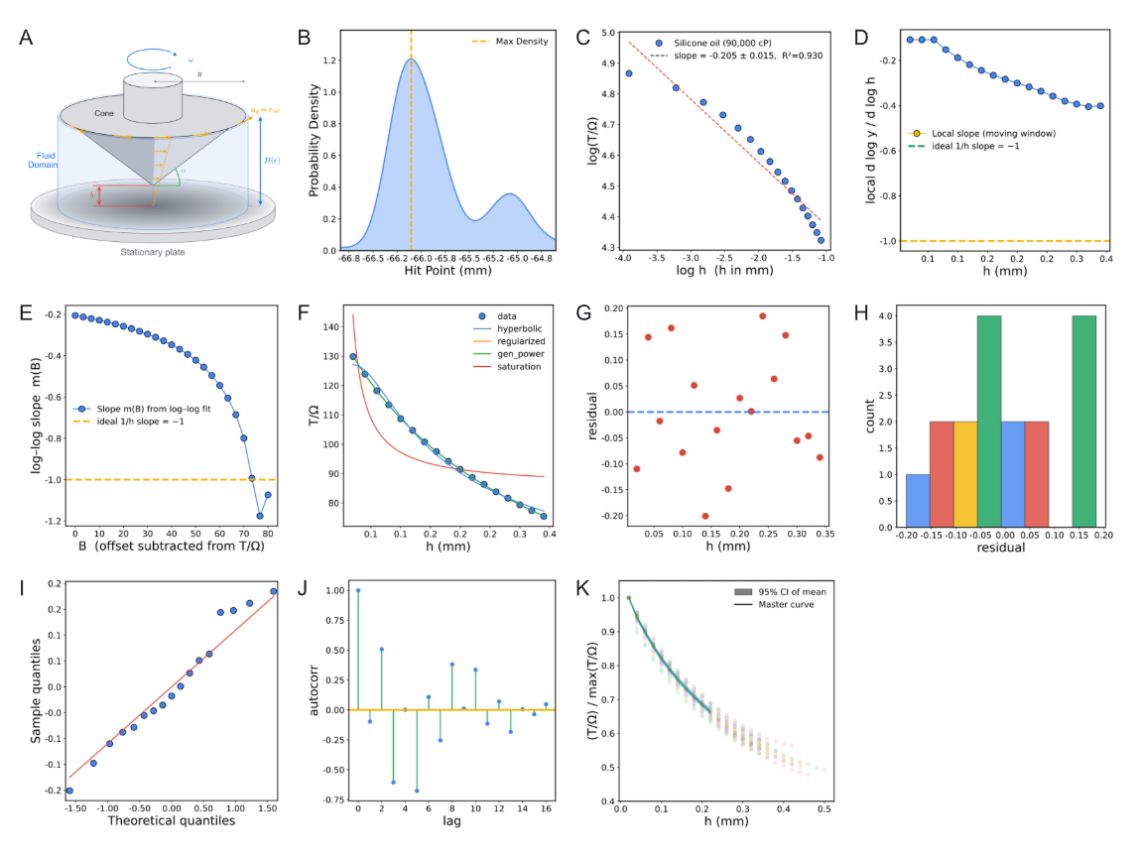
Figure 4. (A) Cone–plate geometry and definitions used in the lubrication-theory model. (B) Uncertainty caused by mechanical components’ accuracy as effective positional variance. (C) Scaling diagnosis of D(h) on the focus silicone. (D) Local slope drift away from −1 at intermediate gaps motivates regularization of the hyperbolic form. (E) Offset-scan diagnostic with a plateau near slope of −1.0 supports a hyperbolic core with a non-trivial baseline term. (F) Physical-space model comparison on the focus silicone dataset. (G-J) Residual and distribution diagnostics for the selected regularized-hyperbolic model. (K) Master-curve construction with bootstrap envelope and best global regularized fit.

2.3 Data-Analysis Pipeline: from Raw Data to Rheological Behaviour
Every automated-descent record (i.e., h, T(%), and Ω) passes through exactly one analysis pipeline, regardless of what fluid produced it.

2.3.1 Signal transformation and scaling diagnosis
Before any transformation is applied, each raw descent record is trimmed to discard data acquired after the spindle makes contact with the container floor. This prevents an end-of-travel collision that would otherwise inject non-physical torque spikes into the downstream gap–torque regression. Contact is detected in real time by a windowed statistical monitor that evaluates six diagnostic parameters computed over the rotational-drag signal D and its coefficient-of-variation transform CV(D): the coefficient of determination R² of D, of CV(D), and of the first time-derivative D′, together with the second time-derivatives D″, CV(D)″, and (D′)″. Each parameter carries an equal weight of 0.2 in a composite confidence score, so a given frame is flagged as a hit once at least four of the six indicators cross their respective anomaly thresholds simultaneously, i.e., a confidence score ≥ 0.8. To reject isolated noise transients that would otherwise register as false positives, the descent is terminated only after three consecutive hit-flagged frames, at which point the record is truncated to the last pre-contact sample before being passed to the transformation pipeline described below.
The first transformation is rotational-drag normalisation,
$$D≡\frac{T\left(\%\right)}{Ω}$$ | Eq. 8
which removes the trivial linear dependence of torque on angular speed for a Newtonian response and isolates the geometry–fluid coupling that remains. A global and local log-log slope diagnosis on the silicone (Fig. S2) set immediately ruled out the simplest hypothesis. Accordingly, no single power law D ∝ h−n explains the full descent range (Fig. 4C), because the local slope drifts toward −1 only near contact that means a pure 1/h model is asymptotically correct but globally incomplete (Fig. 4D).
To identify the correct baseline structure, we performed an offset-scan, subtracting candidate constants B from D and refitting the log-log slope on the positive residual (Fig. 4E); the resulting plateau near slope −1 confirmed the leading-order form D = A/h + B.

2.3.2 Model selection in physical space
Four candidate models (i.e., pure hyperbola, regularized hyperbola, generalized power, and saturation) were compared in physical space using bounded Levenberg-Marquardt fitting and ranked by R², adjusted R², AIC, BIC, and cross-validated RMSE (Fig. 4F). The regularized hyperbola won on every criterion:
$$D\left(h\right)=\frac{A}{h+h_{c}}+B$$ | Eq. 9
Here, A carries the viscosity information, h_{c} absorbs the effective zero-gap effects (slip layer, asperity, compliance, and residual geometric offsets), and B is a small parasitic baseline.
Residual diagnostics confirm that the selected model is unbiased and near-homoscedastic across gap height, supporting a stable downstream inverse calibration (Fig. 4G-J).

2.3.3 Universality of geometry shape and fixed-h_{c} production fitting
The factorization hypothesis D(h, μ) = A(μ) F(h) was tested directly: normalizing each sweep by its own maximum and overlaying all silicone traces on a common gap axis. Their collapse onto a single master shape (Figure 4K) validates a geometry-governed F(h) and a fluid-dependent amplitude (A). This is the central assumption that lets one calibration transfer across every subsequent fluid.
Figure 4K confirms that a global fit to this normalized master curve favours the regularized form as the most parsimonious representation, which justifies extracting a single universal geometric regularization length h⋆_{c} for production fitting.
Operationally, each sweep is first fitted with a free h_{c}, and the median of the high-quality fits (R² > 0.7, h_{c} ∈ [0.05, 1.5] mm) defines h⋆_{c}; every sweep is then refitted with h_{c} fixed at h⋆_{c}, which reduces parameter coupling and improves amplitude identifiability.

2.3.4 Calibration equations and constitutive extension
Silicone standards provide the one-shot amplitude–viscosity calibration,
$$\ln{A}=\ln{k}+p\ln{μ}⟺μ_{app}​={\left(\frac{A}{k​}\right)}^{1/p}$$ | Eq. 10
For non-Newtonian materials measured at multiple RPM values, the amplitude instead becomes shear-rate dependent,
$$A\left(\dot{γ}\right)=A_{0}{\dot{γ}}^{n-1}$$ | Eq. 11
so the slope of “ln A” versus “ln γ̇” returns the flow-behaviour index “n” directly. Shear stress follows from percent torque through the cone-plate conversion
$τ\left[Pa\right]=c_{τ}T\left(\%\right)$, $c_{τ}=\frac{3\left(M_{full}/100\right)}{2πR^{3}}≈1.986 Pa/\%$ | Eq. 12
Uncertainty and robustness are quantified throughout by leave-the-k-smallest-out sensitivity on near-contact points, 500-iteration bootstrap confidence bands for (A, h_{c}, B), and a distributional analysis of per-sweep h_{c} for universality checking.
Accordingly, the data-analysis pipeline as an inference chain (Figure 5), executed identically for Newtonian and non-Newtonian materials with no per-chemistry redesign: the burden of adapting to a new chemistry falls entirely on the data, never on the code.
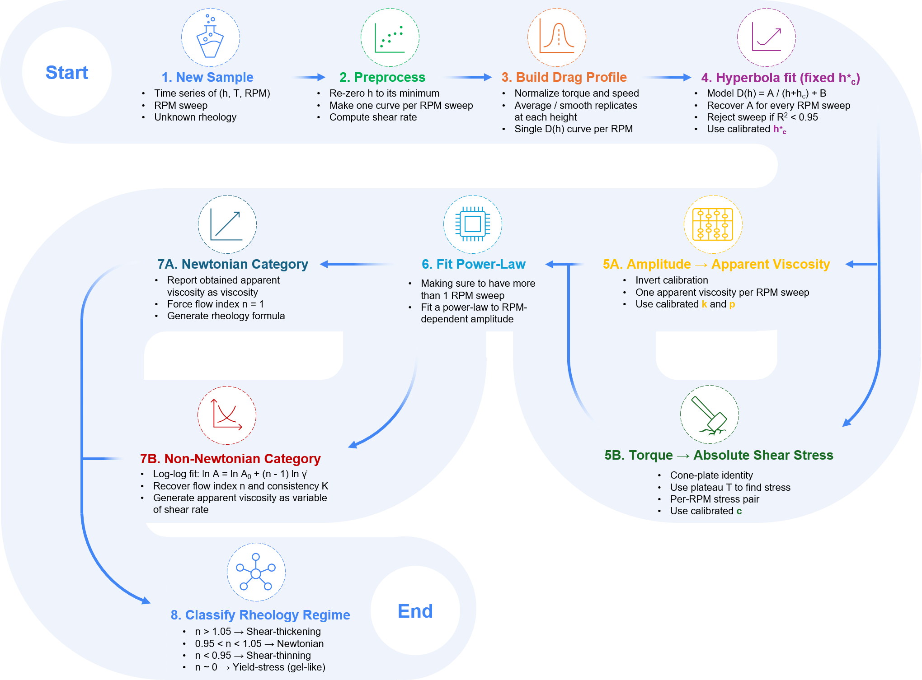
Figure 5. Inference-time view of the physics-constrained analysis pipeline. Annotations mark the universal constants (h⋆_{c}, k, p, c_{τ}) calibrated once and reused across chemistry families.

2.4 Software Orchestration
Rotational sensing, robotic positioning, and washing are integrated within a single control plane. The torquemeter is paired with the three-axis CNC stage for programmable traversal and repeatable spindle alignment, with all machine-level coordinates (e.g. sample and washing positions, safe-height offsets, per-cell calibration) parameterized through YAML files so the deck layout can be reconfigured without touching the control software. An ESP32 microcontroller runs the washing subsystem: a custom PCB with PWM-driven L298N motor drivers actuates six pumps and three agitation motors through a multiplexed, diode-isolated channel-sharing configuration, executing detergent/water/isopropanol rinse cycles from a minimal host command interface (Fig. S3).
At the host level, a dual-Python asynchronous architecture accommodates the torquemeter's proprietary 32-bit communication DLL while centralizing orchestration: a 64-bit runtime handles workflow execution, G-code motion control, washing sequencing, and data logging, exchanging data with the isolated 32-bit torquemeter runtime through synchronized file-based communication. Modular hardware-abstraction layers (CNC, viscometer, washing, analysis trigger) enable the non-blocking, concurrent execution of motion, acquisition, and washing that underlies the platform's throughput, alongside traceability (calibration status, software version, environmental conditions) and recovery mechanisms (instrument reconnection, safe-motion interruption). A real-time web dashboard exposes live torque-displacement traces, batch progress, and manual override/abort/calibration controls, closing each batch with an automated report of per-cell results.
Figure 6 traces this coordination end-to-end: dashboard input/output screenshots (Fig. 6A) and a Sankey diagram (Fig. 6B) show operator actions at the Web Interface flowing through the Python runtimes to the Hardware layer, coordinated by the Workflow Engine into the Data-Analysis Pipeline and out to the recovered rheological outputs — so every result remains traceable back to the workflow decision, hardware channel, and operator input that produced it.
An end-to-end trace of this coordination maps operator actions from the Web Interface through the Python runtimes to the Hardware layer (Fig. 6A-B). The Workflow Engine coordinates these steps into the Data-Analysis Pipeline and out to the recovered rheological outputs, ensuring every result remains traceable back to the workflow decision, hardware channel, and operator input that produced it (Fig. 6C).
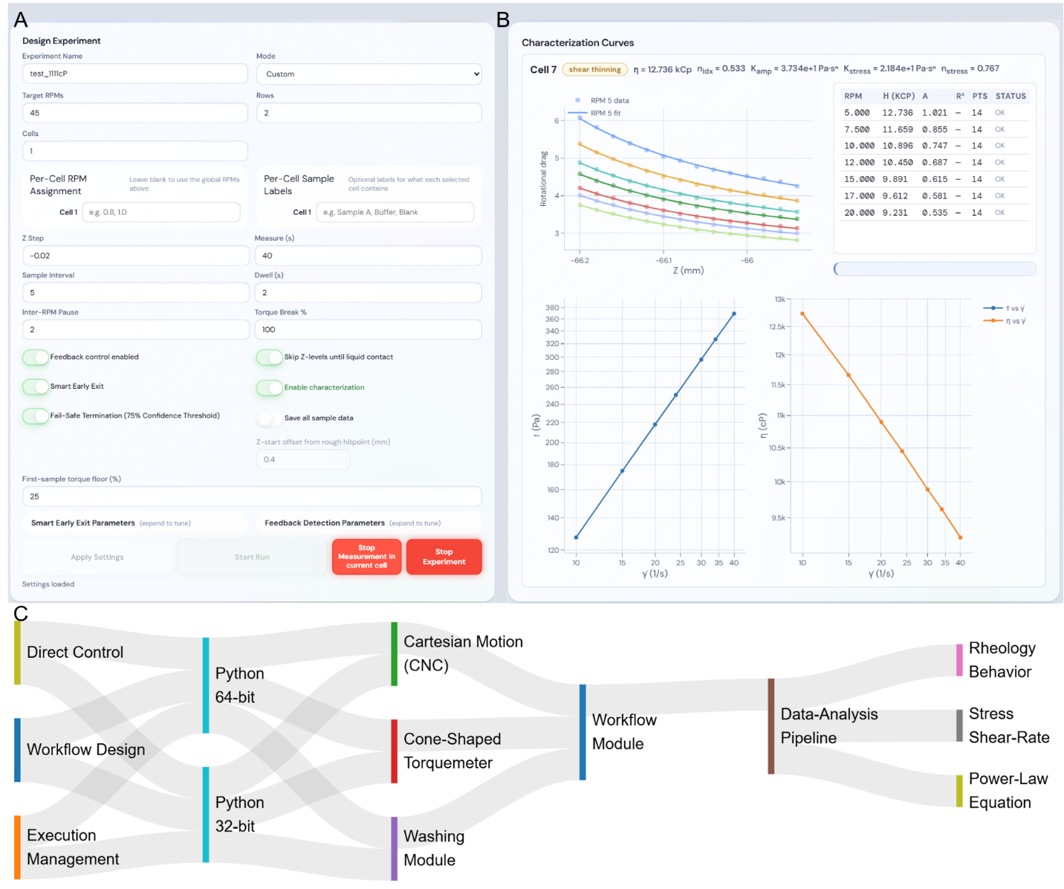
Figure 6. Representative web-interface screenshots: (A) the operator input screen for entering known material properties or experimental conditions. (B) Live recorded rotational drag and final characterization curve of material with determined power-law equation parameters. (C) Diagram of the multi-layer orchestration architecture, with ribbons showing the flow of control and data from the Web Interface, through the Python environments and Hardware, into the Workflow Engine and Data-Analysis Pipeline, and out to the Scientific Outputs.

3. Results and Discussion
The Methods section fixes every equation, fitting rule, and uncertainty calculation used below; what follows is the experimental evidence and its scientific interpretation, presented in two stages: first the acquisition reproducibility and statistical robustness of the automated measurement layer, then the material-level rheological performance across Newtonian and non-Newtonian classes.

3.1 Acquisition Performance and Reproducibility
We evaluated the automated measurement layer using silicone oils spanning 1–125 kcP, a Newtonian reference family for calibration and reproducibility testing. Two questions were addressed: can viscosity be recovered accurately, and do the raw drag signatures acquired during spindle descent contain a transferable physical structure that automated inference can exploit?
Figure 7A shows representative rotational-drag traces during descent: drag rises monotonically as the gap closes, consistent with lubrication-type flow, and traces remain systematically ordered by viscosity throughout. At this stage of the study, before a per-cell calibration mode existed, the recorded height window was sample-dependent rather than fixed: pooled across the library the stage traversed 1.9 mm (-66.4 to -64.5 mm) in total, but individual sweeps covered as little as ~0.16 mm (120 kcP) to ~0.88 mm (1 kcP). This was not a torque limitation as the 120 kcP oil is still only at 50% of full-scale torque at this gap, but reflected the lack of a standardized per-cell descent window. Per-cell calibration now standardizes the sweep to ~0.4 mm for every cell (≈20 Z-height measurements feeding the rheology pipeline), the protocol used for all subsequently calibrated tests; even so, drag remains far from interchangeable across viscosity, with 1 kcP never exceeding D ≈ 0.56 while 120 kcP never falls below D ≈ 250. The raw torque–gap data used for model fitting displays distinct limits at the smallest gaps (Fig. 7B). Under these conditions, the highest-viscosity oils read up to 160% of the sensor's rated full-scale torque, where 100% equals 7187.0 dyne·cm. Because of this, these near-contact readings carry a priori lower confidence. This instrumentation ceiling is flagged as a target for a future hardware revision. Fitting each curve with D(h) = A/(h + h_{c}) + B and normalizing as (D-B)/A tests whether the gap dependence is universal. The fitted gap dependence is approximately shared across the silicone standards, as their normalized traces collapse from sample-dependent values of 3–7 at zero gap onto a common value of approximately 1.5 at a 600 µm gap (Fig. 7C). This behavior isolates viscosity entirely in the amplitude (A). This approximate factorization supports reuse of the silicone-derived calibration without chemistry-specific retuning, provided the measurements remain within the instrument’s valid operating window. The ability to wash the cone between highly viscous polymer samples is equally important for obtaining comparable repeated measurements. This calibration holds up under study. Predicted and reference viscosities track the parity line across more than two orders of magnitude, with 22 of 23 samples (95.7%) falling within 10% (Fig. 7D). The single outlier at 87.0 kcP sits at +13.9%. Furthermore, there is no systematic error trend relative to viscosity (Fig. 7E). Errors are narrowly distributed around zero, featuring a mean of +0.9% and a standard deviation of 4.6%, with 74% of samples landing within ±5% (Fig. 7F). The same agreement is confirmed on a sample-by-sample basis (Fig. 7G). However, absolute error still scales with viscosity magnitude. It registers at approximately 360 cP (2.7%) in the lower half of the range versus roughly 3,340 cP (4.2%) in the upper half. This represents a nearly nine-fold increase in absolute terms, even though the relative error stays in the single digits throughout.
We next asked whether the fitted geometric parameter h_{c} reflects the actual measurement geometry rather than being a fitting artifact. To test this, we performed a leave-the-k-smallest-out analysis (Fig. 7H). The value of h_{c} drifts only mildly as near-contact points are discarded. It shifts 26%, moving from 0.335 mm with the full dataset to 0.422 mm when six points are removed. Meanwhile, its standard error grows from ±0.005 to ±0.024 mm, which represents a graceful loss of precision. Throughout this process, (A) remains essentially unaffected. Bootstrap resampling agrees with these findings. Figure 7I shows every point of a representative sample falling inside a narrow 95% reconstruction band. Additionally, Figure 7J demonstrates that the bootstrap distribution of h_{c} is narrow and unimodal. It features a median of 0.23 mm, a standard deviation of 0.10 mm, and a 95% confidence interval of 0.14–0.50 mm. These values are small relative to the viscosity span of the set. This evidence supports treating h_{c} as a geometry-linked constant that can be fixed globally. Fixing this value successfully reduces the inverse problem to just two free parameters. Consequently, uncertainty from the fitting layer is well below the material-to-material variation the system is designed to resolve. Mechanical imperfections like backlash, compliance, wetting variability, and positioning error are effectively absorbed into the regularized drag representation. This absorption occurs smoothly without compromising viscosity recovery.
Figure 7K benchmarks the platform against a human operator on three viscosities (1, 10, and 60 kcP). Fitting the same regularized hyperbolic drag model to all nine traces (including manual and automated alike) gives R² of 0.982–0.996 in every case, confirming both acquisition modes are governed by the same underlying physical drag law despite differing raw amplitudes from separate gap-zero references. The platform therefore reproduces the same physics a trained operator would extract by hand. A throughput context shows that the full acquisition, washing, analysis, and handling sequence processed 18 samples in approximately 5 hours without operator intervention (Fig. 7L). Excluding the upstream formulation steps common to both workflows, characterization and washing required 27.0 hours of continuous manual operation versus 5.7 hours of unattended robot time. This represents a saving of 21.3 hours, or a roughly 4.7-fold reduction, achieved without sacrificing data quality and establishing the automated layer as a practical foundation for future closed-loop rheology-discovery campaigns.
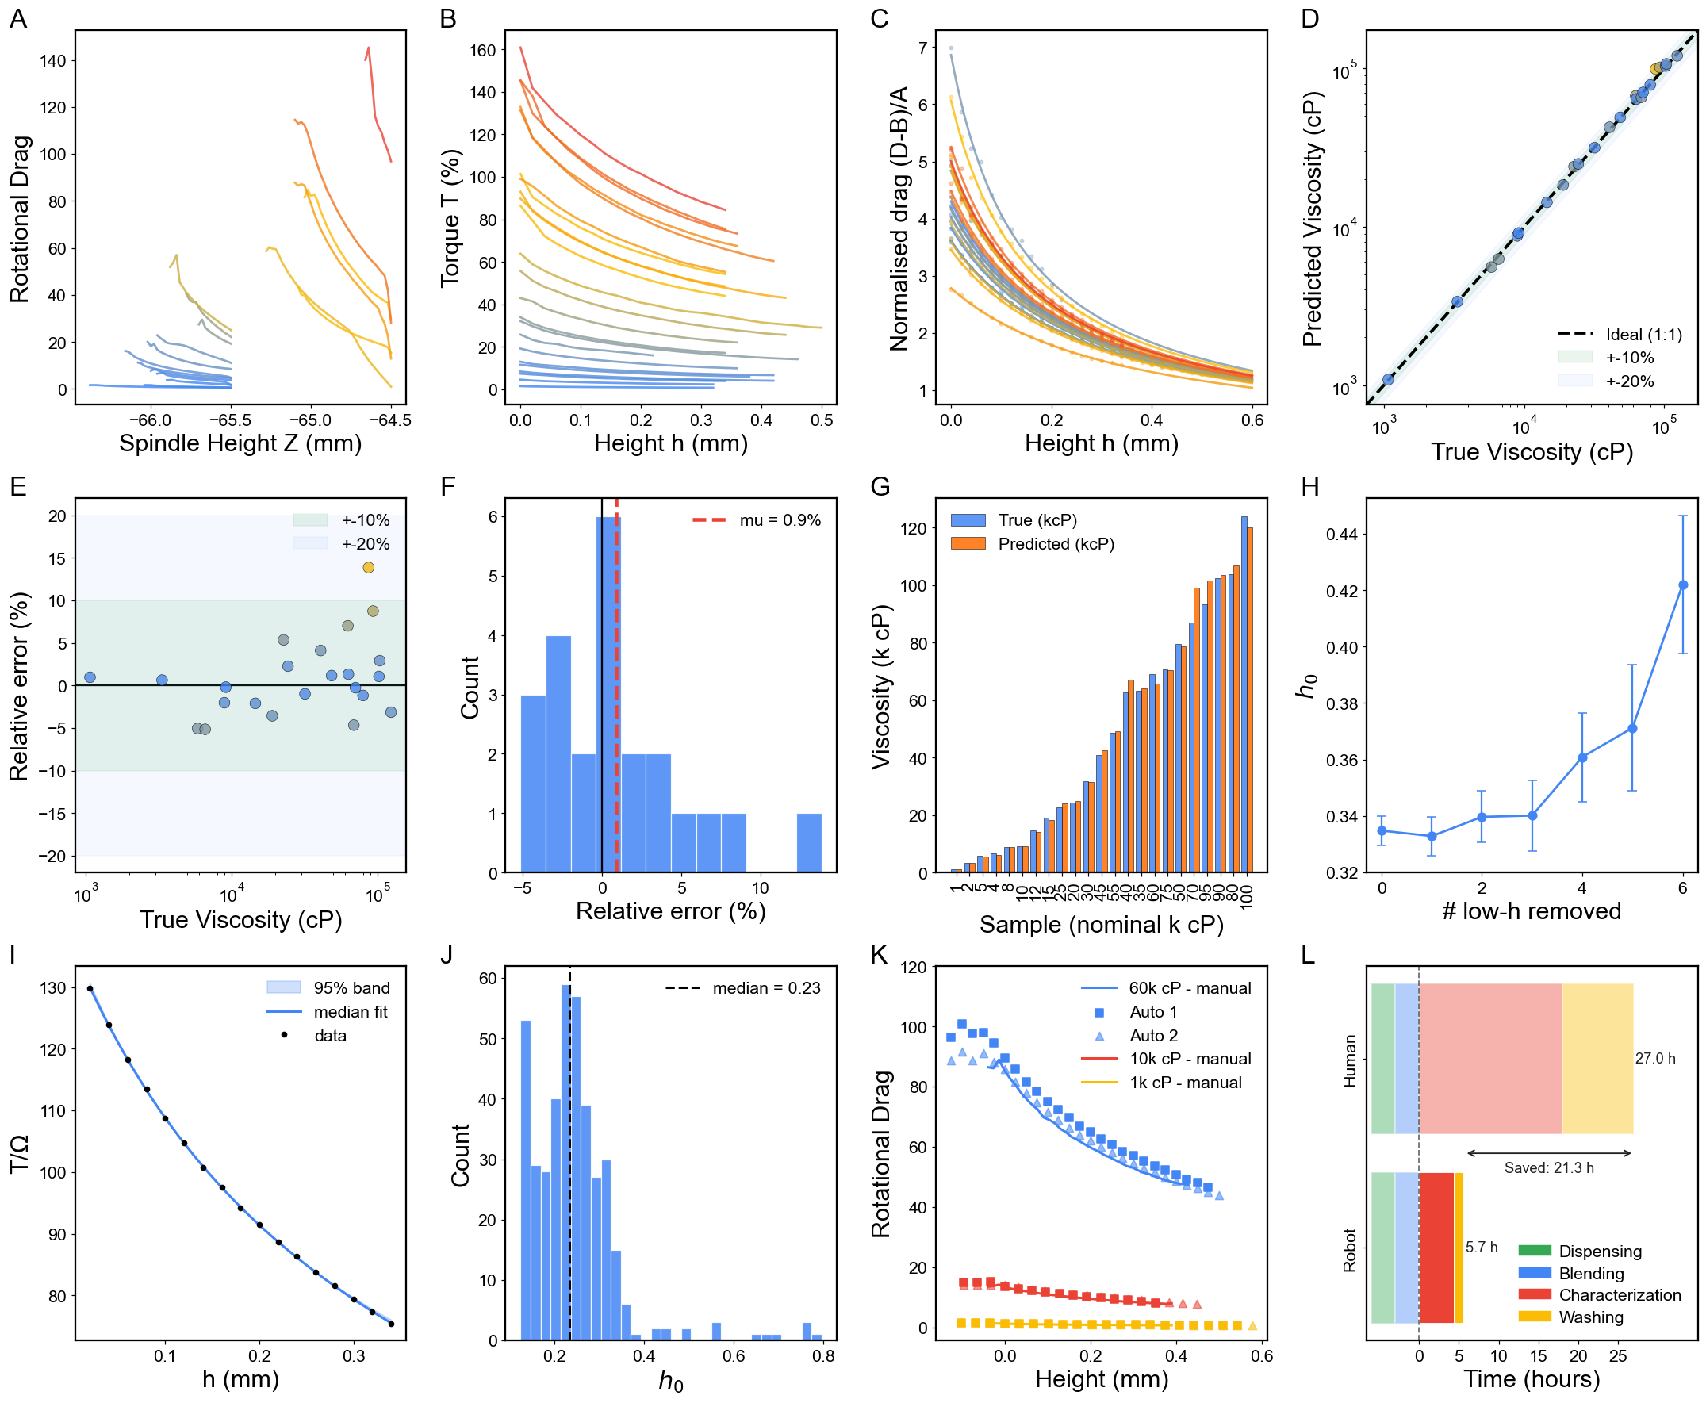
Figure 7. Calibration, validation and robustness of the automated viscometry platform. (A) Rotational drag profiles acquired during spindle descent for silicone oils spanning the calibration range. (B) Raw torque–gap data used for model fitting. (C) Collapse of normalized drag profiles onto a universal master curve, indicating geometry-controlled gap dependence and viscosity-dependent amplitude scaling. (D) Predicted versus reference viscosities. (E) Relative prediction error as a function of viscosity. (F) Distribution of prediction errors across all calibration measurements. (G) Sample-by-sample comparison of reference and predicted viscosities. (H) Sensitivity of the fitted geometric length scale (h_{c}) to removal of near-contact data points. (I) Bootstrap reconstruction of a representative drag profile showing the median fit and 95% confidence interval. (J) Bootstrap distribution of (h_{c}), supporting its interpretation as a geometry-linked parameter. (K) Comparative Evaluation of Human and Robotic Data Acquisition. (L) Time breakdown of the autonomous workflow compared with an equivalent manual procedure, demonstrating high-throughput operation of the platform.

3.2 Material Performance: Newtonian and Non-Newtonian Materials
Acquisition-level reproducibility answers only part of the question; the platform must also recover physically meaningful rheology across distinct chemistries using one fixed inference workflow. The central test is not whether the system repeats, but whether it preserves constitutive meaning as the material moves from a Newtonian standard to a complex, structure-forming formulation. Figure 8 assembles the composite evidence.

3.2.1 Lubricant (Newtonian Anchor)
Silicone oils serve as the Newtonian anchor and validate the core decoding hypothesis: the drag-amplitude signal maps onto a stable apparent viscosity without geometry-specific retuning. Figure 8A-1 shows the expected single-regime drag response, and the reconstructed stress–shear-rate behaviour stays close to linear which is a near-constant apparent viscosity (μ_{app}) over the measured window (Fig. 8A-2). Fitting τ=Kγ̇ⁿ to six representative sweeps returns n=1.00 in every case, the exact Newtonian value, while the consistency index K (i.e. numerically equal to the apparent viscosity under the cone geometry) spans 15.4–65.7 Pa·s across the samples. The uniform n=1.00 shows the pipeline classifies Newtonian behaviour unambiguously regardless of viscosity, while the spread in K confirms it simultaneously tracks that viscosity's magnitude. This is exactly what a chemically simple, weakly structured fluid should return, and the physics-based baseline against which the non-Newtonian results below are anchored.

3.2.2 Rheology Modifier Materials
Applying the same pipeline to high molecular weight PEGs (Poly(ethylene glycol), Polyox™ WSR N750-300K and Polyox™ WSR 205-600K, IFF), Sepineo™ 600 (Acrylamide/Sodium Acryloyldimethyltaurate Copolymer, Seppic), Solagum™ SF 306 (Acacia Senegal Gum + Xanthan Gum), and Carbopol® 980 (crosslinked poly(acrylic acid, Lubrizol) under multi-RPM sweeps traces a chemically interpretable progression from Newtonian-like to strongly non-Newtonian behaviour. PEG shows mild-to-moderate shear thinning, consistent with chain alignment reducing hydrodynamic resistance at higher shear rates (Fig. 8B). The n value for PEG-300K rises slightly from 0.82 (5%) to 0.88 (10%) as K rises from 13.9 to 28.8, while the n value for PEG-600K falls from 1.05 (5%, essentially Newtonian) to 0.74 (6.5%) as K rises from 18.4 to 35.1. At a matched ~5% loading, the higher K value for PEG-600K (18.4 vs. 13.9) flags its higher viscosity even before either grade departs from Newtonian behaviour. Sepineo and Solagum shear-thin more strongly, reflecting progressive breakdown and reorganization of polymer-entangled and associative networks under shear [53] (Fig. 8C-D). The n value for Sepineo drops from 0.69 (1%) to 0.64 (1.5%) before recovering to 0.69 (2%) as K rises from 18.8 to a maximum of 35.9 (1.5%) then falls to 31.1 (2%). This behaviour is non-monotonic but confined to a narrow n=0.64–0.69 band, suggesting a network structure not strongly concentration-sensitive over this range. Solagum trends more cleanly: n falls from 0.72 (1%) to 0.71 (2%) to 0.63 (2.5%) as K rises from 16.8 to 27.8 to 30.0, becoming both more shear-thinning and more viscous with concentration. Carbopol approaches yield-pseudoplastic behaviour, with an apparent low-shear resistance that gives way to flow once the material yields [51] (Fig. 8E). Parameter n falls sharply from 0.56 (0.3%) to 0.39 (0.4%), the strongest shear-thinning of any modifier tested, and the 0.3% fit is markedly poorer (R²=0.85) than the other modifier fits (R²≥0.99). This disparity is a signature of the low-shear yield plateau that a pure power law cannot fully capture. This progression emerges from a single calibrated model stack: the chemistry-specific behaviour is resolved by the data, not imposed by per-material tuning.

3.2.3 Thermal Interface Materials
Thermal interface material (TIM) formulations including SYY, Sekisui B-41, and HY-500 (Halnzie), push the test space toward highly filled, application-driven materials with complex internal architecture. The platform still returns stable drag-to-stress reconstructions within the same autonomous workflow (Fig. 8F-H), but density and fit quality both degrade relative to the lubricants and modifiers. SYY's raw drag profile is visibly non-smooth (Fig. 8F-1), and that noise propagates into the fitted power law τ=21.6γ̇^{0.92}, which achieves only R²=0.65 (Fig. 8F-2). This is far below the modifier fits above as most readings for this high-viscosity, low-torque-margin sample fall above the sensor's accurate range. Sekisui B-41 also shear-thins (Fig. 8G), but only three spindle-height conditions stayed within the measurable torque window before lower gaps exceeded it, leaving a fit of τ=41.7γ̇^{0.31} at only R²=0.47. HY-500 (Fig. 8H) appears shear-thickening, with a fitted τ=452γ̇^{1.81}, but that inference rests on only two measured points plus the origin with the nominal R²=1.00 carries no real statistical weight with so few degrees of freedom, so the trend should be read as preliminary rather than definitive. Both limitations trace to the same hardware ceilings (i.e. a maximum measurable torque of 7187.0 dyne·cm and a minimum spindle speed of 0.1 rpm) which compress the usable operating window for high-viscosity TIM systems into a handful of points; the TIM results are best read as feasibility-level evidence, a target for the next hardware iteration's torque range and low-speed control rather than a pipeline limitation.
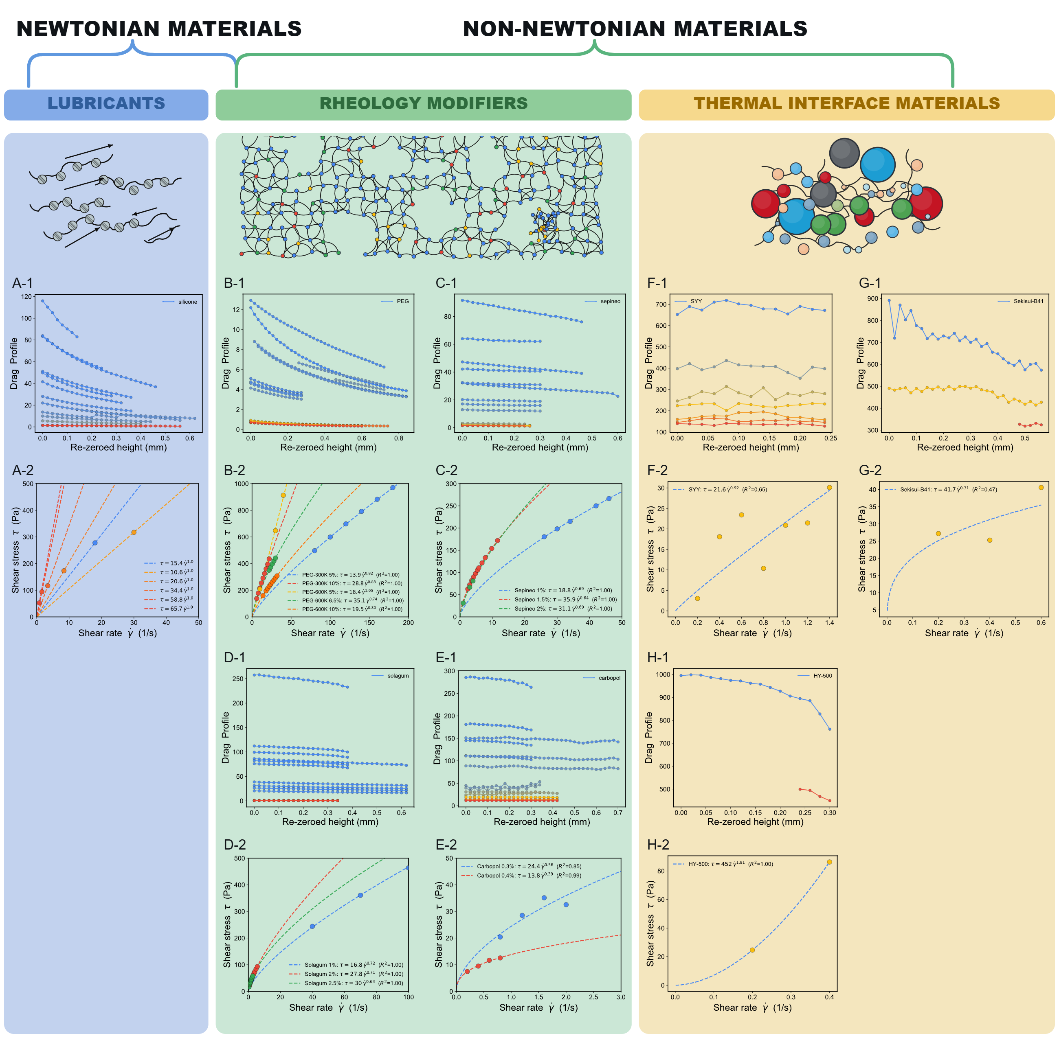
Figure 8. Rheology overview of representative Newtonian lubricants and non-Newtonian rheology modifiers/thermal interface materials, showing paired experimental responses for each formulation: drag-response profiles (panels ending in 1, e.g. A-1, B-1, etc.) and corresponding stress-based rheology curves (panels ending in 1, e.g. A-2, B-2, etc.). Specifically, (A) silicone, (B) PEG, (C) Sepineo, (D) Solagum, (E) Carbopol, (F) SYY, (G) Sekisui B-41, and (H) HY-500.
Figure 9 consolidates the central result of the workflow by placing every material on a single apparent-viscosity–shear-rate map, where rheological class is encoded directly by slope and curvature rather than isolated viscosity values. Silicone sits on a near-horizontal Newtonian line, confirming that the calibration backbone stays physically coherent across the tested shear-rate window, while PEG, Solagum, Sepineo, and Carbopol peel away to progressively steeper fitted power-law slopes (n<1) presenting shear-thinning responses of increasing strength, all captured by the same inference chain with no chemistry-specific retuning. That the geometry-normalized drag formalism and fixed-parameter calibration transfer preserve constitutive meaning across such mechanistically distinct formulations is the central objective of the developed rheogram. This is also operationally useful, letting one rank materials by process-relevant shear response (e.g. pumpability, spreadability, coating behaviour) within a single consistent coordinate system.
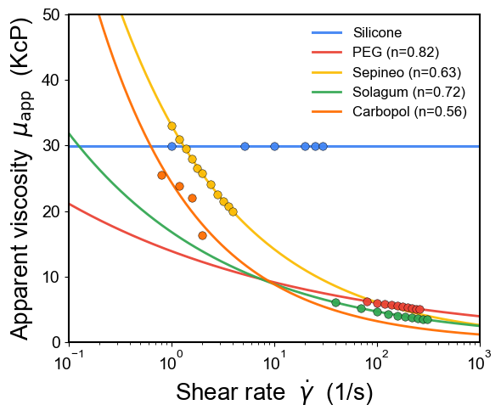
Figure 9. Master flow-curve comparison of representative formulations across material families, plotted as apparent viscosity versus shear rate.
Positioned against the automated-viscometry benchmarks, the platform occupies a materially different point in the accuracy–range–constitutive–detail space. The OT-2 pipetting proxies [46,47] and the camera–based inverted–vial method [49] each return a single apparent viscosity per fluid, are limited to Newtonian or weakly non–Newtonian behavior, and cover at most three decades of viscosity (e.g. 20–20,000 cP [47] or 0.01–1,000 Pa·s [49]) at 6.5–25% error. The present platform measures liquid viscosity across a massive range, from very thin to incredibly thick liquids (1–125,000 cP). Instead of giving just one simple number, it provides a highly detailed map of how a liquid flows under pressure. Even though it gives ten times more data than standard fast testing methods, it remains incredibly accurate. Tests are within 3.4% of the exact value on average, making it just as reliable as slower, traditional laboratory equipment. This trades per-sample speed for high-throughput autonomy. While a pipetting proxy requires only one dispense stroke, our platform performs a multi-height, multi-RPM descent and wash cycle, making it optimal for batch processing (18 samples in ~5 h autonomously) rather than rapid single-sample dispensing. Unlike RheoSense-type commercial microfluidic viscometers, which likewise report a single apparent viscosity per loading, the platform autonomously classifies Newtonian, shear-thinning, and yield-pseudoplastic regimes from one universal calibration, extending automated characterization from proxy Newtonian screening to full non-Newtonian constitutive discovery.

4. Conclusion
We have presented an automated viscometry platform converting torque measurements acquired during multi-speed spindle descents into a calibrated stress–shear-rate flow curve via one physics constrained inference pipeline, integrating a Cartesian motion stage, cone shaped rotational torquemeter, and dual stage washing module. Calibrated once on Newtonian silicone oils, the pipeline transfers with no retuning across six material families spanning 0.001–125 Pa·s (1–125,000 cP); the Newtonian silicone calibration showed a 3.4% mean absolute error, while cutting characterization time 4.7 fold relative to manual operation. Backlash limited positioning and the absence of an operator tuned gap are absorbed as fitted nuisance parameters rather than engineered away. The platform's viscosity ceiling is set by the torquemeter, not the inference pipeline: its torque spring caps full scale torque at 7,187 dyne·cm with a 0.1 rpm speed floor, leaving only two to three usable spindle height conditions per thermal interface material sample before torque saturated. Because the torquemeter sits behind a hardware abstraction layer, it can be swapped for one of several commercially available torquemeters offering substantially wider torque and speed ranges without redesigning the platform, leaving the CNC stage, washing module, and inference pipeline unchanged. This decoupling of transducer from architecture supports the platform as a measurement layer for closed loop rheology discovery campaigns driven by Bayesian optimization and active learning, with planned extensions toward Carreau and Cross shear-rate-dependent viscosity fits, as well as Herschel Bulkley/Maxwell constitutive models, inverse molecular interaction inference, inline NIR/Raman monitoring, and multi spindle scaling.

Author contributions
Drs F. Le Devedec and M. M. Rastegardoost led the conceptualization, platform design, computational studies, and data analysis. I. Ngunga and K. Gaborekwe contributed to software development, platform setup, and experimental studies. M. M. Rastegardoost wrote the original manuscript draft. Prof. H. Naguib and Dr Z. Bao contributed to data analysis and manuscript review and editing.

Conflicts of interest
The authors declare that they have no known competing financial interests or personal relationships that could have appeared to influence the work reported in this paper.

Data availability
Data, code, and the hardware assembly guide associated with this work are publicly available on GitHub at https://github.com/AC-Formulations-SDL5/HTDPA_Analyzer XXXX DOI ….

Acknowledgements
This research was undertaken thanks in part to funding provided to the University of Toronto’s Acceleration Consortium from the Canada First Research Excellence Fund (CFREF-2022-00042) and from our industrial partner SEKISUI CHEMICAL CO., LTD.

5. References
[1] M.M. Rastegardoost, O.A. Tafreshi, Z. Saadatnia, S. Ghaffari-Mosanenzadeh, C.B. Park, H.E. Naguib, Recent advances on porous materials and structures for high-performance triboelectric nanogenerators, Nano Energy 111 (2023) 108365. https://doi.org/10.1016/J.NANOEN.2023.108365.
[2] M.M. Rastegardoost, O.A. Tafreshi, Z. Saadatnia, S. Ghaffari-Mosanenzadeh, C.B. Park, H.E. Naguib, Porous PVDF mats with significantly enhanced dielectric properties and novel dipole arrangement for high-performance triboelectric nanogenerators, Appl. Mater. Today 30 (2023) 101732. https://doi.org/10.1016/J.APMT.2023.101732.
[3] M.M. Rastegardoost, O.A. Tafreshi, Z. Saadatnia, S. Ghaffari-Mosanenzadeh, P. Serles, T. Filleter, C.B. Park, H.E. Naguib, Highly durable triboelectric nanogenerators based on fibrous fluoropolymer composite mats with enhanced mechanical and dielectric properties, Mater. Today Energy 38 (2023) 101431. https://doi.org/10.1016/J.MTENER.2023.101431.
[4] M.M. Rastegardoost, O.A. Tafreshi, S. Ghaffari-Mosanenzadeh, C.B. Park, H.E. Naguib, Ultra-lightweight aerogel-fibrous material with high thermal stability and boosted triboelectricity for crack detection in harsh environments, Mater. Today Energy 56 (2026) 102221. https://doi.org/10.1016/J.MTENER.2026.102221.
[5] M.M. Rastegardoost, O. Aghababaei Tafreshi, S. Ghaffari-Mosanenzadeh, Z. Saadatnia, C.B. Park, H.E. Naguib, Ultra-lightweight aerogel composites for sound-driven triboelectric nanogenerator, Nano Energy 136 (2025) 110765. https://doi.org/10.1016/J.NANOEN.2025.110765.
[6] A. Martini, U.S. Ramasamy, M. Len, Review of Viscosity Modifier Lubricant Additives, Tribology Letters 2018 66:2 66 (2018) 58-. https://doi.org/10.1007/S11249-018-1007-0.
[7] C.S. Wang, G. Chapelle, P. Carreau, M.C. Heuzey, Prediction of sag resistance in paints using rheological measurements, Prog. Org. Coat. 153 (2021) 106139. https://doi.org/10.1016/J.PORGCOAT.2021.106139.
[8] R. Bhavsar, S. Shreepathi, Evolving empirical rheological limits to predict flow-levelling and sag resistance of waterborne architectural paints, Prog. Org. Coat. 101 (2016) 15–23. https://doi.org/10.1016/J.PORGCOAT.2016.07.016.
[9] R.P. Watt, H. Khatri, A.R.G. Dibble, Injectability as a function of viscosity and dosing materials for subcutaneous administration, Int. J. Pharm. 554 (2019) 376–386. https://doi.org/10.1016/J.IJPHARM.2018.11.012.
[10] J. Kim, E.H. Jeong, J.H. Baik, J.D. Park, The role of rheology in cosmetics research: a review, Korea-Australia Rheology Journal 2024 36:4 36 (2024) 271–282. https://doi.org/10.1007/S13367-024-00108-Y.
[11] M. Franceschini, F. Pizzetti, F. Rossi, On the Key Role of Polymeric Rheology Modifiers in Emulsion-Based Cosmetics, Cosmetics 2025, Vol. 12, Page 76 12 (2025) 76. https://doi.org/10.3390/COSMETICS12020076.
[12] S. Sun, M. Li, A. Liu, A review on mechanical properties of pressure sensitive adhesives, Int. J. Adhes. Adhes. 41 (2013) 98–106. https://doi.org/10.1016/J.IJADHADH.2012.10.011.
[13] M. Laun, D. Auhl, R. Brummer, D.J. Dijkstra, C. Gabriel, M.A. Mangnus, M. Rüllmann, W. Zoetelief, U.A. Handge, Guidelines for checking performance and verifying accuracy of rotational rheometers: Viscosity measurements in steady and oscillatory shear (IUPAC Technical Report), Pure and Applied Chemistry 86 (2014) 1945–1968. https://doi.org/10.1515/PAC-2013-0601/XML.
[14] C.W. Macosko, Rheology - Principles, Measurements and Applications - 6. Shear Rheometry: Pressure Driven Flows, Rheology - Principles, Measurements and Applications (1994) 237–283. https://www.wiley.com/en-us/rheology-principles-measurements-and-applications-p-9780471185758 (accessed July 6, 2026).
[15] L. Grunberg, A.H. Nissan, Mixture Law for Viscosity, Nature 1949 164:4175 164 (1949) 799–800. https://doi.org/10.1038/164799b0.
[16] M. Ramírez-De-Santiago, Viscosity of Binary Liquid Mixtures: A Comparative Analysis of Mixing Rules, Ind. Eng. Chem. Res. 63 (2024) 22470–22480. https://doi.org/10.1021/ACS.IECR.4C03240.
[17] O. Redlich, A.T. Kister, Algebraic Representation of Thermodynamic Properties and the Classification of Solutions, Ind. Eng. Chem. 40 (2002) 345–348. https://doi.org/10.1021/IE50458A036.
[18] W. Marczak, N. Adamczyk, M. Łężniak, Viscosity of Associated Mixtures Approximated by the Grunberg-Nissan Model, International Journal of Thermophysics 2011 33:4 33 (2011) 680–691. https://doi.org/10.1007/S10765-011-1100-1.
[19] R.C. Boehm, F. Hauck, Z. Yang, C.T. Wanstall, J.S. Heyne, Error quantification of the Arrhenius blending rule for viscosity of hydrocarbon mixtures, Front. Energy Res. 10 (2022) 1074699. https://doi.org/10.3389/FENRG.2022.1074699/TEXT.
[20] S. Machefer, K. Schnitzlein, Ideal Mixing Rules for the Viscosity of Complex Polymer−Solvent Mixtures: Assessment of Segment-Fraction Approximations, Ind. Eng. Chem. Res. 45 (2006) 7293–7300. https://doi.org/10.1021/IE060429K.
[21] G. Strotos, M. Gavaises, A. Theodorakakos, G. Bergeles, Numerical investigation of the evaporation of two-component droplets, Fuel 90 (2011) 1492–1507. https://doi.org/10.1016/J.FUEL.2011.01.017.
[22] R. Kol, P. Nachtergaele, T. De Somer, D.R. D’Hooge, D.S. Achilias, S. De Meester, Toward More Universal Prediction of Polymer Solution Viscosity for Solvent-Based Recycling, Ind. Eng. Chem. Res. 61 (2022) 10999–11011. https://doi.org/10.1021/ACS.IECR.2C01487.
[23] M. Abolhasani, E. Kumacheva, The rise of self-driving labs in chemical and materials sciences, Nature Synthesis 2023 2:6 2 (2023) 483–492. https://doi.org/10.1038/s44160-022-00231-0.
[24] G. Tom, S.P. Schmid, S.G. Baird, Y. Cao, K. Darvish, H. Hao, S. Lo, S. Pablo-García, E.M. Rajaonson, M. Skreta, N. Yoshikawa, S. Corapi, G.D. Akkoc, F. Strieth-Kalthoff, M. Seifrid, A. Aspuru-Guzik, Self-Driving Laboratories for Chemistry and Materials Science, Chem. Rev. 124 (2024) 9633–9732. https://doi.org/10.1021/ACS.CHEMREV.4C00055.
[25] B. Burger, P.M. Maffettone, V. V. Gusev, C.M. Aitchison, Y. Bai, X. Wang, X. Li, B.M. Alston, B. Li, R. Clowes, N. Rankin, B. Harris, R.S. Sprick, A.I. Cooper, A mobile robotic chemist, Nature 2020 583:7815 583 (2020) 237–241. https://doi.org/10.1038/s41586-020-2442-2.
[26] C.W. Coley, D.A. Thomas, J.A.M. Lummiss, J.N. Jaworski, C.P. Breen, V. Schultz, T. Hart, J.S. Fishman, L. Rogers, H. Gao, R.W. Hicklin, P.P. Plehiers, J. Byington, J.S. Piotti, W.H. Green, A. John Hart, T.F. Jamison, K.F. Jensen, A robotic platform for flow synthesis of organic compounds informed by AI planning, Science (1979). 365 (2019). https://doi.org/10.1126/SCIENCE.AAX1566;WEBSITE:WEBSITE:AAAS-SITE;JOURNAL:JOURNAL:SCIENCE;WGROUP:STRING:PUBLICATION.
[27] N.J. Szymanski, B. Rendy, Y. Fei, R.E. Kumar, T. He, D. Milsted, M.J. McDermott, M. Gallant, E.D. Cubuk, A. Merchant, H. Kim, A. Jain, C.J. Bartel, K. Persson, Y. Zeng, G. Ceder, An autonomous laboratory for the accelerated synthesis of inorganic materials, Nature 2023 624:7990 624 (2023) 86–91. https://doi.org/10.1038/s41586-023-06734-w.
[28] S. Steiner, J. Wolf, S. Glatzel, A. Andreou, J.M. Granda, G. Keenan, T. Hinkley, G. Aragon-Camarasa, P.J. Kitson, D. Angelone, L. Cronin, Organic synthesis in a modular robotic system driven by a chemical programming language, Science (1979). 363 (2019). https://doi.org/10.1126/SCIENCE.AAV2211;ISSUE:ISSUE:DOI.
[29] J.M. Granda, L. Donina, V. Dragone, D.L. Long, L. Cronin, Controlling an organic synthesis robot with machine learning to search for new reactivity, Nature 2018 559:7714 559 (2018) 377–381. https://doi.org/10.1038/s41586-018-0307-8.
[30] V. Dragone, V. Sans, A.B. Henson, J.M. Granda, L. Cronin, An autonomous organic reaction search engine for chemical reactivity, Nat. Commun. 8 (2017) 15733-. https://doi.org/10.1038/NCOMMS15733;TECHMETA.
[31] B.P. MacLeod, F.G.L. Parlane, T.D. Morrissey, F. Häse, L.M. Roch, K.E. Dettelbach, R. Moreira, L.P.E. Yunker, M.B. Rooney, J.R. Deeth, V. Lai, G.J. Ng, H. Situ, R.H. Zhang, M.S. Elliott, T.H. Haley, D.J. Dvorak, A. Aspuru-Guzik, J.E. Hein, C.P. Berlinguette, Self-driving laboratory for accelerated discovery of thin-film materials, Sci. Adv. 6 (2020). https://doi.org/10.1126/SCIADV.AAZ8867;ISSUE:ISSUE:DOI.
[32] R.W. Epps, M.S. Bowen, A.A. Volk, K. Abdel-Latif, S. Han, K.G. Reyes, A. Amassian, M. Abolhasani, Artificial Chemist: An Autonomous Quantum Dot Synthesis Bot, Advanced Materials 32 (2020) 2001626. https://doi.org/10.1002/ADMA.202001626;JOURNAL:JOURNAL:15214095;PAGEGROUP:STRING:PUBLICATION.
[33] S. Sun, N.T.P. Hartono, Z.D. Ren, F. Oviedo, A.M. Buscemi, M. Layurova, D.X. Chen, T. Ogunfunmi, J. Thapa, S. Ramasamy, C. Settens, B.L. DeCost, A.G. Kusne, Z. Liu, S.I.P. Tian, I.M. Peters, J.P. Correa-Baena, T. Buonassisi, Accelerated Development of Perovskite-Inspired Materials via High-Throughput Synthesis and Machine-Learning Diagnosis, Joule 3 (2019) 1437–1451. https://doi.org/10.1016/J.JOULE.2019.05.014.
[34] M. Zhong, K. Tran, Y. Min, C. Wang, Z. Wang, C.T. Dinh, P. De Luna, Z. Yu, A.S. Rasouli, P. Brodersen, S. Sun, O. Voznyy, C.S. Tan, M. Askerka, F. Che, M. Liu, A. Seifitokaldani, Y. Pang, S.C. Lo, A. Ip, Z. Ulissi, E.H. Sargent, Accelerated discovery of CO2 electrocatalysts using active machine learning, Nature 2020 581:7807 581 (2020) 178–183. https://doi.org/10.1038/s41586-020-2242-8.
[35] A. Ramirez, E. Lam, D.P. Gutierrez, Y. Hou, H. Tribukait, L.M. Roch, C. Copéret, P. Laveille, Accelerated exploration of heterogeneous CO2 hydrogenation catalysts by Bayesian-optimized high-throughput and automated experimentation, Chem Catalysis 4 (2024) 100888. https://doi.org/10.1016/J.CHECAT.2023.100888.
[36] C. Wang, Y.J. Kim, A. Vriza, R. Batra, A. Baskaran, N. Shan, N. Li, P. Darancet, L. Ward, Y. Liu, M.K.Y. Chan, S.K.R.S. Sankaranarayanan, H.C. Fry, C.S. Miller, H. Chan, J. Xu, Autonomous platform for solution processing of electronic polymers, Nature Communications 2025 16:1 16 (2025) 1498-. https://doi.org/10.1038/s41467-024-55655-3.
[37] T. Dai, S. Vijayakrishnan, F.T. Szczypiński, J.F. Ayme, E. Simaei, T. Fellowes, R. Clowes, L. Kotopanov, C.E. Shields, Z. Zhou, J.W. Ward, A.I. Cooper, Autonomous mobile robots for exploratory synthetic chemistry, Nature 2024 635:8040 635 (2024) 890–897. https://doi.org/10.1038/s41586-024-08173-7.
[38] B.J. Shields, J. Stevens, J. Li, M. Parasram, F. Damani, J.I.M. Alvarado, J.M. Janey, R.P. Adams, A.G. Doyle, Bayesian reaction optimization as a tool for chemical synthesis, Nature 2021 590:7844 590 (2021) 89–96. https://doi.org/10.1038/s41586-021-03213-y.
[39] A.G. Kusne, H. Yu, C. Wu, H. Zhang, J. Hattrick-Simpers, B. DeCost, S. Sarker, C. Oses, C. Toher, S. Curtarolo, A. V. Davydov, R. Agarwal, L.A. Bendersky, M. Li, A. Mehta, I. Takeuchi, On-the-fly closed-loop materials discovery via Bayesian active learning, Nature Communications 2020 11:1 11 (2020) 5966-. https://doi.org/10.1038/s41467-020-19597-w.
[40] A.A. Volk, R.W. Epps, D.T. Yonemoto, B.S. Masters, F.N. Castellano, K.G. Reyes, M. Abolhasani, AlphaFlow: autonomous discovery and optimization of multi-step chemistry using a self-driven fluidic lab guided by reinforcement learning, Nature Communications 2023 14:1 14 (2023) 1403-. https://doi.org/10.1038/s41467-023-37139-y.
[41] B. Rohr, H.S. Stein, D. Guevarra, Y. Wang, J.A. Haber, M. Aykol, S.K. Suram, J.M. Gregoire, Benchmarking the acceleration of materials discovery by sequential learning, Chem. Sci. 11 (2020) 2696–2706. https://doi.org/10.1039/C9SC05999G.
[42] S. Ament, M. Amsler, D.R. Sutherland, M.C. Chang, D. Guevarra, A.B. Connolly, J.M. Gregoire, M.O. Thompson, C.P. Gomes, R.B. Van Dover, Autonomous materials synthesis via hierarchical active learning of nonequilibrium phase diagrams, Sci. Adv. 7 (2021) 4930. https://doi.org/10.1126/SCIADV.ABG4930;SUBPAGE:STRING:FULL.
[43] F. Häse, L.M. Roch, C. Kreisbeck, A. Aspuru-Guzik, Phoenics: A Bayesian Optimizer for Chemistry, ACS Cent. Sci. 4 (2018) 1134–1145. https://doi.org/10.1021/ACSCENTSCI.8B00307.
[44] E. Stach, B. DeCost, A.G. Kusne, J. Hattrick-Simpers, K.A. Brown, K.G. Reyes, J. Schrier, S. Billinge, T. Buonassisi, I. Foster, C.P. Gomes, J.M. Gregoire, A. Mehta, J. Montoya, E. Olivetti, C. Park, E. Rotenberg, S.K. Saikin, S. Smullin, V. Stanev, B. Maruyama, Autonomous experimentation systems for materials development: A community perspective, Matter 4 (2021) 2702–2726. https://doi.org/10.1016/J.MATT.2021.06.036.
[45] Z. Ren, Z. Ren, Z. Zhang, T. Buonassisi, J. Li, Autonomous experiments using active learning and AI, Nature Reviews Materials 2023 8:9 8 (2023) 563–564. https://doi.org/10.1038/s41578-023-00588-4.
[46] B.W. Soh, A. Chitre, W.Y. Lee, D. Bash, J.N. Kumar, K. Hippalgaonkar, Automated pipetting robot for proxy high-throughput viscometry of Newtonian fluids, Digital Discovery 2 (2023) 481–488. https://doi.org/10.1039/D2DD00126H.
[47] B.W. Soh, A. Chitre, S.Z. Tan, Y. Wang, Y. Yi, W. Soh, K. Hippalgaonkar, D.I. Wilson, Opentrons for automated and high-throughput viscometry, Digital Discovery 4 (2025) 711–722. https://doi.org/10.1039/D4DD00368C.
[48] N. Yoshikawa, K. Darvish, M.G. Vakili, A. Garg, A. Aspuru-Guzik, Digital pipette: open hardware for liquid transfer in self-driving laboratories, Digital Discovery 2 (2023) 1745–1751. https://doi.org/10.1039/D3DD00115F.
[49] I. Arretche, M.T. Hossain, R. Tiwari, A. Kim, M.G. Mills, C.D. Armstrong, J.J. Lessard, S.H. Tawfick, R.H. Ewoldt, High-throughput viscometry via machine-learning from videos of inverted vials, (2025). https://arxiv.org/pdf/2506.02034v1 (accessed July 6, 2026).
[50] V.G. Kulichikhin, A.Y. Malkin, The Role of Structure in Polymer Rheology: Review, Polymers 2022, Vol. 14, Page 1262 14 (2022) 1262. https://doi.org/10.3390/POLYM14061262.
[51] H.A. Barnes, The yield stress—a review or ‘παντα ρει’—everything flows?, J. Nonnewton. Fluid Mech. 81 (1999) 133–178. https://doi.org/10.1016/S0377-0257(98)00094-9.
[52] W.H. Herschel, R. Bulkley, Konsistenzmessungen von Gummi-Benzollösungen, Kolloid-Zeitschrift 39 (1926) 291–300. https://doi.org/10.1007/BF01432034/METRICS.
[53] M.A. Winnik, A. Yekta, Associative polymers in aqueous solution, Curr. Opin. Colloid Interface Sci. 2 (1997) 424–436. https://doi.org/10.1016/S1359-0294(97)80088-X.

6. Supplementary Information
Table S1. Bill of Materials for the Automated Rheology Platform
Component | Specification/Model | Manufacturer/Source | Material/Notes | Cost (USD)
Robotic Motion | 4040-PRO Desktop CNC | Genmitsu (SainSmart) | Cartesian coordinate system | 700.00
Torque Senser | Torquemeter (Max: 7,187.0 dyne-cm) | AMETEK Brookfield | Real-time torque-displacement | 14,500.00 (bought used 3000)
Rotational Spindle | Cone-shaped (3° angle, 12.0 mm diameter) | AMETEK Brookfield | Stainless steel construction | 14,500.00 (bought used 3000)
Sample Containers | Flat-bottom, high-clearance cylinders | Custom/Commercial | Stainless steel; resistant to deformation | 30.00
Platform Layout | T-Slotted Aluminum Rails | Mc-Master | Modular design for scalable layout | 530.00
Container Holders | Custom fitting for T-slotted rails | Fabricated (FDM) | PETG filament (Bambu 3D Printer) | 100.00
Washing Module Housing | Motor container and driving spinner | Fabricated (FDM) | PETG filament (Bambu 3D Printer) | 100.00
Washing Container | High-chemical resistance vessel | Fabricated (SLA) | Rigid 10K Resin (Formlabs) | 100.00
Washing Drive System | DC Motor (12 mm, 1,000:1 gear ratio) | Various | Driving/Driven spinners with magnetic repulsion | 10.00
Fluid Management | Peristaltic Pumps | Chi.Bio (Univ. of Oxford) | Regulates media input and waste removal | 100.00
Cleaning Interfaces | Smooth contact mat and weatherstrip brush | Various | Contact mat and brush lining container holder | 20.00
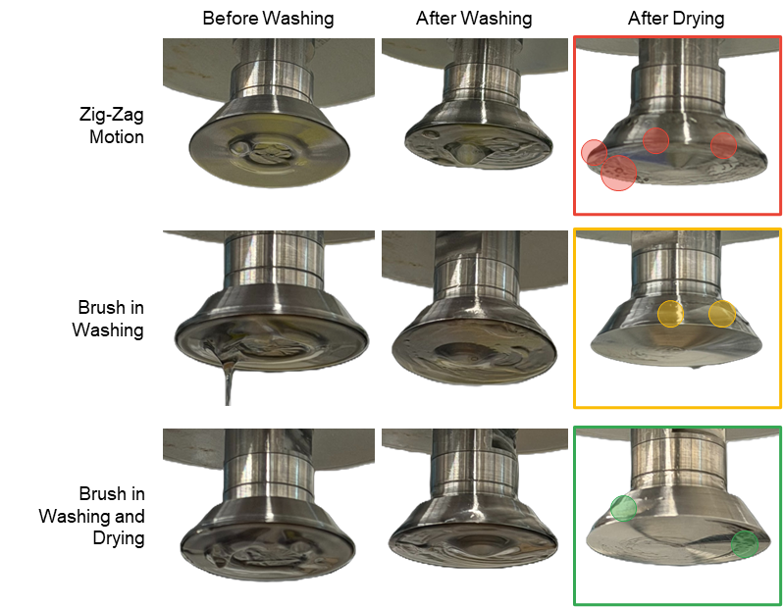
Figure S1. Evaluating performance of different methods and scenarios in washing the cone-shaped spindle
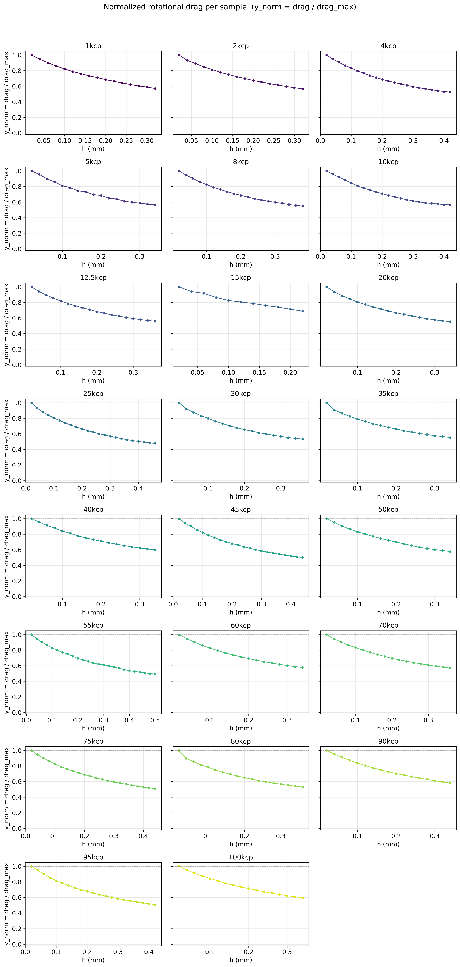
Figure S2. Dimensionless collapse of silicone drag curves, supporting factorization into geometry shape and viscosity amplitude.
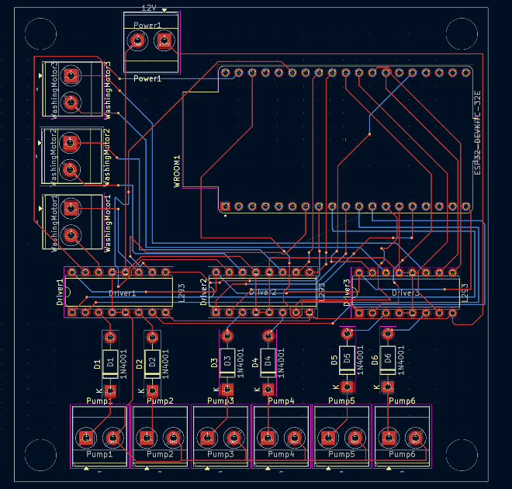
Figure S3. PCB design and embedded motor-control architecture of the automated washing subsystem.

