Basic Plots

2022-09-18

The purpose of this file is to present a coupld of basic plots using ggplot.

First we create a datafram containing variables for our plots.

set.seed(1234)  
  
plot_df = tibble(  
 x = rnorm(1000, sd = .5),  
 y = 1 + 2 * x + rnorm(1000)  
)

First we show a histogram of the x variable.

ggplot(plot_df, aes(x = x)) + geom_histogram()

## `stat_bin()` using `bins = 30`. Pick better value with `binwidth`.

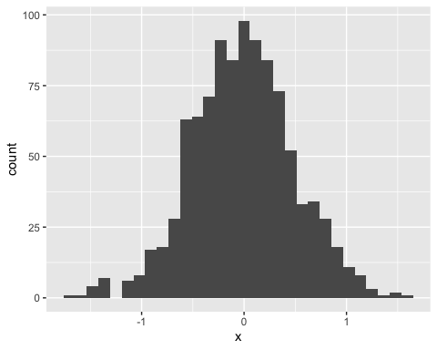

Next we show a scatter plot of y vs x.

ggplot(plot_df, aes(x = x, y = y)) + geom_point()

