

**Background:** Theo Health are a startup health-tech company that are looking to revolutionise how we train and recover from injury. By providing users with quantitative data about their muscle activity during rehabilitative exercises, they are providing both the physiotherapist and injured athlete with a greater knowledge of the recovery, whilst also keeping the athlete engaged and motivated to carry out their exercises.

**User Group 1 Personas**: Injury rehabilitation. Physiotherapists and their clients, injured athletes.

Things to think about:

***Physiotherapists:*** have many clients to keep track of at one time; they are looking to gain greater knowledge of their clients’ progress; would like to easily visualise their client’s progress

***Injured Athletes:*** may be feeling demotivated to carry out their rehabilitative exercises; would like to easily visualise their progress; are looking to make a full recovery and get back to their peak performance.

**User Group 2 Personas:** Fitness Development**.** Athletes who may or may not have a Personal Trainer.

Things to think about:

***Athletes:*** would like to easily visualise their progress and monitor the personal improvements that they are making.

***Personal Trainers*** *(optional):* have many clients to keep track of at one time; they are looking to gain greater knowledge of their clients’ progress; would like to easily visualise their client’s progress.

**Main Objective:**

Create a mobile or web application (with corresponding API) using any language, which takes the CSV files (attached below) containing the set of sensor values as inputs and returns as a heatmap superimposed onto a human body structure.

**Inputs:**

Foursensor values coming from:

Sensor1 – Left Hamstring (Semitendinosus)

Sensor2 – Right Hamstring (Semitendinosus)

Sensor3 – Left Quadricep (Rectus Femoris)

Sensor4 – Right quad (Rectus Femoris)

The sensor values are taken from the csv file provided with columns named - Sensor1, Sensor2, Sensor3 and Sensor4.

**Output:**

The output is to be the video of the heatmap changing on the body as per the given sensor values.

**Exercise in Detail:**

The sensor values come in various ranges starting from 100 to 600, the heatmap is to be designed so that the sensor value with low readings are presented as green/yellow on the heat map, orange for moderate readings and red for high readings.

Example:

The sensor values of range 100 – 200 are displayed in yellow.

The sensor values of range 200 – 400 are displayed in orange.

The sensor values of range 400- 600 are displayed in red.

**Optional extra:**

The body structure is 3D and interactive.

Use any image to construct the heatmap, making sure that the correct muscle group is highlighted with the corresponding readings. Examples below:

a)

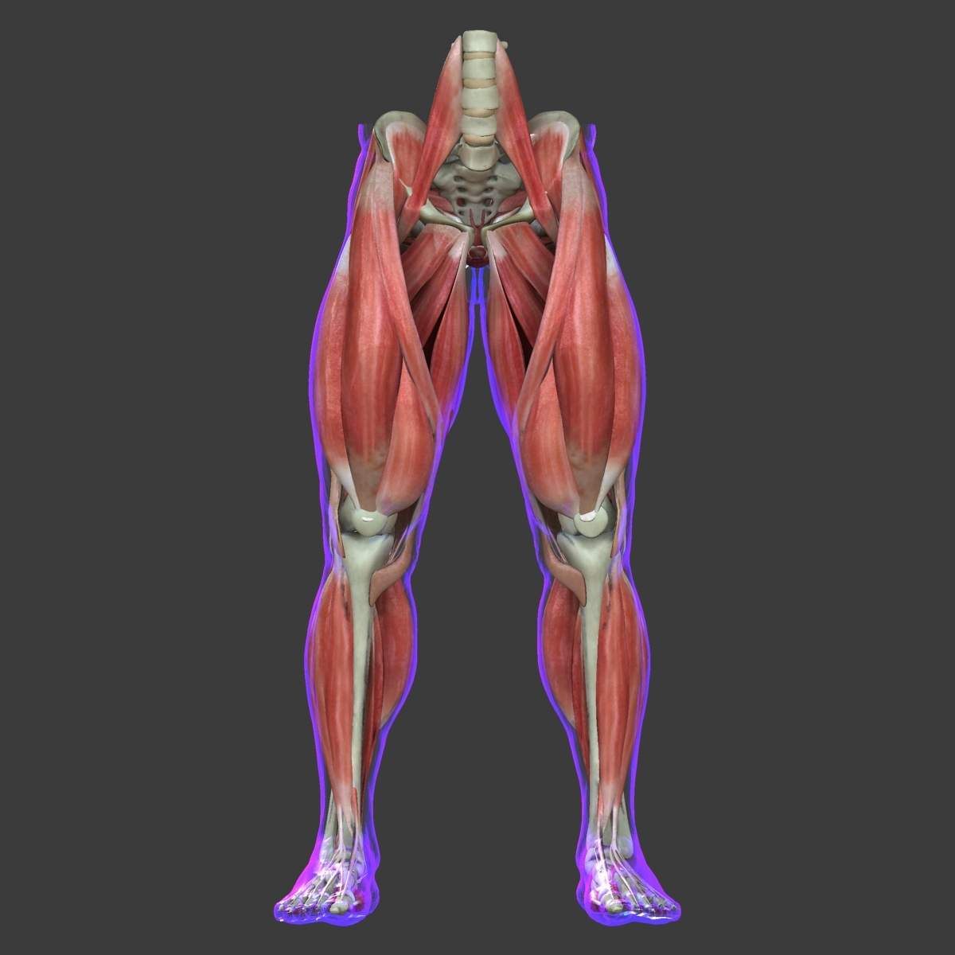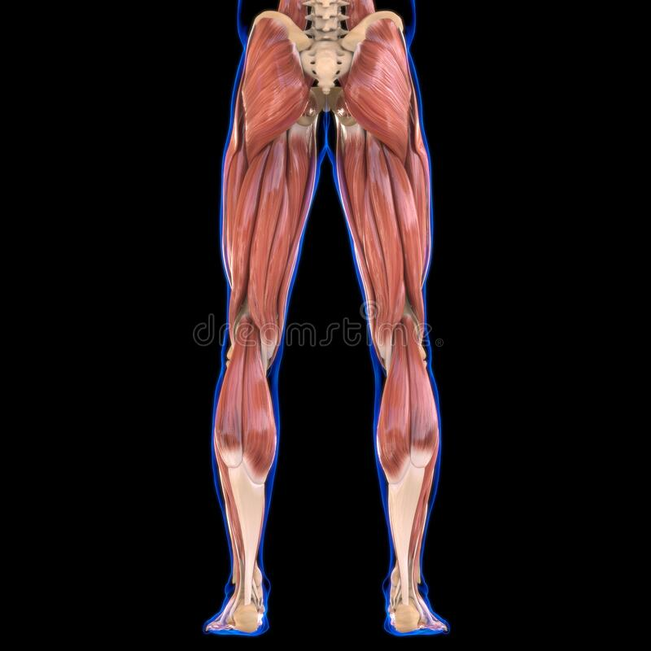

b)

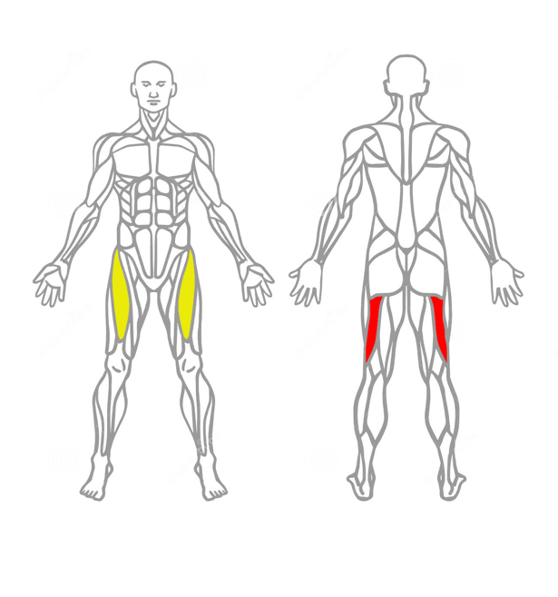

The sample heatmap applied on the human body looks as below:

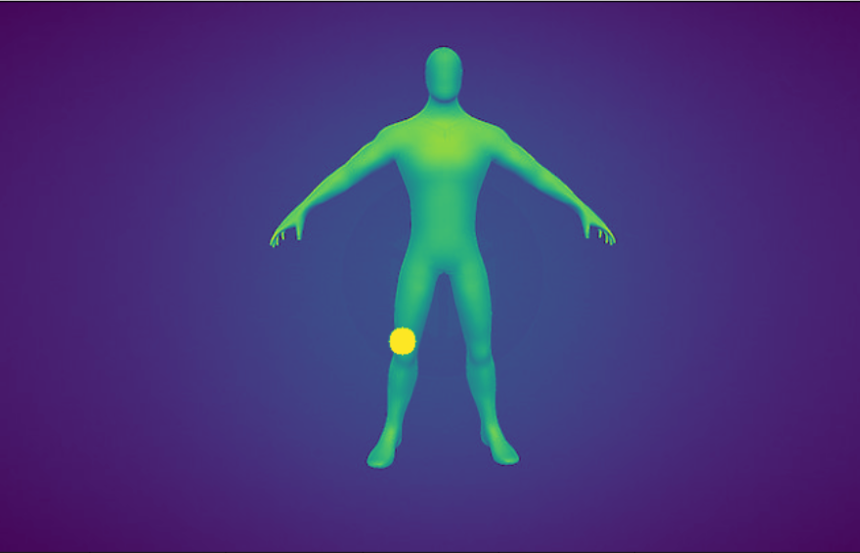

Sample Data:





**References to proceed:**

1. [**https://github.com/LinShanify/HeatMap**](https://github.com/LinShanify/HeatMap)
2. [**http://jjguy.com/heatmap/\**](http://jjguy.com/heatmap/\)
3. [**https://imgaug.readthedocs.io/en/latest/source/examples_heatmaps.html**](https://imgaug.readthedocs.io/en/latest/source/examples_heatmaps.html)