Nepal's Resilient Response: Adapting Agriculture to Climate Challenges

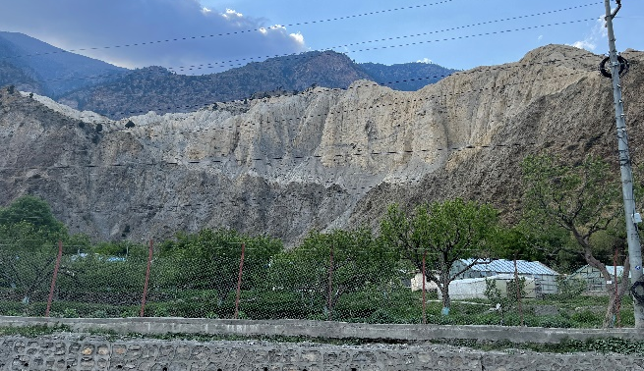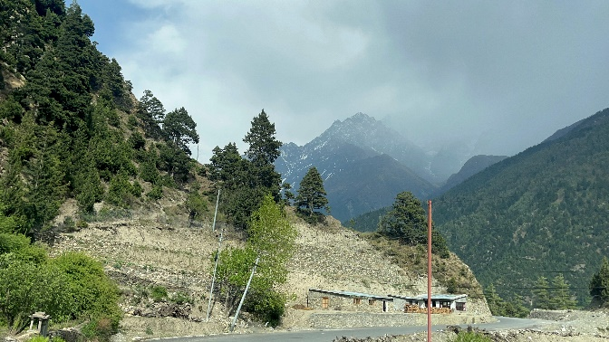

Photo Credit: Sunita Sanjyal

Sunita Sanjyal, PhD, Scientist, National Pasture and Fodder Research Program, Nepal Agricultural Research Council (NARC), Nepal
Roshan Babu Ojha, PhD, Scientist, National Agricultural Environment Research Centre, Nepal Agricultural Research Council (NARC), Nepal
Nepal is nested among the Himalayan ranges known for its breath taking landscapes and rich cultural heritage but also for its resilience in facing the climate change impact. Despite being a mere contributor of global greenhouse gases, Nepal is ranked among the fourth on the global climate risk index. However, amid these challenges, Nepal has shown its remarkable ability to adapt to the impacts of climate change especially in agriculture. Although, climate change has brought a substantial disturbance in the agriculture system, several adaptation strategies through various policies and action plans like National Adaptation Program of Action, National Adaptation Plan, Agriculture Development Strategy, and the Green, Resilient, & Inclusive Development plan are taken in account to respond to the challenges at national level. At the grassroots level, community led initiatives like Climate-Smart Village program empowers the local communities in carbon and energy efficiency, biodiversity conservation, and water management practices through general and locally relevant approaches.

Nepal Agricultural Research Council (NARC), Nepal has played a significant role in addressing the challenges posed by climate change in agriculture through various initiatives. Various climate-resilient crop varieties that are capable of withstanding higher temperatures, drought, salinity, cold and submergence have been developed for ensuring food security against changing climate. Fifteen locally/regionally adapted varieties of crops such as rice, millet, maize, wheat, lentil, mustard suitable for varying climatic conditions are also examples of climate resilient crops. Several other practices like conservation agriculture practices, zero tillage in rice-maize rotation, laser land levelling, system of rice intensification (SRI), alternate wetting and drying (AWD), rainwater harvesting, drip irrigation, mulching, maize-cowpea intercropping etc. technologies have been adopted to mitigate the negative impacts of climate change on crop production. Besides the technologies, the publication of advisory bulletins and digital soil maps has been another way of increasing awareness towards climate adaptation thus enabling farmers to prepare suitable action plans to mitigate climate-related risks. Nepal's efforts to combat climate change effects on agriculture have resulted in significant achievements. Since 2023 Nepal has been a part of the Atlas of Climate Adaptation in South Asian Agriculture (ACASA) which is a part of Borlaug Institute for South Asia (BISA). Under this project various adaptation options relating to different climatic hazards are identified, categorized and adaptation strategies are suggested on different crop and livestock commodities. These measures will play a vital role in minimizing the negative impacts of climate change in food security, and promoting sustainable agriculture in Nepal.

