Group Project 2

Ultrasonic sensor for the Arduino

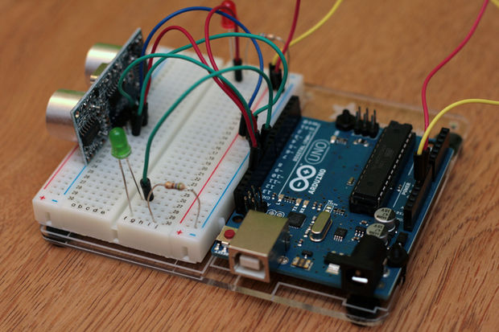

* Daniel Valey
* Jordan Walker
* Rachel Kelmenson
* Alexander Voznesenskiy
* Steffany Vasquez

**Table of Contents**

**Introduction ……………………………………………………………3**

**The Microcontroller Platform……………………………………3**

**The Test Device………………………………………………………..4**

**Development tools……………………………………………………5**

**Your Experiment……………………………………………………..7**

**Conclusion………………………………………………………………8**

**Contributions…………………………………………………..……..9**

**Project code…………………………………….…………………….10**

**Introduction**

For our project, we decided to use the HC-SR04 Ultrasonic Sensor and the Arduino Uno microcontroller. To get it working all that was needed was ten jumper wires, three LEDs (green, red, yellow), a basic breadboard, and the microcontroller. We will experiment to make the Arduino Uno microcontroller be able to recognize if something before sensor or not and our LED lights will tell us about it.

**The Microcontroller Platform**

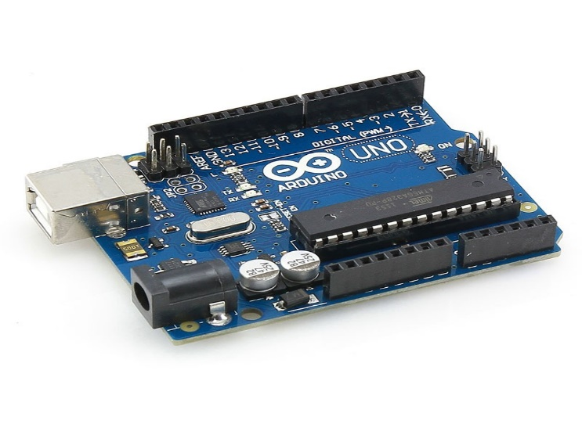In our project, we will use Arduino Uno microcontroller. The Arduino Uno is a microcontroller board based on the ATmega328. It has 14 digital input/output pins (of which 6 can be used as PWM outputs), 6 analog inputs, a 16 MHz crystal oscillator, a USB connection, a power jack, an ICSP header, and a reset button. It contains everything needed to support the microcontroller; simply connect it to a computer with a USB cable or power it with a AC-to-DC adapter or battery to get started. The Uno differs from all preceding boards in that it does not use the FTDI USB-to-serial driver chip. Instead, it features the Atmega8U2 programmed as a USB-to-serial converter.

"Uno" means one in Italian and is named to mark the upcoming release of Arduino 1.0. The Uno and version 1.0 will be the reference versions of Arduino, moving forward. The Uno is the latest in a series of USB Arduino boards, and the

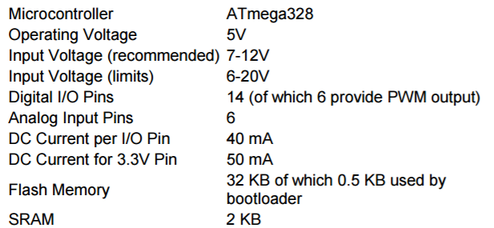

Sources: <https://www.google.com/search?q=arduino+uno+board&espv=2&biw=1163&bih=514&source=lnms&tbm=isch&sa=X&ved=0ahUKEwiavP-K5fHQAhXLrFQKHSfUA0cQ_AUIBygC#imgrc=G1l40Nj2dfTPiM%3A>

<http://www.arduino.org/products/boards/arduino-uno> <http://www.me.umn.edu/courses/me2011/arduino/arduinoGuide.pdf>

**The Test Device**

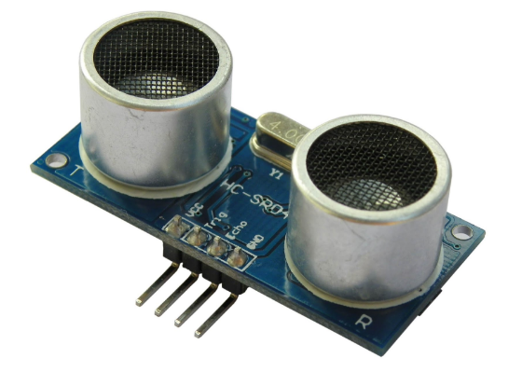For our project we will use HC-SR04 Ultrasonic Sensor. This sensor can be used as a parking sensor in real life or just for measure a distance from any object.

The [HC-SR04](http://cytron.com.my/p-sn-hc-sr04) ultrasonic sensor uses sonar to determine distance to an object like bats or dolphins do. It offers excellent non-contact range detection with high accuracy and stable readings in an easy-to-use package. From 2cm to 400 cm or 1” to 13 feet. It operation is not affected by sunlight or black material like Sharp rangefinders are (although acoustically soft materials like cloth can be difficult to detect).

**Electric Parameter**

|  |  |
| --- | --- |
| Working Voltage | DC 5 v |
| Working Current | 15mA |
| Working Frequency | 40Hz |
| Max Range | 4 m |
| Min Range | 2 cm |
| Measuring Angle | 15 degree |
| Trigger Input Signal | 10uS TTL pulse |
| Echo Output Signal | Input TTL lever signal and the range in proportion |

Sources:

<http://www.micropik.com/PDF/HCSR04.pdf>

**Development tools**

**Experiment**

**Conclusion**

**Contributions**

**Project code**