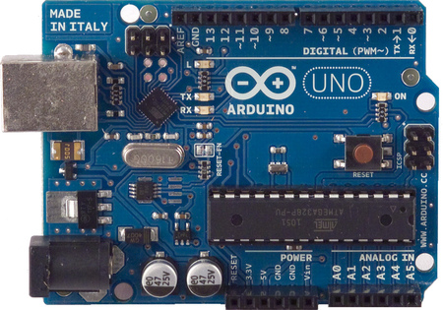**Arduino Joystick in AVR Assembly  
  
Group Project 2**  
by: Team Charlie!

**Group Members:**

* Cody Sears
* 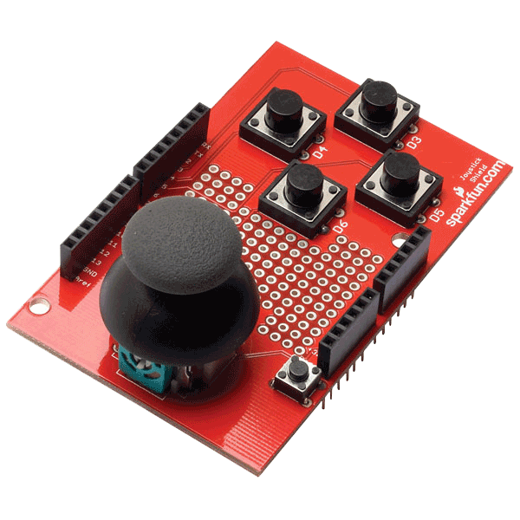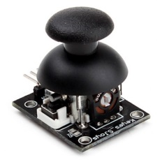Jackson Corgey
* Destiny Nelson
* Arthur Patterson

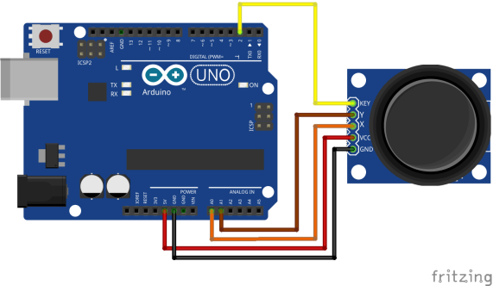  
  
**Main Project Materials:**  
Microcontroller: Arduino Uno  
Analog Device: Joystick Module

**Table of Contents**

**Introduction…………………………………………pg 3**

**The Microcontroller Platform…………………pg 4-5**

**The Test Device………………………………………pg 6**

**Development tools…………………………………pg 7**

**Your Experiment……………….……………………pg 8**

**Conclusions……………………………………………pg 9**

**Contributions…………………………………………pg 10**

**Project code……………………………………………pg 11**

**Introduction**

In this section, you should describe the basic hardware components you chose to experiment with. You should also describe the experiment you are going to conduct that demonstrates that hardware. This section is not a detailed report on those components, just a basic introduction tot he parts you ended up with, and the demonstration you decided to set up.

**The Microcontroller Platform**

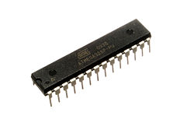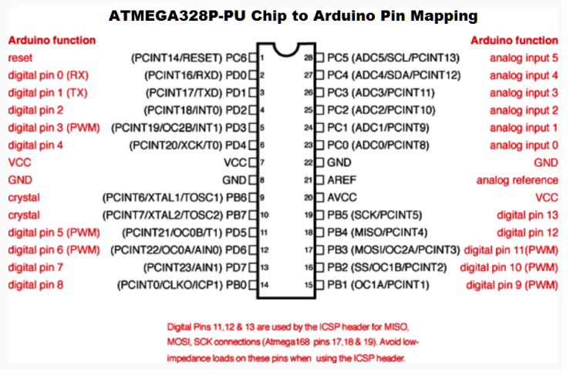We are using the Arduino Uno microcontroller board, which is based on the ATmega328P microchip. The ATmega328P provides access to 14 digital input/output connections, of which, 6 can be used as post width modulation outputs (PWM), which allows you to vary the output voltage when controlling devices light lights with the microcontroller. The control also provides 6 analog inputs for reading analog devices into the controller. There is a built in 16 MHz quartz timing crystal. A port is built in for connecting to computer USB for programming and powering the microcontroller. There is an ICSP header. In-circuit serial programming (ICSP) allows the ATmega328P chip to be programmed while still being embedded in the controller. This makes programming and testing the controller very simple from your computer. Alternately, there is a power jack that allows the board to be powered by an external power supply. There is also a momentary switch built in that acts as a reset button.  
  
These boards can be obtained on the internet from many sites such as adafruit, digi-key, Amazon, eBay, and many other electronics websites. They can also be purchased locally at electronic shops like Fry’s.   
  
The ATmega328P chip must be flashed with the appropriate bootloader in order to run Arduino programs normally. This means that if you purchase the ATmega328P chip by itself (outside of a normal built-in Arduino distribution) that you will need to ensure that the chip has been properly loaded with the Arduino Bootloader. If it hasn’t, the chip can be loaded using another Arduino, a timing crystal, and some other components to load the bootloader onto the chip.  
  
  
  
  
Component Info Source: <https://www.arduino.cc/en/Main/ArduinoBoardUno>

ATmege328P Data Sheet: <http://www.atmel.com/Images/Atmel-42735-8-bit-AVR-Microcontroller-ATmega328-328P_Summary.pdf>

ATmega328P General Info: <http://www.atmel.com/devices/ATMEGA328P.aspx>

ATmega328P Chip to Arduino Pin Mapping: <http://www.instructables.com/file/F2SFHSDH3Z3V3P4/>

**The Test Device**

Each project uses some kind of device that ends up being controlled by the microcontroller. Describe that device and give an overview of what it might be used for. Basically, describe what is involved in interacting with the device. Again, use screen captures of diagrams from documentation if you can.

**Development tools**

Detail the tools you needed to obtain to work with the microcontroller and the device. You also need to identify any additional software you needed to interact with your test device.

**Your Experiment**

Describe the experiment you set up. What led you to pick this particular experiment (hopefully it was not because it was easy!) Be sure to show how your experiment was set up. Show how the device is connected to the microcontroller.

**Conclusions**

What did you learn about hardware control from this project? Did you get any ideas for other projects you might try in the future?  
  
  
  
  
  
  
  
  
  
  
  
  
  
  
  
  
  
  
  
  
  
  
  
  
  
  
  
  
  
  
  
  
  
  
  
 **Contributions  
  
Cody Sears**

* Wrote AVR assembly code for project.
* Wrote Group Report.
* Met outside of class to plan, discuss, and implement project as a team

**Jackson Corgey**

* Wrote AVR assembly code for project.
* Wrote Group Report.
* Met outside of class to plan, discuss, and implement project as a team

**­**

**Project code**

Include a listing of the code you used for this project.