**Para crear un tipo de papel custom**

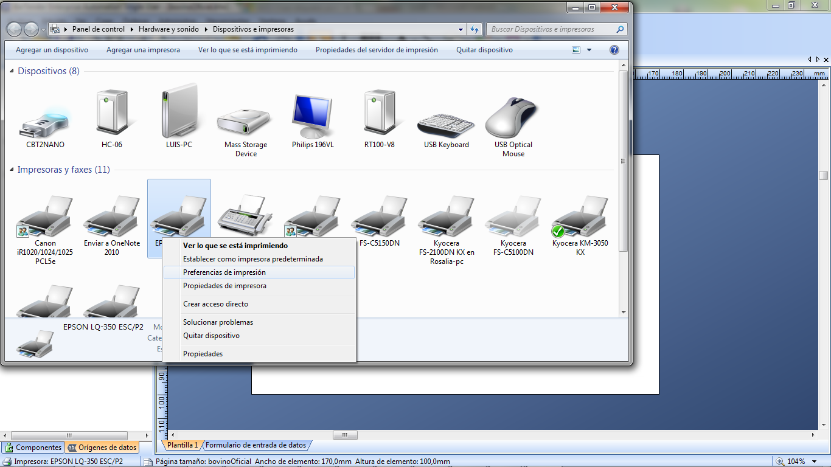

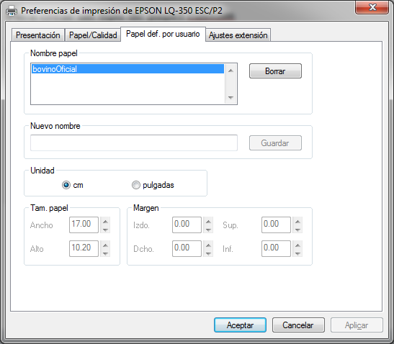

No deja modificar, para modificar hay que borrar y crear un nuevo nombre…

Tam. Papel Ancho 17.00

Alto 10.16

**PARA QUE EL BARCODE SE LEA BIEN**

Hay que poner en propiedades del documento a la hora de imprimir esto

Propiedades del documento/ papel calidad/opciones avanzadas / calidad 180x180

Si ponemos más resolución no sale bien el barcode en pequeño.

**Adjusting the top-of-form position**

The top-of-form position is the position on the page where the printer starts printing. If your printing appears too high or low on the page, you can use the micro adjust feature to adjust the top-of-form position. Follow these steps:

**https://files.support.epson.com/htmldocs/lx350_/lx350_ug/html/files/mark_ca.gifCaution:**

|  |
| --- |
| Never use the paper feed knob to adjust the top-of-form position; this may damage the printer or cause it to lose the top-of-form position. |

**https://files.support.epson.com/htmldocs/lx350_/lx350_ug/html/files/mark_no.gifNote:**

|  |  |  |  |
| --- | --- | --- | --- |
| Your top-of-form position setting remains in effect until you change it, even if you turn off the printer.  The top margin setting made in some application software overrides the top-of-form position setting you make with the Micro Adjust feature. If necessary, adjust the top-of-form position in your software. | | | |
| https://files.support.epson.com/htmldocs/lx350_/lx350_ug/html/files/step_1.gif | Make sure the printer is turned on. |

|  |  |
| --- | --- |
| https://files.support.epson.com/htmldocs/lx350_/lx350_ug/html/files/step_2.gif | If necessary, load paper as described in this chapter. |
| https://files.support.epson.com/htmldocs/lx350_/lx350_ug/html/files/step_3.gif | Remove the printer cover. |

|  |  |
| --- | --- |
| https://files.support.epson.com/htmldocs/lx350_/lx350_ug/html/files/step_4.gif | Hold down the **Pause** button for about three seconds. The **Pause** light starts flashing and the printer enters the Micro Adjust mode. |
| https://files.support.epson.com/htmldocs/lx350_/lx350_ug/html/files/step_5.gif | Press the **LF/FF** https://files.support.epson.com/htmldocs/lx350_/lx350_ug/html/files/fon3_68.gif button to move the top-of-form position down on the page, or press the **Load/Eject** https://files.support.epson.com/htmldocs/lx350_/lx350_ug/html/files/fon3_85.gifbutton to move the top-of-form position up on the page. |

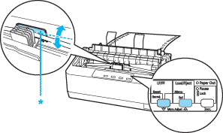

* plastic ribbon cover

**https://files.support.epson.com/htmldocs/lx350_/lx350_ug/html/files/mark_no.gifNote:**

|  |  |  |
| --- | --- | --- |
| The printer has a minimum and a maximum top-of-form position. If you try to adjust it beyond these limits, the printer beeps and stops moving the paper.  When the paper reaches the default top-of-form position, the printer also beeps and stops moving the paper briefly. You can use the default position as a reference point when adjusting the top-of-form position. | | |
| https://files.support.epson.com/htmldocs/lx350_/lx350_ug/html/files/step_6.gif | After you set the top-of-form position, press the **Pause** button to exit the Micro Adjust mode |

### Adjusting the tear-off position

If your paper’s perforation is not aligned with the tear-off edge, you can use the Micro Adjust feature to move the perforation to the tear-off position.

Follow these steps to adjust the tear-off position:

**https://files.support.epson.com/htmldocs/lx350_/lx350_ug/html/files/mark_ca.gifCaution:**

|  |
| --- |
| Never use the paper feed knob to adjust the tear-off position; this may damage the printer or cause it to lose the tear-off position. |

**https://files.support.epson.com/htmldocs/lx350_/lx350_ug/html/files/mark_no.gifNote:**

|  |  |
| --- | --- |
| Your tear-off position setting remains in effect until you change it, even if you turn off the printer. | |
| https://files.support.epson.com/htmldocs/lx350_/lx350_ug/html/files/step_1.gif | Make sure the **Tear Off (Font)**light is flashing (the paper is at the current tear-off position). You may need to press the **Tear Off (Font)** button to advance the paper to the tear-off position. |

|  |  |
| --- | --- |
| https://files.support.epson.com/htmldocs/lx350_/lx350_ug/html/files/step_2.gif | Open the paper guide cover. |
| https://files.support.epson.com/htmldocs/lx350_/lx350_ug/html/files/step_3.gif | Hold down the **Pause** button for about three seconds. The **Pause** light begins to flash and the printer enters the Micro Adjust mode. |

|  |  |
| --- | --- |
| https://files.support.epson.com/htmldocs/lx350_/lx350_ug/html/files/step_4.gif | Press the **LF/FF** https://files.support.epson.com/htmldocs/lx350_/lx350_ug/html/files/fon3_68.gif button to feed the paper backwards, or press the **Load/Eject** https://files.support.epson.com/htmldocs/lx350_/lx350_ug/html/files/fon3_85.gif button to feed the paper forwards, until the paper perforation is aligned with the tear-off edge. |

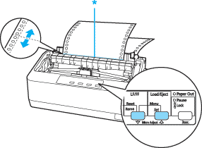

* tear-off edge

**https://files.support.epson.com/htmldocs/lx350_/lx350_ug/html/files/mark_no.gifNote:**

|  |  |  |  |
| --- | --- | --- | --- |
| When the paper reaches the default position, the printer beeps and stops moving the paper.  The printer has a minimum and a maximum tear-off position. If you try to adjust the tear-off position beyond these limits, the printer beeps and stops moving the paper. | | | |
| https://files.support.epson.com/htmldocs/lx350_/lx350_ug/html/files/step_5.gif | After you set the tear-off position, press the **Pause** button to exit the Micro Adjust mode. |

|  |  |
| --- | --- |
| https://files.support.epson.com/htmldocs/lx350_/lx350_ug/html/files/step_6.gif | Tear off the printed pages. |

When you resume printing, the printer automatically feeds the paper back to the top-of-form position and begins printing.