Figures for the DIR microsimulation manuscript (BMC format)
Nota de borrador (27-oct-2026, retirar antes de enviar). Formato BMC: cada figura se sube como archivo aparte (PNG 450 dpi a 170 mm; SVG y PDF vectoriales en __andres_control/figures_paper_outline/output/). Título de figura ≤ 15 palabras y leyenda ≤ 300 palabras, ubicados en el manuscrito después de las referencias; abreviaturas definidas en cada leyenda. Las citas dentro de las figuras van como autor-año y deben pasar a numeración [n]. Componentes que aún no están implementados en el motor: paso 3 (conexión PIF), 6a (matrices EPS/TSM), 6c–6d (módulo DIR), persistencia HED propia y seguimiento de la mortalidad después de los 64 años (población inicial 15–64, edad máxima 73 en 2034; muertes DEIS y RR de 65–73 por preparar; Calvo/EPS como posible sensibilidad del consumo después de los 65). Denominador APS provisional (≈9,43 M, tramos A–D repartidos por edad; se espera la v8 de Codex): las coberturas son aproximadas. Comparación de exposición con ENPG 2026 aún no implementada (se implementará); alternativa: ENCAVI 2023–24.

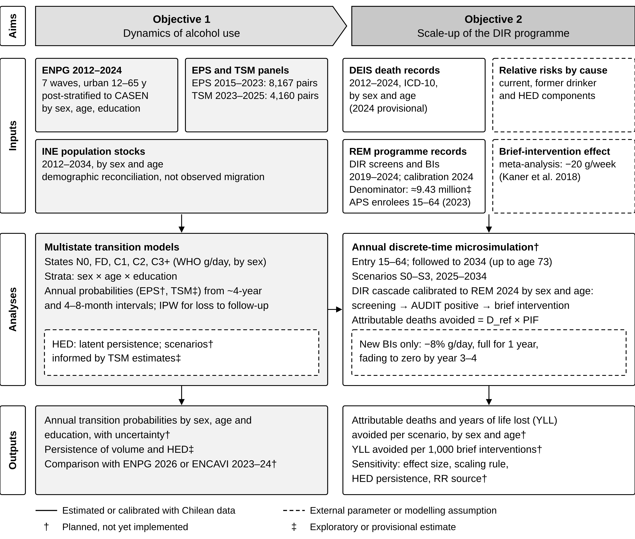
Fig. 1 Study design: objectives, data sources, analyses and outputs
Objective 1 estimates alcohol use transitions from two Chilean panels, with ENPG providing population margins; Objective 2 feeds them into a microsimulation of the alcohol-attributable deaths and years of life lost (YLL) avoided by expanding the DIR programme in 2025–2034. States: C1, C2 and C3+, WHO risk levels (women >0–20, >20–40 and >40 g of ethanol per day; men >0–40, >40–60 and >60 g/day; upper bounds inclusive; 12 g per drink); FD, former drinker; N0, no current or earlier drinking observed. N0 and FD definitions differ between ENPG and panels; panel counts are interview pairs. Post-stratification corrects composition but does not identify rural drinking patterns. HED: TSM supports an annual correlation of 0.24–0.36; decay is weakly identified and 5–10-year persistence is assumed; comparison: Puka et al. 2023; the engine currently uses a common ρ = 0.8 (to be replaced for HED). APS denominator: enrolees in FONASA groups A–D, December 2023, apportioned to ages 15–64; equivalence with validated enrolment is unconfirmed, so coverage rates are approximate. Screening is any AUDIT; at ages 15–19 most screening uses CRAFFT (AUDIT 1.0% vs 18.5% with any instrument). Reference deaths are total cause-specific deaths, excluding wholly attributable causes; YLL use the Human Mortality Database life table for Chile. Abbreviations: APS, primary health care; AUDIT, Alcohol Use Disorders Identification Test; BI, brief intervention; CASEN, National Socioeconomic Characterisation Survey; DEIS, Department of Health Statistics and Information; DIR, Detection, brief Intervention and assisted Referral programme; D_ref, reference deaths; ENCAVI, National Survey of Quality of Life and Health; ENPG, National Drug Survey in the General Population; EPS, Social Protection Survey; FONASA, National Health Fund; HED, heavy episodic drinking; INE, National Statistics Institute; IPW, inverse probability weighting; PIF, potential impact fraction; REM, Monthly Statistical Records; TSM, Mental Health Thermometer (ACHS-UC); WHO, World Health Organization.

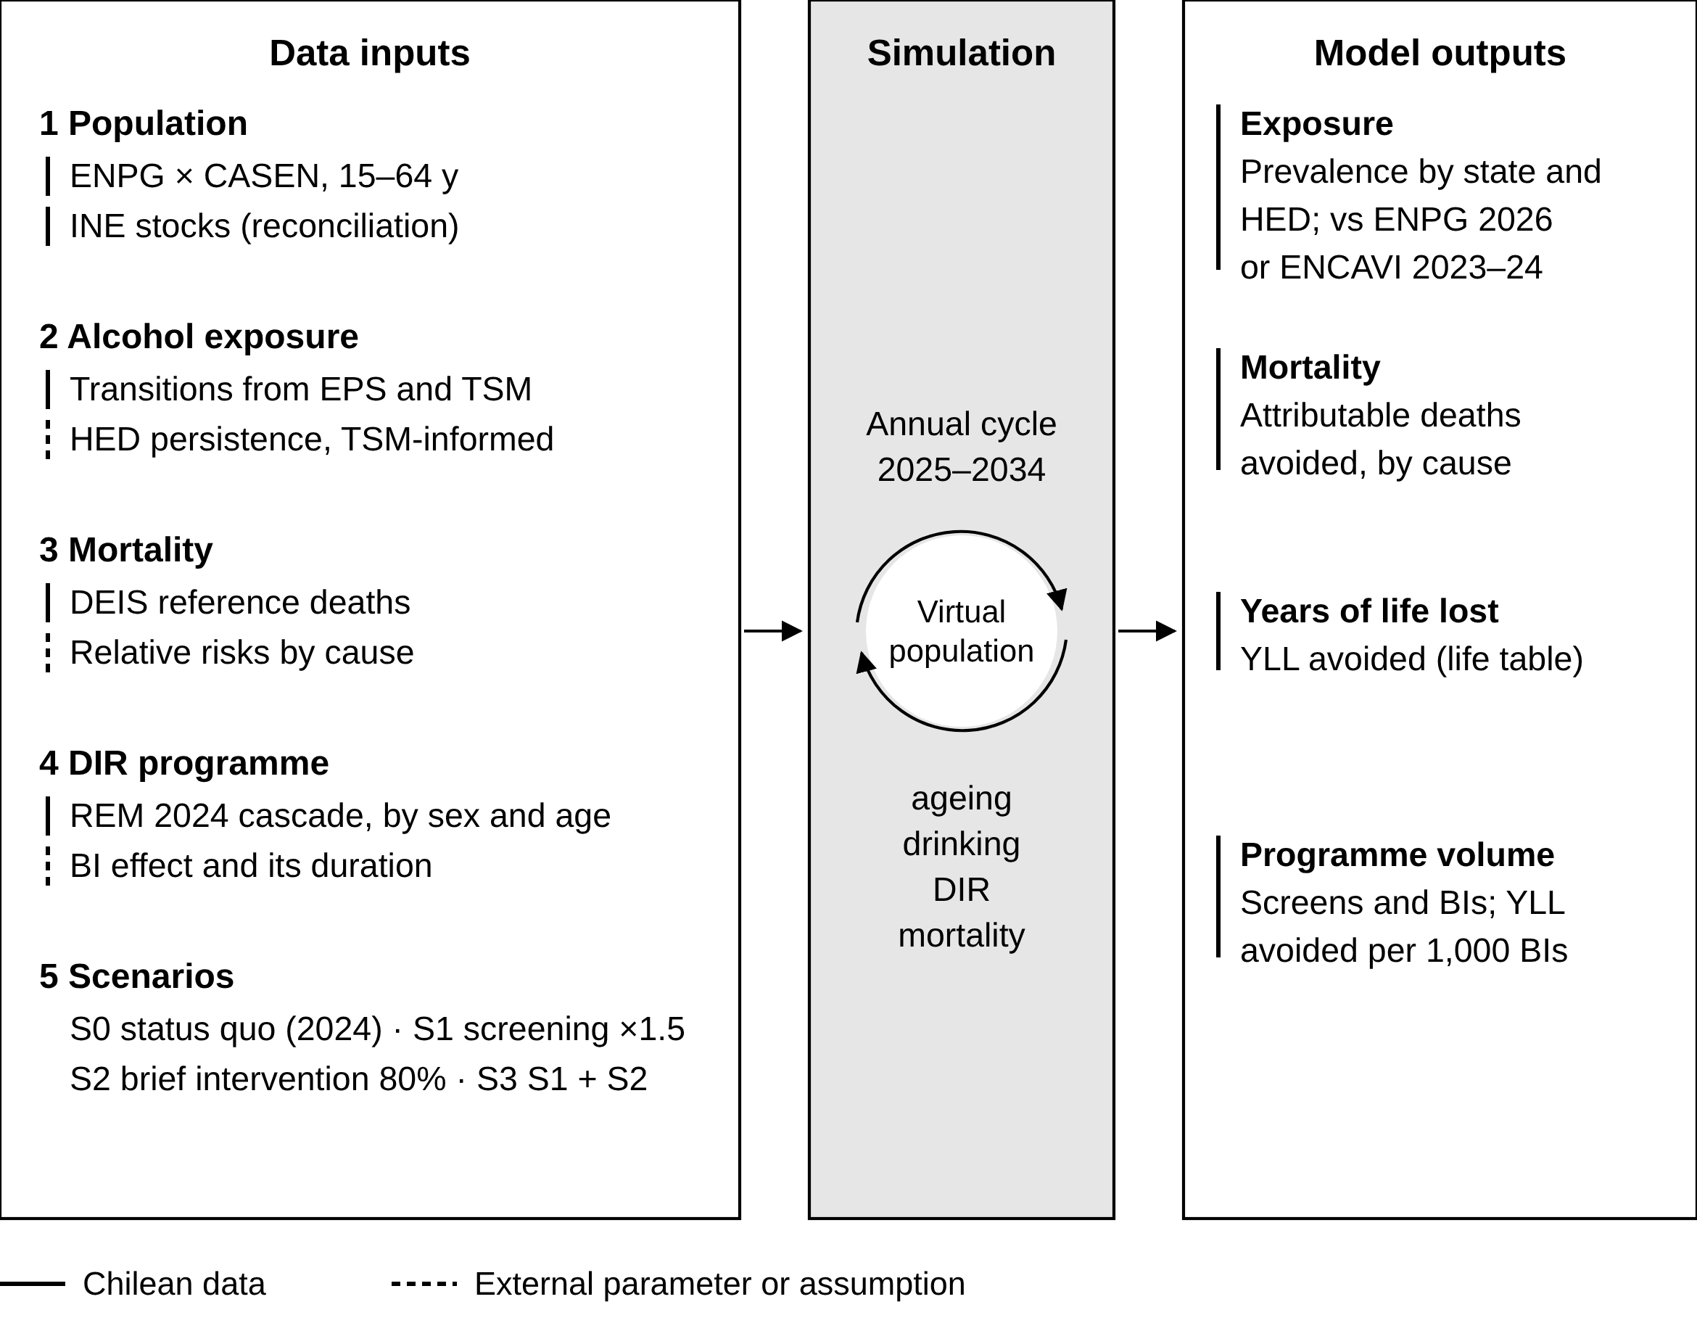
Fig. 2 Model modules, annual simulation cycle and outputs
Five input modules (left) feed an annual cycle applied to a synthetic population (centre), which produces exposure, mortality and programme outputs (right). Line markers: solid, Chilean data; dashed, external parameter or assumption. Population: ENPG respondents aged 15–64 years post-stratified with CASEN; nobody enters after age 64, so the oldest reach age 73 by 2034; INE stocks are used for demographic reconciliation, not to observe individual migration. Exposure: annual transition probabilities estimated from EPS and TSM; heavy episodic drinking assigned from volume plus a latent persistence term informed by TSM (the engine currently uses a common ρ = 0.8). Mortality: reference deaths from DEIS and cause-specific relative risks for current drinking, former drinking and heavy episodic drinking. DIR programme: probabilities of screening, of a positive result and of brief intervention calibrated to REM 2024 by sex and age; coverage is approximate until the APS denominator is confirmed; the effect applies only to brief interventions additional to the status quo. Scenarios: S0, programme coverage held at 2024 levels; S1, screening coverage multiplied by 1.5 with an unchanged probability of brief intervention after a positive result; S2, brief intervention after 80% of AUDIT scores of 8–15; S3, S1 and S2 combined. Exposure is compared with ENPG 2026 or, alternatively, ENCAVI 2023–24. Implementation status is marked in Figs. 1 and 3. YLL computed from the Human Mortality Database life table for Chile; years of potential life lost (YPLL) before age 75 reported only for comparison with Lemp et al. AUDIT, Alcohol Use Disorders Identification Test; other abbreviations as in Fig. 1.

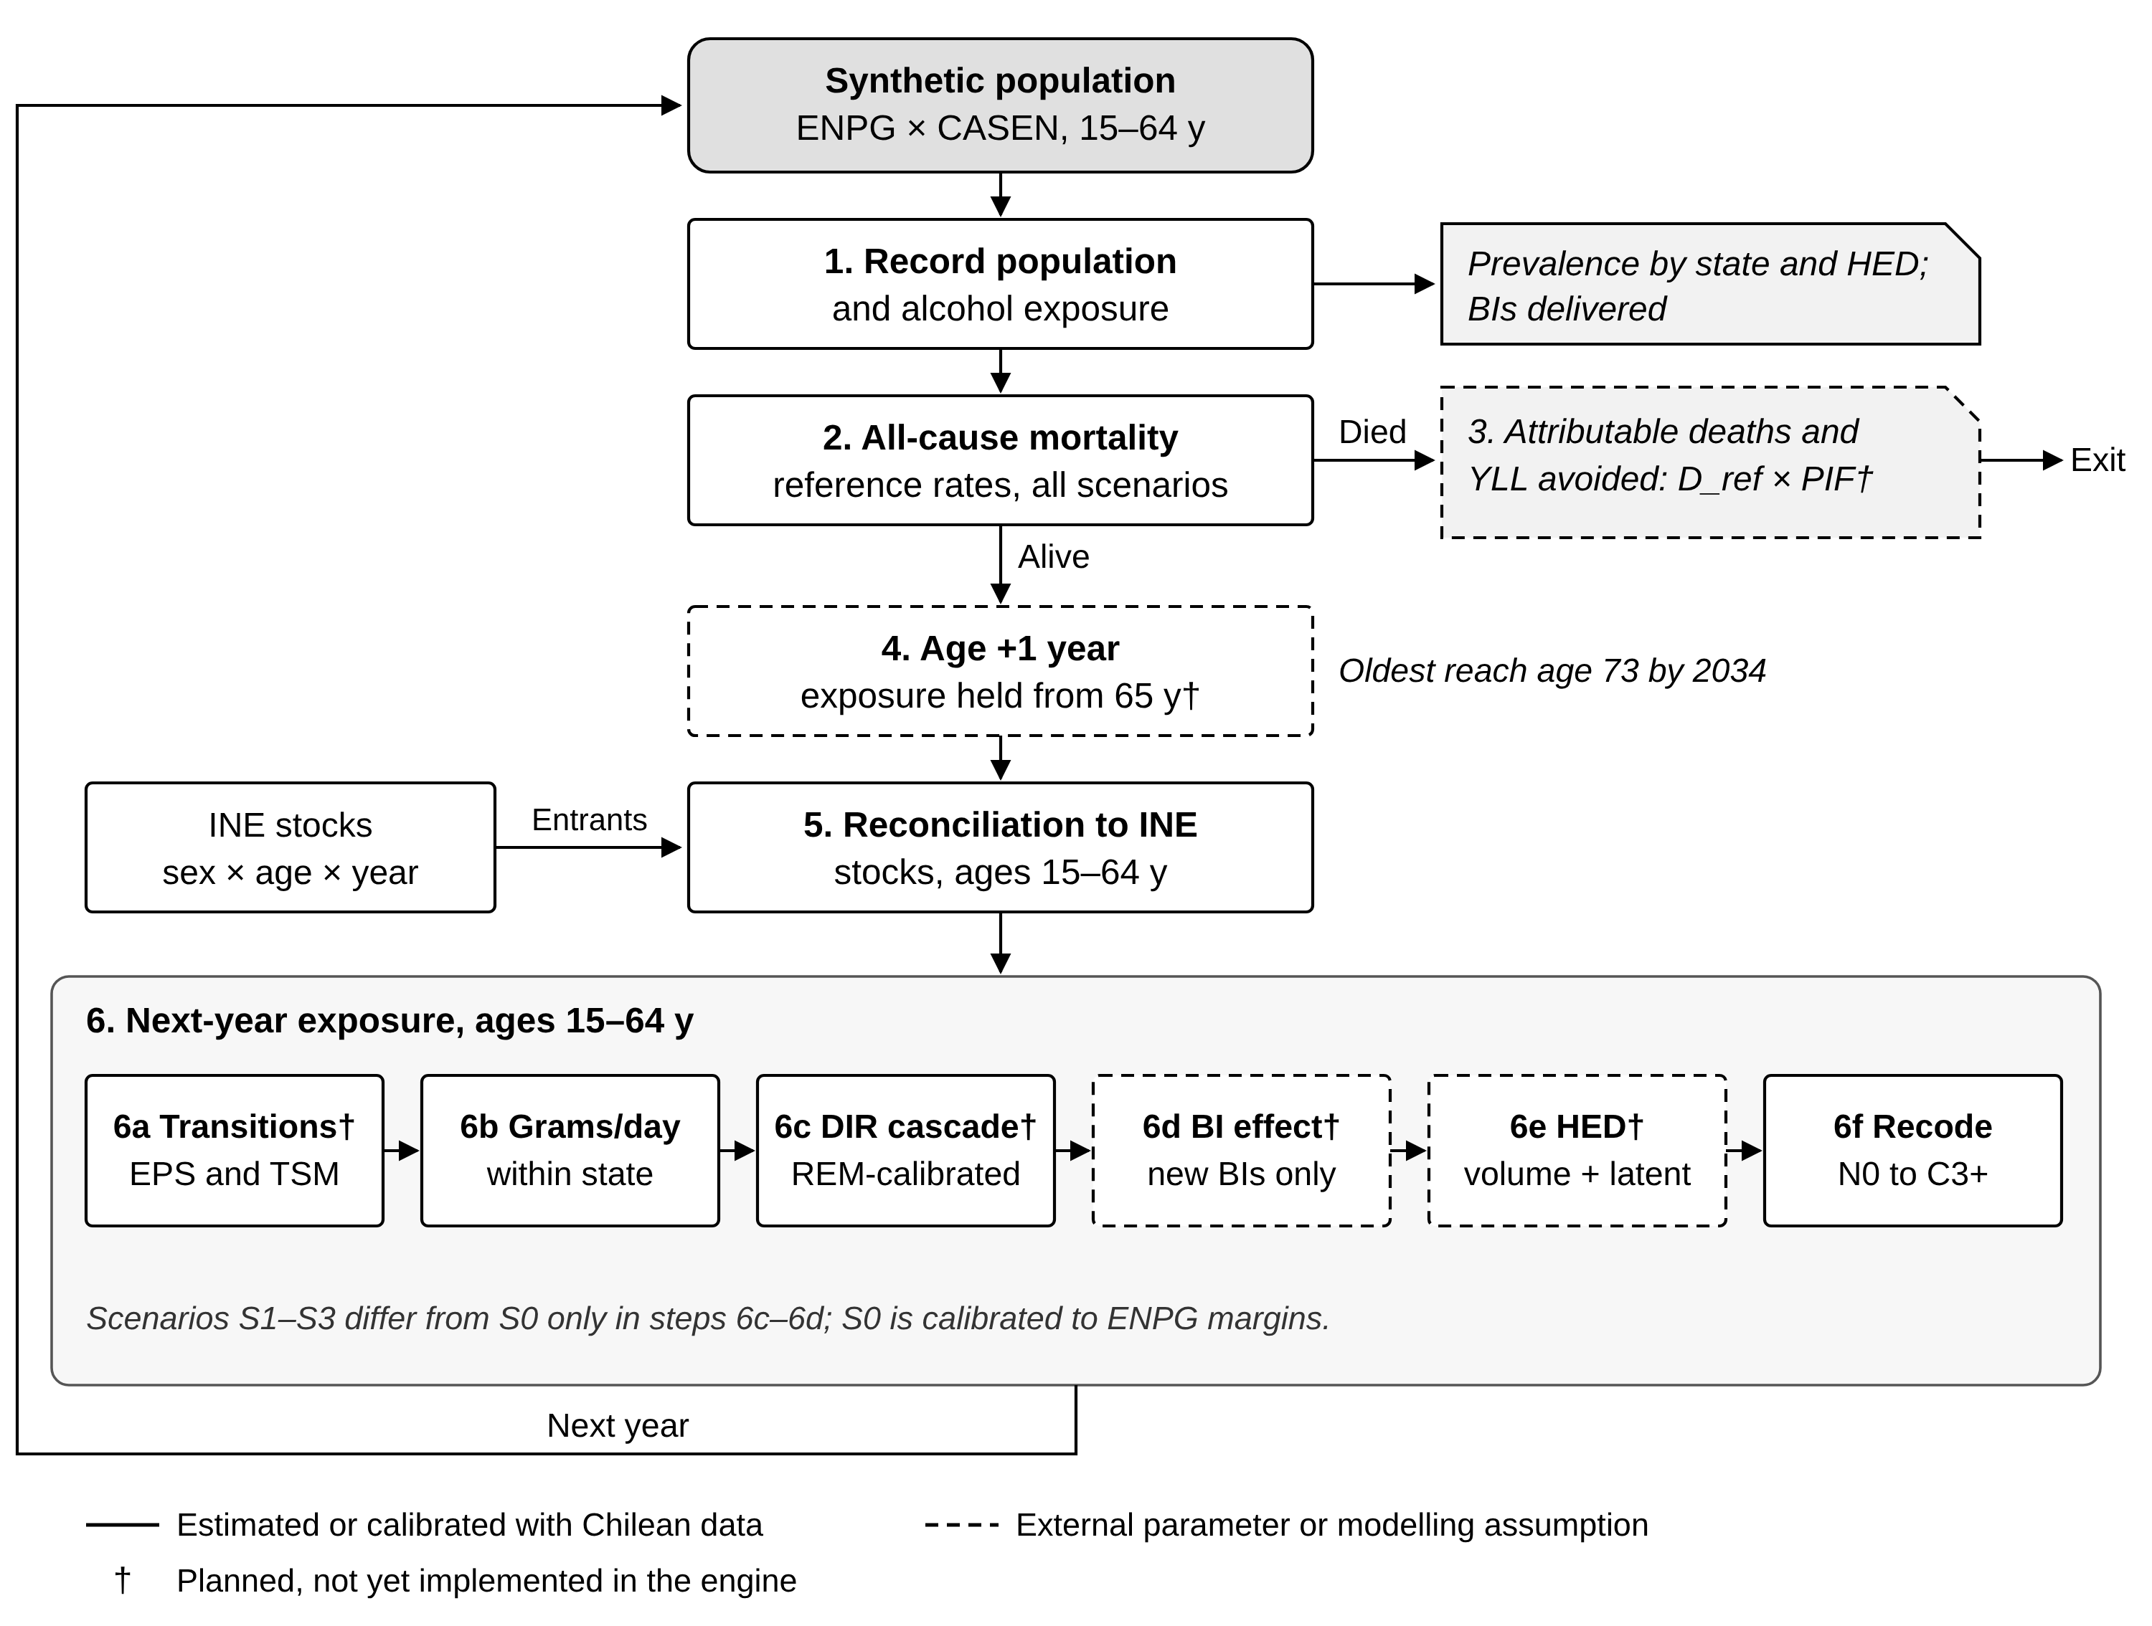
Fig. 3 Annual process overview of the microsimulation
Each simulated year starts with the recording of population and exposure in January (step 1). All-cause deaths are drawn from reference rates that are identical across scenarios (step 2). Alcohol-attributable deaths and YLL avoided are computed as expected values by multiplying reference deaths by the potential impact fraction for each cause, sex, age group and year (step 3): PIF = 1 − Σp′RR / ΣpRR, where p and p′ are the simulated exposure distributions under S0 and under the scenario; reference deaths are all DEIS deaths from each cause, 2012–2024, and fully attributable causes are excluded. Survivors age one year; baseline exposure is held constant from age 65, while the effect of an earlier brief intervention keeps fading; nobody enters the model after age 64, so the oldest members reach age 73 by 2034 (step 4). The population aged 15–64 is reconciled to INE stocks by sex and age; entrants, mainly people turning 15, receive exposure drawn from the ENPG distribution of their cell (step 5). Exposure for the next year is then updated for people aged 15–64: annual transitions between states (6a); grams of ethanol per day drawn within the assigned state (6b); the DIR cascade calibrated to REM records (6c); the effect of new brief interventions, an 8% reduction in grams per day, full during the first year and fading to zero by year 3–4 (6d); heavy episodic drinking from volume and a latent persistence term to be informed by TSM (6e); and recoding of states (6f). The model is initialised in 2012; scenarios diverge from 2025 and run to 2034. Solid borders, Chilean data; dashed borders, external parameters or modelling assumptions; †, not yet implemented in the engine. Adapted from Kilian et al. [ref]. Abbreviations as in Fig. 1.

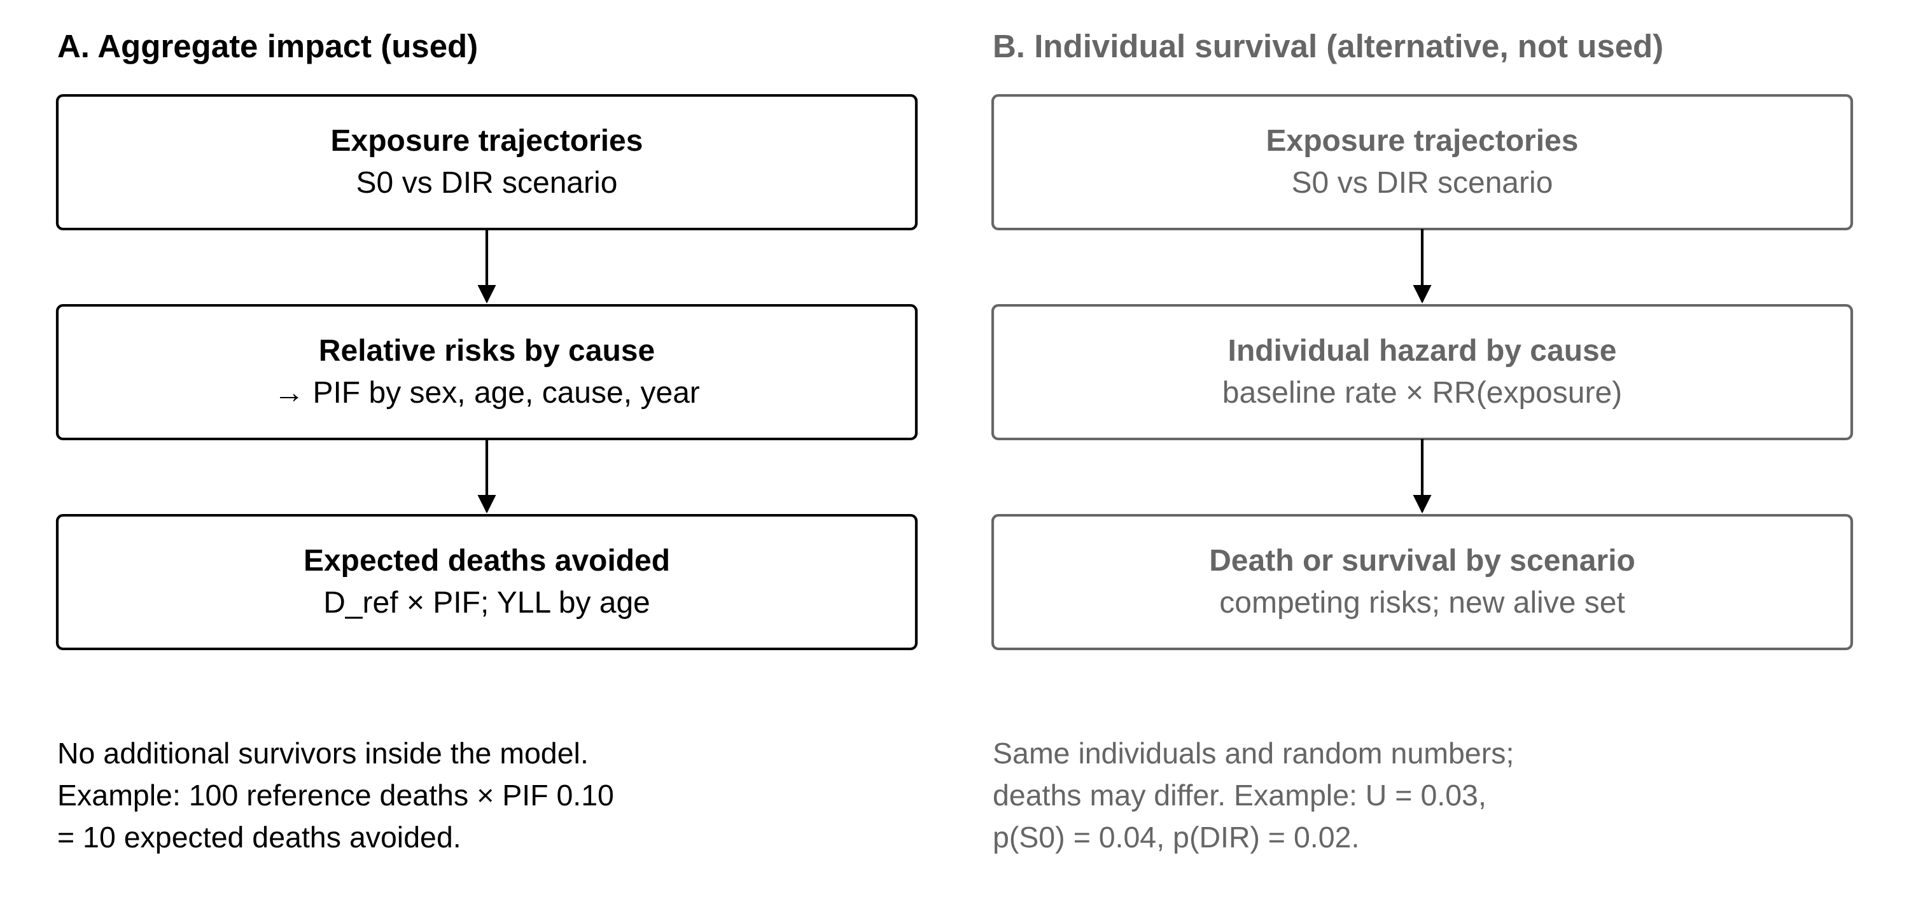
Additional file 1: Fig. S1 Two routes to estimate the mortality impact of the scenarios
Route A (used): the model projects exposure under each scenario; relative risks by cause convert the exposure distributions into potential impact fractions, and expected deaths avoided are reference deaths multiplied by the PIF. No additional survivors are simulated. Route B (not used): individual cause-specific hazards depend on exposure, so deaths differ between scenarios while individuals and random numbers are shared; it would require an alcohol-free baseline rate, no reconciliation to population stocks in the intervention arms and more Monte Carlo replicates. The routes are alternatives and are not added together. RR, relative risk; U, uniform random number; other abbreviations as in Fig. 1.

