Figures for the DIR microsimulation manuscript (BMC format)
Nota de borrador (27-oct-2026, retirar antes de enviar). Formato BMC: cada figura se sube como archivo aparte (PNG 450 dpi a 170 mm; SVG y PDF vectoriales en micsim/reports/figuras_revista/). Título de figura ≤ 15 palabras y leyenda ≤ 300 palabras, ubicados en el manuscrito después de las referencias; abreviaturas definidas en cada leyenda. Las citas dentro de las figuras van como autor-año y deben pasar a numeración [n]. Componentes que aún no están implementados en el motor: paso 3 (conexión PIF), 6a (matrices EPS/TSM), 6c–6d (módulo DIR) y seguimiento de mortalidad hasta los 79 años.

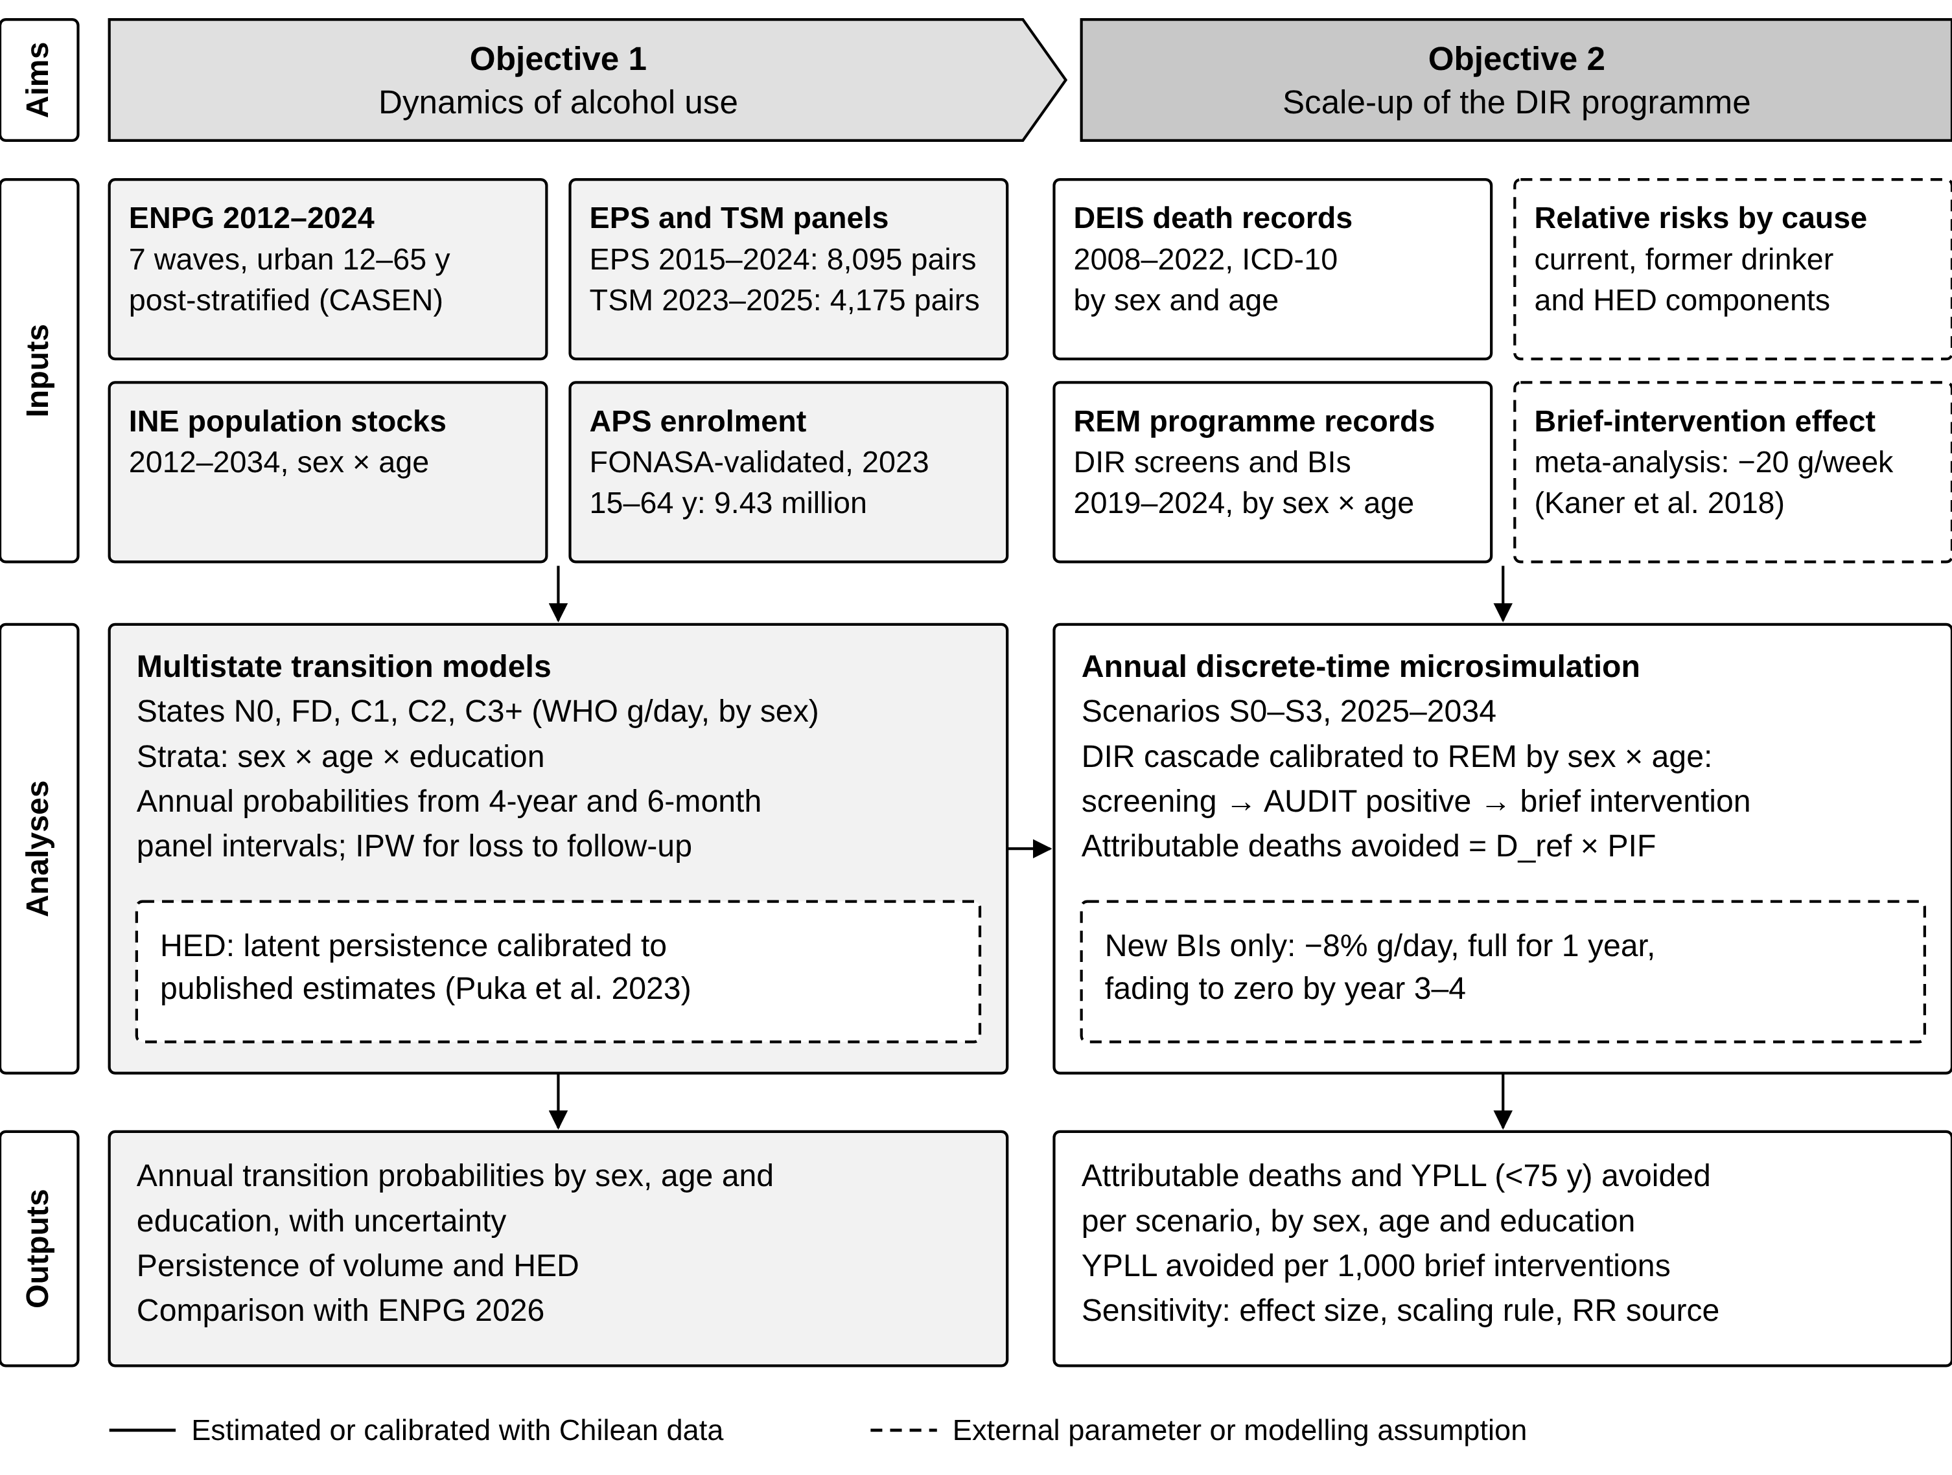
Fig. 1 Study design: objectives, data sources, analyses and outputs
Objective 1 estimates annual transitions between alcohol use states from two Chilean panels, with repeated cross-sectional surveys providing population margins. Objective 2 integrates these transitions into an annual discrete-time microsimulation to estimate the alcohol-attributable deaths and years of potential life lost (YPLL) avoided by expanding the DIR programme between 2025 and 2034. Solid borders, components estimated or calibrated with Chilean data; dashed borders, external parameters or modelling assumptions. States: N0, not currently drinking with no earlier drinking observed (not equivalent to lifetime abstention); FD, former drinker; C1, C2 and C3+, World Health Organization drinking risk levels (women: >0 to <20, 20 to <40 and ≥40 g of ethanol per day; men: >0 to <40, 40 to <60 and ≥60 g/day). ENPG waves 2012–2024 were post-stratified with CASEN by sex, age and education; this corrects composition but does not identify rural drinking patterns. Abbreviations: APS, primary health care; BI, brief intervention; CASEN, National Socioeconomic Characterisation Survey; DEIS, Department of Health Statistics and Information; DIR, Detection, brief Intervention and assisted Referral programme; D_ref, reference deaths; ENPG, National Drug Survey in the General Population; EPS, Social Protection Survey; FONASA, National Health Fund; HED, heavy episodic drinking; INE, National Statistics Institute; IPW, inverse probability weighting; PIF, potential impact fraction; REM, Monthly Statistical Records; TSM, Mental Health Thermometer (ACHS-UC); WHO, World Health Organization; YPLL, years of potential life lost.

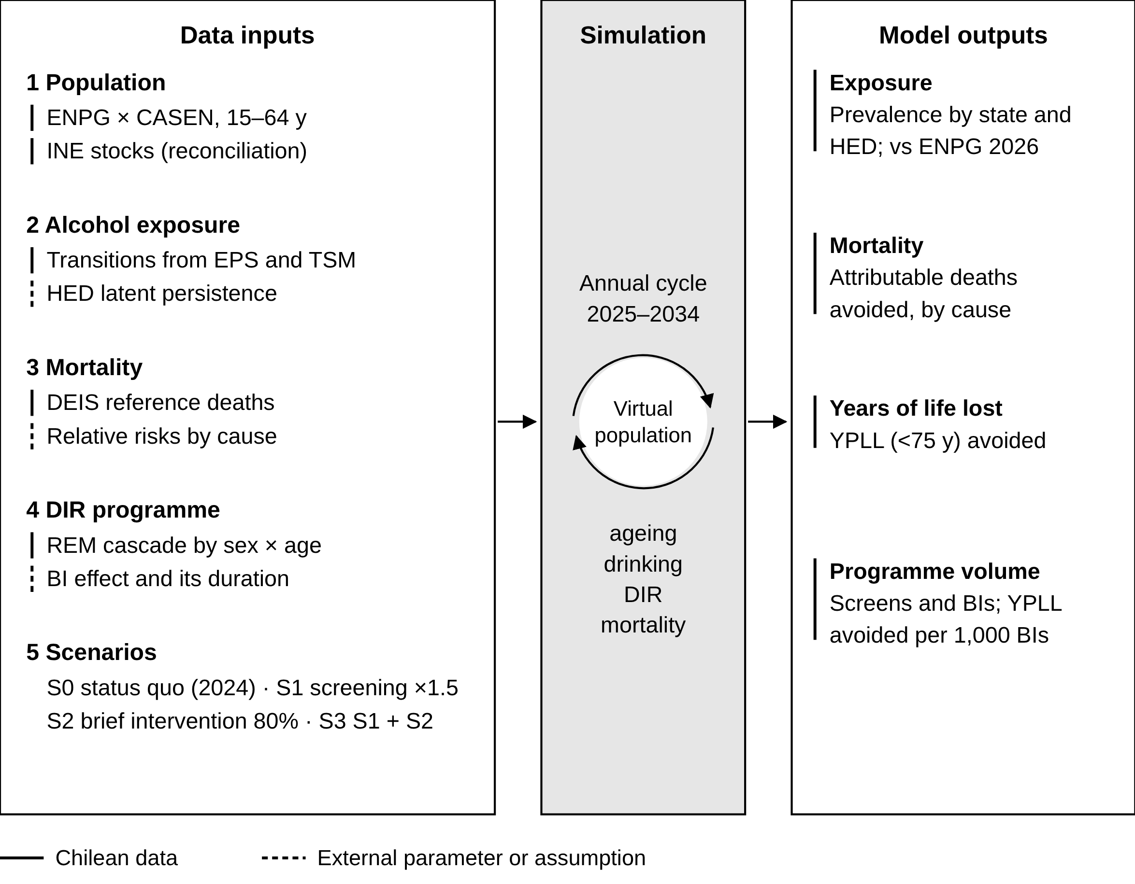
Fig. 2 Model modules, annual simulation cycle and outputs
Five input modules (left) feed an annual cycle applied to a synthetic population (centre), which produces exposure, mortality and programme outputs (right). Line markers: solid, Chilean data; dashed, external parameter or assumption. Population: ENPG respondents aged 15–64 years post-stratified with CASEN; INE stocks are used for demographic reconciliation, not to observe individual migration. Exposure: annual transition probabilities estimated from EPS and TSM; heavy episodic drinking assigned from volume plus a latent persistence term. Mortality: reference deaths from DEIS and cause-specific relative risks for current drinking, former drinking and heavy episodic drinking. DIR programme: probabilities of screening, of a positive result and of brief intervention calibrated to REM 2024 by sex and age; the effect applies only to brief interventions additional to the status quo. Scenarios: S0, programme coverage held at 2024 levels; S1, screening coverage multiplied by 1.5 with an unchanged probability of brief intervention after a positive result; S2, brief intervention after 80% of AUDIT scores of 8–15; S3, S1 and S2 combined. YPLL computed with a fixed cut-off at 75 years. AUDIT, Alcohol Use Disorders Identification Test; other abbreviations as in Fig. 1.

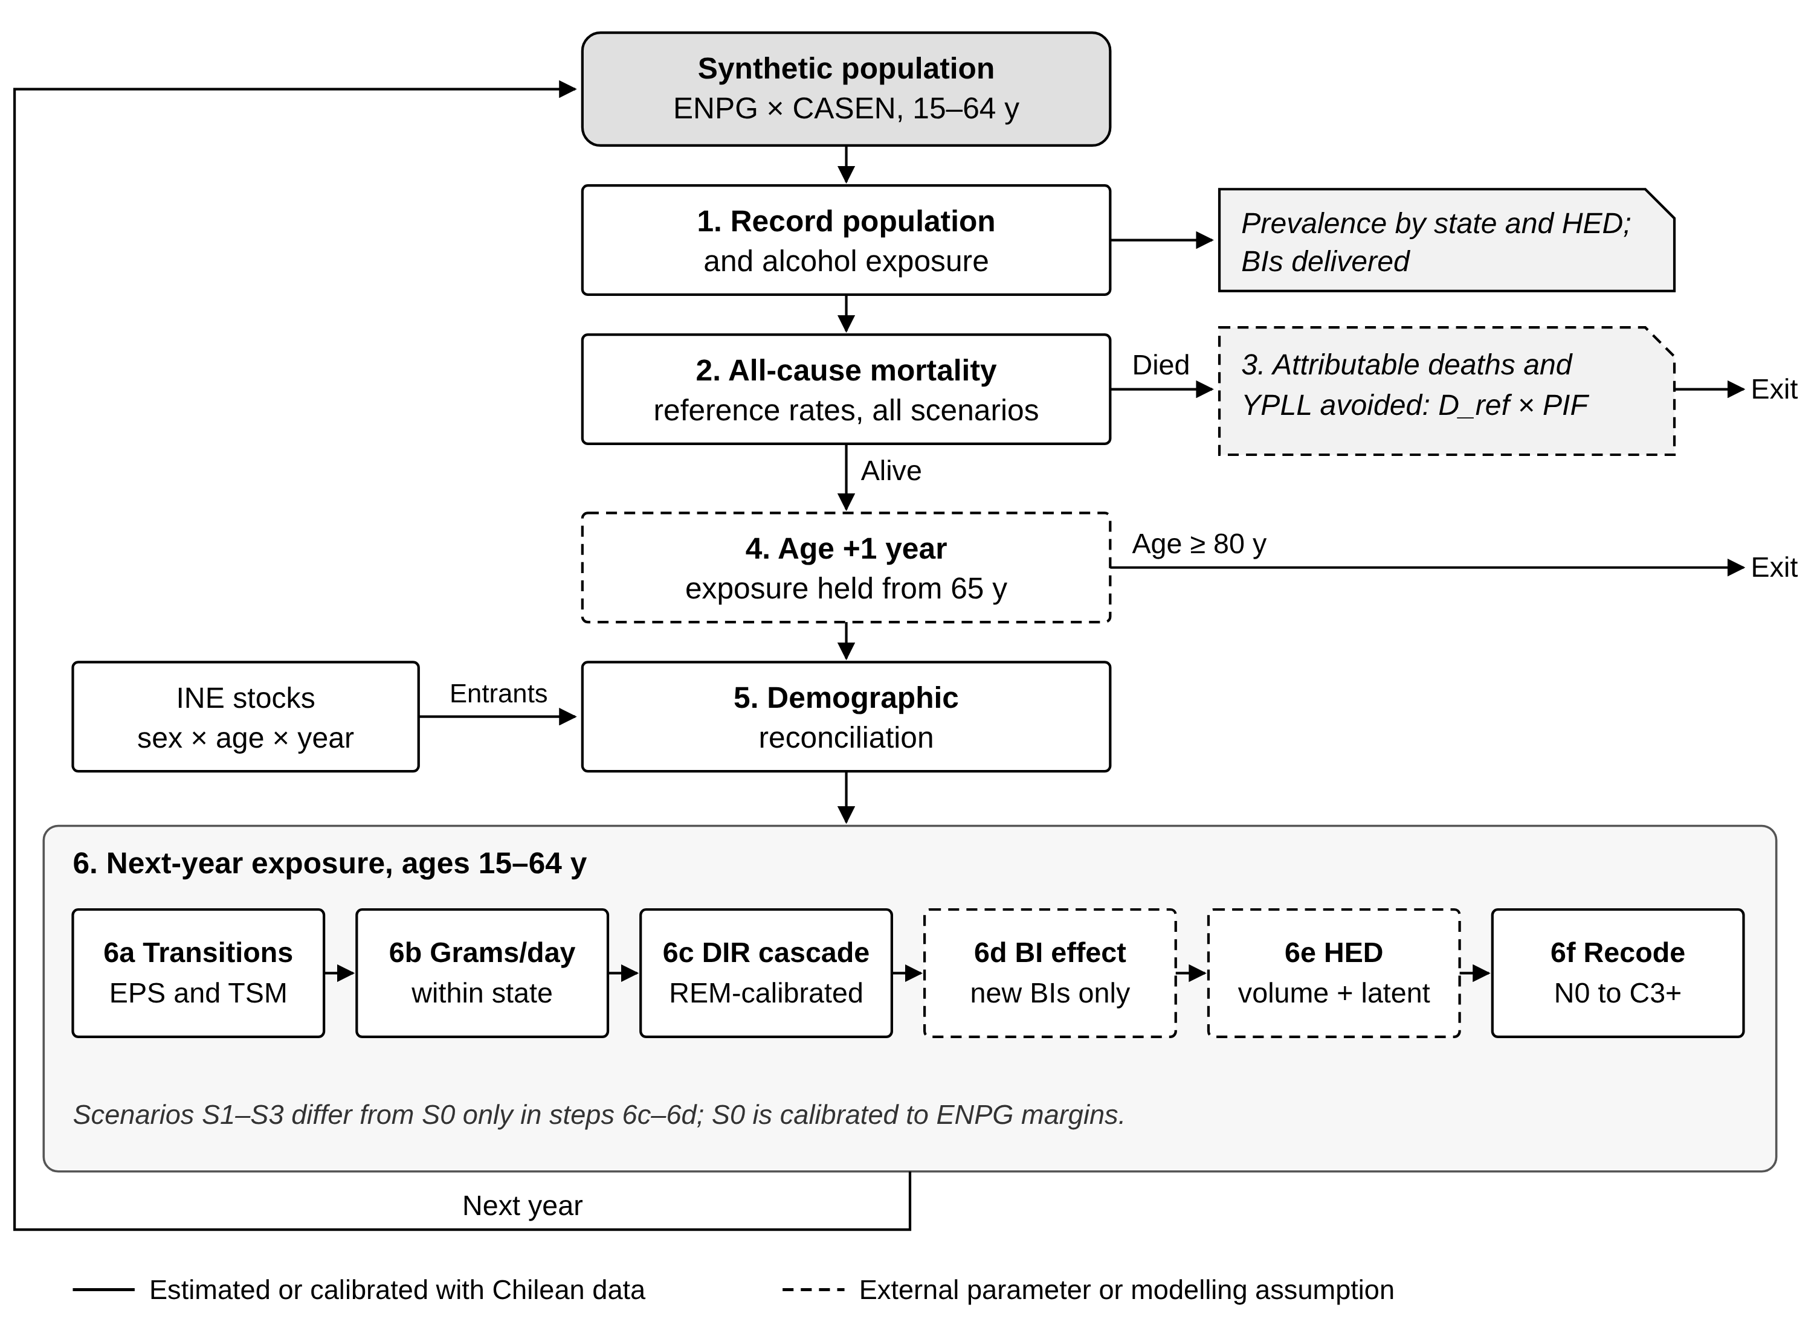
Fig. 3 Annual process overview of the microsimulation
Each simulated year starts with the recording of population and exposure in January (step 1). All-cause deaths are drawn from reference rates that are identical across scenarios (step 2). Alcohol-attributable deaths and YPLL avoided are computed as expected values by multiplying reference deaths by the potential impact fraction for each cause, sex, age group and year (step 3): PIF = 1 − Σp′RR / ΣpRR, where p and p′ are the simulated exposure distributions under S0 and under the scenario. Survivors age one year; exposure is held constant from age 65 and attributable mortality is followed up to age 79 (step 4). The population is reconciled to INE stocks by sex and age; entrants, mainly people turning 15, receive exposure drawn from the ENPG distribution of their cell (step 5). Exposure for the next year is then updated for people aged 15–64: annual transitions between states (6a); grams of ethanol per day drawn within the assigned state (6b); the DIR cascade calibrated to REM records (6c); the effect of new brief interventions, an 8% reduction in grams per day, full during the first year and fading to zero by year 3–4 (6d); heavy episodic drinking from volume and a latent persistence term (6e); and recoding of states (6f). The model is initialised in 2012; scenarios diverge from 2025 and run to 2034. Solid borders, Chilean data; dashed borders, external parameters or modelling assumptions. Adapted from Kilian et al. [ref]. Abbreviations as in Fig. 1.

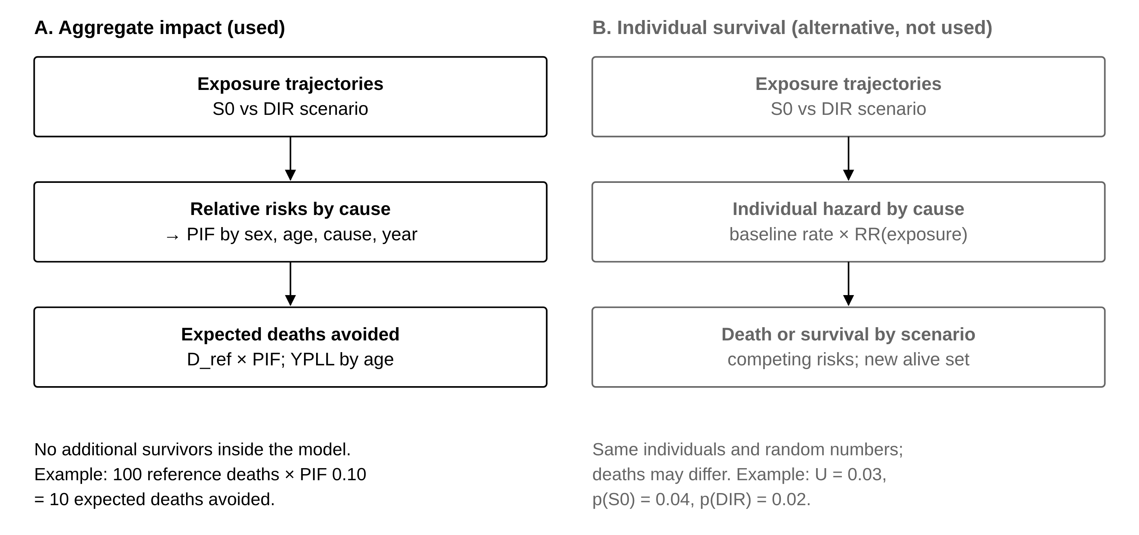
Additional file 1: Fig. S1 Two routes to estimate the mortality impact of the scenarios
Route A (used): the model projects exposure under each scenario; relative risks by cause convert the exposure distributions into potential impact fractions, and expected deaths avoided are reference deaths multiplied by the PIF. No additional survivors are simulated. Route B (not used): individual cause-specific hazards depend on exposure, so deaths differ between scenarios while individuals and random numbers are shared; it would require an alcohol-free baseline rate, no reconciliation to population stocks in the intervention arms and more Monte Carlo replicates. The routes are alternatives and are not added together. RR, relative risk; U, uniform random number; other abbreviations as in Fig. 1.

