

Turing School of Software and Design

Module 4 Capstone Project

August 2017

*Wakaru*

Customer Relationship Management Tone Analyzer

[Carl Richmond](https://www.linkedin.com/in/carl-richmond/)

[Repository](https://github.com/ACC25/wakaru)

Abstract

Curating user experiences has become central to many industries in the digital age, where presenting a unified story, across company and product, is central to a holistic marketing strategy (Zeiser 316). Customer Service represents one of the pillars of business and controlling a user’s experience in that area is important to presenting a unified front.

With the emergence of accessible natural language processing technologies, such as IBM’s Watson Tone Analyzer and Google’s Natural Language API, companies can now track the language and tone of their front-facing employees — such as customer service agents.

The present work is focused on developing methodologies to manage the data received from these natural language processing programs, in such a way as to infer whether front-facing employees are contributing to the story of a business or hurting its overall brand.

Wakaru, the tone analyzer app, aims to present these conclusions to businesses in an easy to understand manner.

# Introduction

The history of natural language processing began in the early 1950s with Alan Turing proposing, in his article *Computing Machinery and Intelligence*, that one method to determine a machines intelligence would be to play an imitation game, where the computer must fool an interrogator into believing it is human. At a fundamental level this involves a program breaking down human sentences and text into machine understandable data.

The work around Wakaru does not involve contributing any new ideas to the field of natural language processing, but rather how a business can deal with the resulting data in a statistically sound way. It aims to answer the question of whether a business can use the data from IBM Watson’s API to inform its practices in Customer Service departments.

# Sample Selection

The sample size for Wakaru was determined using the following equation for a company of 200 employees, confidence level of 80% and margin of error of 5%.

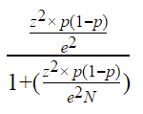

Population size = N | Margin of error = e | Z-score = z

To reach the goal of 91 samples, surveys were sent out and recipients were prompted to reply as if they were customer service agents. All the surveys and results can be found [here](https://github.com/ACC25/wakaru). The surveys were split into several categories to focus the language of the respondents and help identify trends in different customer service interactions. Twelve different surveys were created, each with a unique prompt, to cover a variety of different scenarios.

Following the study done by Software Advice (Software Advice), the categories were set as: granting requests with a good tone, denying requests with a good tone and denying request with a bad tone. The study found that customer’s perception of tone changed dramatically between granting and denying interactions. Specifically, customers prefer a casual tone when being granted a request, but find it offensive when being denied one. The categories of the surveys, as with the prompts, were designed to focus in on the tone differences between granting and denying interactions.

# IBM Watson Tone Analyzer

IBM Watson’s Tone Analyzer returns 10 metrics per segment of text that you provide: disgust, fear, joy, sadness, anger, openness, conscientiousness, extraversion, agreeableness and emotional range. Each metric has a score between 0 (lowest) and x (highest). By themselves, they were found to mean very little – especially with professional language. The words we use in casual conversations are much different than the words we use in a professional conversation, even a casual one, and the tone scores indicate difficulty in classifying professional interactions.

For instance, many good toned responses taken from the sample surveys scored as low as bad toned responses across IBM’s metrics. Disgust for instance, had a STDEV of 0.02 across all categories, which indicates the metric is statistically insignificant and cannot help inform whether an interaction was ultimately good or bad – by itself. Anger, fear, openness and emotional range had similar results. The lack of deviation across the tonal categories highlights the difficulty in classifying language and the need to look at all the results together, and focus on how the scores correlate to each other.

# Classification

To differentiate the good emails from the bad, the tonal categories with the strongest correlations were combined into scores. The Pearson Correlation Coefficient or Bivariate Correlation were used to rank the relationships between the different tonal categories.



Through linear regressions and looking at the overall breakdown of the sample data, Joy and Sadness stood out as being moderately correlated to the categories of the emails, while also being moderately negatively correlated to each other. Their p-values scored 0.004 and 0.07, respectfully, against the null hypothesis, which was that their scores are not related to the category of an email. The p-values of the other Watson metrics were far outside of the scope of what is considered statistically significant — 0.05.

Joy and Sadness’ relationship with one another, calculated using the Pearson Correlation, and their other strongest relationships are displayed below. Green represents only the good emails, red represents only the bad emails and blue represents a mix of good and moderate emails.

../../../../Desktop/breakdown.jpeg

What stands out in the data returned from Watson, is there are few obvious positive relationships that help identify how an email should be classified. To get around this, Wakaru created scores out of the information that is moderately correlated.

Because Joy was found to be a solid indicator of category, an Enjoyment Score was created using the following formula:

extraversion = E | Agreeableness = A | Joy = J

Using the other categories that Joy is moderately to strongly correlated with, the Enjoyment Score is designed to use Joy as a coefficient to the sum of the other metrics that correlate with it, to accentuate the relationships that would not be easily identifiable otherwise.

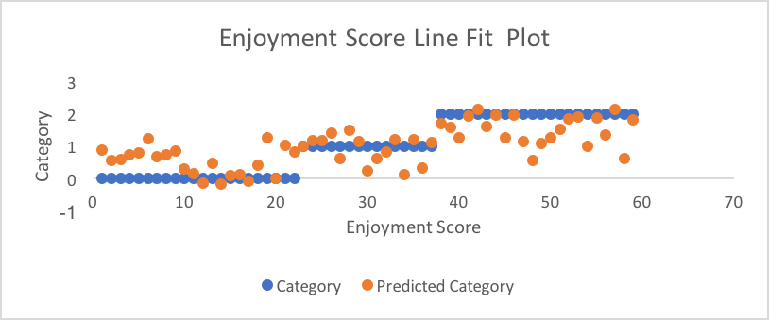

# Sadness was found to be the second most important indicator of category, so a Dissatisfaction Score was created using the following formula:

Extraversion = E | Enjoyment Score = e | Sadness = S

# Using the other categories that Sadness is moderately negatively correlated with, Dissatisfaction Score is designed to use Sadness as a coefficient to the difference of the other metrics that negatively correlate with it, to accentuate the relationships that would not be easily identifiable otherwise.

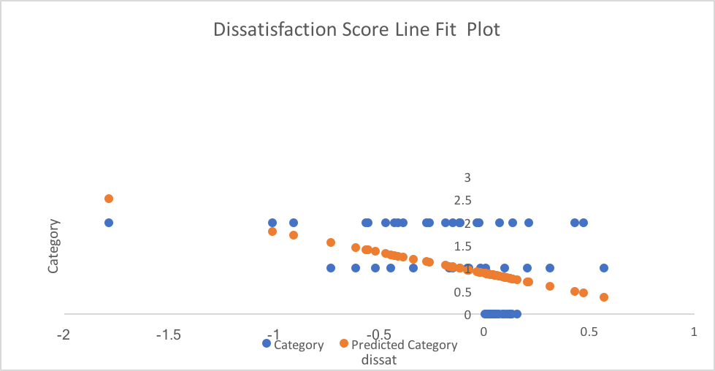

In the IBM documentation for Watson, they reference the Big 5 emotions—openness, conscientiousness, extraversion, agreeableness and emotional range—which are explained to be significant when examined as a whole. Because of the importance put onto those categories by the creators of Watson, a Big 5 score was created by adding their scores together to act as a guard against the other assumptions made in the project.

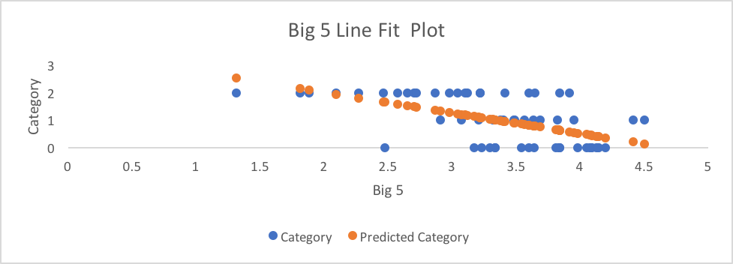

# Wakaru looks at the percentile rank of each score—enjoyment, dissatisfaction and big 5 score—within each tonal category (good, medium, bad). Each score is given three different percentile ranks, which indicate it’s placement in relation to the other emails of that category.

# A very well written email may have an enjoyment score breakdown of: 50th percentile rank in category 0 (good), 75 percentile rank in category 1 (medium) and a 100 percentile rank in category 2 (bad), which indicates that the email’s enjoyment score is higher than all the bad emails, but only higher than half of the good emails. We can therefore deduce that in the area of the enjoyment score, the email fits squarely into the middle range of a good email and the high end of a moderate email. This same process happens to the dissatisfaction score and big 5 score. Once the percentile rank of each score has been calculated, the findings are summarized based on this decision three.

1. **def** low_medium_high(number)
2. **if** number >= 75.0
3. "high"
4. **elsif** number >= 45.0 && number <= 75.0
5. "medium"
6. **elsif** number <= 45.0
7. "low"
8. **end**
9. **end**

This results in three different scores of either high, medium or low for each of our aggregate scores (enjoyment, dissatisfaction and big5 score).

These scores then go into another decision tree to further summarize the information and create two sentences, one to breakdown the overall enjoyment and another to breakdown the effect on the brand. The enjoyment and big5 scores are used to determine the enjoyment factor of an email, from the customers perspective, and the enjoyment score and dissatisfaction score are used to determine the brand impact. These generalizations are intended to give an idea on how to interpret the raw percentile rank returns, which Wakaru displays to the user.

Wakaru also has the ability for users to set fixtures, which is a feature whereby users can set how an email should be categorized. When a user sets a fixture it triggers a reclassification of every other email in the users account, which allows the program to be reactive to the style of writing a business uses. This reclassification process means that a company could decide to make what me might consider to be bad emails, good emails.

# Conclusion

Wakaru a proof of concept that businesses can use the aggregate data from Watson in ways that can result in actionable insights. Even within the short timeframe of this project (two weeks), it was possible to make a model that can accurately determine extremes of good or bad. With more time and resources, it would be possible to use machine learning and create a much more accurate statistical model. Within a different framework, other than Ruby on Rails, it would have been possible to add-in more statistical analysis as well. The only indication of the standard error rate of Watson is the regression models used to make determinations on what Watson metrics to use, and those are not representative of the accuracy of the final product. Much more testing would be necessary to determine how accurate Watson picks up the nuances of a moderately bad or good email, for instance. At its core, Watson is a very small peak at what we can possibly achieve with regards to Natural Language Processing and how it can inform business practices.

# Bibliography

Software Advice. "The Best Tone for Email Customer Support." 2014. *Software Advice.* <http://www.softwareadvice.com/resources/the-best-tone-for-email-customer-support/>.

Zeiser, Anne. *Transmedia Marketing: From Film and TV to Games and Digital Media*. New York: Focal Press, 2015.