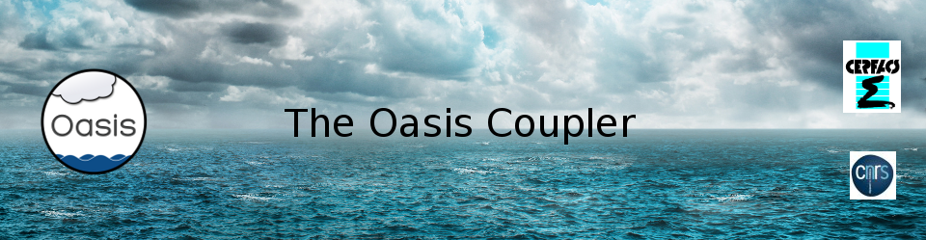

tutorial_communication,
a tutorial on how to instrument a code with OASIS3-MCT API calls
September 2021

Introduction
This directory contains the files of a tutorial to learn how to instrument a code with calls to the OASIS3-MCT library so to couple it with other components. The tutorial involves two toy model codes, ocean.F90 and atmos.F90, into which you are invited to implement the calls to OASIS3-MCT API (Application Program Interface) routines. Toy models are skeleton programs that do not contain any real physics or dynamics but that can reproduce real exchanges of coupling fields. Instrumenting those toy models gives a practical experience of using the OASIS3-MCT library.
This tutorial is extracted from the Short Private Online Course (SPOC) on “Code Coupling with OASIS3-MCT” developed in the framework of the ESiWACE Centre of Excellence. This SPOC is composed of videos, quizzes and hands-on. If you are interested in attending the SPOC, please visit the online training section of CERFACS web site at https://cerfacs.fr/online-training/. Videos and quizzes were also extracted from the SPOC and are available as Open Education Resources (OER) material at https://www.oercommons.org/courseware/lesson/85340 .
OASIS3-MCT is a coupling library that can be used to exchange information, the so-called coupling fields, between different codes or even within one same code. Internally, OASIS3-MCT uses the Model Coupling Toolkit (MCT) developed by the Argonne National Laboratory. Usually, the codes to be coupled represent different parts of the Earth System, e.g. the ocean or the atmosphere. The codes can be sequential, i.e. run on only one process, or parallel, i.e. run on more than one process. Each code must be compiled and linked with the OASIS3-MCT library. During the simulation, the OASIS3-MCT library performs the exchange of coupling fields between the different executables (i.e. the compiled codes). When the code is parallel, each process can send or receive its part of the coupling field (i.e. there is no need to gather the whole coupling field on one process). When the OASIS3-MCT library performs the exchanges, it can apply different transformations on the coupling fields, for example spatial regridding (i.e transforming the coupling field from the grid of the source code to the grid of the target code).
The toy coupled model to implement
The objective of the tutorial is to instrument the codes of the toy models provided (ocean.F90 and atmos.F90) to implement basic coupling exchanges between those toy models. In their original form, ocean and atmos run for 4 hours (14400 seconds) without exchanging any coupling field; ocean has a timestep of 3600 sec and atmos a timestep of 1800 sec.
The grid of ocean has 182x149 grid points globally but ocean is parallel so each ocean process defines its local partition and reads only its part of the grid in the file ocean_mesh.nc. Then each process allocates two local arrays field_send_ocean, a coupling field to send and field_recv_ocean the coupling field to receive. The coupling field field_send_ocean is function of the longitude and the latitude of the grid points and of the timestep number, so it varies at each timestep. At the first timestep, field_send_ocean looks like this (in the 182x149 grid point space):
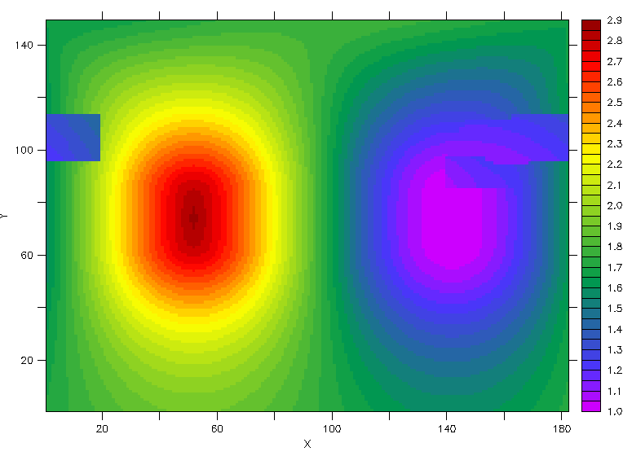
Note that the square-like patterns are due to the distortion of the grid over the continents.
The grid of atmos has 96 x 72 grid points globally but, as ocean, atmos is parallel so each atmos process defines its local partition and reads only its part of the grid in the file atmos_mesh.nc. The next figure illustrates the sea-land mask on the atmos grid. Following OASIS3-MCTconvention, masked cells have a value of 1 (red) and non-masked cells a value of 0.
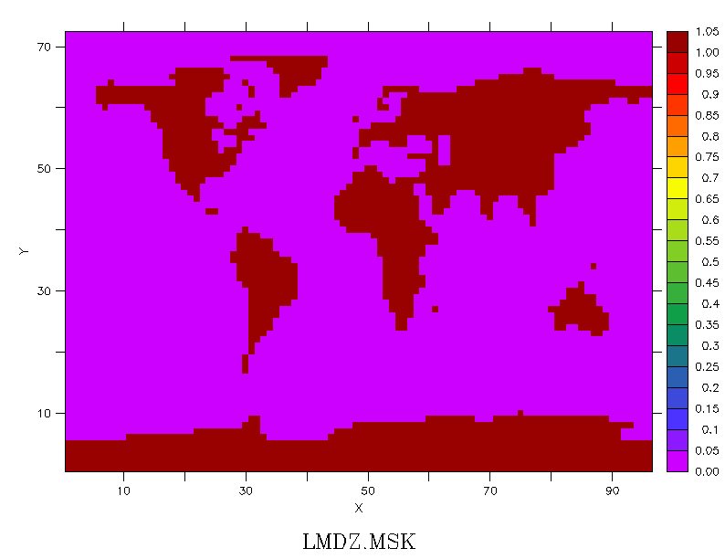
Then each process allocates two local arrays field_send_atmos, the coupling field to send and field_recv_atmos the coupling field to receive. The coupling field field_send_atmos is defined with a function that varies with the longitude and the latitude faster than in ocean and it also varies in time. At the first timestep, field_sent_atmos looks like this (in the 96 x 72 grid point space):
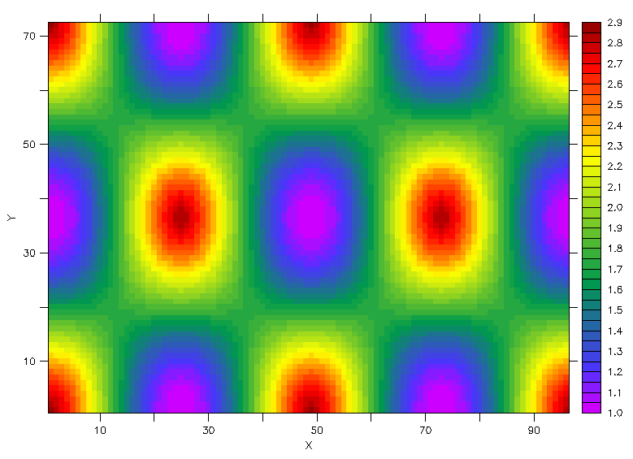
The coupling exchanges to implement are illustrated here. The ocean sends its array field_send_ocean (with symbolic name FIELD_SEND_OCEAN) to atmos which receives it in the array field_recv_atmos (with symbolic name FIELD_RECV_ATMOS); the coupling period is 3600 sec. In return, atmos sends its array field_send_atmos (with symbolic name FIELD_SEND_ATMOS), to ocean which receives it in the array field_recv_ocean (with symbolic name FIELD_RECV_OCEAN); the coupling period is 1800 sec.

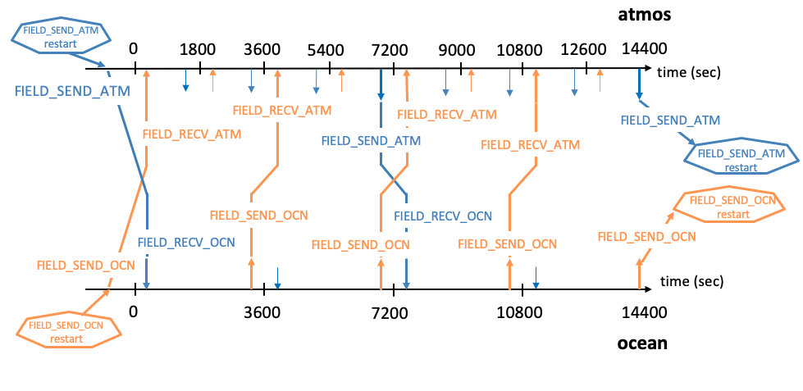
Compiling and running “empty” tutorial toy models
To compile the toy model components, you first have to compile OASIS3-MCT on your computing platform (see section 6 of the User Guide). Then to compile the toy model components, simply type, in the tutorial_communication directory:
> make clean; make
Note that the Makefile in this directory automatically includes your OASIS3-MCT header makefile – see the first line in the Makefile. The executables atmos and ocean should be available in the current directory.
To run the two tutorial components as separate models, edit the script run_tutorial to adapt it to your platform and execute it
>./run_tutorial
The results of the component models should now be in subdirectory $rundir defined in run_tutorial. In their current form, atmos.F90 and ocean.F90 are not interfaced with the OASIS3-MCT library and do not perform any exchanges. They just run, on 4 processes each for 4 model hours without doing anything specific. Have a look at the files atmos.out_10? and ocean.out_10? (where ? goes from 0 to 3, one for each process), in the $rundir subdirectory.
Interfacing the toy models with OASIS3-MCT and running it
The tutorial toy model should reproduce the coupling exchanges between atmos and ocean as described above. To do so, modify atmos.F90 and ocean.F90 so to implement the initialisation, definition and declaration calls of OASIS3-MCT library. In the time step of the models, implement the reception of the input coupling fields (oasis_get) at the beginning of the time step and the sending of the output coupling field (oasis_put) at the end of the time step. The lines where to introduce the OASIS3-MCT specific calls are marked with a line specifying the call to implement, for example:
!!!!!!!!!!!!!!!OASIS_DEF_PARTITION!!!!!!!!!!!!!!!!!!!
Once instrumented, recompile atmos.F90 and ocean.F90 . To run the two tutorial components as a coupled models, edit the script run_tutorial_oa to adapt it to your platform and execute it
>./run_tutorial_oa
Note that run_tutorial_oa copies the configuration file namcouple_LAG from directory /data_tutorial, in the $rundir directory as namcouple. This namcouple specifies that a coupling field with symbolic name FIELD_SEND_OCN has to be matched with a coupling field with symbolic name FIELD_RECV_ATM and that the mapping between the two fields has to use the pre-existing weight and addresses file my_remapping_file_bilinear.nc. It also specifies that a coupling field with symbolic name FIELD_SEND_ATM has to be matched with a coupling field with symbolic name FIELD_RECV_OCN and that the interpolation to transform the field has to be the SCRIPR/BILINEAR one (i.e. the weight and addresses file used for the interpolation will be calculated in the initialisation phase with the SCRIP library).
The results of the tutorial coupled model should now be in your $rundir subdirectory. The file nout.000000, written by the master process of one model, contains the information read in the configuration file namcouple. The OASIS3-MCT debug files debug.01.00000? and debug.02.00000? (where ? goes from 0 to 3, one for each process) are written by each process of ocean and atmos respectively. The level of debug information in these files corresponds to the value of the first number on the line below $NLOGPRT in the namcouple. If your run was successful, these debug files should all end with :
(oasis_terminate) SUCCESSFUL RUN
-- EXIT (oasis_terminate)

We hope that you have successfully instrumented the tutorial toy models and run them in coupled mode. If you have not, please note that a version of the toy model codes instrumented with OASIS3-MCT API calls is available in the directory, see atmos.F90_oa and ocean.F90_oa.
If you need further help, do not hesitate to consult the OER material available at https://www.oercommons.org/courseware/lesson/85340 and/or to follow the SPOC on “Code Coupling with OASIS3-MCT” (see https://cerfacs.fr/online-training/). We are also available at oasishelp@cerfacs.fr to answer questions you may have.
Have fun with OASIS3-MCT !

