**A Basic Introduction to Robotics.**

**What is a Robot** – A robot / machine is a piece of hardware or software made to simplify  
 or automate a task. [For our purpose we will be looking at hardware.]

When making a robot there are seven basic stages that can be loosely drawn as follows:

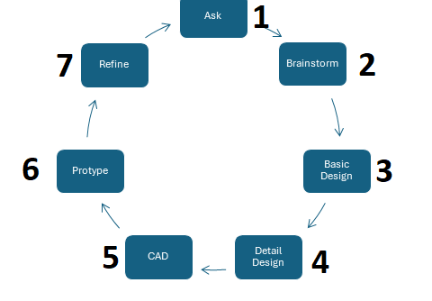

1) Ask the question and set goals.  
 - What does my robot need to do?  
 - What materials do I have or need to build my robot?  
 - How will my robot navigate and interact with things?  
 **- Does my robot have any predetermined design requirements?** **- Is there any time constraints on the build?**

2) Brainstorm Designs and Concepts  
 - Create rough sketches of what your robot will look like.  
 - **You should have as many designs as possible**.   
 - After an iterative process of querying and critiquing each possibility, a selection is made.

3) Create a Basic Layout Drawing  
 - You will now draw out what was selected as the design to be built.  
 - In this layout you will ensure that   
 **- you can not only find the components but also afford to build it.  
 - it will perform the job efficiently and effectively.**

**- This gives you the basic layout of the robot. Where will the robot’s battery, Roberio, radio   
 and motors be located? Will there be sensors? If yes, how many, what type and where will  
 they be located.**

4) Detail Design  
 - This is a technical document that has your robot drawn with precise measurements.  
 - It shows the robots operation, how different parts will interact, where gears, screws, axles,   
 chains. It should also show where things like gears, screws, and axles should go. The exact   
 measurements of every part should be included.  
 - the exact location of all electronics and how they will be connected should be noted.  
 - this acts as the document from which you create your prototype  
5) CAD (Computer Aided Design)  
 - Use the detail design created in Step 4 to create a computer model that can be utilized by  
 different manufacturing devices.  
 - This modeling can be done by various software programs eg Solid Works, Auto CAD, OnShape   
 etc.  
 - Some manufacturing devices require specific file formats. Ensure that your design program can   
 export the correct file type that will be used in the manufacture of the part.

6. Construct a Prototype.  
 - This is where you build the robot / part to be tested. The design is ‘executed’ and tested to see if   
 it meets the real-world requirements.  
 - This is what is constantly updated and implemented.

7. Refine your design  
 - This is where the design and operation are analyzed to see deficiencies and what  
 optimization can be done. Eg (Robot is running with a cycle time of 15 secs, I need it to be 10   
 secs can I modify the speed using code or do I need to change the gearing)

**[NB The process is truly cyclical with multiple cycles. Although it is loosely drawn as seen below:**

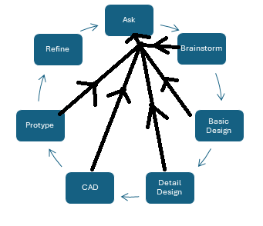

***If in any stage a ‘tweak’ is made we need to ensure that it answers the questions asked and then follows the chart to where the tweak was made. In short we return to 1 and revisit the processes along the way***].

**Simple Machines**

What is a robot – From a mechanical perspective we can think of a robot as a complex machine.  
 A complex machine is a machine that consists of many **Simple Machines**.  
 So rewriting the definition of a robot we can say that **A robot consists of many   
 simple machines.**

So what is a simple machine?

A Simple Machine – any of several devices with a few or no moving parts that are used to modify   
 motion and the amount of force needed to do work.  
 - is a device that multiplies the user’s little effort to create a great effort to   
 perform ‘work’ on an object. Ie let the object change its state.  
 -in many cases uses some form of leverage (mechanical advantage – effort   
 multiplier) to perform ‘work’.

Examples of Simple machines:

**1)Inclined Plane** – This is used to lift heavy bodies. It is a sloping surface known as a ramp.  
 It is important to note that the steeper the slope, the greater the force that is   
 needed to move an object on the slope.  
 - it is created by joining two ‘planes’ at an angle.  
 Eg. 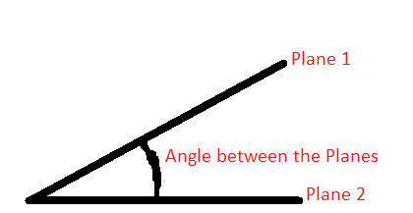

How does a incline plane make moving an object easier?

If an object is on a flat surface (assuming no friction) the force (effort) to move it is  
 the mass of the object X gravity. Gravity (invisible force that pulls objects towards   
 each other. On the earth the gravitational constant is 9.8ms2)

So if we have the image below

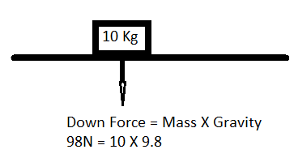  
 Eg To lift the above 10Kg block on a flat surface would require 98N of force.

However, if we had the block on an incline plane our analysis changes.

Why? Because the Down Force is acting at an angle it has to now be split into two,  
 Force A and Force B. Force A is the force perpendicular to the plane of motion and   
 Force B is the force parrallel to the plane of motion (this is the force that provides the  
 lift, the desired change in height). To get the block moving up the incline, the main force  
 that needs to be overcome is Force B. (Assuming no friction)  
 Force B = Down Force X Sin *angle*   
 The force exhibited by the plane on the block is Force A  
 Force A = Down Force X Cosine *angle*

For it to be considered an incline the angle must be greater than 0 and less than 90  
 degrees. Now, the Sin of an agle approches 1 as the angle approches 90 so this means  
 **that Force B (the force to get a change in object height) on the incline plane will   
 always be less than the Down force as shown in the chart below.**

|  |  |  |  |
| --- | --- | --- | --- |
| **D. Force on Flat(N)** | **Force to lift on flat (N)** | **Incline angle** | **Force B (N)** |
| 98 | 98 | 15 | **98 * Sin 15 = 25.4** |
| 98 | 98 | 30 | **98 * Sin 30 = 49** |
| 98 | 98 | 45 | **98 * Sin 45 = 69.3** |
| 98 | 98 | 60 | **98 * Sin 60 =85** |

***The above example is somewhat simplsitic but it highlights that using an incline   
 plane is an efficient way to lift a heavy object.***

As we do not do a lot of heavy lifting in our designs, our use of incline planes are  
 primarily to assist in pickups or getting light objects to the desired heights.

**2)Wedge –** is a triangular shaped tool commonly called a portable inclined plane. Its main  
 feature is that it tapers to an edge and as such it can  
 - split objects (axe) - cut (knife) - tighten and hold objects in place (door stop).   
 - hold together (nail)   
 - aerodyamics uses the principle of a wedge to reduce friction caused by air or liquids.

Complex example – Zipper - It has two rows of metallic or plastic teeth which   
 interlock (hook) resulting in binding the piece of material. It also has a slider which helps   
 to bind or separate those two rows of teeth stitches with the fabric from both sides of the  
 edge. The mechanism behind the zipper is that It has two lower wedges in the slider  
 which close the zip and one upper wedge which opens the zip.

**3)Screw -**An inclined plane that is wrapped around a cylinder. The most popular use for a screw   
 is to hold things together. This can be done using screws only or a combination of   
 screws (bolts) and nuts. A special application of screws called a lifting screw is used  
 to lift heavy objects and to dig holes. A screw jack is an example of a lifting screw.  
 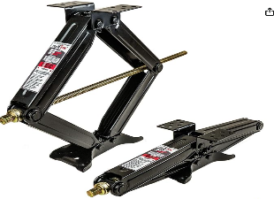

**4)Pulley -**A grooved circular disk (or disks) that guide a rope or cable pulled around its perimeter.   
 With a single pulley engineers can change the direction of an applied force, such as pulling a   
 rope down to lift a weight up. However, using a combination of pulleys in a pulley system can  
 change both the amount and direction of the applied effort. Engineers design large   
 machines, like cranes, bulldozers and elevators, with a system of pulleys to manipulate huge   
 loads with a little force supplied by a relatively small motor. A simple practical example of  
 this is on the old robot

**5)Wheel and axle-** Composed of a circular wheel directly connected to a circular shaft or axle, this   
 device rotates around the common axis and has the ability to increase a rotational force   
 instead of a linear force. Rotational force is known as torque and plays an important role  
 in the creation of use or gears. Use the old robot to highlight this for students

**6)Lever -**A long beam that rests on a point or support called a fulcrum or pivot. By having this  
 point close to a heavy object and applying an effort from far away, levers can be used to   
 easily lift heavy objects. The object being moved by the lever is often called the load, or   
 output force, while the force applied to the lever is called the effort, or input force.   
 Prybars are a commonly-used lever that help workers separate two objects**.** Show students the prybars we have in house and how we use them.

**Combining simple machines to create intakes.**

**Hooks – are mechanisms that are used for grasping objects generally in a “pulling” manner.**

Hooks

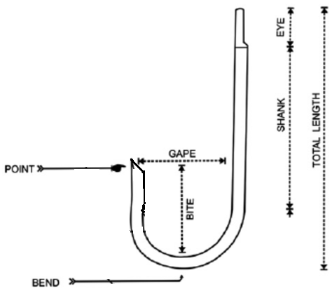

**Implementation in Robotics**

Andy Mark Climber in a box.  
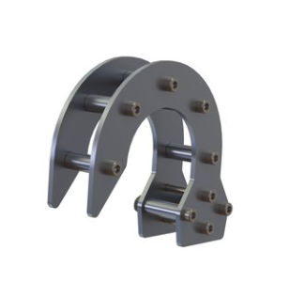 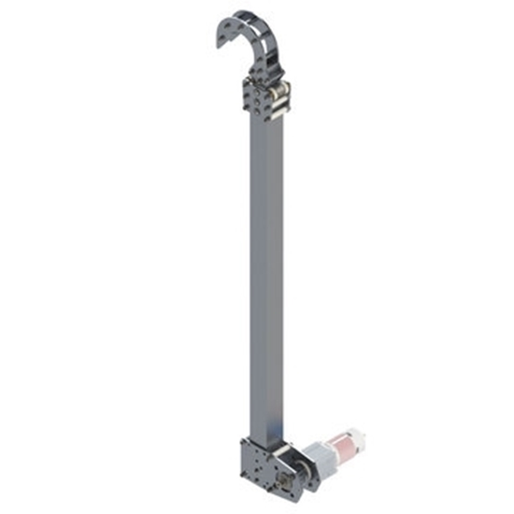

How would this be used:

This hook would be used as part of a climbing structure. Ie it would be attached to a series of bars that can be extended or contracted using various mechanisms.

Climber in a box (1 Minute)

<https://www.youtube.com/watch?v=iZadt9wJaOo>

Understanding the Climber in a Box

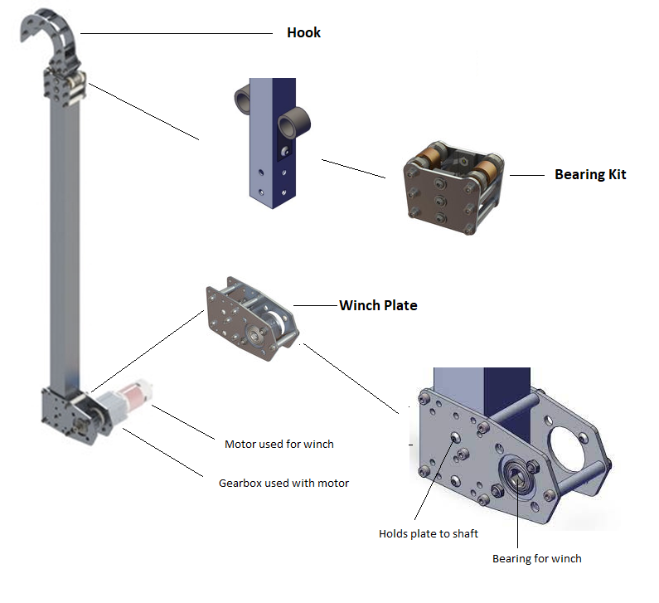

How does it work:  
The climber has two states deployed ie when the structure is at its maximum length

and its ready state ie when it is at its minimum length. The climber facilitates climbing

by moving from the deployed state to ready. By moving from maximum length to  
minimum length any object to which the climber is attached its attachment point will have moved the difference from its point of reference.

The main components of this climber are:

Hook, Two shafts (inner and outer), bearing kit, winch plate, motor and gearbox.

The hook is attached to the inner shaft and at its base it has a connected that runs to the winch. It is this cord that is used to return the climber to its “ready” state.

Attached to the inner shaft at its base is a constant force spring that is used to extend the inner shaft to transform the ready to deployed state. In the ready state the spring is loaded (ie it is at its maximum extension and the cord is at its minimum ie the winch has the maximum amount of cord attached). To get to the deployed state the motor starts unwinding the cord thereby increasing its length and the spring starts recoiling thereby reducing in length. When fully deployed the spring is at minimum length and the cord is art its maximum.

Rope assembly – Used to retract Hook / Climb (3 MINUTES)

https://www.youtube.com/watch?v=G9H6aP9wJUs

**Claws**

**Claws - are usually attached to an end of an arm and are used for grasping an object. Motors or pneumatic systems are used to activate the claws. Motors are commonly used with a**[**gear ratio**](https://kb.vex.com/hc/en-us/articles/360035590932-How-to-Use-Simple-Gear-Ratios)**or sprocket/chain system.**

**Single-sided and double-sided claws may use an increase torque gear ratio and roller claws may use an increase speed gear ratio.**

Claws fall into three categories:  
1- Single Sided  
2- Double Sided

3-Roller

Single Sided  
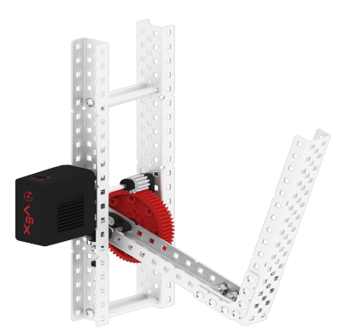

**Single-sided claw** or sometimes called a clamping claw is typically assembled with a fixed piece of structural metal and a second piece structural metal attached to a motor/gear system.

The side of the claw activated by the motor, opens and closes, clamping the game piece against the fixed piece of structural metal.

Double Sided

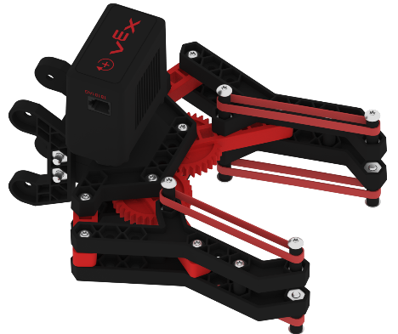  
**Double-sided claw** will activate both sides of the claw.

Double-sided claws typically have an even number of gears setup to move the two sides of the claw. One side of the claw will be attached to the first gear in the assembly and the second side of the claw will be attached to the last gear in the assembly, allowing the claw to open and close as the gears are rotated.

Roller Claws

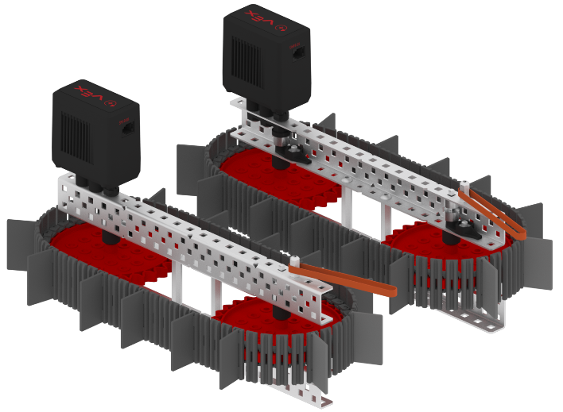

**Roller Claws** are typically assembled using Wheels, Intake Rollers, or Tank Treads. Roller claws function by spinning their rollers and having game pieces pulled into the claw. Then the rollers can be reversed, pushing them out.

Roller claws can be assembled with one side of the claw having a fixed piece of structural metal serving as a friction plate. The other side will have an active roller to roll the game piece in, along the fixed side. A roller claw can also be assembled with a roller on both sides of the claw.

Typically roller claws are designed to spin faster than the robot can move forward.

Roller claws allow game pieces to be picked up with less time aligning the robot, however, they require more time and planning to assemble.

Understanding Claws:

https://www.youtube.com/watch?v=X4JHUDGzyv0&t=59s

**Elevators (Linear Slides)**

Elevators – are used to move objects from one height to another. They fall into two categories continuous and cascading.

What highlights the difference between the two is how the stages are rigged to facilitate movement.

**Continuous:**

[**https://www.youtube.com/watch?v=orezTYhf6FM**](https://www.youtube.com/watch?v=orezTYhf6FM) **(5)**

**Cascade:**[**https://www.youtube.com/watch?v=zV4m8BtDQRI**](https://www.youtube.com/watch?v=zV4m8BtDQRI) **(5 Minutes)**

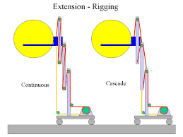

**Cascade rigging is a bit more complicated than continuous rigging. Much like continuous rigging, an extension string originating from a spool is rigged to the top of the base, running down to the bottom of the first stage. However, instead of being rigged to the top of the stage, the extension string is anchored to the bottom of the first stage. A second extension string, anchored to the top of the base, is rigged to the top of the first stage and anchored at the bottom of the second stage. The pattern continues until all stages have been rigged.**

**When the motor rotates one direction, the extension spool reels in the first string, decreasing the distance between the base and the bottom of the first stage. This pushes the second string forward, decreasing the distance between the top of the first stage and the bottom of the second stage, and so on. Note that unlike continuous rigging, every stage moves at the same time. The second stage moves 2 times as fast as the first stage relative to the base, the third 3 times as fast, and so on.**

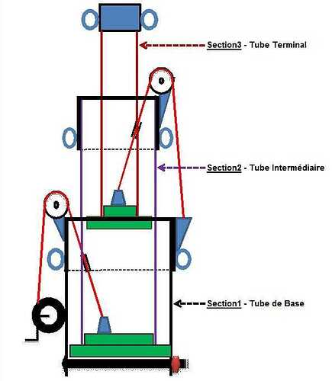

**INTAKES**

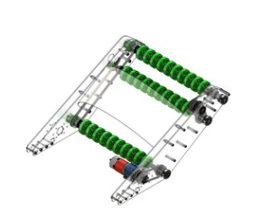

[**https://www.youtube.com/watch?v=def5QH7UUIU**](https://www.youtube.com/watch?v=def5QH7UUIU)

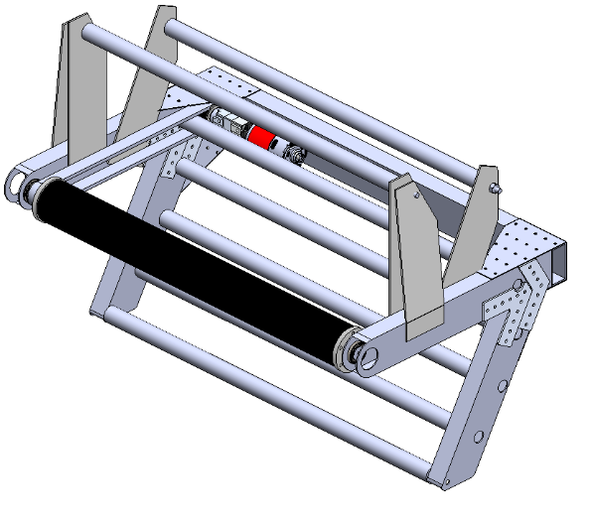

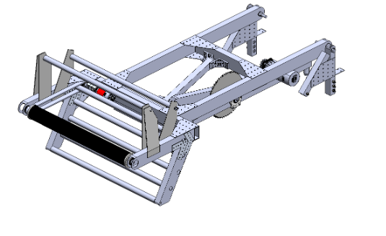

[**https://www.youtube.com/watch?v=HdQ-mWPG9GY**](https://www.youtube.com/watch?v=HdQ-mWPG9GY)

[**https://www.youtube.com/watch?v=5dS50DV7x9U**](https://www.youtube.com/watch?v=5dS50DV7x9U) **(1)**

[**https://www.youtube.com/watch?v=CUbA1NEPsdw(5)**](https://www.youtube.com/watch?v=CUbA1NEPsdw(5))

[**https://www.youtube.com/watch?v=JlKwRAvDue8**](https://www.youtube.com/watch?v=JlKwRAvDue8) **(5)**

**PART 2**

Any robot that you will design will consists of two parts:  
1) Base or Drive train – this is what is used to make the robot move around the course.  
2) Super Structure - this is what is used to let the robot complete specific tasks

Base – the core components will look the same for a specific implementation.  
 - there are basically two types Tank / Mechanum/ Swerve

TANK

Tanks - a method of controlling the motors of a tank drive drivetrain using two axes of a controller, where each of the axes operate motors on one side of the robot.

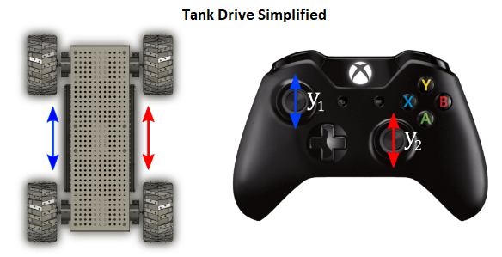

As seen by the image driving is done by controlling wheels in groups on a particular side.

There are variations to this type of base by changing the wheels or motor configurations to enhance drivability.

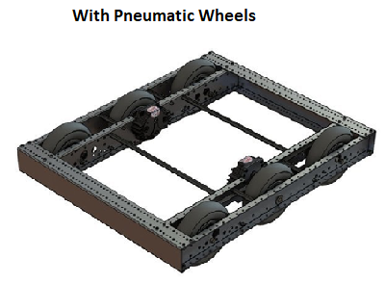

MECANUM

Mecanum is not our choice so I will not cover it but you need to know that it exists. Here is a video showing how it works.

https://www.youtube.com/watch?v=mKcHXxC8aJY

Highlight any differences you observed between the Mecanum and the tank.

SWERVE

In this design the possibility exists for all wheels to move independently so there is a lot more maneuverability.

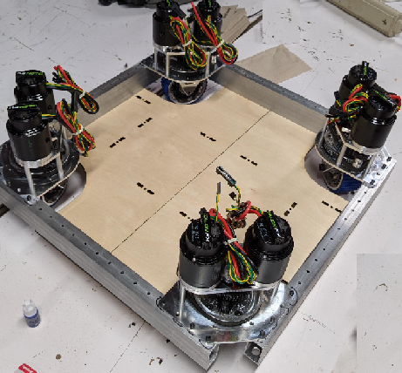

<https://www.youtube.com/watch?v=FLnUZBHBczM>

Highlight any differences you observed between the three systems.

This year we will be creating another drive base for the competition using swerve. This one will be a bit different as we will be using a product created by Thriftybot.

**Working with Screws**

* **Knowing when screw has reached its torque limit (nut and bolt egs)**
* **Knowing when you have over tightened screw (Wood screw egs)**