Measuring Distances

Distances is always measured in inches, cm or mm.  
How many mm make a cm?  
How many cm make an inch?  
Hom many mm make an inch?

How do we measure normal distances? a tape measure, square or ruler

How do we measure very small distances? Using a vernier caliper.

How do we measure thickness, inner diameter etc? Can use a piece of string and then  
 measure the string. Or use a vernier caliper

You always try to measure from a perpendicular line to the desired length.  
  
Eg: Suppose I would like to cut 10 inches out of the metal tubing below.



How would I go about it?

1) Check to see if one end is at 90 degrees.  
Put your square on the end and verify that it is straight (90)

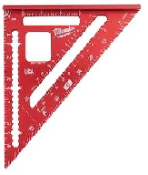

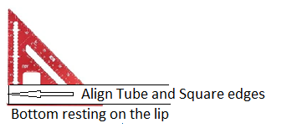

2) From the end that is at 90 degrees measure your 10 inches.

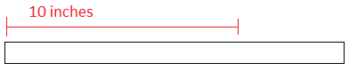

3)Put in a scribe line (A scribe line is a line indicating the position at which the object will be cut.)

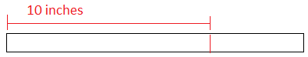

A scribe line is the line about which you are going to when making your cutline and then deciding to cut you should always consider the width of your blade. Depending on its width and the tolerance  
required you may make another scribe line at length + the width of your blade.

3.b)When cutting you should always consider the width of the

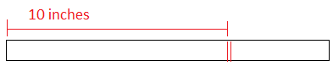

4) Consider cutting 10 inches from the tube below. How would you do it?

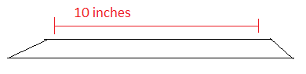

4b) Scribe the 10 inch dimensions out of the tube.  
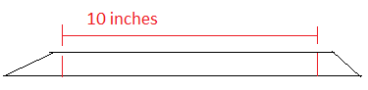

Make the cut.