Working with Screws:

1) The different types of screws:  
 - Wood  
 - Metal  
 - Multi-purpose

2) Different Size  
 - Imperial  
 - Metric

3) Different head types  
 - Hex Pan Head Counter sink Truss   
 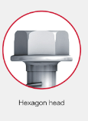 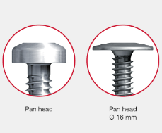 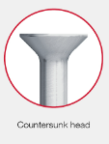 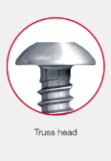

Socket Cap  
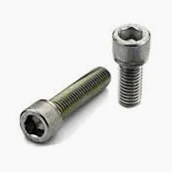

4) Different Types of Drives (External / Internal)  
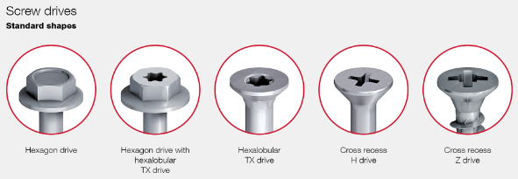

Summary Diagram

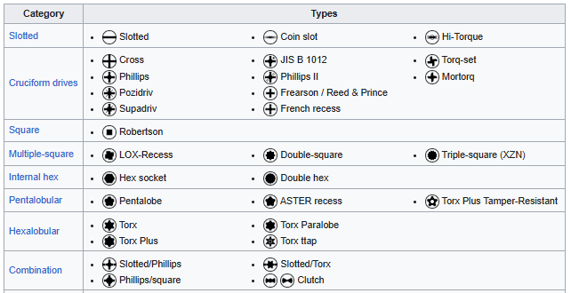

Main types (Robertson, Hex Socket, Hex, French Cross)

Understanding Screw Measurements.  
Length  
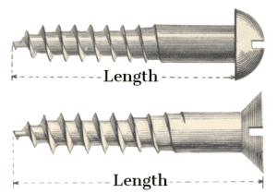

For IMPERIAL screws, diameters of 1/4 inch and smaller (for machine and sheet metal screws) or 5/16 inch and smaller (for wood screws) are expressed with a # and a whole number (ex., a screw with a major diameter of 3/16 inch is a #10 screw). Smaller numbers indicate smaller diameters.

Length indicates the distance between point and the work piece surface once the screw is installed. For example, on flat-head, countersinking screws, this runs from the point to the top of the screw head. On oval-head, countersinking screws, length runs from the point to where the screw head meets the surface of the work piece. On noncountersinking screws, it runs from the point to the bottom of the head.

A screw’s measurements are usually indicated as diameter x length, so a countersinking wood screw with a 5/32-inch diameter and a 1-1/2-inch length would be labeled as a #8 x 1-1/2-inch countersinking head wood screw.

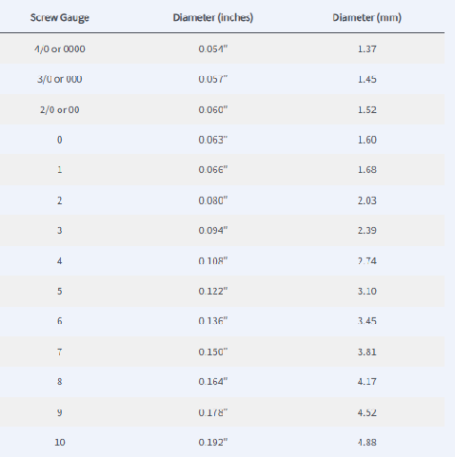

**Metric Screw Sizes**

Metric screws are listed by the diameter of the screw thread in millimetres by the length of the screw (in millimetres). The diagram below shows the diameter and length of a screw. For example, 4.5 x 40mm means the screw has a thread diameter (including teeth) of 4.5mm and the length from the head (assuming the head is flat) to the tip of 40mm

Summary Video  
https://www.youtube.com/watch?v=Eyai_I-WNXM