10605 BigML Assignment 6:

Hao Gao (haog)

Did you receive any help whatsoever from anyone in solving this assignment? No

Did you give any help whatsoever to anyone in solving this assignment? No

Q1

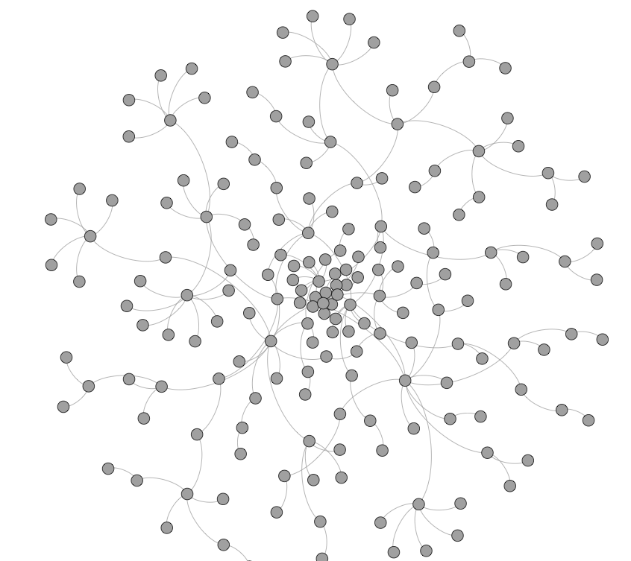

Q2

1. seed: Google, alpha = 0.3, epsilon = 0.0001

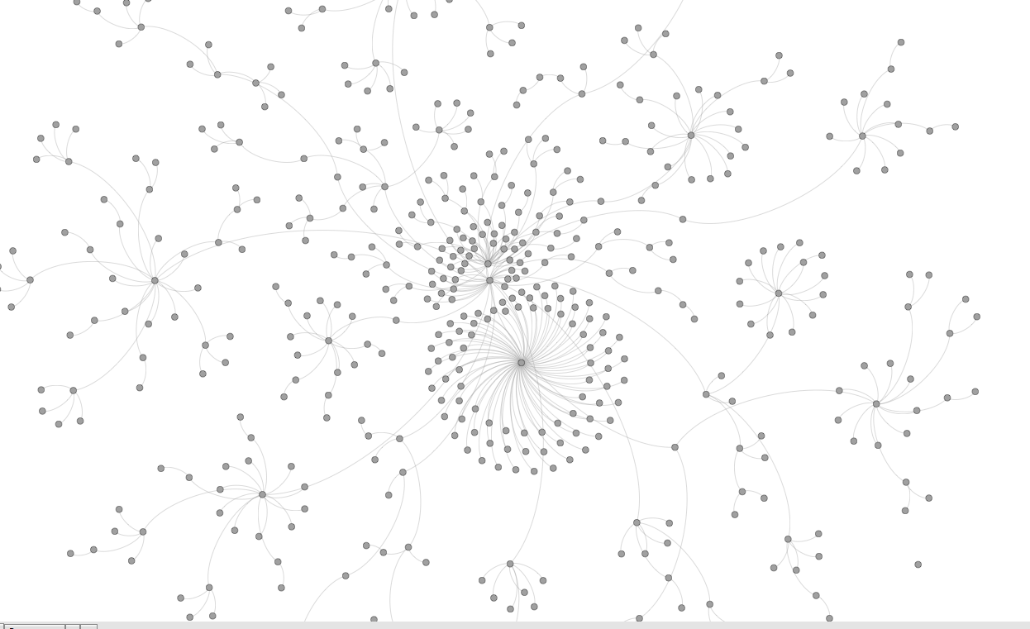

1. seed: China, alpha = 0.5, epsilon = 0.001

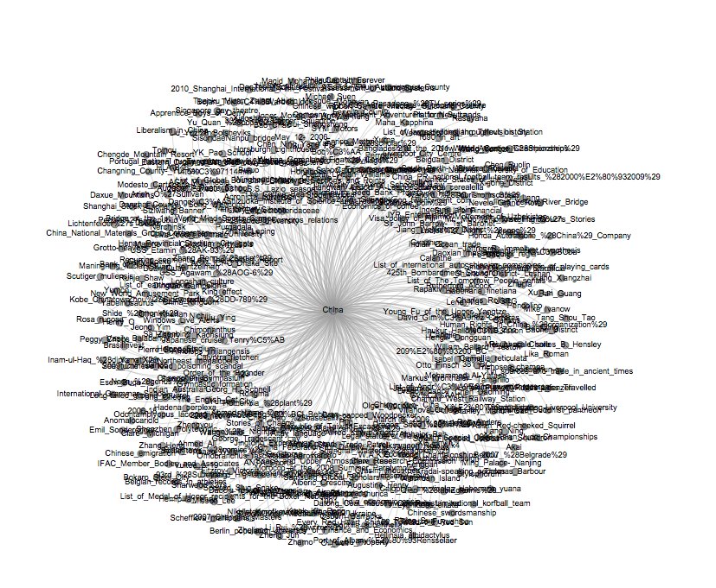

Q3

Set Alpha higher than 0.01 takes very long to converge.

Alpha Nodes Edges

0.7 44 86

0.5 78 156

0.3 177 357

0.1 659 1329

Epsilon Nodes Edges

0.01 6 10

0.001 25 48

0.0001 71 142

0.00001 177 357

0.000001 426 857

0.0000001 1121 2257

So the result graph is very sensitive to Alpha.