Name: Aoife Doherty
Student Number: L00170098

Introduction
This is a report for an ASP.Net core web application using MVC framework.
The purpose for this report is to document the development of a salon management system using ASP.Net core web application using MVC framework. The SalonApp2 is designed to manage the salons hairdressing records of employees, appointments and clients with the potential to expand the functionality to include other services.

Requirements
The main requirement for this application is to have a system for managing employee, appointments and client information. The clients can book appointments with a specific hairdresser. Employees have their specialized roles within the salon. Employees can have meany appointment in a day.

Data Model
This data model of the Salon management system has three main entities employee which represents the different hairdressers and stylists that are employed by the salon, the clients which represents the different clients that uses the services provided by the salon and appointment which are the appointments that are scheduled between the clients and stylists. The relationship between the entities are:
- An Employee can have many clients, but a client has one hairdresser.
- A Client can have many appointments booked but an appointment has one client.
- An Employee can have many appointments, but an appointment has one Employee.
Here is a diagram of the entities, their attributes and the relationship between them:
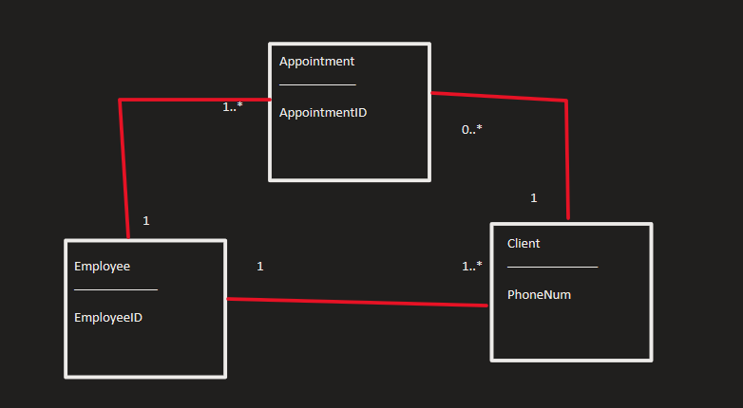

Design Decisions
I choose to use a client’s phone number as the primary key instead of their name because some clients may have the same name, but a phone number is a unique identifier. For the employees I made the employed the primary key because it is also a unique identifier. For the appointment I mad the primary key the appointment so that every appointment has a different ID.
I decided to let the appointment attribute in the client entity be nullable with DateTime? Because a client may not have a booked appointment at any given time, it might depend on their schedule.
the employeeID allows for how ever is entering the information to be able to quickly input the number of the employee. In the case of two employees having the same name this eliminates the potential confusion.
A customer must be put on the system before they can make an appointment so that the salon has their information if needed or if they don’t pay their bill so authorised can take over.

Conclusion
This highlights the key components and design decisions that were involved in the creation of the Salon Management System. This system demonstrates the use of ASP.NET Core MVC, Entity Framework Core, and application design aligned with an N-Tier architecture. This application will manage the salons records and provide a clear path for future development and expansion to the system.

