ECDAT Project Architecture and Technical Reference
Technical overview of the review build
This document explains the project objective, architecture, module responsibilities, technology stack, implemented result, limitations, and future direction. It gives developers and reviewers enough context to understand the system without requiring a file by file walkthrough.
Project | Enterprise Cryptographic Discovery and Analysis Tool
Review branch | improve/integration-ui
Source baseline | Git commit 398f8f1
Document date | 08 September 2026

Prepared for local review before any upstream pull request or merge.

Project Summary
ECDAT inventories cryptographic usage across software and deployment artifacts, converts scanner evidence into a common asset model, estimates post quantum migration urgency, and presents the result through an interactive dashboard and reports. Its practical purpose is to answer three questions: what cryptography exists, which items deserve attention first, and what migration action should be reviewed.
The review branch is a working local application. It accepts local paths, public HTTPS Git repositories, file or ZIP uploads, and container package evidence. It runs the three discovery families through one pipeline, persists results, and exposes them through a redesigned React interface. It is suitable for demonstration and controlled analysis; it is not an enterprise compliance product.

Implemented Outcome
Area | Current result | Status
Input handling | Path, HTTPS Git, file, ZIP, offline image inventory, and optional live image input | Implemented
Discovery | Source, dependency and binary, configuration, IaC, certificate, and package evidence | Implemented
Analysis | Normalization, Mosca urgency, composite risk, and migration guidance | Implemented
Experience | Responsive overview, inventory, detail, heatmap, recommendations, and history | Implemented
Exports | PDF, CSV, XLSX, and CycloneDX aligned JSON | Implemented
Production platform | Distributed work, RBAC, SSO, observability, and managed deployment | Future scope

Verified review results were 10 assets with 3 Critical findings for the supplied workspace, 2 assets for the offline image inventory, and 51 assets for a public Git scan of this repository. The backend test suite passed 66 tests, the frontend passed 14 tests, and the production frontend build completed successfully.

System Architecture
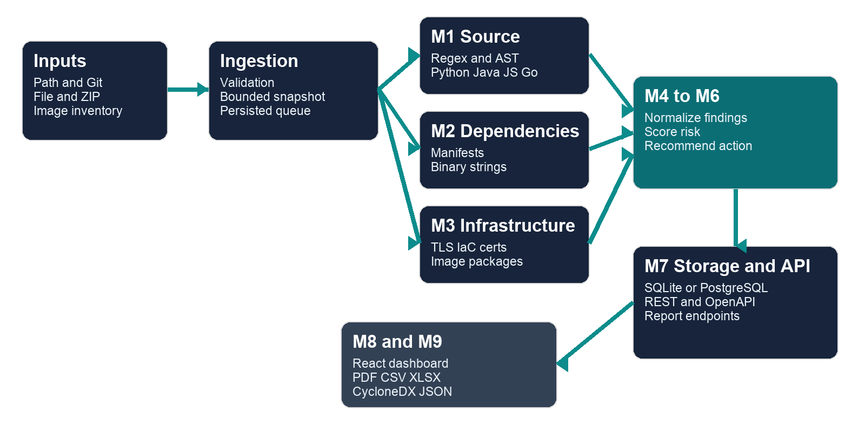
Figure 1 ECDAT processing architecture
The system uses a pipeline architecture. Input adapters prepare a bounded, static target. M1 through M3 produce a shared RawFinding contract. M4 normalizes and deduplicates those findings, M5 adds risk values, and M6 adds review recommendations. M7 persists the scan and exposes REST endpoints. M8 and M9 consume the same stored representation for the dashboard and exports.

Processing Flow
1. A user selects an input mode and submits a target through the dashboard or REST API.
2. The ingestion layer validates the input, takes a bounded snapshot or safely extracts it, and records a queued job.
3. The worker changes the scan to running and invokes M1, M2, and M3.
4. The normalizer converts scanner evidence into canonical cryptographic assets and removes duplicate occurrences.
5. The risk and recommendation engines enrich each asset with urgency, business context, and a suggested review action.
6. SQLAlchemy stores the scan, assets, recommendations, job options, and threat model configuration.
7. The dashboard polls status, reads all asset pages, and renders analysis views. Report endpoints generate export formats from the saved assessment.

Module Structure
Module | Why it exists | Primary file groups | Depends on
M1 Source scanner | Find cryptographic API and algorithm signals in source code. | backend/scanners/source | Signal rules and Tree sitter grammars
M2 Dependency and binary scanner | Identify cryptographic packages, versions, symbols, and banners. | backend/scanners/binary_deps | Manifest parsers and registry.json
M3 Infrastructure scanner | Inspect TLS configuration, IaC, certificates, and image package evidence. | backend/scanners/infra | cryptography, PyYAML, optional Trivy
M4 Normalizer | Provide one canonical asset contract for every scanner. | backend/engine/normalizer.py | RawFinding and canonical schemas
M5 Risk engine | Make migration urgency explainable and configurable. | backend/engine/risk.py | X shelf life, Y migration time, Z threat timeline
M6 Recommender | Translate risk into a reviewable migration direction. | backend/engine/recommend.py | Primitive category, algorithm, policy target
M7 API and orchestration | Manage jobs, persistence, configuration, and API contracts. | backend/api backend/engine/jobs.py backend/models | FastAPI, Pydantic, SQLAlchemy
M8 Dashboard | Give users a practical way to start scans and interpret findings. | frontend/src | React, TypeScript, Vite, Tailwind CSS
M9 Reporting | Create portable evidence for review and downstream work. | backend/api/reports.py backend/api/cbom.py | ReportLab, openpyxl, stored scan data

The module numbering comes from the original design document. The current implementation keeps those responsibilities but integrates them through a single backend package and shared database.

Data Model and Risk Logic

Scanner Boundary
Every discovery module emits RawFinding records with the source module, location, detected primitive, category, confidence, and detection tier. This contract keeps scanner logic independent from storage and user interface concerns.

Canonical Asset
The normalizer produces a canonical cryptographic asset with CycloneDX style crypto properties, occurrences, and an ECDAT enrichment section. The enrichment stores quantum vulnerability, business criticality, data classification, exposure, Mosca values, risk tier, recommendation, and reference standard.

Risk Calculation
Mosca urgency is represented by r = (X + Y) / Z. X is the required confidentiality shelf life, Y is estimated migration time, and Z is the assumed time until a relevant quantum threat. Higher ratios mean less schedule margin. The implemented tiers are Critical at r ≥ 1.2, High at r ≥ 0.9, Medium at r ≥ 0.6, and Low below 0.6. Known classically broken primitives can be escalated to Critical.
A separate composite score combines quantum vulnerability, normalized urgency, business criticality, and exposure. These values are heuristics for prioritization. They require owner review and do not prove regulatory compliance.

Technology Stack
Layer | Technology | Purpose
Frontend | React 18 and TypeScript | Component based interface and typed API mapping
Frontend build | Vite 6 and Tailwind CSS 3 | Development proxy, production bundle, and responsive styling
API | FastAPI and Uvicorn | REST endpoints, validation, polling, and OpenAPI documentation
Contracts | Pydantic 2 | Request, response, finding, and CBOM model validation
Persistence | SQLAlchemy 2 with SQLite default | Scans, assets, recommendations, jobs, and threat configuration
Discovery | Tree sitter, cryptography, PyYAML, packaging | AST inspection, X509 parsing, configuration and package analysis
Reporting | ReportLab and openpyxl | PDF and spreadsheet generation
Verification | pytest and Vitest | Backend, scanner, integration, and frontend behavior tests

Key Dependencies Between Layers
- M1, M2, and M3 depend only on scanner rules and the RawFinding model; they do not depend on the frontend.
- M4, M5, and M6 depend on the shared Pydantic contracts and configuration values.
- The orchestrator depends on all scanner and analysis modules, then writes through SQLAlchemy.
- REST routes depend on database sessions and schemas; the worker owns background execution.
- The frontend depends only on HTTP contracts and can be deployed separately when the /api proxy behavior is preserved.
- Reports depend on completed stored scans, so exploratory heatmap changes do not silently alter exported evidence.

API Surface
Endpoint group | Purpose
POST /scans | Validate a path, Git URL, or image target and create a queued scan
POST /scans/upload | Upload a file, ZIP, or image inventory and create a queued scan
GET /scans and GET /scans/{id} | List history and poll lifecycle state
GET /assets and GET /assets/{id} | Read paginated inventory, filters, dynamic Z results, and asset detail
GET /cbom/{scan_id} | Download the completed CycloneDX aligned CBOM JSON
GET /reports/{scan_id} | Download PDF, CSV, XLSX, or JSON reports
GET and PATCH /config/threat-model | Read or update threat timeline and scoring defaults
GET /health | Unprotected service health check

Input and Security Boundaries
- Local paths are copied into a temporary snapshot. Common dependency and output folders are excluded, and symbolic links are not followed.
- Git input accepts public HTTPS URLs from an allowlist. Clones are shallow, noninteractive, bounded by a 120 second timeout, and configured to reject redirects and local file transport.
- Uploads are limited to 20 MB. Expanded workspaces and ZIP files are limited to 100 MB and 10000 files or entries.
- ZIP extraction rejects absolute paths, traversal, links, backslash paths, and encrypted members.
- A shared bearer token can protect all routes except health. CORS origins are configurable.
- The persisted worker queue recovers interrupted work but intentionally permits one API worker for each state directory.

User Interface
The redesigned interface uses a navy navigation shell, responsive cards and tables, consistent risk colors, and explicit loading, empty, failure, and disconnected states. The five main views are Overview, Inventory, Risk Heatmap, Asset Detail, and Recommendations.
- Overview summarizes scan status and risk distribution.
- Inventory provides search, filters, pagination, and asset selection.
- Risk Heatmap changes the Z timeline for exploration while preserving saved results.
- Asset Detail explains occurrence, risk inputs, urgency, and migration advice.
- Recommendations groups remediation work and provides protected report downloads.

Current Limitations
- Live image scanning needs Trivy and registry access. The offline JSON route was verified in this environment; the live route was not because Trivy and a Docker daemon were unavailable.
- Source AST coverage is limited to Python, Java, JavaScript, and Go. Binary inspection uses strings and symbols rather than disassembly.
- Detection rules and package registries are curated. False positives and false negatives remain possible.
- Risk values and recommendations are prioritization aids that need application owner and cryptography review.
- The export uses CycloneDX 1.6 vocabulary, but formal schema conformance and downstream interoperability need dedicated validation.
- SQLite and a single local worker are appropriate for the demo. Production use needs distributed execution, stronger identity, managed persistence, observability, and retention controls.

Future Scope
Priority | Capability | Reason
Near term | Formal CycloneDX schema validation and golden interoperability tests | Makes exported CBOMs dependable for downstream tools
Near term | CI integration with SARIF or a GitHub Action | Moves discovery into normal development workflows
Near term | Rule packs and measured precision and recall datasets | Improves scanner quality and makes progress measurable
Medium term | Distributed queue, PostgreSQL deployment, telemetry, and retention | Supports larger repositories and concurrent teams
Medium term | OIDC or SSO, RBAC, tenants, and audit history | Creates accountable enterprise access
Longer term | Cloud KMS, network TLS, deeper binaries, HSM and certificate lifecycle | Extends visibility beyond static repository evidence

Repository References
- README.md for setup, current capability, and operational boundaries.
- ECDAT_Design_and_Technical_Document.md for the original objective and M1 through M9 design.
- CONTRACT.md and backend/models/schemas.py for the scanner and canonical asset contracts.
- backend/scanners for discovery logic, backend/engine for normalization and analysis, and backend/api for REST behavior.
- frontend/src for the application shell, pages, components, and API adapter.
- openapi.json for the generated HTTP contract and tests for executable verification.

External References
- CycloneDX Cryptography Bill of Materials
- NIST FIPS 203 Module Lattice Based Key Encapsulation Mechanism
- NIST FIPS 204 Module Lattice Based Digital Signature Standard
- NIST FIPS 205 Stateless Hash Based Digital Signature Standard
- FastAPI Documentation
- Tree sitter Parser Documentation
- SQLAlchemy ORM Documentation

