ECDAT Installation Usage and Demonstration Guide
Step by step guide for the review build
This guide explains how to install, run, use, and demonstrate ECDAT with the supplied sample data. It is written for a reviewer or presenter who needs a repeatable local demonstration and clear expected results.
Project | Enterprise Cryptographic Discovery and Analysis Tool
Review branch | improve/integration-ui
Source baseline | Git commit 398f8f1
Document date | 08 September 2026

Prepared for local review before any upstream pull request or merge.

Demo Goal
The demonstration should show one complete path from input to evidence. A presenter starts a scan, watches the queued and running states, reviews the discovered inventory, explains the risk calculation, opens a recommendation, changes the exploratory threat timeline, and downloads a report.
The recommended first run uses demo/workspace because it is small, fast, and produces a mix of source, dependency, and TLS configuration evidence.

Prerequisites
Requirement | Purpose | Required
Python 3.10 or newer | Backend API, scanners, worker, and reports | Yes
Node.js 22.12 or newer | Frontend development and build | Yes
Git | Repository installation and Git input mode | Yes
Modern browser | Dashboard at the local frontend URL | Yes
Trivy | Live container image mode only | Optional

Installation
1. Open a terminal in the cloned Akatsuki-Ecdat repository.
2. Create a Python virtual environment and install backend dependencies.
3. Install frontend packages with the lock file.
python3 -m venv .venv
.venv/bin/python -m pip install --upgrade pip
.venv/bin/python -m pip install -r requirements.txt
cd frontend
npm ci
cd ..

Start the Application
Backend Terminal
.venv/bin/uvicorn backend.main:app --host 127.0.0.1 --port 8000
Check http://127.0.0.1:8000/health. The response should report healthy. Interactive API documentation is available at http://127.0.0.1:8000/docs.

Frontend Terminal
cd frontend
npm run dev
Open http://127.0.0.1:3000. If Vite selects another local port, use the URL printed in that terminal.

Optional Access Token
Set ECDAT_API_TOKEN before starting the backend to protect all API routes except health. Enter the same value under Workspace access token in the dashboard and choose Connect. The browser holds it in memory for the current tab.
export ECDAT_API_TOKEN=review-secret
.venv/bin/uvicorn backend.main:app --host 127.0.0.1 --port 8000

Sample Data
Sample | Use | Verified result
demo/workspace | Local path demonstration with Python, Nginx, and a dependency manifest | 10 assets and 3 Critical
demo-workspace.zip | Same workspace through the upload flow | Content equivalent to workspace fixture
demo-image-inventory.json | Delivered offline CycloneDX style image package inventory | 2 assets
Repository Git URL | Public HTTPS Git ingestion | 51 assets in the review run

Counts are evidence from the verified review build. They can change when rules or sample content change.

Recommended Dashboard Demo
1. On Overview, set Input type to Local path.
2. Enter demo/workspace and choose Start scan.
3. Point out the queued and running lifecycle. Wait for the status to become completed.
4. Use Overview to explain the total inventory and risk distribution. The verified fixture produced 10 assets and 3 Critical findings.
5. Open Inventory. Search for SHA or TLS, apply a risk filter, and open one asset.
6. On Asset Detail, show the occurrence, X shelf life, Y migration effort, Z threat timeline, urgency ratio, and suggested action.
7. Open Risk Heatmap and adjust the Z value. Explain that this is an exploratory view and does not overwrite the saved assessment.
8. Open Recommendations, download a report, and use Scan history to demonstrate persisted results.
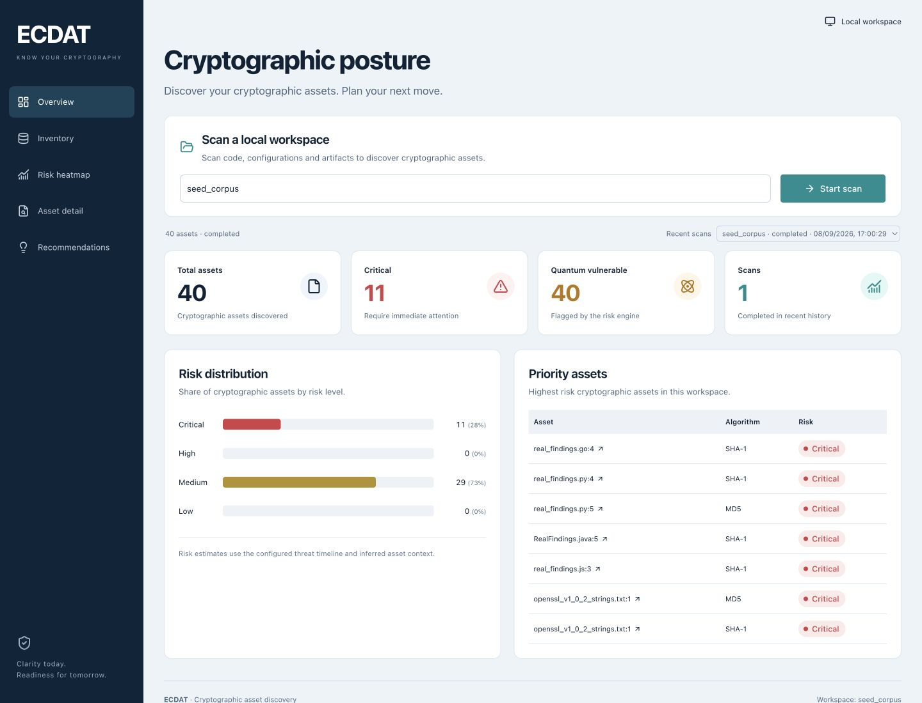
Figure 1 Review build dashboard

Additional Input Demonstrations

Git Repository
Choose Git repository and enter the public URL below. The default allowlist supports GitHub, GitLab, and Bitbucket. The backend performs a shallow HTTPS clone and scans a bounded snapshot.
https://github.com/ACE4AKSHAY/Akatsuki-Ecdat

File or ZIP Upload
Choose File or ZIP upload, select demo-workspace.zip from the delivered outputs, and start the scan. The server rejects unsafe ZIP members and applies expanded size and entry limits.

Offline Image Inventory
Choose Container image or SBOM, select demo-image-inventory.json, and start the scan. This path reads package evidence without needing Docker or Trivy.

Live Image Reference
When Trivy is installed and the machine can access the registry, choose Container image or SBOM, leave the file selector empty, and enter an image reference such as alpine:3.20. ECDAT invokes Trivy to obtain CycloneDX package evidence. This route was implemented but was not verified in the review environment.

Automated Smoke Demo
With the backend running, the supplied script submits the workspace and offline image fixtures, waits for completion, and downloads PDF, CSV, XLSX, and JSON reports.
.venv/bin/python scripts/demo_smoke.py
The script writes its working results under work/demo-results. It does not execute any code from the scanned samples.

REST API Examples

Start a Local Scan
curl -s -X POST http://127.0.0.1:8000/scans \ -H 'Content-Type: application/json' \ -d '{"sourceType":"path","target":"demo/workspace"}'

Poll a Scan
curl -s http://127.0.0.1:8000/scans/SCAN_ID

Read Assets
curl -s 'http://127.0.0.1:8000/assets?scanId=SCAN_ID&pageSize=200'

Download a Report
curl -L -o ecdat-report.pdf 'http://127.0.0.1:8000/reports/SCAN_ID?format=pdf'
When token protection is enabled, add -H 'Authorization: Bearer review-secret' to protected API requests.

Seven Minute Presenter Script
Time | Action | Message
0 to 1 min | Introduce the objective | ECDAT creates visibility into cryptographic dependencies and migration urgency.
1 to 2 min | Start demo/workspace | Inputs are validated and scanned statically through one pipeline.
2 to 3 min | Explain Overview | The dashboard makes scope and risk distribution visible.
3 to 4 min | Search Inventory | Every finding retains a location and a normalized asset identity.
4 to 5 min | Open Asset Detail | Mosca values explain timing; recommendations translate evidence into review work.
5 to 6 min | Adjust Risk Heatmap | Reviewers can compare different threat timelines without altering saved evidence.
6 to 7 min | Export and close | Reports support handoff; current constraints and production roadmap are explicit.

Troubleshooting
Symptom | Check | Action
Cannot reach backend | Health URL and backend terminal | Start Uvicorn on port 8000 and retry
401 response | ECDAT_API_TOKEN | Enter the same token in Workspace access token
Local path rejected | Backend working directory and path spelling | Use an existing relative or absolute path
Git input rejected | HTTPS URL and allowed host | Remove credentials, query text, fragments, or nonstandard ports
Upload rejected | File size and ZIP contents | Use a file under 20 MB and ordinary relative ZIP members
Live image fails | Trivy installation and registry access | Use the offline JSON fixture or install and authenticate Trivy
Frontend API error | Vite proxy target | Confirm API_PROXY_TARGET points to the backend
Worker lock error | Multiple API processes sharing state | Run one API worker for each ECDAT_STATE_DIR

Demo Checklist
- Backend health endpoint responds.
- Frontend opens and shows connected status.
- demo/workspace completes and shows 10 assets in the verified build.
- Inventory search and asset detail work.
- Heatmap Z control changes the exploratory risk view.
- At least one report downloads successfully.
- Offline image inventory completes when container tooling is unavailable.
- Limitations are stated before questions about production readiness.

Stop and Reset
Stop the frontend and backend with Ctrl C in their terminals. The default database is ecdat.db and the default state directory is .ecdat. Keep them when scan history is needed. For a clean local reset, stop the application first, then remove those local state files only after confirming the history is no longer needed.

